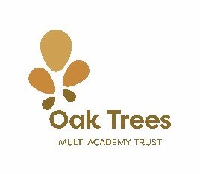

Oak Trees Multi Academy Trust

Oak Trees Multi Academy Trust, which was formed on June 1st 2017. There are six schools in the trust all Wirral based:
- Brackenwood Junior School
- Stanton Road Primary School
- Egremont Primary School
- Great Meols Primary School
- Church Drive Primary School
- Poulton Lancelyn Primary School

The Trust was set up to provide the best possible education experience for all pupils within the schools. The Trust enables schools to keep their uniqueness and individuality whilst working together for the benefit of all the children. Oak Trees is a Trust that challenges and supports, that recognises each schools’ strengths and uses these to support areas of development across all schools.

Oak Trees is a Trust that recognises the importance of Local Governing Bodies and how they shape the uniqueness of the school. We recognise that our staff are the most important and valuable resource we have to improve the outcomes of children and we recognise the huge importance parents and carers play in the education of their children.

The Trustees, via the Chief Executive Officer, Chief Finance Officer and School Improvement Lead, set the standards required for the Multi Academy Trust as a whole and for all individual schools. Each school, through their scheme of delegation, is responsible for their own budget and how they allocate their resources in order to meet the standards set by the Trustees. More information can be found on the Trust website, www.oaktreesmat.co.uk, or from the CEO Tony Lacey by emailing ceo@oaktreesmat.co.uk.

If you looking for a post that will allow you to be an integral part of a Multi Academy Trust, as well as shaping the future of the Trust, then this could be the post for you.

