Logging on to google Classroom from Home:

Step1: sign in to your Google account by typing in www.google.com into your web browser and clicking the blue sign in button in the upper right corner of the screen.

Your login is:
(Year of starting in Year 3)(first initial)(surname)@brackenwood-junior.wirral.sch.uk
e.g. 20tjones@brackenwood-junior.wirral.sch.uk
Unique Log-Ins: We have created unique log-ins for each child to use when logging into Google Classroom. These log-ins can be used for Google Classroom only. Your child’s log-in is formed using three elements, described below:

Year of Entry to Brackenwood Junior School | Name | Domain
Choose one of the following 2-digit numbers, depending upon the year group of your child:  For Year 3 Children: 20  For Year 4 Children: 19  For Year 5 Children: 18  For Year 6 Children: 17 | Take the first letter of your Christian name and add your surname (all lowercase):  Tom Jones = tjones  Double-barrelled surnames should not be abbreviated:  Amelia Rose-Brown = arose-brown | Add the domain:  @brackenwood-junior.wirral.sch.uk

Examples:
Tom Jones (Year 3): 20tjones@brackenwood-junior.wirral.sch.uk
Amelia Rose-Brown (Year 6): 17arbrown@brackenwood-junior.wirral.sch.uk

Your password is: BrackJr123 (this is case sensitive)
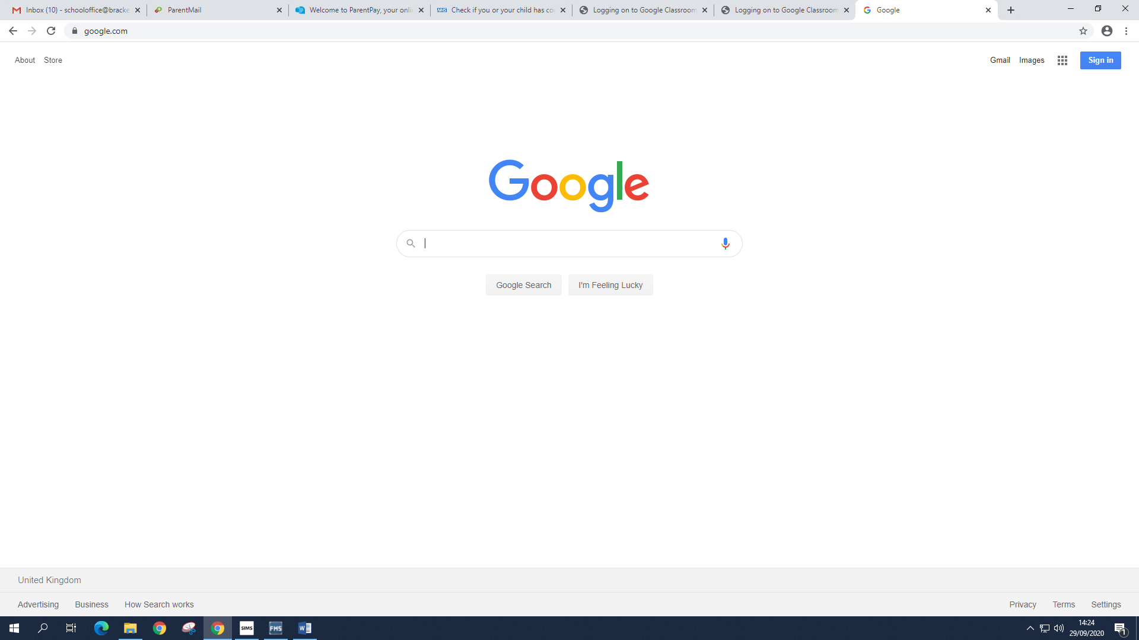

If you are having trouble logging in from home, make sure all other Google accounts are signed out before you login. If they aren’t you won’t be able to log in.

Step 2: Click the plus sign to join your class (first time)
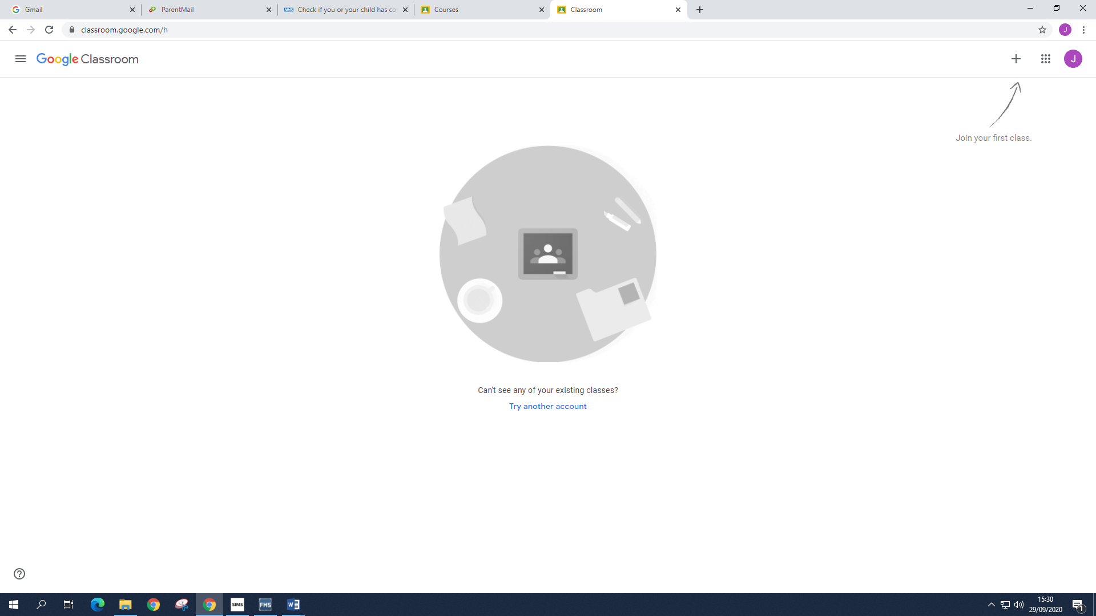

Step 3: Select your class by entering your class code (case sensitive)
The class codes are listed below:

Class | Code
Class 3D | 6yjrnn2
Class 3W | n7i62wv
Class 4K | niet6zd
Class 4L | 2zkic3p
Class 5W | rywzra3
Class 5K | 5h3mkgq
Class 6WT | 5jplb32
Class 6B | pozqdmm

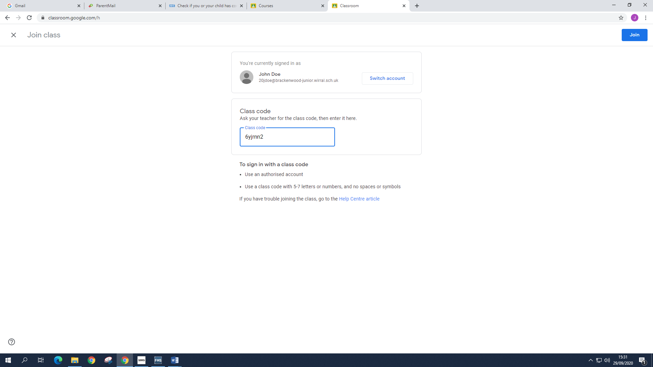

The next time you log in your class will be there:

To log out: Click on the coloured initial in the top right corner, then select sign out.
