Brackenwood Junior School
Learning for Life

Headteacher: Mr. C. Holmes MMUS.PGCE.NPQH

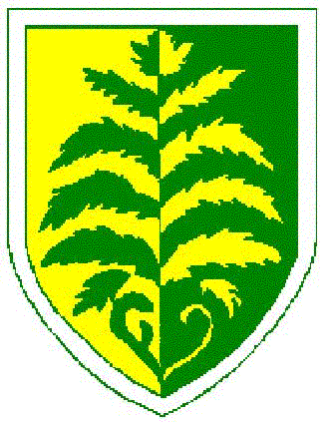

OFSM Check – Consent Form

I agree that you will use the information provided to process my claim for free school meals and will contact other sources as allowed by law to verify my initial, and ongoing, entitlement.
I agree that the information may be used to ensure accuracy of records across the local authority and the check against fraud.
I agree that you can inform the school(s) attended by my child of their initial and ongoing entitlement to free school meals.
Eligibility is based on one of the following benefits:
- Universal Credit (provided you have an annual net earned income of no more than £7,400, as assessed by earnings from up to three of your most recent assessment periods)
- Income Support
- Income-based Jobseeker's Allowance
- Income-related Employment and Support Allowance
- Support under Part VI of the Immigration and Asylum Act 1999
- The guarantee element of Pension Credit
- Child Tax Credit (provided you're not also entitled to Working Tax Credit and have an annual gross income of no more than £16,190)
- Working Tax Credit run-on - paid for four weeks after you stop qualifying for Working Tax Credit

To complete an application you will need to provide:

Your name
National Insurance Number
or
National Asylum Support Service Ref Number
Your Date of Birth
Relationship to child
Your Email
Your Phone Number
Home address (first line and post code)
Childs name
Childs Date of Birth
Childs gender
School that they attend

Signed: ______________________________________________________________________

Date: ___________________________________________

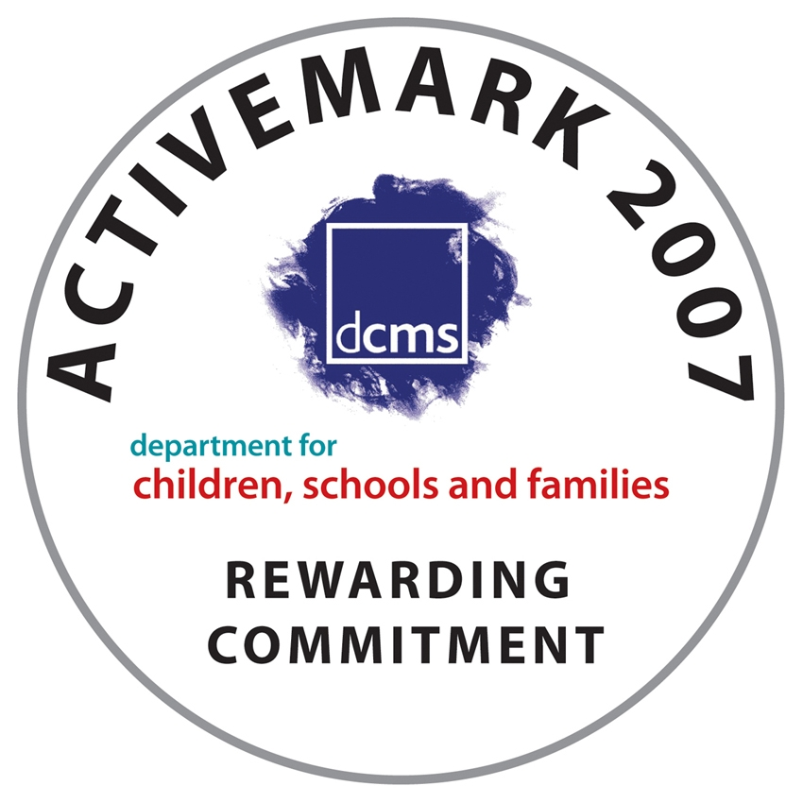


Norbury Avenue, Bebington, Wirral, CH63 2HH
Tel: 0151 608 3001 Fax: 0151 609 0179
e-mail: schooloffice@brackenwood-junior.wirral.sch.uk website: www.brackenwoodjuniors.co.uk

