Brackenwood Junior School


Positive Behaviour for Learning Policy 2026-2027


Collaboration Inspiration Expression Citizenship

This document was adopted and approved by the Local Governing Body September 2026

Introduction
Oak Trees Multi Academy Trust expects a high standard of behaviour at all times from pupils, parents and staff. The Board of Oak Trees Multi Academy Trust has the duty to lay down the broad strategy for maintaining a high standard of student behaviour and discipline in Oak Tree Academies. The Board has delegated to each Academy/school the responsibility for a localised detailed approach to meeting the Trust’s expectations.
The Board of Oak Trees Multi Academy Trust expects:
- All students to show respect and courtesy towards teachers and other staff and towards each other;
- Headteachers to prevent and deal with all forms of bullying, including cyberbullying in a timely and efficient manner;
- Parents to encourage their children to show that respect and support the school’s authority to discipline its students;
- Headteachers to help to create that culture of respect by supporting their staff's authority to discipline students and ensuring that this happens consistently across the school;
- Local governing committees and Headteachers to deal with allegations against teachers and other school staff quickly, fairly and consistently in a way that protects the pupil and at the same time supports the person who is the subject of the allegation;
- That every teacher will be effective at managing and improving pupil’s behaviour, and will be well supported by the senior leadership team at the school to help them achieve this. The advice below summarises the legal powers and duties that govern behaviour and attendance in schools and explains how they apply to teachers, governing bodies, students and parents.

The Board of Oak Trees Multi Academy Trust’s statement and policy
Oak Trees Multi Academy Trust has charged each Local Governing Committee with the duty to set the framework of the school's policy by providing a written statement of general principles relating to discipline, taking into account the needs of all students. Oak Trees Multi Academy Trust expects each school to establish and maintain a behaviour protocol that promotes self-discipline, respect for others and proper regard for authority.
Each school will publish on its website their individual protocol for dealing with behaviour issues in the school.
It will be reviewed annually or more frequently if necessary.

Academy Trust ethos
The ethos of Oak Trees Multi Academy Trust is echoed through the Oak Trees Values (collaboration, citizenship, expression and inspiration) and through the British Values of:
Tolerance
Individual liberty
Democracy
Rule of law
Mutual respect

Rules of conduct
The Headteacher of each school will draw up and review periodically a positive and constructive set of school rules that will:
- Promote self-discipline and proper regard for authority among students;
- Encourage good behaviour and respect for others, and prevent all forms of bullying among students;
- Ensure standard of behaviour is acceptable;
• Regulate students’ conduct.

Rewards and sanctions
None of the school’s sanctions must be degrading or humiliating. The Trust expects all rewards and disciplinary penalties to be applied fairly and consistently. High standards of student behaviour and discipline provide a positive environment in which teachers can teach and students can learn. We should expect these high standards at all times but the list below represents the most common sanctions against less than acceptable behaviour:
- rebukes to individual, group or class;
- movement to another seat;
- report to teacher at break time/lunchtime;
- written punishment e.g. additional or reattempt work;
- referral to more senior teacher/Headteacher;
- parents asked to visit school, joint monitoring by parents, tutor as appropriate;
- fixed term exclusion;
- permanent exclusion.

Disability
Where the misbehaviour of students is related to a mental or physical disability, the Trust expects that the Headteacher will make reasonable adjustments to enable those students to be included within the school community. These will include:
- ensuring that staff have had training in the nature of disabilities, and how they should treat students with disabilities;
- ensuring that staff are aware of any students with such disabilities;
- ensuring that appropriate help is sought to enable the school to make reasonable adjustments;
- ensuring that school resources are committed to assist in making reasonable adjustments; and
- making reasonable adjustments to school organisation to the timetable of particular students.

Child-on-Child Abuse
The school has a zero-tolerance approach to child-on-child abuse and is committed to providing a safe and respectful environment where all pupils are protected from harm. Child-on-child abuse will always be taken seriously and will never be dismissed as "banter", "part of growing up" or "just having a laugh".
Child-on-child abuse may include, but is not limited to:
- bullying, including cyberbullying and prejudice-based bullying;
- physical abuse;
- sexual harassment or sexual violence;
- abuse in intimate personal relationships between children;
- sharing or threatening to share nude or semi-nude images or videos without consent;
- online abuse; and
- initiation or hazing-type violence.
Any concerns or allegations of child-on-child abuse will be reported to the Designated Safeguarding Lead (DSL) and managed in accordance with the school's Child Protection and Safeguarding Policy. Incidents will be treated as safeguarding concerns and, where appropriate, behaviour sanctions will be applied in line with this Behaviour Policy.
The school will provide appropriate support for pupils who have experienced abuse and will also work with pupils who display harmful behaviour to promote positive change. Pupils are encouraged to report concerns about themselves or others and can expect these to be taken seriously and dealt with promptly.
This section should be read alongside the school's Child Protection and Safeguarding Policy, Anti-Bullying Policy, Online Safety Policy and Relationships, Sex and Health Education (RSHE) Policy.

Responsibilities
The Headteacher's role is to establish and maintain a behaviour protocol that promotes self-discipline, respect for others and proper regard for authority. The Headteacher, when determining the behaviour protocol, must do so with a view to ensuring that students complete any tasks reasonably assigned to them in connection with their education. The Headteacher will determine measures (including the making of rules and provision of disciplinary penalties) to be taken, with a view to:
- promoting self-discipline and proper regard for authority among students;
- encouraging good behaviour and respect for others, and preventing all forms of bullying among students;
- ensuring that the standard of behaviour is acceptable; otherwise regulating the conduct of students.

The Headteacher is required to set out the behaviour and discipline protocol in a written document and to consult the local governing committee before publishing it by making it generally known to staff, students and parents. It must be brought to their attention at least once a year.
Responsibilities of the Headteacher:
- Ensure the behaviour policy is regularly reviewed
- Provide staff training
- Ensure the behaviour policy is implemented consistently by staff
- Publish the policy on the website and communicate it to staff
- Promote a positive school behaviour culture
- Support and investigate serious behaviour breaches
- Investigate any use of reasonable force
- Review any incidents of searches in school
- Take responsibility for serious disciplinary decisions such as suspensions and exclusions
- Monitor behaviour incidents and patterns
- Communicate with parents about serious behaviour concerns
- Work with external services
Responsibilities of staff:
- Read and understand the behaviour policy
- Promote positive behaviour
- Model positive behaviour and professionalism at all times
- Encourage and recognize positive behaviour
- Implement the school’s behaviour policy, using the agreed rules, rewards and sanction systems
- Use the insist prompts and de-escalation strategies
- Seek support from senior staff where appropriate if behaviour issues persist or escalate
- Record behaviour incidents on CPOMs
- Be aware of individual pupils needs
- Work with colleagues to support pupils who require additional behaviour support
- Communicate behaviour achievements and concerns with parents
Responsibilities of pupils:
- Follow the school’s behaviour expectations at all times
- Treat all members of school with respect and kindness
- Avoid behaviour that may upset, hurt or harm others
- Reflect on their behaviour where it does not meet expectations
Responsibilities of parents and families:
- Be aware of and support the school’s behaviour policy and expectations
- Encourage their child to follow the school rules
- Support their child in developing positive attitudes towards learning and behaviour
- Work in partnership with the school to address behaviour concerns
- Attend meetings with staff to discuss behaviour issues
- Inform the school of any behaviour concerns or issues
- Support the school in applying rewards and sanctions where appropriate
- Help their child to reflect on behaviour and make improvements where needed
This policy should be read in conjunction with the following policies:
- Anti-Bullying
- Attendance
- Positive handling
- Safeguarding
- Equality and Diversity
- Exclusion
- Online Safety
- SEND

This policy is underpinned by the following legislation and guidance:

- Education Act (2002), as amended by Education Act (2011)
- Education and Inspections Act (2006)
- School Discipline [Pupil Exclusions and Reviews] – England – Regulations (2012)
- Equality Act (2010, revised 2018)
- Searching, Screening and Confiscation at Schools (2018)
- When to call the police: guidance for schools and colleges (NPCC)
- Keeping Children Safe in Education
- Behaviour in Schools
- Suspension and Permanent Exclusion

Staff Training
To ensure good behaviour and discipline in our school, all staff receive appropriate and relevant training in behaviour management. Staff have received training on de-escalation procedures. All staff, including lunchtime assistants, have opportunities to be involved in specific training in behaviour management. This allows for the updating of procedure and strategies as well as refreshing knowledge and understanding of the school’s systems.

Equal opportunities
The staff ensure that high standards of behaviour are expected from all children. We promote self and mutual respect and a caring and non-judgmental attitude throughout the school.

Use of Reasonable Force
The MAT Positive Handling Policy should also be read in conjunction with this document.
Although circumstances would be considered to be extremely rare, there might be times when staff at Brackenwood Juniors have the power to use reasonable, proportionate and necessary force. This would be utilised to prevent pupils from committing an offence, injuring themselves or others or damaging school property with the aim to keep everybody safe. Where such action is necessary, parents will be informed and details of the incident recorded securely in school.

Power to search pupils
The headteacher, and staff authorised by the headteacher, have the power to search pupils or their possessions, without consent, where they suspect the pupils to have prohibited items e.g. knives and weapons, alcohol, illegal drugs, tobacco and stolen items. These items can be confiscated and the law protects staff from liability for damage, provided they have acted lawfully. Force cannot be used to search for items banned under the school rules. Where such action is deemed necessary, searches must be carried out by the same sex as the pupil being searched and there must be a witness. An exception to this would be that a search of a pupil from the opposite sex can take place, and without a witness, only if there is reason to believe that significant harm will be caused if the search is not carried out immediately.

Brackenwood Juniors
Behaviour Management Procedures 26-27

Policy Statement
This policy has been written for the staff, pupils, parents and Governors of Brackenwood Junior School. It is expected that all staff and children will adhere to the details as set out in order that the highest standards of behaviour are achieved at all times. For this to be successful, consistent application of its principles should be applied by staff and supported by parents and governors. The school’s behaviour policy applies to all aspects of the school day during school-based activities and off-site visits, and includes extra-curricular activities that occur when they are led by school staff or externally provided coaches.
This policy has been written in collaboration with Governors, staff and children to benefit all members of the school community and is the foundation for facilitating high levels of attainment and progress.
At Brackenwood Junior School, we believe that the highest standards for behaviour are central to achieving the best education for our pupils and to achieve a successful and safe environment in which children can learn and develop to their full potential. We seek to achieve this through the promotion of a positive culture, building social norms, proactively teaching students how to behave well through the use of fair and transparent systems of rewards and sanctions.
We believe in the power of positive framing but also sanctioning, where applicable, in order to create a culture conducive to learning and thriving in education.
We aim to give all pupils the knowledge and understanding that will enable them to become increasingly independent, resilient and responsible individuals.
Brackenwood Junior School has consistently high expectations of behaviour for learning and overall conduct. All pupils are expected to behave in a responsible manner both to themselves and to others, showing consideration, courtesy and respect for other people at all times. We actively seek to tackle any form of bullying, harassment or prejudice through the use of appropriate sanctions.
Our behaviour systems are research informed through the implementation of strategies outlined by Tom Sherington CPD (Walkthrus) and by reading P.Dix When The Adult Changes Everything Changes.
Scope and purpose
At Brackenwood Junior School we:
- have high expectations of pupil behaviour in order to maximise their opportunity to achieve
- ensure all pupils develop the excellent learning habits that they need to be successful in school and in life
- realise and celebrate the potential of all pupils through promoting independence, high self-esteem and enabling students to reach their full potential
- create an environment in which pupils are enabled to become mature, self-disciplined, industrious and able to accept responsibility for their own actions
- have a no tolerance approach to all forms of child on child abuse, including bullying and cyberbullying, and work hard to create a positive and safe learning environment
- work to develop and support all staff to manage behaviour with a high level of professionalism, dignity and fairness in order to maintain a safe and purposeful environment
- build positive relationships between families, school and pupils through a three-way partnership, makes clear the expectations of all three parties in developing and maintaining a safe and positive culture and an active partnership with parents and carers to support their children’s learning

School Rules
Our behaviour procedures are underpinned by 3 overarching rules:
- Be Ready
- Be Respectful
- Be Safe
Staff will refer to these rules when acknowledging positive behaviour and when reflecting on negative behaviour.
Recognition, reward and praise
The school recognises that praise is key to making pupils feel valued and ensuring that their work and efforts are celebrated. When giving praise, teachers ensure:
- They define the behaviour that is being rewarded.
- The praise is given immediately following the desired behaviour.
- The way in which praise is given is varied.
- Praise is related to effort, rather than only to work produced.
- Perseverance and independence are encouraged.
- Praise is only given when a pupil’s efforts, work or behaviour needs to be recognised, rather than continuously without reason.
- The praise given is always sincere and is not followed with immediate criticism.

The school understands that providing rewards after certain behaviour means that pupils are more likely to model the same behaviour again. For rewards to be effective, the school recognises that they need to be:
- Immediate – immediately rewarded following good behaviour
- Consistent – consistently rewarded to maintain the behaviour.
- Achievable – keeping rewards achievable to maintain attention and motivation.
- Fair – making sure all pupils are fairly rewarded.

Promoting positive behaviour
The following strategies are utilised consistently across the school to promote and encourage good behaviour from all pupils as individuals and collectively as classes.
Individual rewards via staff
- Verbal praise
- Stickers
- Reward tokens- given daily for positive behaviour or when excellent learning habits are observed. The pupil with the most tokens each week in class will receive the class bear.
- Value and kindness award – given out in Friday assembly to a child in each class who has been recognised for the class value that week
- Proud postcards sent home.

Headteacher rewards
      - Proud postcards sent home.
      - Headteacher Recognition Trophy - given out weekly to one pupil in assembly.

Collective rewards
- Green passes – classes can achieve green passes from members of staff for collectively demonstrating positive behaviour and learning habit. When a class achieves 25 green passes, they receive 5 minutes extra break time.

All staff have been asked to follow these behaviour systems to maintain a consistent approach across the school.
The following are examples of positive behaviour and learning habits that should be praised and rewarded
- Calm quiet and sensible transitions around school
- Single file walking during transition
- Holding the door open for adults
- Remembering manners when requesting or receiving
- Listening carefully to, and tracking the speaker during inputs
- Maintaining focus and concentration during lessons
- Being prepared for lessons with the correct equipment out (all stationery is provided by school)
- Demonstrating high standards of presentation
- Following staff instructions

During lessons and transitions, staff will gain the attention of the class in order to refocus learning or reframe behaviour. Staff will should insist on this by using one of the following prompts to gain class focus.

Insist Prompts
Verbal gestures | Non-verbal gestures
Class chant  Clapping | Team stop gesture

Sanctions and Consequences
Occasionally, some children might display behaviour that is below the standard that we expect and that is not in accordance with our school rules. The following escalation system has been developed with staff and governors.
Low level behaviours include but are not limited to:
- Talking at inappropriate times
- Walking around the classroom without permission.
- Shouting out
- Making inappropriate or rude noises
- Attempting to upset others
- Purposefully damaging equipment

All staff, including supply teachers and sports coaches, are expected to use the system consistently. Supply teachers and sports coaches must report back to the class teacher when a child has had a restorative conversation.
- Reminder – a reminder about behaviour expectations with an attempt to recall positive behaviour seen previously e.g. Tim, remember our school rules. I love it when you show me that you’re ready to learn
- Verbal warning – for continuing to demonstrate behaviour below the expected standard, This will be again be a brief interaction e.g. Tim, this is a warning. I need you to change your behaviour by demonstrating the respectful listening that I know you are capable of.
- Playtime missed and restorative justice conversation with a member of SLT and the staff member. Reflection - At the third interaction, staff will speak to the individual for no more than 30 seconds to explain that a reflective conversation will take place regarding unacceptable behaviour at an appropriate time after the lesson e.g. a short duration of break time, which will last no more than 5 minutes. This reflection will focus on the type of behaviour, the school rules that were broken, the impact that this had on the lesson and will attempt to understand why the behaviour was demonstrated so that it is not repeated.

Restorative conversation starters
- What happened?
- What were your thoughts/feelings at the time?
- What have been your thoughts/feelings since?
- Which rule do you think you were breaking?
- Who has been affected by what happened?
- How have they been affected?
- What do you need to happen now?
- How can we do things differently in the future?

If step 4 has been utilised then a record of the incident will be recorded on CPOMs and parents will be informed via a phone call or an informal meeting at the end of the day. SLT are automatically notified of all CPOMs records.

De-escalation strategies
Where negative behaviour is present, staff members will implement de-escalation strategies to diffuse the situation. This includes:
- Appearing calm and using modulate, low tone of voice.
- Using simple, direct language.
- Avoid being defensive, e.g. if comments or insults are directed at the staff member.
- Provide adequate personal space and not blocking a pupil’s escape route.
- Showing open, accepting body language, e.g. not standing with arms crossed.
- Reassuring the pupil and creating an outcome goal.
- Identifying any points of agreement to build rapport.
- Provide choices
- Rephrasing requests made up of negative words with positive phrases, e.g. “if you don’t return to your seat, I won’t help you with our work” becomes “if you return to your seat, I can help you with your work”.

Serious behaviour breaches
Any major breaches of the school’s behaviour policy will be dealt with by the Headteacher or Assistant Headteacher. Sanctions for such breaches will be serious and may result in a fixed-term or permanent exclusion. Examples of this type of behaviour are:
- Physical assault
- Deliberate damage to property
- Stealing
- Leaving school premises without permission
- Violent behaviour
- Refusal to follow instructions
- Swearing at adults and/or other children in anger
- Child on child abuse
- Racist or homophobic behaviour
- Discrimination
- Bullying

When specific children demonstrate any of these types of behaviours repeatedly, a range of strategies will be used including home/school books, regular updates to parents from class teachers, visual behaviour charts, and referral to the SENDco for external agency advice/support.
A staged approach will be taken to major disciplinary breaches

Stage 1
A discussion will take place with the Headteacher/Deputy Headteacher, the child and the parents detailing the incident. The child will be issued with a behaviour chart which must be completed daily by the class teacher and signed by the parents.
The child will follow this report chart for at least 1 week.
If no improvements are made then the child will move to Stage 2 – parents will be informed of this.

Stage 2
A behaviour chart will be continued for a fixed period of time and a referral made to the SENDCo. The SENDCo will seek further advice and support from appropriate external agencies and, if necessary, a behaviour support plan put in place. The plan will set out clear targets to improve behaviour and the support accessed. This plan will be reviewed half-termly. If there is no significant improvement at Stage 2 following the behaviour support plan, the child will move to Stage 3 – parents will be informed.

Stage 3
At stage 3, further advice will be sought and assessments undertaken as appropriate by external agencies. It might be necessary for an ‘internal exclusion’ to be put into place. This might include the child working in an alternative classroom and/or loss of playtimes, including lunchtime break. Parents will be kept informed and integral to the process. If there is no significant improvement at Stage 3, the child will move to Stage 4 – parents will be informed.

Stage 4
Parents will be informed that their child is at risk of exclusion due to continued unacceptable behaviour. There are circumstances where there is no alternative but to exclude a pupil. In these cases, the Local Authority exclusion procedures will be followed, which may result in a fixed term or permanent exclusion.

Dealing with Incidents of Bullying
There are some incidents which may be considered to be bullying. The trust’s anti-bullying policy should be read in conjunction with this document.
At Brackenwood Juniors staff will monitor and record any incidents which concern them on CPOMs. Pupils are actively encouraged to report any incidents that might constitute an incident of bullying to an adult in school. The information will be handled sensitively and passed to members of SLT. A detailed investigation will take place and findings recorded.
Fixed term and Permanent Exclusion
All of our schools within Oak Trees Mulit-Academy Trust work tremendously hard to avoid and fixed term and permanent exclusion but at times it can be necessary to address a more serious behaviour matter. All of our schools comply with the law and communicate with families clearly. More information can be found in our Exclusions Policy.

Behaviour expectations and pupils with SEND
Some pupils with SEND may have behaviours that arise from their additional needs and the law requires flexibility and responsiveness, often through provision that is ‘additional to or different from’ the main offer, in order to meet those needs. In addition, pupils with SEND may have behaviours that are not arising from their additional needs and other pupils’ behaviour may be arising from SEND that has not yet been identified or understood. We aim to establish behaviour systems that are consistent and based on high expectations as the norm, but are also flexible and responsive enough to support a wide range of needs and support all pupils to learn from their behaviour and move forward in a positive way. This should include directly teaching pupils the skills and understanding that underpins good behaviour, and anticipating likely triggers of challenging behaviour and putting provision in place to support and prevent it wherever possible.

Appendix B (Behaviour Report):
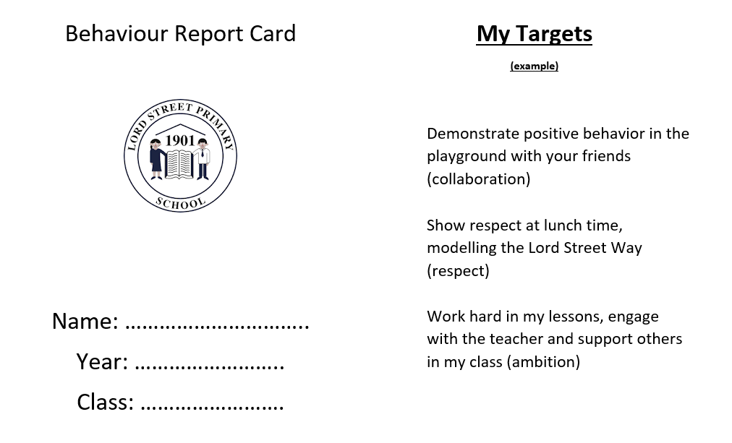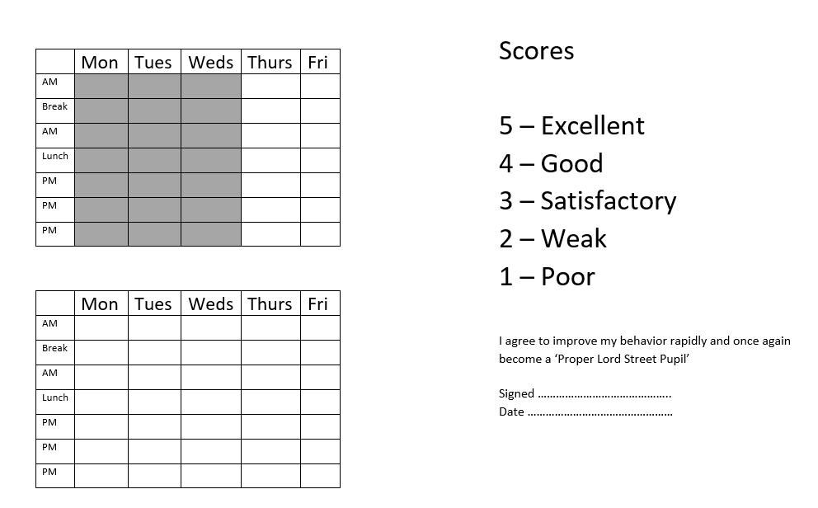

Brackenwood Junior School Behaviour Policy 2026-2027
Our school rules
Be Ready
Be Respectful
Be Safe
Examples of positive behaviour/learning habits | Examples of negative behaviour/learning habits
- Calm quiet and sensible transitions around school  - Single file walking during transition  - Holding the door open for adults  - Remembering manners when requesting or receiving  - Listening carefully and tracking the speaker during inputs  - Maintaining focus and concentration during lessons  - Being prepared for lessons with the correct equipment out (all stationery is provided by school)  - Demonstrating high standards of presentation  - Following staff instructions | - Talking at inappropriate times  - Walking around the classroom without permission.  - Shouting out  - Making inappropriate or rude noises  - Attempting to upset others  - Purposefully damaging equipment
Rewards for positive behaviour | Sanctions for negative behaviour
- Verbal praise  - Stickers  - Reward tokens- given daily for positive behaviour or when excellent learning habits are observed. The pupil with the most tokens each week in class will receive the class bear.  - Values award and kindness award – given out in Friday assembly to a child in each class who has been recognised for the class value that week  - Proud postcards sent home.  - Headteacher Recognition Trophy - given out weekly to one pupil in assembly  - Green class passes – classes can achieve green passes from members of staff for collectively demonstrating positive behaviour and learning habits. When a class achieves 25 green passes, they receive 10 minutes extra break time. | - Reminder – a reminder about behaviour expectations with an attempt to recall positive behaviour seen previously e.g. Tim, remember our school rules. I love it when you show me that you’re ready to learn.  - Verbal warning – for continuing to demonstrate behaviour below the expected standard, This will again be a brief interaction e.g. Tim, this is a warning. I need you to change your behaviour by demonstrating the respectful listening that I know you are capable of.  - Playtime missed and restorative justice conversation with a member of SLT and the staff member. Reflection - At the third interaction, staff will speak to the individual for no more than 30 seconds to explain that a reflective conversation will take place regarding unacceptable behaviour at an appropriate time after the lesson e.g. a short duration of break time, which will last no more than 5 minutes. This reflection will focus on the type of behaviour, the school rules that were broken, the impact that this had on the lesson and will attempt to understand why the behaviour was demonstrated so that it is not repeated.
Any major breaches of the school’s behaviour policy will be dealt with by the Headteacher or Deputy Headteacher.

Behaviour Insist Prompts | Restorative conversation starters | De-escalation strategies
Verbal gestures  Class chant  Clapping  Non-verbal gestures  Team stop | What happened?  What were your thoughts/feelings at the time?  What have been your thoughts/feelings since?  Which rule do you think you were breaking?  Who has been affected by what happened?  How have they been affected?  What do you need to happen now?  How can we do things differently in the future? | Appearing calm and using modulate tone of voice.  Using simple, direct language.  Avoid being defensive  Provide adequate personal space  Showing open, accepting body language  Reassuring the pupil and creating an outcome goal.  Identifying any points of agreement to build rapport.  Provide choices  Rephrasing requests made up of negative words with positive phrases

