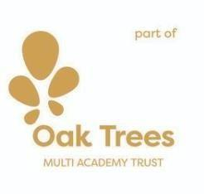
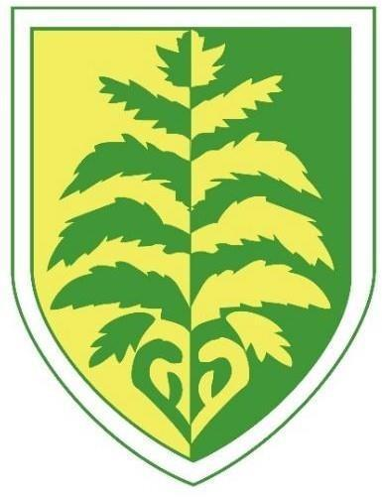
Brackenwood Junior School

PSHE Long Term Plan 2026-2027

Whole School Intent

 | Autumn | Spring | Summer
Year 3 | Kapow: Family and Relationships  Kapow: Health and Wellbeing | Kapow: Health and Wellbeing Kapow: Safety and the Changing Body  Kapow: Citizenship | Kapow: Citizenship Kapow: Economic Wellbeing Kapow: Transition Lesson
 | First Aid | First Aid | PANTS Lesson
Year | Kapow: Family and Relationships | Kapow: Health and Wellbeing Kapow: Safety and the Changing Body | Kapow: Citizenship Kapow: Economic Wellbeing Kapow: Transition Lesson  Speak Out, Stay Safe
4 | Kapow: Health and Wellbeing
 | First Aid | First Aid
Year | Kapow: Family and Relationships | Kapow: Health and Wellbeing Kapow: Safety and the Changing Body | Kapow: Citizenship Kapow: Economic Wellbeing
5 | Kapow: Health and Wellbeing | Kapow: Citizenship | Kapow: Transition Lesson
 | First Aid | First Aid | Next stop, Puberty!  (including Speak Out, Stay Safe lesson)
Year | Kapow: Family and Relationships | Kapow: Health and Wellbeing Kapow: Safety and the Changing Body | Kapow: Citizenship Kapow: Economic Wellbeing
6 | Kapow: Health and Wellbeing | Kapow: Citizenship | Kapow: Identity  Kapow: Transition Lesson
 | First Aid | First Aid | Puberty and Consent lessons  (including Speak Out, Stay Safe lesson)

Personal, Social and Health Education

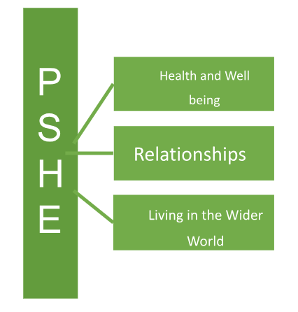Our key driving themes are:
Skills Progression Map
PSHE

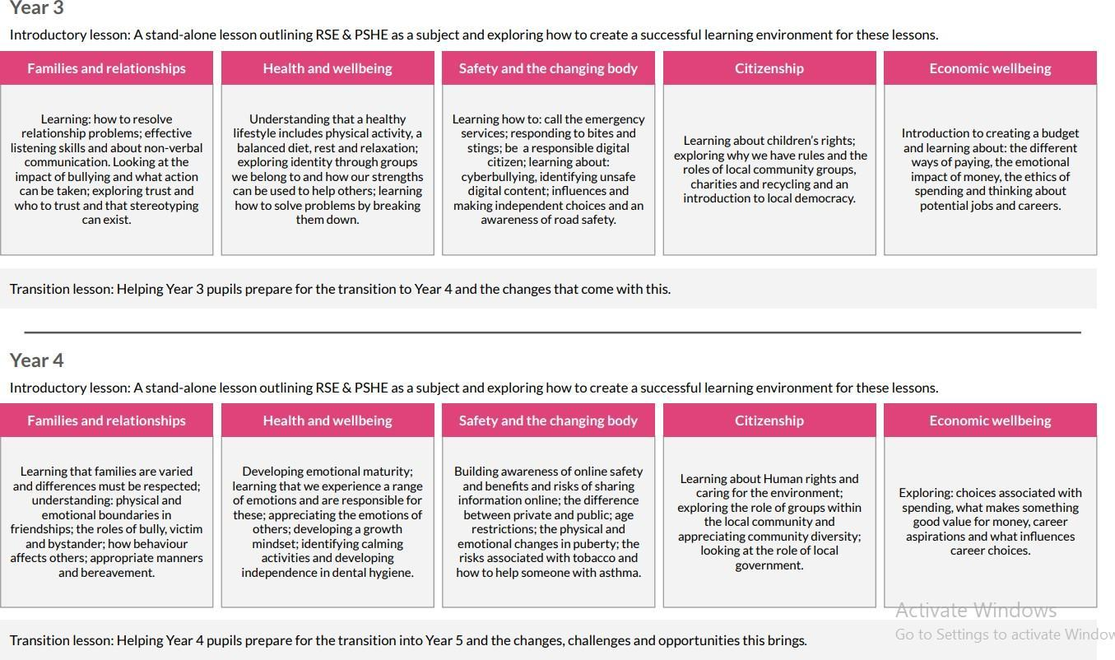
Why should children learn this subject? | PSHE enables our children to become healthy, independent and responsible members of society. It aims to help them understand how they are developing personally and socially, and tackles many of the moral, social and cultural issues that are part of growing up.
What will children learn to do in this subject? | At Brackenwood Junior School, children will:  - Recognise and apply the British Values  - Be able to recognise, understand and manage their own emotions  - Understand who they can rely on and ask for support.  - Look after their own mental health and ask for support where necessary.  - Be on their way to maintaining a healthy lifestyle.  - Recognise differences and have an understanding of diversity.  - Apply learnt skills in real life situations  - Demonstrate self-confidence and self-esteem.  - Have developed and maintained healthy relationships with peers and adults.  - Understand the physical aspects involved in the teaching of RSE at the level appropriate to them as an individual.  - Show respect to themselves and others.
How will we inspire them? | - Set ground rules  - Consider the individuals  - Pose intriguing questions  - Allow time for discussions and questioning  - Encourage children to think for themselves  - Solve problems together

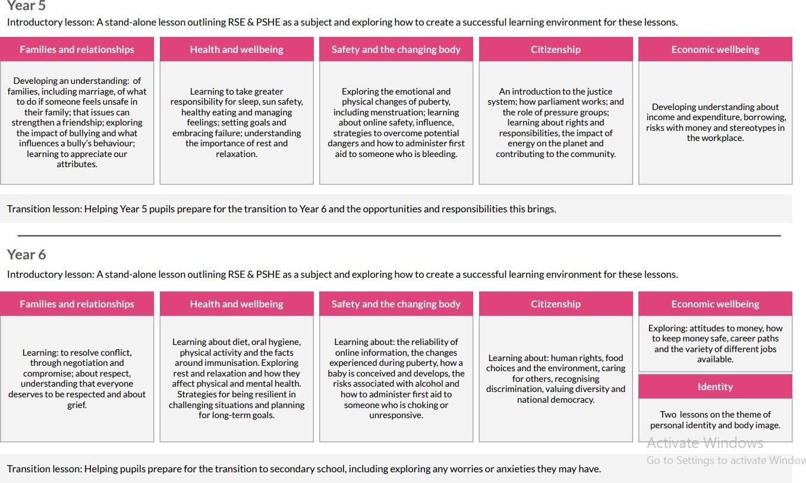

PSHE Purpose of Study

“Personal, Social, Health and Economic (PSHE) education is a school subject through which pupils develop the knowledge, skills and attributes they need to manage their lives, now and in the future. It helps children and young people to stay healthy and safe, while preparing them to make the most of life and work. When taught well, PSHE education also helps pupils to achieve their academic potential. “
PSHE Association
(https://www.pshe-association.org.uk/curriculum-and-resources/resources/programme-study-pshe-education-key-stages-1%E2%80%935)

Attainment Targets

During key stages 1 and 2, PSHE education offers both explicit and implicit learning opportunities and experiences which reflect pupils’ increasing independence and physical and social awareness, as they move through the primary phase. It builds on the skills that pupils started to acquire during the Early Years Foundation stage (EYFS) to develop effective relationships, assume greater personal responsibility and manage personal safety, including online. PSHE education helps pupils to manage the physical and emotional changes at puberty, introduces them to a wider world and enables them to make an active contribution to their communities
PSHE Association
(https://www.pshe-association.org.uk/curriculum-and-resources/resources/programme-study-pshe-education-key-stages-1%E2%80%935

