

**The Principles of the Oak Trees Character Development Framework**

*Achieving Excellence Together*

Collaboration – Expression – Citizenship - Inspiration

***Character is a set of personal traits that produce specific moral emotions, inform motivation and guide conduct.***

***Character education includes explicit and implicit educational activities that help young people develop positive personal strengths which are called virtues.***

Oak Trees MAT schools pledge to provide **equity of opportunity** for **ALL** pupils irrespective of socio-economic background, gender, ethnicity and protected characteristic in order to enable pupils to become good citizens, able to lead good lives and contribute to the common good. Human flourishing is the ultimate aim of character education and requires the acquisition of intellectual, moral and civic virtues. Schools will aim to develop confident and compassionate pupils who are effective contributors to society, successful learners and responsible citizens.

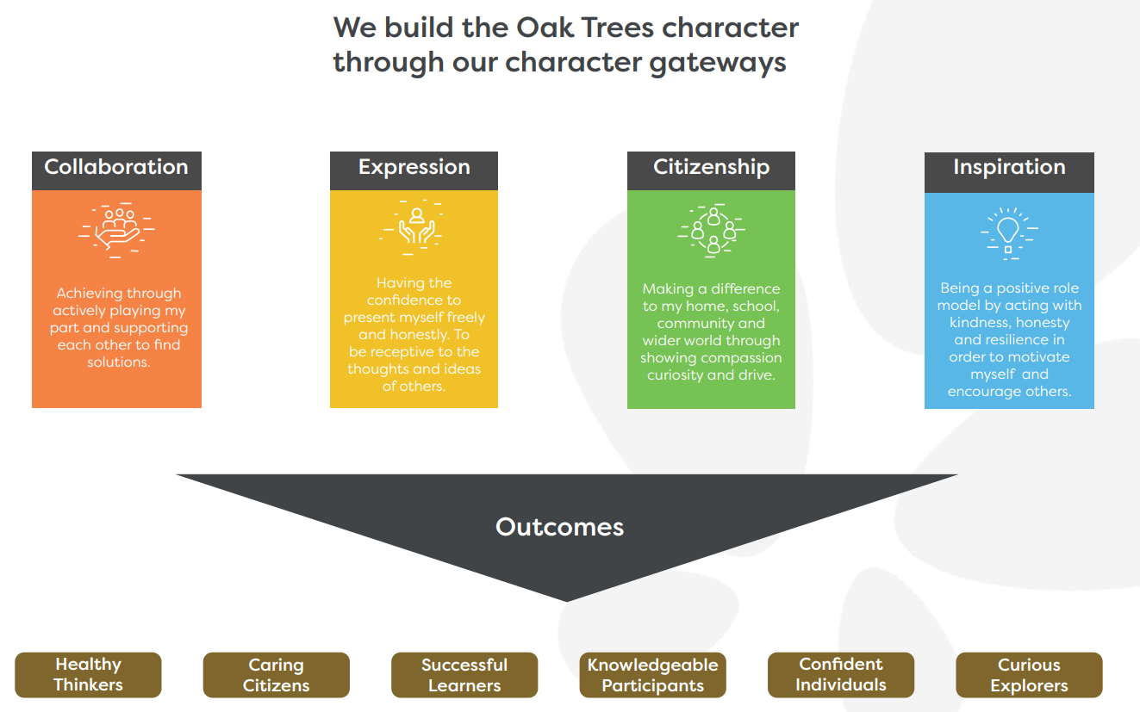

**Character Caught** – through a positive school community, formational relationships and a clear ethos.

**Character Taught** – through the curriculum using teaching and learning strategies, activities and resources.

**Character Sought** – through experiences that occur within and outside of the formal curriculum it is vital that every member of a school community understands what character is, Pupils and teachers therefore need to know the names and meanings of the character virtues but display them in the school’s thinking, attitudes and actions.



**Character Caught**

**Environment**

* A cared for, safe and well-designed physical environment which promotes a sense of belonging
* A collaborative, supportive learning environment which strikes a balance between academic progress and character development
* A positive spiritual, moral, social and cultural environment which encourages staff and pupils to root their character in their personal beliefs and world views

**Vision, Ethos and Culture**

Leaders

* Develop a whole school shared language which is consistently communicated
* Drive and maintain whole school and trust character education
* Integrate character into existing policies and strategic plans
* Establish clear and ethical expectations informed by the values and mission statement
* Ensure equality and inclusion
* Include values and character in the recruitment of staff
* Induct new staff so that each individual has clarity of purpose and role
* Positively recognise and celebrate examples of good character

Relationships

* Pupils form meaningful and respectful relationships with staff
* Pupils develop positive relationships with peers prioritising compassion, friendship and trust
* Staff develop compassionate and supportive relationships where pupils feel valued
* Staff form trusting and respectful relationships with colleagues to motivate and support each other
* Staff form collaborative and supportive relationships with parents
* Families of all pupils are actively involved in school life
* The school and trust participate in activities alongside the local community reinforcing a sense of belonging and responsible citizenship
* The trust establishes partnerships with educational institutions for example National Institute of Teaching.

All Staff

* All staff recognise their role as moral exemplars
* Understand the school’s character development approach

Teachers

* Acknowledge their influence as character educators
* Engage in professional development in character education
* Support pupils through pastoral care and mentoring
* Utilise research to evaluate and improve

**Character Taught**

**The curriculum**

* A discrete and bespoke timetabled subject focused on building character and virtue
* Existing subjects – identity opportunities to include character, virtues and values
* PSHE – use issues or topics to teacher character, values and virtues
* Citizenship – teach how to be an active and responsible citizen
* RE – use personal beliefs and world views to explore character and virtue
* Assemblies – bring the whole school together to explore character, values and virtue

**Teaching and Learning**

* Discussion based learning engages pupils with moral and ethical issues
* Independent learning encourages pupils to self-regulate and take responsibility
* Reflective learning guides pupils to consider their character through critical reflection
* Co-operative learning involves pupils working together, encouraging teamwork and communication
* Enquiry based learning encourages curiosity
* Experiential learning offer learners opportunities to be active learners through a range of virtue and value forming experiences

**Activities and Resources**

* Stories focussing on moral and ethical complexities
* Moral dilemmas encouraging pupils to discuss and reflect on situations with an ethical response
* Current affairs, reflecting on the presence or absence of values in news stories
* Moral exemplars which inspire pupils to live by their values and virtues
* Debates – discussion of key moral and ethical issues
* Literature – including poetry and historical narratives
* School trips encouraging pupils to engage with a range of people and places
* Sport – development of character through team and individual activity
* Creative arts including musical and the visual arts
* Drama encouraging pupils to understand the perspective of others

**Character Sought**

**Enrichment**

* Offer opportunities for pupil leadership
* Establish thriving extra-curricular activities
* Plan and organise school and trust events that allow pupils to demonstrate the values and character
* Organise residential trips that provide challenging experiences and new environments
* Encourage pupils into work experience, careers and plans for the next stage

**Social Action and Volunteering**

* Offer school led social action experiences that promote self-awareness, enabling pupils to make a positive difference to their community and themselves
* Promote community led social actions
* Encourage pupils to make a commitment to purposeful voluntary activity
* Enable pupils to be active citizens within their school, community and globally