By

Drawing, painting and sculpture

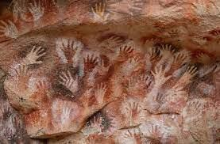

Drawing and Painting

Artist- Sandra Silberzweig and Picassod Picasso

Artist:

|  |  |  |  |  |
| --- | --- | --- | --- | --- |
| L.S. Lowry: 'I'm Fed Up With Painting' - ArtReview  1`````````````    **LS Lowry** is a **modern artist** and is most famous for painting scenes of life in the industrial districts of the North-West England in the mid-20th century. He is a **Naïve** artist which means he lacked formal education/did not attend college to train to become an artist. He used a range of techniques such as using a pallete knife, his fingers, and nails to scrape paint surfaces or would simply rub away areas to create tonal effects. | | | **Year 5 Drawing Skills**   1. Use a variety of source material for their work. Work in a sustained and independent way from observation, experience and imagination. 2. Use a sketchbook to develop ideas. 3. Explore the potential properties of visual elements, line, tone, pattern, texture, colour and shape.   **Year 5 Painting skills**   1. Demonstrate a secure knowledge about primary & secondary, warm and cold, complimentary and contrasting colours. 2. Work on preliminary studies to test media and materials. Create imaginative work from a range of sources. | |
|  | | | | |
| Tone | Adding white to make a lighter shade. |  | | Proportion  How the sizes of different parts of a piece of art or design relate to each other. |
| Tint  A person who did not attend college or train to become a professional artist. | Adding black to make a darker shade. |  | | Perspective  Perspective in art is what gives your work a 3D look rather than a flat painting or drawing.  Drawing from **observing, or looking** at things in real life, rathe than a printed image. |
|  | Naïve artist | Observation | |  |

* What are we learning?

What are we learning?

This lesson is learning about **LS Lowry**

* **Modern artist-** not alive today. 1887-1976
* Most famous for **painting scenes of life** in the industrial districts of the North West, mainly Manchester and Salford.
* His artistic style was **Naïve art,** which meant he did not study to become a qualified artist.
* He uses a range of techniques such as **using a pallete knife, his fingers and nails to scrape paint surfaces.**
* He used **oil paints** mainly to create his work. He worked withy just 4 colours; ivory black, vermillion, Prussian blue, yellow ochre and flake white.

In this lesson, you will be creating **observational drawings** of the school grounds in the style of Lowry.

* **Observational drawing-** Drawing from **observing**, or **looking** at things in real life, rather than a printed image.
* **Tone-** how light or dark a mark or colour is.
* **Proportion-** How the sizes of different parts of a piece of art or design relate to each other.
* **Shading-** Drawing darker pencil marks show darker tones.
* **Perspective-** Perspective in art is what gives your work a 3D look rather than a flat painting or drawing.

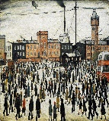

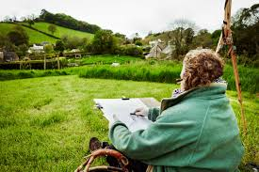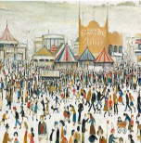

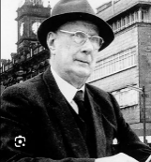

In this lesson, you will begin the first stage of your final piece in the style of Lowry.

* **Perspective-** Perspective in art is what gives your work a 3D-look rather than a flat painting or drawing.
* **Proportion-** How the sizes of different parts of a piece of art or design relate to each other.

In this lesson, you will be completing the seconds stage of your final piece- the **adding the background using water colours.**

You will need to create a colour pallete **to express mood and tone.**

* **Tone-** Adding white to make a lighter shade.
* **Tint-** Adding black to make a darker shade.

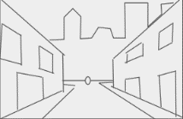

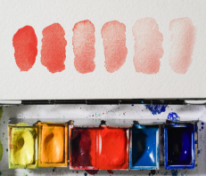

* **Explain choices made** during the process, such as selection of colours and lines/marks made.
* Explain how the artwork is **similar/different** to LS Lowry’s work
* Say what **worked well** and what could be **improved** with explanations

In this lesson, you will be completing step three of your final piece- adding a detail to your work.

* **Collage/mixed media-** Using lots of different art materials to make one piece of art work.
* **Tints-** Adding white to make lighter shades.
* **Tones-** Adding black to make darker shades



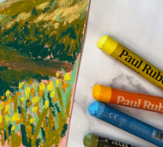

Year KS1 and year 3,4 and 5 drawing and painting skills.

Yr3 and 4 collage skills.

Yr3 printing skills



 

Scan to explore a magical gallery and walk int the painting ‘Britain at Play’ by L.S. Lowry.

Scan to listen to L.S. Lowry share his artist techniques and isnpirations.

Scan to practice painting different landscapes with water colour paints.

Scan to learn more about drawing and painting landscapes.

Helpful links