By

Musical style/genre: Ballads

Ballads

|  |  |  |  |  |
| --- | --- | --- | --- | --- |
| Famous musicians you will look at during this unit who have created Ballads.  Whitney - Album by Whitney Houston | SpotifyThe Righteous Brothers - WikipediaSamantha Barks | United AgentsChanges: David Bowie as a style iconReckless (Bryan Adams album) - Wikipedia  The Righteous Brothers  Samantha Barks  Bryan Adams  Whitney Houston  David Bowie | | | | **Year 3 key knowledge**   * To know that a ballad tells a story through song. * To know that lyrics are the words of a song * To know that in a ballad, a ‘stanza’ is a verse. |
|  | | | | |
| ballad | A song which tells a story- similar to a poem | Repeated sections of the music with the same tune and lyrics. | Chorus  A short section of text, known as a verse in a song or poem. | |
| ensemble | A small group of musicians who perform together |  | Stanza  Performing alone. | |
| Compose | To create an original piece of music. | Solo |  | |
|  | Words which have no meaning and are often used for filling time in songs, e.g. la, do, oooh  Nonsense  words | Expression | Making your thoughts or feelings known when reading, singing or performing. | |

* What are we learning?

What are we learning?

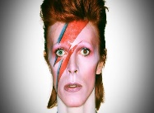

You will be singing ‘**Everything I do’ by Bryan Adams** and **‘Space oddity’ by David Bowie.**

What type of music are these songs? **Ballads**

You will sing in a **ensemble.**

When singing these songs, think about;

* Speed
* Instruments
* Story line
* Lyrics
* Chorus
* Verses

**Chorus**- a **repeated section** of music with the **same** tune and **lyrics.**

**Stanza-** a story written in short phrases

What is a ballad?

**Features**

* ABAB rhyme scheme- **lines 1 and 3** rhyme and **lines 2 and 4** rhyme.
* Can be dramatic, funny or romantic.
* Strong rhythms
* Repetition of key phrases.
* Can be in many styles, such as pop, musical theatre and were used in ancient times to carry news and legends across countries.

**Stanza-** a short section, known as the verse.



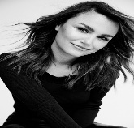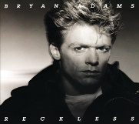

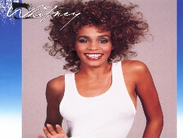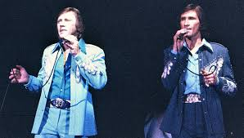

Songs usually tell a **story.**

**Ballad-** a song which tells a story.

**Lyrics-** the words to a song.

**Story mountain**

**Opening-** describes the setting, introduces the characters.

**Build up-** excitement and tension, gives emotion.

**Climax-** major dilemma

**Resolution-** characters find a route through their difficulties.

**Ending-** happily ever after.

When creating a song based off an animation, include the following things;

* A **stanza-** a verse
* **Chorus-** a repeated section of music with the **same tune and lyrics.**
* Happy tune- Feeling, showing or causing pleasure.

**Ballad-** a song which tells a story.

**Lyrics-** the words to a song.

**Ensemble-** A small group of musicians who perform together.

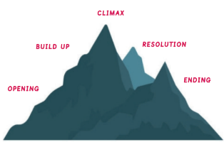

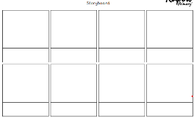

Adding **nonsense words** into your lyrics from previous lesson.

**Nonsense words-** Words which have no meaning and are often used for filling time in songs, usually pop songs, e.g. la, do, oooh.

**Ballad-** A song which tells a story- similar to a poem.

**Compose-** to create an original piece of music.

**Ensemble-**  a small group of musicians who perform together.

**Happy-** feeling, showing or causing pleasure.

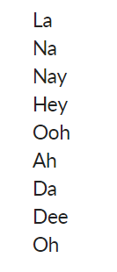

Year 1 and 2 drawing and painting skills





Scan to complete your Quiz

Scan to listen to the top 100 best Pop Ballads

Helpful links