SECTION B
SECTION A

SECTION A

Complete this section and Section A for a Behavioural Concerns referral.
*Child Details: - SENCO/Referrer or Parent/Carer to Complete
*Surname: | *Address:
*Forename: | *Address:
*DOB: | *Address:
 | *Postcode:

* How many months have concerns been present for? - SENCO/Referrer to Complete –
Must Be Completed
*Behaviours at School - SENCO/Referrer to Complete
Please go through each of the behaviours listed below and write an example of how this behaviour presents itself at School. Please give as many examples as possible, or write N/A if not observed.

Behaviour | Example
Listens when spoken to directly
Follows through on instructions
Knows where to start with a task
Remains on task without getting distracted
Is organised and can find things when asked.
Can sit still when expected or required
Waits for question to be finished before answering
Engages with activities quietly
Can control their emotions

Talks at a reasonable speed

Does not interrupt or intrude on others
Appears attentive, rarely day dreaming
Can wait to take their turn

Can sustain attention in long tasks
Has an awareness of risk/danger

Classroom behaviour - SENCO/Referrer to Complete –
SECTION B

* Please describe any further concerns you have about how this child behaves in class,
e.g. concentration, ability to sit still, oppositionality, organisation, waiting turns, etc

*Please indicate names of any professionals/organisations involved
- SENCO/Referrer to Complete
e.g. Health Visitor, Paediatrician, Social Worker, therapists etc (with contact detail)
Name | Profession | Tel No.

*Is the child supported through any of the following? (Please tick)
- SENCO/Referrer to Complete
Enhanced quality first provision |  | Additional intervention
Individual SEND support plan |  | Support provided
Positive handling plan |  | High needs top up funding
EHC plan |  | None

*Does this child receive any other interventions or special help? -SENCO/Referrer to Complete
Please fill in and tick box below specifying, e.g. small group work, pastoral programme,
Speech & Language therapy etc, otherwise tick “No interventions in place”.
No interventions in place

*Child's positive qualities, strengths and interests - SENCO/Referrer to Complete

* Child’s attendance/punctuality:- SENCO/Referrer to Complete – Must be Completed
Are there any concerns regarding school attendance? Yes No
Is Punctuality a concern? Yes No
Please share any relevant information you feel we should be informed of to support triage:

Child’s Academic progress and academic area(s) of strength. (If applicable) - SENCO/Referrer to Complete
Below age related expectations
Age related expectations
Above related expectations

Please share any relevant information you feel we should be informed of to support triage:

*How would you describe this child’s relationships with the following?
- SENCO/Referrer to Complete
(Please ✓appropriate box)
Comment
- With other children one 1-to-1
- With other children in a group
- With adults/teaching staff
- In response to rules and discipline:

*What do you feel are the barriers for this child to achieve their learning goals?
Please be as descriptive as possible.

SECTION B

*Social behaviour - SENCO/Referrer to Complete
*How does the child behave during uninstructed time?
e.g. break / dinner times? Please describe as much detail as possible.
SECTION B

*Please describe the quality of the child’s relationships with peers:
Do they show interest in others, have friends, understand other’s feelings, take turns, play constructively?

Emotional Wellbeing - SENCO/Referrer to Complete
*Do you have any concerns regarding this child's emotional wellbeing?
If yes, please describe these and the impact they have. Note N/A if none.

*ADHD Skills Course – Parent/Carer to Complete
Have you previously attended the ADHD Skills Course with the ADHD Foundation?
This may have been part of a siblings ADHD Assessment. If unsure, tick “No”. If date unknown, approximate is acceptable.
Yes No If Yes: Date Attended:
*Please give detailed description of your concerns of behaviours at home:
SECTION B

- A detailed description is required or we cannot accept this referral.
- Parent/Carer to Complete
*Behaviours at Home – Parent/Carer to Complete
Please go through each of the behaviours listed below and write an example of how this behaviour presents itself at Home. Please give as much detail as you can, or write N/A if not observed.

Behaviour | Example
Listens when spoken to directly
Follows through on instructions
Knowing where to start with a task
Remains on task without getting distracted
Remembers daily activities like brushing teeth.
Is Organised and can find things when asked.
Can sit still when expected or required
Waits for question to be finished before answering
Engages with activities quietly
Can control their emotions
Can sit still at home.

Talks at a reasonable speed
Does not interrupts or intrude on others
Appears attentive, rarely day dreaming
Can wait to take their turn
Can sustain attention in long tasks
Has an awareness of risk/danger

*QB Test - Parent/Carer to Complete
As part of the ADHD assessment, this child may be invited to attend a QB test.
SECTION B

The QB test is a clinical measure of a child’s activity, attention, and impulsivity.
It is performed on a computer. The child watches a screen and clicks along with shapes on a screen for about 15-20 minutes.
The child must be on their own in the QB test room, with any parents/carer waiting outside for the duration of the test.


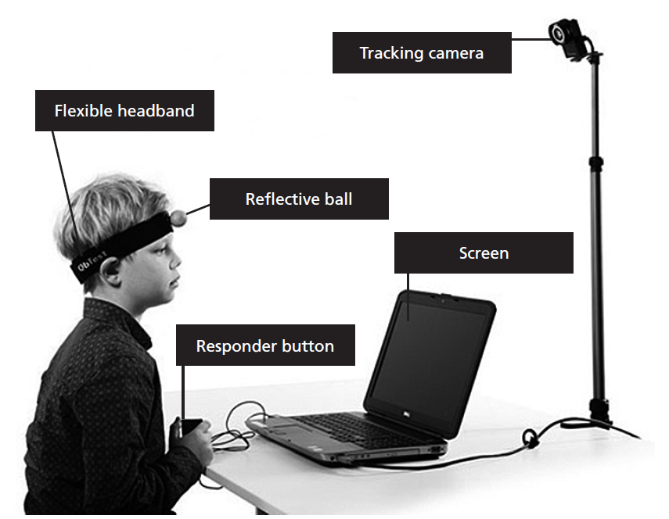

YouTube Link: https://www.youtube.com/watch?v=02UqEGIOJO0

If this test is not appropriate for this child we will arrange an alternate assessment if your child is in primary. Secondary school children must attempt a QB test, even if test is unsuccessful.

Do you feel this child would have great difficulty or experience great stress doing the QB test?
Yes
No

SECTION C
Complete this section and Section A for a Social Communication Concerns referral.
*Child Details: - SENCO/Referrer or Parent/Carer to Complete
*Surname: | *Address:
*Forename: | *Address:
*DOB: | *Address:
 | *Postcode:

Please fill in all fields of this section providing as much detail as possible when filling out each section.
This form MUST be signed by parent/carer and SENCO/referring professional (verbal consent from parent/carer will be accepted).
Support for parent/carers
SENCO: Please direct parents/carers to access Autism Together if they have not already, as parents/carers can access support without a diagnosis www.autismtogether.co.uk.

Referrals can only be accepted if the following criteria have been met:

- Completed referral form
- Concerns must be identified at home and by the class teacher (in more than one setting)
- If a SALT social communication report has already been completed, this should be attached to the referral (this could include a previous SALT report from NHS or a private provider)
- If the child is under 7, a full WellComm screen should be completed and attached to the referral

Language and Social Communication Needs in School - SENCO/Referrer to Complete
Please comment on the child’s ability in all the sections below.
Attention and Listening skills (in 1:1 and group settings):
Is this an area of concern? Yes No
If yes, please detail the support currently provided:

Comprehension (understanding of what people say) / Expressive Language (sentences/grammar):
Is this an area of concern? Yes No
If yes, please detail the support currently provided:
(If child is under 7, please attach full Wellcomm screening result)

Social Communication Skills (interactions with others):
Is this an area of concern? Yes No
If yes, please detail the concerns:
Other:

Communication in School - SENCO/Referrer to Complete
Does the child use other methods of communication e.g. signing, gesture, haptic?
If yes, please describe:
Additional Language - SENCO/Referrer to Complete
Is English an additional language Yes No

Would an interpreter be required? Yes No

If yes, what is language and language level like in first language?

SECTION C

SECTION C

Child’s Name: | NHS No: | D.o.B:
School:
Name of Person Completing Form: |  | Date Completed:
Observation Profile

Part 1: Teacher/SENCO to complete
Give a brief “word picture” of the child within the class.
Note positive points as well as difficulties and describe any ASD characteristics observed.
Part 2: Observed Behaviours in School Teacher/SENCO to complete
Key: 1 No cause for concern
2 Mild cause for concern
3 Moderate cause for concern
4 Serious cause for concern
5 Great cause for concern
- Social Interaction | 1 | 2 | 3 | 4 | 5
- Ability to use gesture, body posture, facial expression and eye to eye gaze in 1:1 situations.
- Ability to use gesture, body posture, facial expression and eye to eye gaze in group interaction.
- Ability to follow social cues in 1:1 – with adults.
- Ability to follow social cues in 1:1 – with other children.
- Ability to follow social cues in group interaction.
- Ability to share an activity with other children.
- Ability to share an activity with an adult.
- Ability to develop peer friendships.
- Ability to seek comfort/affection when upset.
- Ability to offer comfort/affection to others.
- Ability to share in others’ enjoyment/pleasure.
- Ability to imitate other children.
- Ability to imitate adults.
- Ability to show different responses to different people in different situations.
- Ability to respond appropriately to social praise.
- Ability to respond appropriately to criticism.
Summary: Please summarise 1. Social Interaction comment boxes above

- Social Communication | 1 | 2 | 3 | 4 | 5
- Ability to respond when called by name.
- Ability to follow verbal instructions in 1:1 setting.
SECTION C

- Ability to follow instructions in a small group setting.
- Ability to follow verbal instructions in a whole class setting.
- Ability to take turns in conversations.
- Ability to initiate conversation.
- Ability to change topic of conversation.
- Ability to maintain an appropriate conversation.
- Ability to show awareness of the listener’s needs.
- Ability to give appropriate non-verbal signals as a listener.
- Ability to change the topic or style of a conversation to suit the listener.
- Ability to appropriately change the tone and volume of their voice.
- Ability to recognise and respond to non-verbal cues e.g. a frown.
- Ability to understand implied meanings.
- Ability to tell or write an imaginative story.
- Ability to relate a sequence of events.
- Ability to give a simple sequence of instructions.
Summary: Please summarise 2. Social Communication comment boxes above

- Social Imagination and Flexible Thinking | 1 | 2 | 3 | 4 | 5
- Ability to have varied interests.
- Ability to share interests.
- Ability to change behaviour according to the situation.
- Ability to accept changes in rules, routines or procedures.
- Ability to play imaginatively when alone.
- Ability to play imaginatively together with others.
- Ability to accept others’ point of view.
- Ability to generalise learning.
- Ability to transfer skills across the curriculum.
- Ability to plan an event or a task.
- Ability to suggest possible explanations for events.
- Ability to use inference and deduction.
Summary: Please summarise 3. Social Imagination and Flexible Thinking.

- Motor and Organisational Skills | 1 | 2 | 3 | 4 | 5
- Ability to find their way around the classroom.
- Ability to find their way around the school.
- Ability to sit still.
- Ability to sit amongst a small group.
- Ability to sit amongst a large group e.g. In assembly.
- Ability to find and organise the equipment they needs for a given task.
- Ability to write legibly and draw accurately.
- Ability to get changed without help e.g. For P.E.
- Ability to organise their movements in P.E and Games.
Summary: Please summarise 4. Motor and Organisational Skills

SECTION C

Part 3:
Prioritise the 3 Difficulties Which Cause you the Greatest Concern:
Teacher/SENCO to complete
1)
2)
3)
Note the settings or situations in which the Child Shows
Anxiety, Stress or Frustration:
E.g. P.E. in the hall at transition times/sitting amongst a large group.
Please tell us what strategies / interventions are in place in school to support and manage difficulties and behaviours

Part 4: Parent/Carers to complete
Prioritise the 3 Difficulties Which Cause you the Greatest Concern:
1)
2)
3)

SECTION C

Please tell us what strategies you use at home to support and manage your child’s difficulties and behaviours
Have you attended any parent courses/workshops related to social communication development/autism/child development?
If yes, please give details.

Do you access support from any other agencies?
e.g. Autism Together? If yes, please give details.

SECTION D
Complete this section and Section A for a Dyspraxia referral.
*Child Details: - SENCO/Referrer or Parent/Carer to Complete
*Surname: | *Address:
*Forename: | *Address:
*DOB: | *Address:
 | *Postcode:

Development Co-ordination Disorder (DCD)
Referrals can only be accepted if the following criteria have been completed/met:

- Child is between 5 years and 12 years old.
(If child is under 5 years old, please advise parent/carer to their Health Visitor/School Nurse)
(If child is 12 years old or over, please advise parent/carer to contact GP)
- Please complete this referral, including parent/carer views
- Please complete a Movement ABC checklist and attach to this form – Total the scores from A + B sections and only refer if child is in high amber or red zone

Details of concerns at home - Parent/Carer to Complete
Please go through each of the traits listed below and ✓ the box at the level that most closely represent this child provide details or examples.
 | Tick ✓ | Comments
Family History of ASD/ADHD/DCD

Difficulties in adapting to a structured school routine
Difficulties in Physical Education lessons
Slow at dressing. Unable to tie shoe laces
Barely legible handwriting

Immature drawing and copying skills

Limited concentration and listening skills
Literal use of language

Inability to remember more than two or three instructions at once
Slow completion of class work

Tendency to become easily distressed and emotional
Problems with coordinating a knife and fork

Any other concerns:

Details of concerns at school: - SENCO/Referrer to Complete
Please give a detailed description of how this child presents in a school setting, ensuring a description of any DCD charactistics observed.
SECTION D

Movement ABC Checklist: - For SENCO/Referrer to Complete
A DCD referral requires a completed Movement Assessment Battery Checklist form
Please complete a Movement ABC checklist and attach to this form
- Please total the scores from A + B sections and only refer if child is in high amber or red zone

