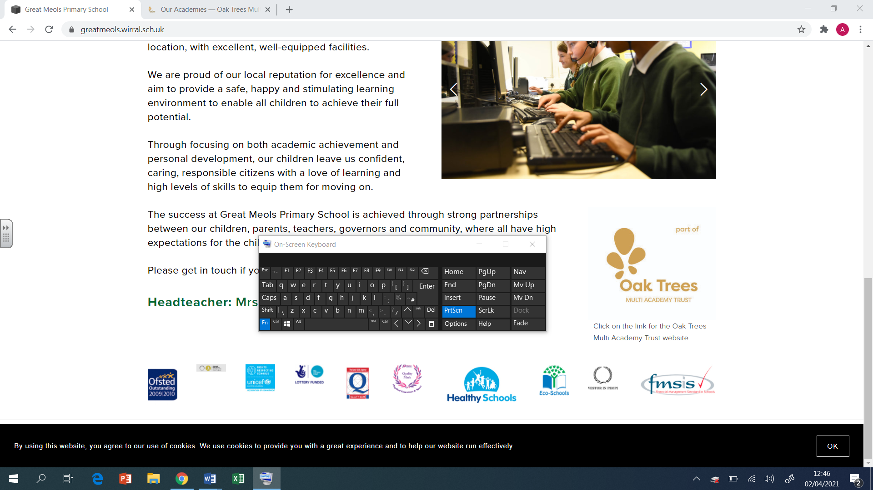

Brackenwood Junior School

English

Long Term Plan

Y5

2024-25

|  |  |  |  |  |  |  |  |
| --- | --- | --- | --- | --- | --- | --- | --- |
| Autumn 1  Grammarsaurus PVGV objectives 4-6 weeks  Application unit – Letter – Hansel’s escape | | | | | | | |
|  | **Week 1** | **Week 2** | **Week 3** | **Week 4** | **Week 5** | **Week 6** | **Week 7** |
| Extended Writing  Genre |  | | | | | | |
| Spelling  Focus  Teaching | ing and ed endings  Irregular verbs | Comparitive/superlative  (er, ier and est) | Plural – s, es, ies | Adding y | Homophones | Homonyms  Homographs | Silent letters |
| Grammar/  punctuation  Focus Teaching |  | | | | | **Letter – Hansel’s Escape**  **Application unit** | |

|  |  |  |  |  |  |  |  |
| --- | --- | --- | --- | --- | --- | --- | --- |
| Autumn 2  Text – Listen by Shannon Stocker (diverse picture book) | | | | | | | |
|  | **Week 1** | **Week 2** | **Week 3** | **Week 4** | **Week 5** | **Week 6** | **Week 7** |
| Extended Writing  Genre | Listen by Shannon Stoker  **Genre – Persuasive letter – importance of inclusivity and equal opportunity** | | | **Genre – Diary – day she loses her hearing** | | | |
| Spelling  Focus  Teaching | ing and ed endings  Irregular verbs | Comparitive/superlative  (er, ier and est) | Plural – s, es, ies | Adding y | Homophones | Homonyms  Homographs | Silent letters |
| Grammar/  punctuation  Focus Teaching | **Year 5 Grammar**  Organisational features is non-narrative writing  Fronted adverbials and fronted subordinate clauses  Adverbs and modal verbs  Range of conjunctions  Parenthesis  **Greater depth**  Write effectively for a range of purposes and audiences, selecting the appropriate form  Enhance meaning by selecting precise and effective vocabulary  Use full range of punctuation taught so far | **Genre Related Grammar – Persuasive letter**  **Language Features:**  Present tense  First person  Persuasive features  Persuasive openers  **Structural Features:**  Addresses  Date  Greeting  Introduction  Main body  Conclusion  Signature | | **Year 5 Grammar**  Paragraphs developed around a theme  Expanded noun phrases  Varied sentence length  Adverbs and modal verbs  Commas to clarify meaning  **Greater depth**  Write effectively for a range of purposes and audiences, selecting the appropriate form (difference between dialogue and stage directions)  Enhance meaning by selecting precise and effective vocabulary  Use the full range of punctuation taught so far accurately | | **Genre Related Grammar - Diary**  **Language Features:**  First person  Past tense  Chronological order  Time adverbs and conjunctions  Writer’s point of view  Person emotions and feelings  Informal voice (I reckon…)  **Structural Features:**  Date  Greeting (Dear diary,)  Introduction  Main body  Conclusion  Sign-off | |

|  |  |  |  |  |  |  |  |  |
| --- | --- | --- | --- | --- | --- | --- | --- | --- |
| Spring 1  Text – The Last Bear by Hannah Gold | | | | | | | | |
|  | **Week 1** | **Week 2** | **Week 3** | **Week 4** | **Week 5** | **Week 6** | **Week 7** | **Week 8** |
| Extended Writing  Genre | **Genre – Non-chronological report on arctic circle** | | | | **Genre – Newspaper – Extinction of last polar bear** | | | |
| Spelling  Focus  Teaching | **Consonant spellings -** que’/’ck’/’ch’ sounding k‘sc’ sounding ‘s’‘c’ sounding ‘s’ | **Consonant spellings -**  ‘s’ sounding ‘z’ ‘y’ sounding ‘i’ ‘gue’ sounding ‘g’ ‘g’/’ge’/’dge’ sounding ‘j’ | **Consonant spellings -** ‘th’ sounding ‘t’ ‘gh’/‘ph’ sounding ‘f’ ‘wh’ sounding ‘w’ ‘qu’ sounding ‘kw’ | **Short vowel sounds -**a/ea/sounding ‘e’ i/o/u/y/sounding ‘i’ a sounding o o/ou/oo/ sounding ‘u’ | **Long vowel sounds -** ei/ai sounding long á ea/ie sounding long é | **Long vowel sounds -** i/i-e sounding long í ow/ou sounding long ó u sounding long ú | **Digraphs and trigraphs -** oi,oy ow, ou ar air, are, ear | |
| Grammar/Punctuation  Focus  Teaching | **Year 5 Grammar**  Relative clauses for additional information  Commas to separate items in a list  Non-chronological adverbials e.g. mostly, often, sometimes etc  Brackets, dashes and commas to indicate parenthesis  **Greater depth standard**  Sentence types are manipulated to engage the reader  Confident use of parenthesis to suit the purpose of the writing (commas, dashes, brackets)  Expand noun phrases conveying complicated information with greater precision  Making apt vocabulary choices to fit the purpose | | **Genre Related Grammar – Non-chron**  **Language Features:**  Information in non-chronological order  Factual information  Third person  Present tense (sometimes past)  Technical vocabulary  **Structural Features:**  Heading  Subheading  Paragraphs  Bullet points  Diagrams/photos with caption | | **Year 5 Grammar**  Modal verbs  Relative clauses  Adverbials  Adapt sentence length  Present tense e.g. If you have additional information, please….  **Greater depth**  Write effectively for a range of purposes and audiences, selecting the appropriate form  Enhance meaning by selecting precise and effective vocabulary | | **Genre Related Grammar - Newspaper**  **Language Features:**  Third person  Past tense  Dialogue  Time adverbials  Chronological order  **Structural Features:**  Headline  Orientation – 5Ws  Main body  Reorientation  Picture with caption | |

|  |  |  |  |  |  |  |  |
| --- | --- | --- | --- | --- | --- | --- | --- |
| Spring 2  Text – The Last Bear by Hannah Gold | | | | | | | |
|  | **Week 1** | **Week 2** | **Week 3** | **Week 4** | **Week 5** | **Week 6** | |
| Extended Writing  Genre | **Genre – Narrative**  Retelling of the story – change main character or animal | | | | | | |
| Spelling  Focus  Teaching | **Digraphs and trigraphs** ear, ere, eer | **Digraphs and trigraphs** ir, er, ur, or,ore,au,aw, augh,ough | **Prefixes- de, mis, dis dis’**- not/ opposite of **‘mis’** –wrong/ opposite of **‘de’** – undo/do opposite of | **Prefixes- in/im/il/ir in’** means ‘not’. When the root word starts with a ‘p’ or ‘m’ ‘in’ becomes **‘im’** When the root word starts with ‘l’, ‘in’ becomes **‘il’** When the root word starts with ‘r’, ‘in’ becomes ‘ir’ | **Prefixes ‘un’** means ‘not’. **‘ex’** means former. **Anti** means opposing | **Prefixes – ‘fore’**- before **‘post’** – after/later **‘pre’**- before **‘re’** - again | **Digraphs and trigraphs**  ir, er, ur, or,ore,au,aw, augh, ough |
| Grammar/Punctuation  Focus  Teaching | **Year 5 Grammar**  Commas for clarity  Modal verbs  Dialogue to convey a character  Correct use of tenses including progressive and perfect  Apostrophes for possession  Parenthesis – dashes, brackets, commas  **Greater depth**  Manipulate sentence types purposefully to engage the reader and create atmosphere  Write effectively for a range of purposes and audiences, selecting the appropriate form  Enhance meaning by selecting precise and effective vocabulary  Use the full range of punctuation taught so far accurately | | | **Genre Related Grammar - Narrative**  **Language Features:**  Dialogue to advance the action  Past or present tense  First or third person  Expanded noun phrases  Adverbs of time, place and manner  Prepositions  **Structural Features:**  Title  Opening (setting/character description)  Build-up (dialogue to advance action)  Problem  Resolution  Conclusion | | | |

|  |  |  |  |  |  |  |
| --- | --- | --- | --- | --- | --- | --- |
| Summer 1  Text – Rainforest Warrior by Anita Ganeri (picture book) | | | | | | |
|  | **Week 1** | **Week 2** | **Week 3** | **Week 4** | **Week 5** | |
| Extended Writing  Genre | **Genre – persuasive letter to the estate owners** (workers rights, fair trade, right to an education | | | **Genre - Non-chronological report (rainforest)** | | |
| Spelling  Focus  Teaching | **Prefixes**  Inter  micro  Auto  sub | **Prefixes**  under  Out  Over  super | **Words ending (Y5)**  **ant, ance, ancy**  **ent, ence, ency**  For related words with ‘long a’ in the same place use ‘ant’ | **Words ending (Y5)**  **ent, ence, ency**  Use -ent after soft c, soft g | Noun suffixes  ‘ness’-quality /state  ‘ment’-action/state  ‘ship’-state/condition | |
| Grammar/Punctuation  Focus  Teaching | **Year 5 Grammar**  Organisational features for non-narrative writing  Fronted adverbials and fronted subordinate clauses  Adverbs and modal verbs  Range of conjunctions  Parenthesis  **Greater depth**  Write effectively for a range of purposes and audiences, selecting the appropriate form  Enhance meaning by selecting precise and effective vocabulary  Use full range of punctuation taught so far | **Genre Related Grammar – Persuasive letter**  **Language Features:**  Addresses  Date  Greeting  Introduction  Main body  Conclusion  Signature  **Structural Features:**  Present tense  First person  Persuasive devices  Persuasive openers | | **Year 5 Grammar**  Relative clauses for additional information  Commas to separate items in a list  Non-chronological adverbials e.g. mostly, often, sometimes etc  Brackets, dashes and commas to indicate parenthesis  **Greater depth standard**  Sentence types are manipulated to engage the reader  Confident use of parenthesis to suit the purpose of the writing (commas, dashes, brackets)  Expand noun phrases conveying complicated information with greater precision  Making apt vocabulary choices to fit the purpose | | **Genre Related Grammar – Non-chron**  **Language Features:**  Information in non-chronological order  Factual information  Third person  Present tense (sometimes past)  Technical vocabulary  **Structural Features:**  Heading  Subheading  Paragraphs  Bullet points  Diagrams/photos with caption |

|  |  |  |  |  |  |  |  |
| --- | --- | --- | --- | --- | --- | --- | --- |
| Summer 2  Text – Children of Benin Kingdom by Dinah Orji | | | | | | | |
|  | **Week 1** | **Week 2** | **Week 3** | **Week 4** | **Week 5** | | **Week 6** |
| Extended Writing  Genre | **Genre – Narrative (alternate ending)** | | | **Genre – Persuasive letter to become a prefect** | | | |
| Spelling  Focus  Teaching | **Adjective suffixes**  **ful’**-full of  **‘less’**-without | **Words ending –cious, tious, cial, tial**  The ‘shus’ sound- spelt as ‘cious’ at the end of an adjective. ‘tious’ -few words. ‘shul’ sound: ‘tial’ is used after a consonant -‘cial’ is used after a vowel. | | | **Adverb suffixes**  Adding ly to words correctly | | **Word ending-ture, sure** |
| Grammar/Punctuation  Focus  Teaching | **Year 5 Grammar**  Commas for clarity  Modal verbs  Dialogue to convey a character  Correct use of tenses including progressive and perfect  Apostrophes for possession  Parenthesis – dashes, brackets, commas  **Greater depth**  Manipulate sentence types purposefully to engage the reader and create atmosphere  Write effectively for a range of purposes and audiences, selecting the appropriate form  Enhance meaning by selecting precise and effective vocabulary  Use the full range of punctuation taught so far accurately | **Genre Related Grammar - Narrative**  **Language Features:**  Dialogue to advance the action  Past or present tense  First or third person  Expanded noun phrases  Adverbs of time, place and manner  Prepositions  **Structural Features:**  Title  Opening (setting/character description)  Build-up (dialogue to advance action)  Problem  Resolution  Conclusion | | **Year 5 Grammar**  Organisational features for non-narrative writing  Fronted adverbials and fronted subordinate clauses  Adverbs and modal verbs  Range of conjunctions  Parenthesis  **Greater depth**  Write effectively for a range of purposes and audiences, selecting the appropriate form  Enhance meaning by selecting precise and effective vocabulary  Use full range of punctuation taught so far | | **Genre Related Grammar – Persuasive letter**  **Language Features:**  Addresses  Date  Greeting  Introduction  Main body  Conclusion  Signature  **Structural Features:**  Present tense  First person  Persuasive devices  Persuasive openers | |