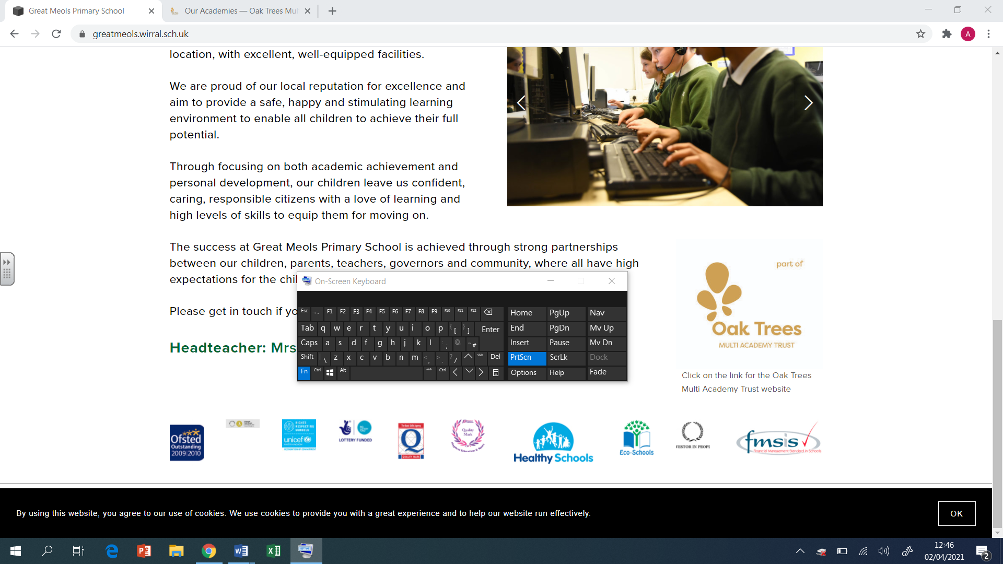

Brackenwood Junior School

English

Long Term Plan

Y4

2024-25

|  |  |  |  |  |  |  |  |  |
| --- | --- | --- | --- | --- | --- | --- | --- | --- |
| **Autumn 1**  **Grammarsaurus PVPG objectives 4-6 weeks**  **Application unit – Letter – Stone Age**  **Begin to read ‘Desirable’ as class read** | | | | | | | | |
|  | **Week 1** | **Week 2** | **Week 3** | **Week 4** | **Week 5** | **Week 6** | | **Week 7** |
| Extended Writing  Genre |  | | |  | | | | |
| Spelling  Focus  Teaching | **Prefix ‘super’**  (natural, supernatural) | **Prefix ‘sub’**  (divide, subdivide) | **Prefix ‘inter’** (city, intercity) | **Prefix ‘anti’**  (clockwise, anticlockwise) | **Prefix ‘auto’**  (biography, autobiography) | **Prefix ‘non’**  (sense, nonsense) | | **Prefix ‘in’**  (visible, invisible) |
| Grammar/ punctuation  Focus Teaching |  | | | | | | **Letter – Stone Age**  **Application unit** | |

|  |  |  |  |  |  |  |  |  |
| --- | --- | --- | --- | --- | --- | --- | --- | --- |
| **Autumn 2**  **Text –** **Desirable by Frank Cottrell Boyce** | | | | | | | | |
|  | **Week 1** | **Week 2** | | **Week 3** | **Week 4** | **Week 5** | | **Week 6** |
| Extended Writing  Genre | Desirable  **Genre - Diary** | | | | Desirable  **Genre – Persuasive advert (selling the aftershave)** | | | |
| Spelling  Focus Teaching | **Words ending –ous**  (fabulous, tremendous) | **Suffix – ous**  (danger, dangerous) | | **Suffix – ous**  (fame, famous) | **Plural possessive apostrophe**  (girls’, boys’) | **Plural possessive apostrophe**  (people’s children’s) | | **Words ending –sion**  (confuse, confusion) |
| Grammar/ punctuation  Focus Teaching | **Year 4 Grammar**  **Noun phrases expanded with adjectives and prepositional phrases**  **Range of sentence structures with more than one clause**  **Fronted adverbials**  **Pronouns**  **Subordinating and coordinating conjunctions**  **Greater depth**  **Use the full range of punctuation taught so far accurately**  **Control the use of a variety of sentence structures, placement of subordinating conjunctions and adverbials**  **Control the use of a rich and varied vocabulary** | | **Genre Related Grammar - Diary Entry**  **Language Features:**  First person  Past tense  Chronological order  Time adverbs and conjunctions  Writer’s point of view  Person emotions and feelings  Informal voice (I reckon…)  **Structural Features:**  Date  Greeting (Dear diary,)  Introduction  Main body  Conclusion  Sign-off | | **Year 4 Grammar**  **Organisational features in non-narrative writing**  **Prepositions and adverbs**  **Fronted adverbials**  **Pronouns and noun phrases for cohesion**  **Greater depth**  **Write effectively for different purposes and audiences, selecting language that shows awareness of the reader**  **Control the use of a variety of sentence structures, placement of subordinating conjunctions and adverbials**  **Use full range of punctuation taught so far** | | **Genre Related Grammar – Persuasive advert**  **Language Features:**  Present tense  First person  Persuasive devices  Persuasive openers  **Structural Features:**  Pictures  Title/brand  Boxes with information | |

|  |  |  |  |  |  |  |  |  |
| --- | --- | --- | --- | --- | --- | --- | --- | --- |
| **Spring 1**  **Text - Arthur and the Golden Rope by Joe Todd-Stanton** | | | | | | | | |
|  | **Week 1** | **Week 2** | **Week 3** | **Week 4** | **Week 5** | **Week 6** | **Week 7** | **Week 8** |
| Extended Writing  Genre | Arthur and the Golden Rope  **Genre – Non-chronological report - Vikings** | | | | Arthur and the Golden Rope  **Genre - Narrative - Myth** | | | |
| Spelling  Focus  Teaching | **Prefix ‘im’** (perfect, imperfect) | **Prefix ‘im’**  (mature, immature) | **Prefix ’de’** (deflate, demist) | **Prefix ‘re’**  (redo, refresh) | **Suffixes begin with a vowel** (begin, beginner) | **Suffixes begin with a vowel** (garden, gardener) | **Suffix – ation** (inform, information) | |
| Grammar/ punctuation  Focus Teaching | **Year 4 Grammar**  **Use of headings and subheadings**  **Use paragraphs to organise information around a theme**  **Use determiners to give more information about nouns e.g. some, many**  **Use a range of sentences with more than one clauses by using a range of conjunctions**  **Greater depth standard**  **A range of determiners to avoid repetition**  **A good control of rich and varied vocabulary** | | **Genre Related Grammar – Non-chron**  **Language Features:**  Information in non-chronological order  Factual information  Third person  Present tense (sometimes past)  Technical vocabulary  **Structural Features:**  Heading  Subheading  Paragraphs  Bullet points  Diagrams/photos with caption | | **Year 4 Grammar**  **Create setting and characters**  **Fronted adverbials (to introduce**  **paragraphs and within paragraphs)**  **Coordinating and subordinating conjunctions**  **Apostrophes for singular and plural possession**  **Pronouns to avoid repetition**  **Greater depth**  **Write effectively for different purposes and audiences, selecting language that shows awareness of the reader**  **Control the use of a variety of sentence structures, placement of subordinating conjunctions and adverbials**  **Control the use of a rich and varied vocabulary** | | **Genre Related Grammar - Explanation Text**  **Language Features:**  Dialogue to advance the action  Past or present tense  First or third person  Expanded noun phrases  Adverbs of time, place and manner  Prepositions  **Structural Features:**  Title  Opening (setting/character description)  Build-up (dialogue to advance action)  Problem  Resolution  Conclusion | |

|  |  |  |  |  |  |  |  |  |  |
| --- | --- | --- | --- | --- | --- | --- | --- | --- | --- |
| **Spring 2**  **Text – Escape from Pompeii by Christina Balit** | | | | | | | | | |
|  | **Week 1** | **Week 2** | | **Week 3** | **Week 4** | | **Week 5** | | **Week 6** |
| Extended Writing  Genre | Escape from Pompeii by Christina Balit  **Genre – Diary entry** | | | | | Escape from Pompeii by Christina Balit  **Genre – Non-chron (volcanos)** | | | |
| Spelling  Focus Teaching | **Words ending –ous**  (fabulous, tremendous) | **Suffix – ous**  (danger, dangerous) | | **Suffix – ous**  (fame, famous) | **Plural possessive apostrophe**  (girls’, boys’) | | **Plural possessive apostrophe**  (people’s children’s) | | **Words ending –sion**  (confuse, confusion) |
| Grammar/ punctuation  Focus Teaching | **Year 4 Grammar**  **Noun phrases expanded with adjectives and prepositional phrases**  **Range of sentence structures with more than one clause**  **Fronted adverbials**  **Pronouns**  **Subordinating and coordinating conjunctions**  **Greater depth**  **Use the full range of punctuation taught so far accurately**  **Control the use of a variety of sentence structures, placement of subordinating conjunctions and adverbials**  **Control the use of a rich and varied vocabulary** | | **Genre Related Grammar - Diary Entry**  **Language Features:**  First person  Past tense  Chronological order  Time adverbs and conjunctions  Writer’s point of view  Person emotions and feelings  Informal voice (I reckon…)  **Structural Features:**  Date  Greeting (Dear diary,)  Introduction  Main body  Conclusion  Sign-off | | **Year 4 Grammar**  **Create setting and characters**  **Fronted adverbials (to introduce**  **paragraphs and within paragraphs)**  **Coordinating and subordinating conjunctions**  **Apostrophes for singular and plural possession**  **Pronouns to avoid repetition**  **Greater depth**  **Write effectively for different purposes and audiences, selecting language that shows awareness of the reader**  **Control the use of a variety of sentence structures, placement of subordinating conjunctions and adverbials**  **Control the use of a rich and varied vocabulary** | | | **Genre Related Grammar - Explanation Text**  **Language Features:**  Dialogue to advance the action  Past or present tense  First or third person  Expanded noun phrases  Adverbs of time, place and manner  Prepositions  **Structural Features:**  Title  Opening (setting/character description)  Build-up (dialogue to advance action)  Problem  Resolution  Conclusion | |

|  |  |  |  |  |  |  |  |  |
| --- | --- | --- | --- | --- | --- | --- | --- | --- |
| **Summer 1**  **Text –** **I am not a label – Kerry Burnell**  **Begin to read ‘The Lost Whale’ as class read** | | | | | | | | |
|  | **Week 1** | **Week 2** | | **Week 3** | **Week 4** | **Week 5** | | **Week 6** |
| Extended Writing  Genre | I am not a Label  **Genre - Newspaper** | | | | I am not a Label  **Genre - Narrative** | | | |
| Spelling  Focus Teaching | **Words ending –ous**  (fabulous, tremendous) | **Suffix – ous**  (danger, dangerous) | | **Suffix – ous**  (fame, famous) | **Plural possessive apostrophe**  (girls’, boys’) | **Plural possessive apostrophe**  (people’s children’s) | | **Words ending –sion**  (confuse, confusion) |
| Grammar/ punctuation  Focus Teaching | **Year 4 Grammar**  **Expanded noun phrases**  **Fronted adverbials**  **Commas after fronted adverbials**  **Inverted commas for speech**  **Present tense e.g. If you have any more information…**  **Greater depth**  **Write effectively for different purposes and audiences, selecting language that shows awareness of the reader**  **Control the use of a variety of sentence structures, placement of subordinating** **conjunctions and adverbials** | | **Genre Related Grammar - Newspaper**  **Language Features:**  Third person  Past tense  Dialogue  Time adverbials  Chronological order  **Structural Features:**  Headline  Orientation – 5Ws  Main body  Reorientation  Picture with caption | | **Year 4 Grammar**  **Create setting and characters**  **Fronted adverbials (to introduce**  **paragraphs and within paragraphs)**  **Coordinating and subordinating conjunctions**  **Apostrophes for singular and plural possession**  **Pronouns to avoid repetition**  **Greater depth**  **Write effectively for different purposes and audiences, selecting language that shows awareness of the reader**  **Control the use of a variety of sentence structures, placement of subordinating conjunctions and adverbials**  **Control the use of a rich and varied vocabulary** | | **Genre Related Grammar - Explanation Text**  **Language Features:**  Dialogue to advance the action  Past or present tense  First or third person  Expanded noun phrases  Adverbs of time, place and manner  Prepositions  **Structural Features:**  Title  Opening (setting/character description)  Build-up (dialogue to advance action)  Problem  Resolution  Conclusion | |

|  |  |  |  |  |  |  |  |  |  |  |
| --- | --- | --- | --- | --- | --- | --- | --- | --- | --- | --- |
| **Summer 2**  **Text - The Lost Whale by Hannah Gold** | | | | | | | | | | |
|  | **Week 1** | **Week 2** | | **Week 3** | | **Week 4** | | **Week 5** | **Week 6** | **Week 7** |
| Extended Writing  Genre | **The Lost Whale**  **Genre – Non-chronological report** | | | | **The Lost Whale**  **Genre – Narrative** | | | | | |
| Spelling  Focus  Teaching | **Words with the ‘g’ sound spelt ‘gue’** (tongue, league) | **Homophones/ Near Homophones long o** (groan, grown) | | **Homophones/ Near Homophones long i**  (site, sight) | | **Homophones/ Near Homophones** (meddle, medal) | | **Homophones/ Near Homophones**  (fair, fare) | **Irregular past tense ‘d’ to ‘t’**  (bend, bent) | **Irregular past tense ‘eep’ to ‘ept’**  (keep, kept) |
| Grammar/ punctuation  Focus Teaching | **Year 4 Grammar**  **Use of headings and subheadings**  **Use paragraphs to organise information around a theme**  **Use determiners to give more information about nouns e.g. some, many**  **Use a range of sentences with more than one clauses by using a range of conjunctions**  **Greater depth standard**  **A range of determiners to avoid repetition**  **A good control of rich and varied vocabulary** | | **Genre Related Grammar – Non-chron**  **Language Features:**  Information in non-chronological order  Factual information  Third person  Present tense (sometimes past)  Technical vocabulary  **Structural Features:**  Heading  Subheading  Paragraphs  Bullet points  Diagrams/photos with caption | | | | **Year 4 Grammar**  **Create setting and characters**  **Fronted adverbials (to introduce**  **paragraphs and within paragraphs)**  **Coordinating and subordinating conjunctions**  **Apostrophes for singular and plural possession**  **Pronouns to avoid repetition**  **Greater depth**  **Write effectively for different purposes and audiences, selecting language that shows awareness of the reader**  **Control the use of a variety of sentence structures, placement of subordinating conjunctions and adverbials**  **Control the use of a rich and varied vocabulary** | | **Genre Related Grammar - Explanation Text**  **Language Features:**  Dialogue to advance the action  Past or present tense  First or third person  Expanded noun phrases  Adverbs of time, place and manner  Prepositions  **Structural Features:**  Title  Opening (setting/character description)  Build-up (dialogue to advance action)  Problem  Resolution  Conclusion | |