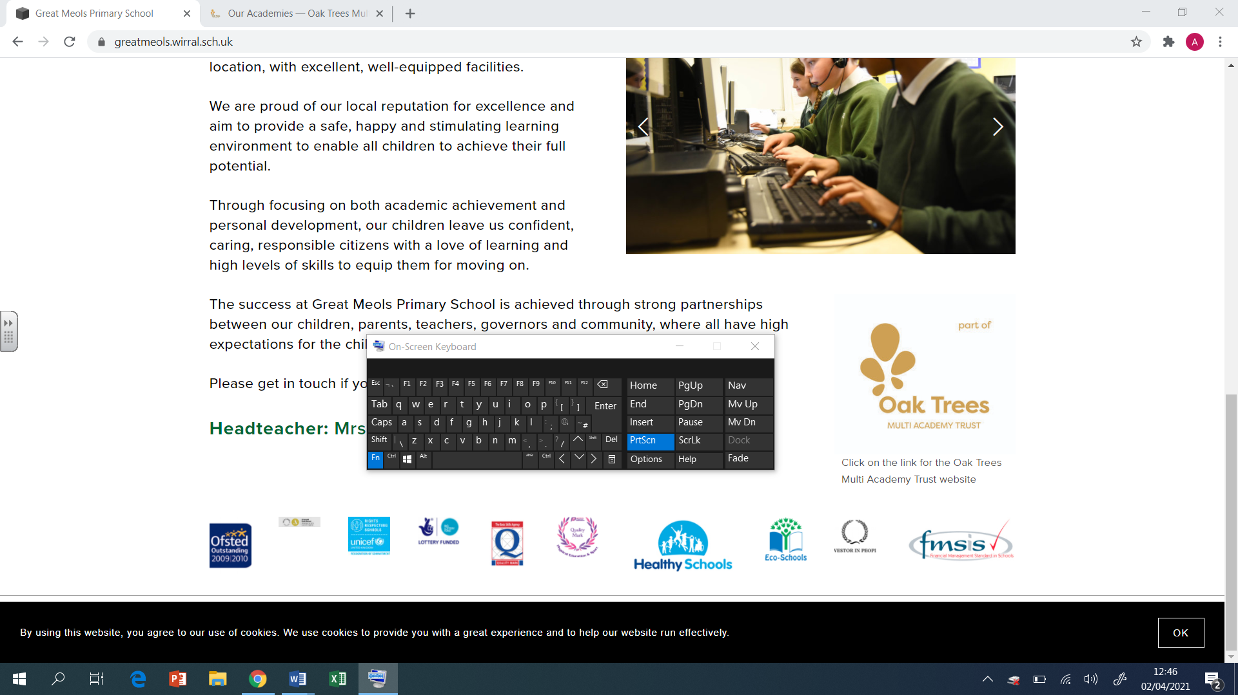

Brackenwood Junior School

English

Long Term Plan

Y3

2024-25

|  |  |  |  |  |  |  |  |  |
| --- | --- | --- | --- | --- | --- | --- | --- | --- |
| **Year 3 Autumn 1**  **Grammarsaurus**  **PVPG objectives 4-6 weeks**  **Final 2 weeks application – Non-chronological report – Extinct Animals** | | | | | | | | |
|  | **Week 1** | **Week 2** | **Week 3** | **Week 4** | **Week 5** | **Week 6** | **Week 7** | **Week 8** |
| Extended Writing  Genre |  | | | | | | | |
| Spelling  Focus  Teaching | **Homophones/ Near Homophones long á** | **‘ei’ sounding ‘ay’**  **In some words ‘ei’ together make a long ‘a’ sound (ay)** | **‘ey’ sounding ‘ay’** | **Homophones/ Near Homophones long é** | **Homophones/ Near Homophones ed/ t** | **‘ou’ sounding ‘u’** | **‘y’ sounding ‘i’** | |
| Grammar/  punctuation  Focus Teaching |  | | | | | | **Non-chron – Extinct Animals**  **Application unit** | |

|  |  |  |  |  |  |  |  |  |  |  |
| --- | --- | --- | --- | --- | --- | --- | --- | --- | --- | --- |
| **Autumn 2**  **Text – Counting on Katherine** | | | | | | | | | | |
|  | **Week 1** | **Week 2** | | **Week 3** | **Week 4** | | | **Week 5** | **Week 6** | **Week 7** |
| Extended Writing  Genre | **Diary** | | | | | | **Non-chronological report (NASA)** | | | |
| Spelling  Focus Teaching | **Suffixes –ed/ing** | **Suffixes –ed/ing** | | **Suffixes –ed/ing** | **Suffixes – ed/ing** | | | **Suffix –er** | **Suffix –er** | **Adding s to words-‘ey’ sounding long ‘e’ (ee)** |
| Grammar/  punctuation  Focus Teaching | **Year 3 Grammar**  Commas to separate items in a list  Paragraphs  Apostrophes for singular possession  **GDS**  Use a more varied and rich vocabulary  Use a variety of verb forms with purpose and confidence  Use paragraphs with greater control | | **Genre Related Grammar – Diary**  **Language Features:**  First person  Past tense  Chronological order  Time adverbs and conjunctions  Writer’s point of view  Emotions and feelings  Informal  **Structural Features:**  Date  Greeting  Introduction  Main body  Conclusion  Sign-off | | | **Year 3 Grammar**  Show time and place using adverbs and prepositions  A range of coordinating conjunctions  Use of present and past tense consistently correctly (including present perfect)  A rich and varied vocabulary  **GDS**  Controlled use of a rich and varied vocabulary drawn from reading  Fronted subordinate clause e.g. Although pandas seem gentle, they can be vicious if provoked. | | | | **Genre Related Grammar – Non-chronological report**  **Language Features**  Information in chronological order  Factual information  Third person  Present tense (sometimes past)  Technical vocabulary  **Structural Features**  Heading  Subheadings  Paragraphs  Picture with caption  Bullet points |

|  |  |  |  |  |  |  |  |
| --- | --- | --- | --- | --- | --- | --- | --- |
| Spring 1  **Text – Call Me Lion** | | | | | | | |
|  | **Week 1** | **Week 2** | **Week 3** | **Week 4** | **Week 5** | | **Week 6** |
| Extended Writing  Genre | **Newspaper** | | | **Letter** | | | |
| Spelling  Focus  Teaching | **Adding –es to words ending consonant –y** | **Suffixes –ed/ing** | **Words ending –tion** | **Words ending –tion** | **Words ending-sure** | | **Prefix- dis** |
| Grammar/  punctuation  Focus Teaching | **Year 3 Grammar**  Capital letters, full stops, question marks  Inverted commas for speech  Adverbs for time, place and manner  Prepositions  **GDS**  Write effectively for a range of purposes, using paragraphs with greater control  Use a variety of sentence construction, with some use of fronted adverbials and clauses | | **Genre Related Grammar - Newspaper**  **Language Features:**  Third person  Past tense  Speech  Time adverbials  Chronological order  **Structural Features:**  Headline  Orientation – 5Ws  Main body  Reorientation  Picture with caption | **Year 3 Grammar**  A clear introduction and conclusion  Adverbs and prepositions  Commas in a list  A range of conjunctions  Question marks  **GDS**  Use a variety of verbs forms with purpose and confidence  Use the full range of punctuation learned so far | | **Genre Related Grammar – Letter**  **Language Features:**  Present tense  First person  Persuasive devices  Persuasive openers  **Structural Features:**  Addresses (recipient’s and author’s)  Date  Greeting  Introduction  Main body  Conclusion  Signature | |

|  |  |  |  |  |  |  |  |  |  |
| --- | --- | --- | --- | --- | --- | --- | --- | --- | --- |
| **Year 3 Spring 2**  **Text – Boy Who Grew Dragons** | | | | | | | | | |
|  | **Week 1** | **Week 2** | **Week 3** | | **Week 4** | **Week 5** | **Week 6** | **Week 7** | **Week 8** |
| Extended Writing  Genre | **Narrative** | | | | | **Newspaper** | | | |
| Spelling  Focus  Teaching | **Homophones/ Near Homophones long á** | **‘ei’ sounding ‘ay’**  **In some words ‘ei’ together make a long ‘a’ sound (ay)** | **‘ey’ sounding ‘ay’** | | **Homophones/ Near Homophones long é** | **Homophones/ Near Homophones ed/ t** | **‘ou’ sounding ‘u’** | **‘y’ sounding ‘i’** | |
| Grammar/  punctuation  Focus Teaching | **Year 2**    Use of capital letters, full stops, questions marks exclamation  Expressing time, place and cause using:  -conjunctions (eg. when, before, after, while, so because)  -adverbs (eg, then, next, soon, therefore)  -prepositions (eg. before, after, during, in, because of).  Commas in a list  Coordinating and subordinating conjunctions | | | **Genre Related Grammar - Narrative**  **Language Features:**  Dialogue  Past or present tense  First or third person  Expanded noun phrases  Adverbs  Prepositions  **Structural Features:**  Title  Opening  Build-up  Problem  Resolution  Conclusion | | **Year 3 Grammar**    Use of capital letters, full stops, questions marks exclamation  Expressing time, place and cause using:  -conjunctions (eg. when, before, after, while, so because)  -adverbs (eg, then, next, soon, therefore)  -prepositions (eg. before, after, during, in, because of).  Inverted commas for speech  **GDS**  Write effectively for a range of purposes, using paragraphs with greater control  Use a variety of sentence construction, with some use of fronted adverbials and clauses | **Genre Related Grammar - Newspaper**  **Language Features:**  Third person  Past tense  Speech  Time adverbials  Chronological order  **Structural Features:**  Headline  Orientation – 5Ws  Main body  Reorientation  Picture with caption | | |

|  |  |  |  |  |  |  |  |
| --- | --- | --- | --- | --- | --- | --- | --- |
| **Summer 1**  **Text – Wild Robot** | | | | | | | |
|  | **Week 1** | **Week 2** | **Week 3** | **Week 4** | | **Week 5** | |
| Extended Writing  Genre | **Diary** | | **Narrative** | | | | |
| Spelling  Focus  Teaching | **Suffix - ly** | **Suffix - ly** | **Suffix - ly** | **Suffix – ly** | | **Suffix – ly** | **Suffix – ly/ally** |
| Grammar/  punctuation  Focus Teaching | **Year 3 Grammar**  Commas to separate items in a list  Paragraphs  Apostrophes for singular possession  **GDS**  Use a more varied and rich vocabulary  Use a variety of verb forms with purpose and confidence  Use paragraphs with greater control | **Genre Related Grammar – Diary**  **Language Features:**  First person  Past tense  Chronological order  Time adverbs and conjunctions  Writer’s point of view  Emotions and feelings  Informal  **Structural Features:**  Date  Greeting  Introduction  Main body  Conclusion  Sign-off | **Year 3 Grammar**  Prepositions  Coordinating and subordinating conjunctions  Purposeful dialogue  Paragraphs sequenced logically  **GDS**  Write effectively for different purposes, using paragraphs with greater control  Use a more varied and rich vocabulary  Use a greater variety of sentence construction, with some use of fronted adverbials or clauses | | **Genre Related Grammar – Narrative**  **Language Features:**  Dialogue  Past or present tense  First or third person  Expanded noun phrases  Adverbs of time, place and manner  Prepositions  **Structural Features:**  Title  Opening  Build-up  Problem  Resolution  Conclusion | | |

|  |  |  |  |  |  |  |  |
| --- | --- | --- | --- | --- | --- | --- | --- |
| **Summer 2**  **Text – If I was Prime Minister** | | | | | | | |
|  | **Week 1** | **Week 2** | **Week 3** | **Week 4** | **Week 5** | **Week 6** | **Week 7** |
| Extended Writing  Genre | **Non-chronological report (British Values)** | | | | **Persuasive letter** | | |
| Spelling  Focus  Teaching | **Suffix – ful/-less** | **Plural of words ending –o** | **Plural of words ending –f/-fe** | **Irregular plurals** | **Irregular past tense ‘ow’ to ’ew’** | **Irregular past tense**  **‘in’ to ‘an’** |  |
| Grammar/  punctuation  Focus Teaching | **Year 3 Grammar**  Show time and place using adverbs and prepositions  A range of coordinating conjunctions  Use of present and past tense consistently correctly (including present perfect)  A rich and varied vocabulary  **GDS**  Controlled use of a rich and varied vocabulary drawn from reading  Fronted subordinate clause e.g. Although pandas seem gentle, they can be vicious if provoked. | | **Genre Related Grammar – Non-chronological report**  **Language Features**  Information in chronological order  Factual information  Third person  Present tense (sometimes past)  Technical vocabulary  **Structural Features**  Heading  Subheadings  Paragraphs  Picture with caption  Bullet points | | **Year 3 Grammar**  A clear introduction and conclusion  Adverbs and prepositions  Commas in a list  A range of conjunctions  Question marks  **GDS**  Use a variety of verbs forms with purpose and confidence  Use the full range of punctuation learned so far | **Genre Related Grammar – Letter**  **Language Features:**  Present tense  First person  Persuasive devices  Persuasive openers  **Structural Features:**  Addresses (recipient’s and author’s)  Date  Greeting  Introduction  Main body  Conclusion  Signature | |