`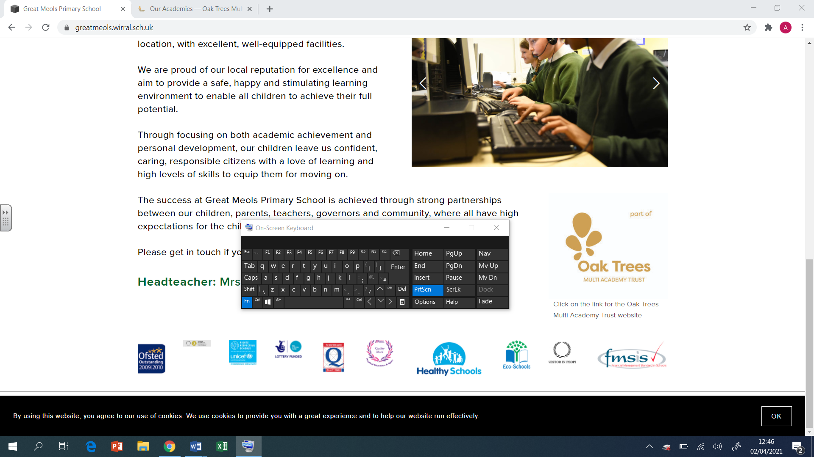

Brackenwood Junior School

English

Long Term Plan

Year 6

2024-25

|  |  |  |  |  |  |  |  |
| --- | --- | --- | --- | --- | --- | --- | --- |
| Autumn 1  Grammarsaurus PVPG objectives 4-6 weeks  Application unit – Non-chronological report – Planets of the Solar System  Begin to read Nowhere Emporium | | | | | | | |
|  | **Week 1** | **Week 2** | **Week 3** | **Week 4** | **Week 5** | **Week 6** | **Week 7** |
| Extended Writing  Genre |  | | | | | | |
| Spelling  Focus  Teaching | **Spelling test 3+4 words**  **Consonant spellings**  **g** - g for gue  **J** – g gerbil, dge – badger, ge – age  **K** - k for que, ck, ch (scheme)  **Z** - ss – scissors  **Y** – I – onion | **Consonant spellings**  **T** – th – thyme  W – qu  **F** = gh, ph  **W** – wh  **S** – c – cell and race  **S** – sc – science  I before e | **Silent letters**  **Mb** – lamb  **Bt** – doubt  D – Wednesday, sandwich  **Gn** – gnome  **H** – ghost rhino | **Silent letters**  **Kn** – knot  **L**  **Mn** – column  **Wr** – write  **St** – whistle | **Diagraphs – what is a diagraph?**  **ch** – ch, t (picture), tch  **zh** – division, measure  **sh** – ce (ocean), ch (chef), cia (special), sh, ss(mission), t (motion | **Short sounds**  **short e** – ai said, a many, ea head, eo leopard, ie friend  **short I** – e pretty, o women, u, busy, y gym  **short o** – salt  **short u** – o dove, ou young, oo good | **Long sounds**  **A** = a, ai, aigh, ay, a-e, ei, eigh, ey  **E** = e, ea, ee, ei, ey, e-e, ie, y (ie before e)  **I** = I, eigh, ie, igh, i-e, y, ye, y-e  **O** = o, oa, oe, ol, ou, ough, ow, o-e  **U** = u, ew, ue, u-e, oo |
| Grammar/ punctuation  Focus Teaching |  | | | | | **Non-chronological report – Planets of the Solar System**  **Application unit** | |

|  |  |  |  |  |  |  |  |  |  |  |
| --- | --- | --- | --- | --- | --- | --- | --- | --- | --- | --- |
| Autumn 2  Text – The Nowhere Emporium by Ross Mackenzie (Lancashire recommended unit) | | | | | | | | | | |
|  | **Week 1** | **Week 2** | | **Week 3** | **Week 4** | **Week 5** | **Week 6** | | **Week 7** |
| Extended Writing  Genre | The Nowhere Emporium  **Genre - Narrative** | | | | | Text – The Nowhere Emporium  **Genre – Non-chronological report on magic (and magical items)** | | | | |
| Spelling  Focus  Teaching | **Spelling test 3+4 words**  **Consonant spellings**  **g** - g for gue  **J** – g gerbil, dge – badger, ge – age  **K** - k for que, ck, ch (scheme)  **Z** - ss – scissors  **Y** – I – onion | **Consonant spellings**  **T** – th – thyme  W – qu  **F** = gh, ph  **W** – wh  **S** – c – cell and race  **S** – sc – science  I before e | | **Silent letters**  **Mb** – lamb  **Bt** – doubt  D – Wednesday, sandwich  **Gn** – gnome  **H** – ghost rhino | **Silent letters**  **Kn** – knot  **L**  **Mn** – column  **Wr** – write  **St** – whistle | **Diagraphs – what is a diagraph?**  **ch** – ch, t (picture), tch  **zh** – division, measure  **sh** – ce (ocean), ch (chef), cia (special), sh, ss(mission), t (motion | **Short sounds**  **short e** – ai said, a many, ea head, eo leopard, ie friend  **short I** – e pretty, o women, u, busy, y gym  **short o** – salt  **short u** – o dove, ou young, oo good | | **Long sounds**  **A** = a, ai, aigh, ay, a-e, ei, eigh, ey  **E** = e, ea, ee, ei, ey, e-e, ie, y (ie before e)  **I** = I, eigh, ie, igh, i-e, y, ye, y-e  **O** = o, oa, oe, ol, ou, ough, ow, o-e  **U** = u, ew, ue, u-e, oo |
| Grammar/ punctuation  Focus Teaching | **Year 6 Grammar**  Passive voice  Modal verbs  Dialogue to advance the action  Range of clauses and sentence lengths – prepositional phrases, fronted adverbials  Semi-colons, colons, hyphens  Parenthesis – brackets, dashes, commas  **Greater depth**  Distinguish between the language of speech and writing and choose the appropriate register.  Exercise an assured and conscious control over levels of formality particularly through manipulating grammar and vocabulary to achieve this (formal e.g. technical vocab, modal verbs unless contracted, subjunctive form, pronoun ‘one’ / informal e.g. question tags, speech, contractions, colloquial language, ellipsis)  Write effectively for a range of purposes and audiences selecting the appropriate form and drawing independently on what they have read as models for their own writing (e.g. literary language, characterisation, structure) | | **Genre Related Grammar - Narrative**  **Language Features:**  Dialogue to advance the action  Past or present tense  First or third person  Expanded noun phrases  Adverbs of time, place and manner  Prepositions  **Structural Features:**  Title  Opening (setting/character description)  Build-up (dialogue to advance the action)  Problem  Resolution  Conclusion | | | **Year 6 Grammar**  Adapt the sentence length and vocabulary to change and enhance the meaning  Colons and semi-colons  Hyphenated words  Expanded noun phrases, adverbs and prepositions to convey complicated information concisely  Relative clauses  **Greater depth**  Exercise an assured and conscious control over levels of formality particularly through manipulating grammar and vocabulary to achieve this  Subjunctive form e.g. Many suggest that…. | | **Genre Related Grammar – Non-chronological report**    **Language Features:**  Information in non-chron order  Factual information  Third person  Present tense  Technical vocabulary  **Structural Features:**  Heading  Subheading  Paragraphs  Bullet points  Pictures with caption | |

|  |  |  |  |  |  |  |  |
| --- | --- | --- | --- | --- | --- | --- | --- |
| **Spring 1**  **Text – 1000 Year Old Boy by Ross Welford** | | | | | | | |
|  | **Week 1** | **Week 2** | **Week 3** | **Week 4** | **Week 5** | **Week 6** | **Week 7** |
| Extended Writing  Genre | Text - 1000 Year Old Boy by Ross Welford  **Genre – Persuasive advert (object that provides immortality)** | | | Text - 1000 Year Old Boy by Ross Welford  **Genre – Narrative (alternate ending)** | | | |
| Spelling  Focus  Teaching | **Suffix – ful/-less** | **Plural of words ending –o** | **Plural of words ending –f/-fe** | **Irregular plurals** | **Irregular past tense ‘ow’ to ’ew’** | **Irregular past tense**  **‘in’ to ‘an’** |  |
| Grammar/  punctuation  Focus Teaching | **Year 6 Grammar**  Conjunction, prepositions and adverbs  Synonyms  Parenthesis  Modal verbs  Brackets, dashes, commas for clarity  Hyphenated words  **Greater depth**  Subjunctive form (formality)  Distinguish between the language of speech and writing and choose the appropriate register  Use the range of punctuation taught so far (semi-colons, colons, dashes, hyphens) | **Genre Related Grammar - Narrative**  **Language Features:**  Present tense  First person  Persuasive devices  Persuasive openers  **Structural Features:**  Pictures  Title/brand  Boxes with information | | **Year 6 Grammar**  Passive voice  Modal verbs  Dialogue to advance the action  Range of clauses and sentence lengths – prepositional phrases, fronted adverbials  Semi-colons, colons, hyphens  Parenthesis – brackets, dashes, commas  **Greater depth**  Distinguish between the language of speech and writing and choose the appropriate register.  Exercise an assured and conscious control over levels of formality particularly through manipulating grammar and vocabulary to achieve this (formal e.g. technical vocab, modal verbs unless contracted, subjunctive form, pronoun ‘one’ / informal e.g. question tags, speech, contractions, colloquial language, ellipsis)  Write effectively for a range of purposes and audiences selecting the appropriate form and drawing independently on what they have read as models for their own writing (e.g. literary language, characterisation, structure) | | **Genre Related Grammar - Narrative**  **Language Features:**  Dialogue to advance the action  Past or present tense  First or third person  Expanded noun phrases  Adverbs of time, place and manner  Prepositions  **Structural Features:**  Title  Opening (setting/character description)  Build-up (dialogue to advance the action)  Problem  Resolution  Conclusion | |

|  |  |  |  |  |  |  |  |
| --- | --- | --- | --- | --- | --- | --- | --- |
| Spring 2  Victorians History topic  The Final Year by Matt Goodfellow | | | | | | | |
|  | **Week 1** | **Week 2** | **Week 3** | **Week 4** | **Week 5** | **Week 6** | |
| Extended Writing  Genre | Victorians – Style Mill  **Genre - Balanced argument – Should children be allowed to work?** | | | Text – The Final Year  **Genre – Diary entry** | | | |
| Spelling  Focus  Teaching | **Other long sounds**  **Oi** = oi, oy  **Ow** = ow, ou  **Ar**  **Air** – air, ear, are | **Ear** – ere ear  **Er** = er, ur, ir, or  **Or** = or, ore, au, aw, al, ar, ure | **Tense**  ing and ed  Irregular verbs | **Comparitive/superlative**  Er, ier and est  Plural – s, es, ies | **Latin Etymology**  Min Mat and pat  Quad Terr  Tri Uni  Aqua Cent  Circum Form  Liber bi | **Greek Etymology**  Pan Path  Phobia Photo  Poly tele  Aero Bibl  Cycl Dec  Mega therm  homo | **3+4 spelling test review** Homophones  Homonyms  Homographs  Hyphen |
| Grammar/ punctuation  Focus Teaching | **Year 6 Grammar**  Conjunctions, prepositions and adverbs  Passive voice  Modal verbs  Brackets, dashes, commas for clarity  Hyphenated words  **Greater depth**  All Year 6 punctuation correct  Write effectively for a range of purposes and audiences selecting the appropriate form and drawing independently on what they have read as models for their own writing (e.g. literary language, characterisation, structure) | **Genre Related Grammar – Setting description**  **Language Features**  Present tense  Rhetorical questions  Refer to groups of people e.g. Scientists suggest…  Formal, impersonal style  Logical conjunctions e.g. therefore, consequently  **Structural Features**  Question  Introduction  Arguments for  Arguments against  Conclusion | | **Year 6 Grammar**  Modal verbs  Conjunctions, adverbs, prepositions  Pronouns  Synonyms  Range of punctuation – semi-colons, colons, hyphens  **Greater depth**  Write effectively for a range of purposes and audiences selecting the appropriate form and drawing independently on what they have read as models for their own writing (e.g. literary language, characterisation, structure)  Exercise an assured and conscious control over levels of formality particularly through manipulating grammar and vocabulary to achieve this | | **Genre Related Grammar - Diary**  **Language Features:**  First person  Past tense  Chronological order  Time adverbs and conjunctions  Writer’s POV  Emotions and feelings  Informal voice (I reckon…)  **Structural Features:**  Date  Greeting (Dear diary…)  Introduction  Main body  Conclusion  Sign-off | |

|  |  |  |  |  |  |  |  |
| --- | --- | --- | --- | --- | --- | --- | --- |
| Summer 1  Text – Murder in Velvet by Sarah Wynne | | | | | | | |
|  | **Week 1** | **Week 2** | **Week 3** | **Week 4** | | **Week 5** | **Week 6** |
| Extended Writing  Genre | **Genre – Non-chron – Life in Britain during WW2** | | | | Text – Murder in Velvet by Sarah Wynne  **Genre - Narrative** | | |
| Spelling  Focus  Teaching | **Noun Suffixes**  ness  Ment  ship  Sion, Tion, Cian, Ssion | **Noun Suffixes**  Age  Sure and ture | **Adjective Suffixes**  Able ably/ ible ibly  ic  Ful/less  tious and cious | **Adjective Suffixes**  Ish  Ive  y  ous, eous, ious  cial /tial | | **Verb Suffixes**  Ice/ise  Ate  En  Ify  **Adverb Suffixes**  ly | |
| Grammar/ punctuation  Focus Teaching | **Year 6 Grammar**  Adapt the sentence length and vocabulary to change and enhance the meaning  Colons and semi-colons  Hyphenated words  Expanded noun phrases, adverbs and prepositions to convey complicated information concisely  Relative clauses  **Greater depth**  Exercise an assured and conscious control over levels of formality particularly through manipulating grammar and vocabulary to achieve this  Subjunctive form e.g. Many suggest that…. | **Genre Related Grammar – Non-chronological report**    **Language Features:**  Information in non-chron order  Factual information  Third person  Present tense  Technical vocabulary  **Structural Features:**  Heading  Subheading  Paragraphs  Bullet points  Pictures with caption | | **Year 6 Grammar**  Passive voice  Modal verbs  Dialogue to advance the action  Range of clauses and sentence lengths – prepositional phrases, fronted adverbials  Semi-colons, colons, hyphens  Parenthesis – brackets, dashes, commas  **Greater depth**  Distinguish between the language of speech and writing and choose the appropriate register.  Exercise an assured and conscious control over levels of formality particularly through manipulating grammar and vocabulary to achieve this (formal e.g. technical vocab, modal verbs unless contracted, subjunctive form, pronoun ‘one’ / informal e.g. question tags, speech, contractions, colloquial language, ellipsis)  Write effectively for a range of purposes and audiences selecting the appropriate form and drawing independently on what they have read as models for their own writing (e.g. literary language, characterisation, structure) | | | **Genre Related Grammar - Narrative**  **Language Features:**  Dialogue to advance the action  Past or present tense  First or third person  Expanded noun phrases  Adverbs of time, place and manner  Prepositions  **Structural Features:**  Title  Opening (setting/character description)  Build-up (dialogue to advance the action)  Problem  Resolution  Conclusion |

|  |  |  |  |  |  |  |  |  |  |
| --- | --- | --- | --- | --- | --- | --- | --- | --- | --- |
| Summer 2  Text - The Fight that makes us by Sarah Hagger-Holt | | | | | | | | | |
|  | **Week 1** | **Week 2** | | **Week 3** | **Week 4** | | **Week 5** | | |
| Extended Writing  Genre | Text – The Fight That Makes Use  **Genre - Diary** | | | | | Text – The Fight That Makes Us  **Genre - Newspaper** | | | |
| Spelling  Focus  Teaching | **Spelling test 5+6 words**  Nouns - Al metal/Il pencil  Le apple/El camel  Ol | **Prefixes**  Co,  Dis  Ex  Mis  Re | | **Prefixes**  Im  In  Ill  Ir  De | **Prefixes**  Inter  Intra  micro  Fore  Un | | **Prefixes**  Post pre  Sub  Super  Trans  Anti | | **Combining Prefixes**  com, con  Auto  audi  under  Out  Over  <https://www.myenglishteacher.eu/blog/prefixes-suffixes-list/>  **Noun Suffixes**  Ent ency/ant ancy  Dom  Er,ar and or  Ist  ity |
| Grammar/ punctuation  Focus Teaching | **Year 6 Grammar**  Modal verbs  Conjunctions, adverbs, prepositions  Pronouns  Synonyms  Range of punctuation – semi-colons, colons, hyphens  **Greater depth**  Write effectively for a range of purposes and audiences selecting the appropriate form and drawing independently on what they have read as models for their own writing (e.g. literary language, characterisation, structure)  Exercise an assured and conscious control over levels of formality particularly through manipulating grammar and vocabulary to achieve this | | **Genre Related Grammar - Diary**  **Language Features:**  First person  Past tense  Chronological order  Time adverbs and conjunctions  Writer’s POV  Emotions and feelings  Informal voice (I reckon…)  **Structural Features:**  Date  Greeting (Dear diary…)  Introduction  Main body  Conclusion  Sign-off | | **Year 6 Grammar**  Conjunction, prepositions and adverbs  Passive voice  Modal verbs  Brackets, dashes, commas for clarity  Hyphenated words  **Greater depth**  Subjunctive form (formality)  Distinguish between the language of speech and writing and choose the appropriate register | | | **Grammar -Newspaper**  **Language Features:**  Third person  Past tense  Dialogue  Time adverbials  Chronological order  **Structural Features:**  Headline  By-line  Orientation – 5Ws  Main body  Reorientation  Picture with caption | |