

Retrieval

British values

Vocabulary threads

Type of History

Victorians



 Religion Conflict Leadership KS1 –Grace Darling

Religious Social Economic beliefs power monarchy Y3 - Romans– power/invasion

invasion empire Y4 – Vikings - conflict

Y5 - Tudors – Monarchy

When?

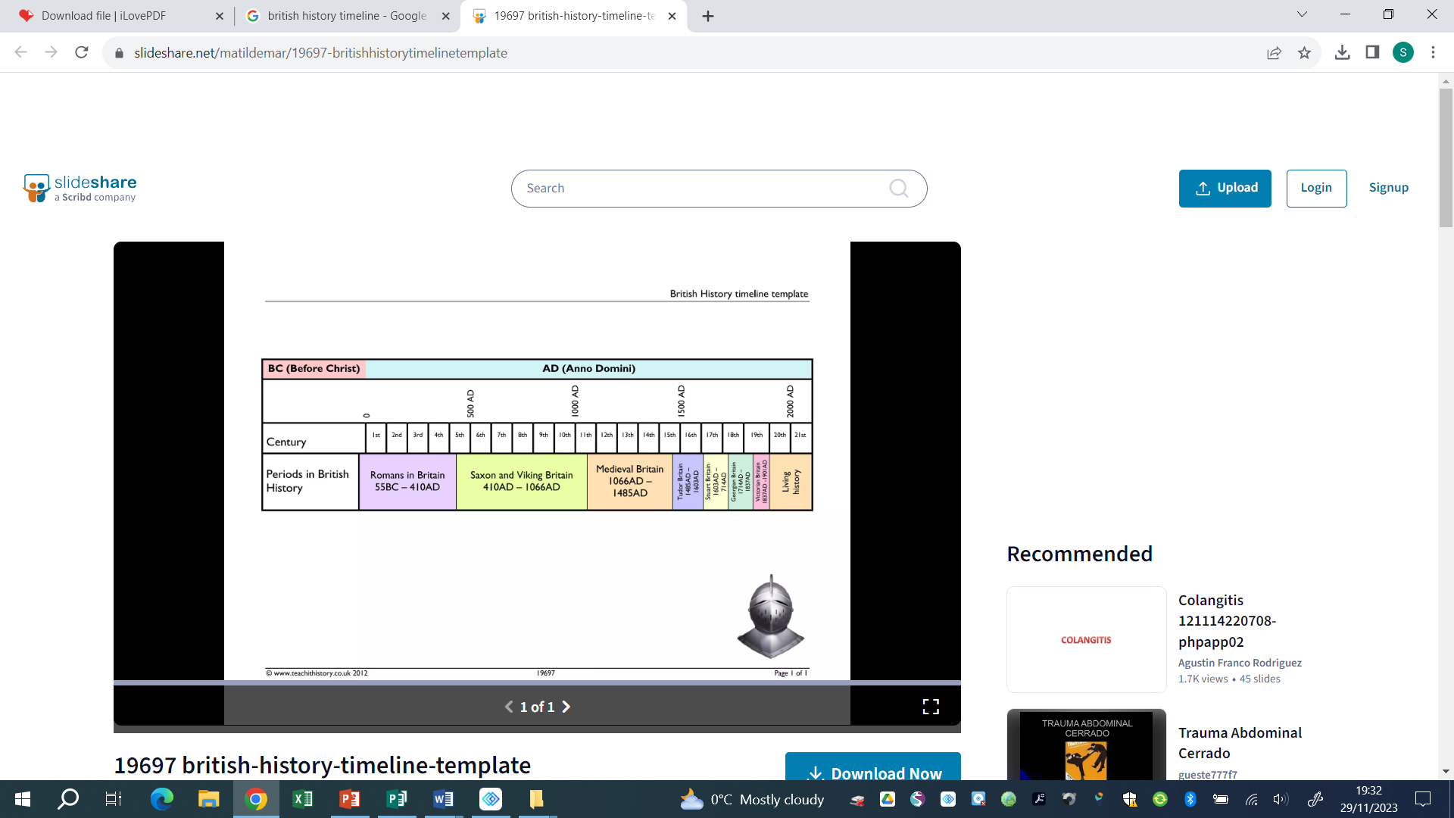



9500- 4000 BCE 2300-800 BCE 800 BCE – 50 CE 43 CE 793 **CE** 1485 – 1603 CE **1819 – 1901 CE 1888**   **1939 – 1945 CE**

**Human occupation of Bronze Age Britain Iron Age Britain Roman Invasion Viking Invasion** Tudor Dynasty **Victorian England Port Sunlight** WWII

Britain began (Stone Age) of Britain **soap factory opens**

Key vocabulary

|  |  |
| --- | --- |
| Colony | A group of people from one country who build a settlement in another territory or land |
| Empire | A group of territories ruled by one single ruler or state |
| Industrial Revolution | A period of major changes in the way products are made |
| Migration | The movement of a person or people from one place to settle in another |
| Nation | A country and its people |
| Rural | An area of land that has few buildings and a low population density |
| Urban | An area where many people live and work |
| Urbanisation | More areas become cities and fewer are small towns or farmland |

Helpful links -

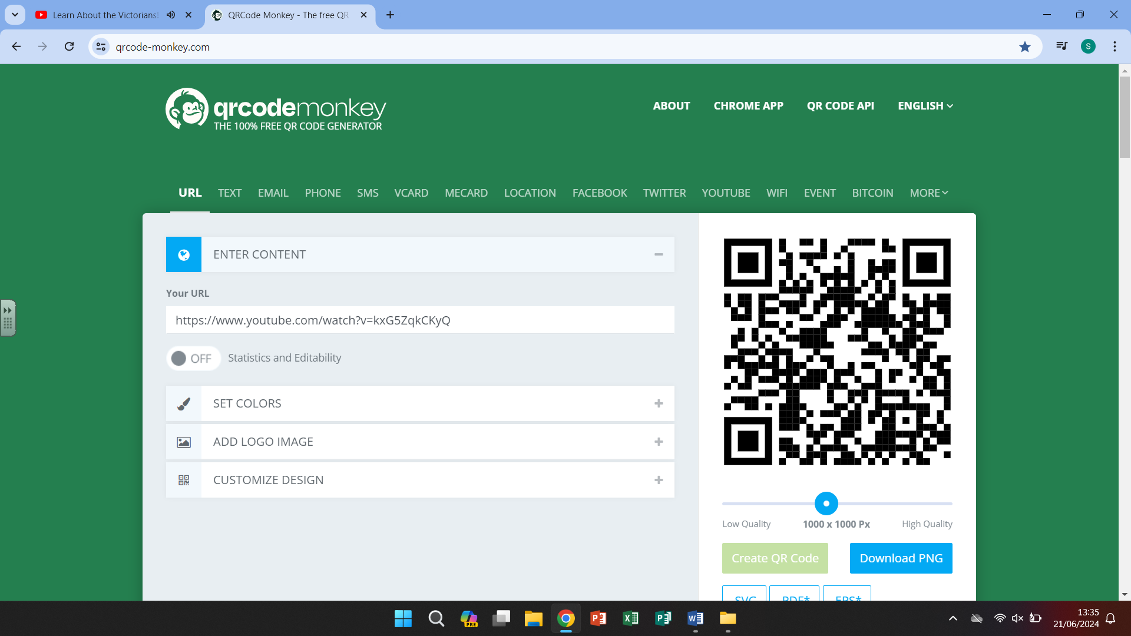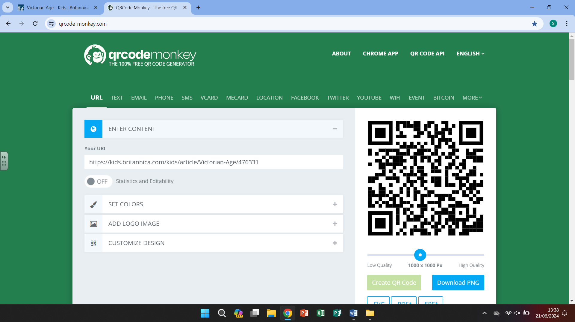 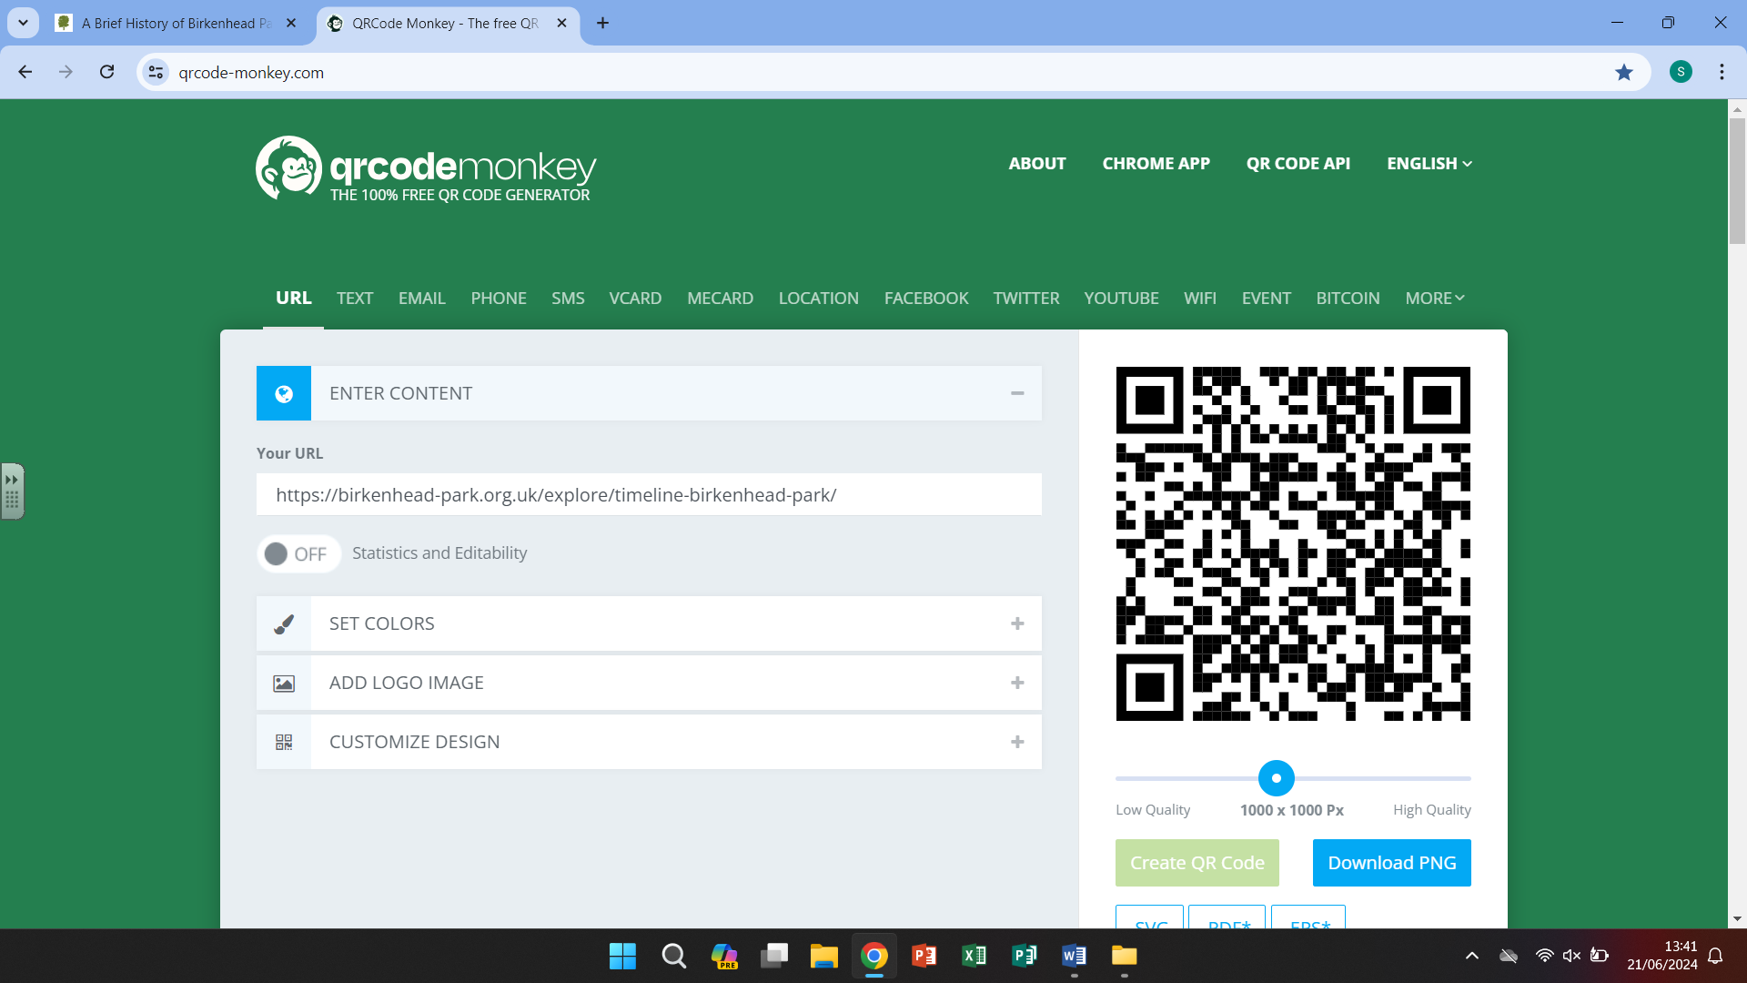 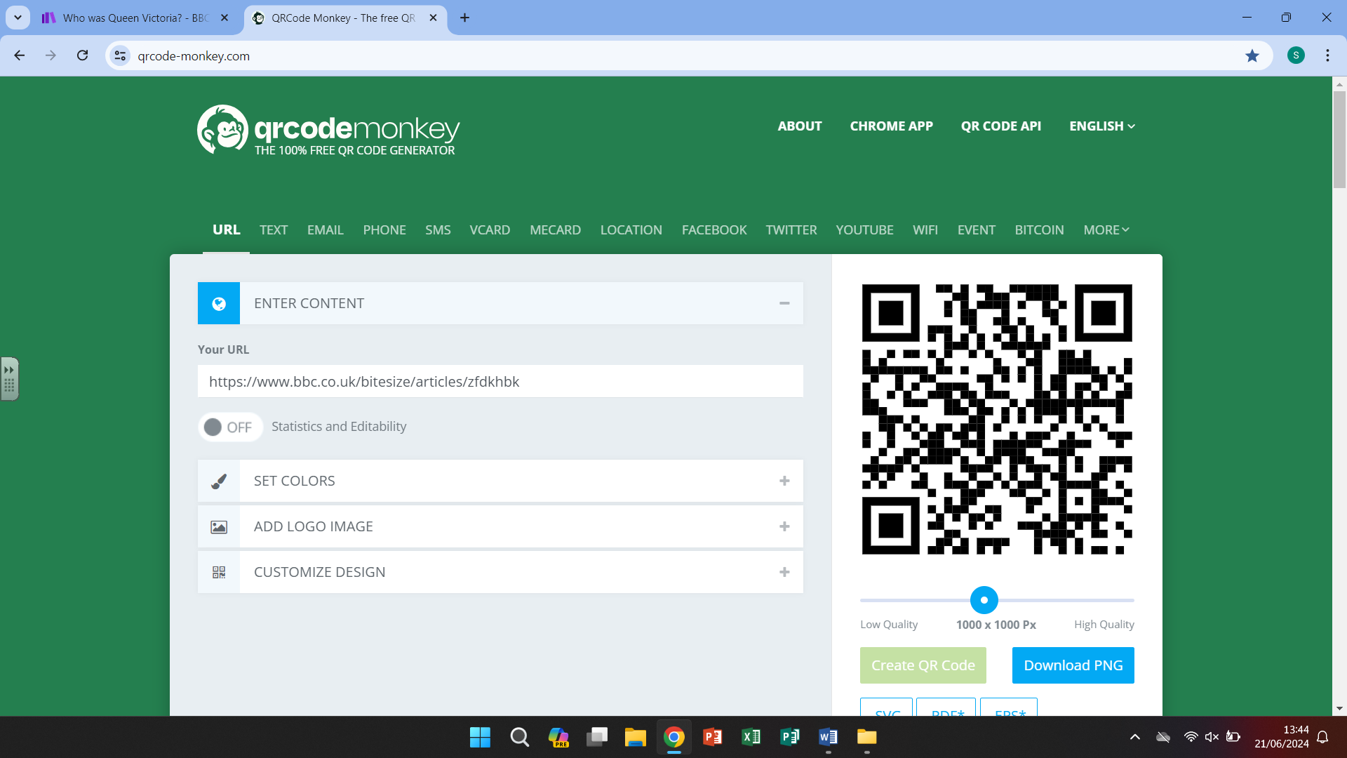

Horrible histories The Victorian Age Birkenhead Park Queen Victoria

QR codes

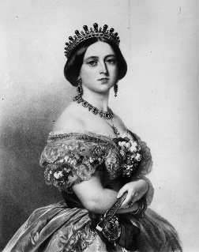

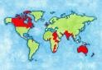

Our curriculum -

The Victorian era began in 1837 when Queen Victoria ascended to the throne. This began a reign that

would last for almost 64 years. This was a period of huge change, seeing the growth of the British

Empire and the beginning of the Industrial Revolution.

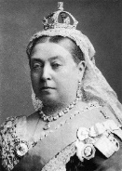

-During the Industrial Revolution there was a surge in the number of people living in cities, having moved from more rural areas to find work.

-some cities became know for the items they produced and sold

-Sadly, the more people that lived in an area the lower their standard of living was and hygiene and cleanliness were difficult to maintain.

-Queen Victoria passed laws to protect children and adults from poor working conditions

-She passed an act that stated all children were entitled to an education

-Victorian school had some differences compared to school today

**5.**

-The lives of Victorian children were very different to how children live now.

-Working conditions/risk for children, in some jobs, were very dangerous.

-The rights of a child weren’t respected and they did as they were told.

**2.**

-Great Britain led the way with many inventions during the Industrial Revolution including safe, electric lighting and public flushing toilets.

-Many great inventors lived during Victorian times and made objects that we still use today including Thomas Edison and George Stevenson

**4.**

**1.**

-Life locally was also impacted. Liverpool expanded as a result of the Industrial Revolution bringing many people through the port

-Birkenhead/Hamilton Square was developed due to the Industrial Revolution and there was a huge divided between the very rich and the very poor.

-Queen Victoria reigned for many years. She married, had children and ruled a country.

-She became Queen in 1837 at the very young age of just 18.

-She led Great Britain at a time of great industrial change with huge strides forward with technology and machinery.

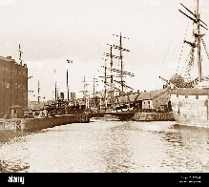

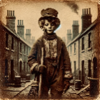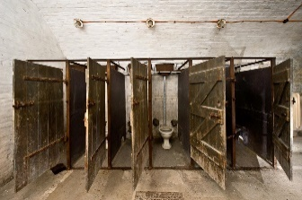

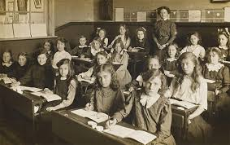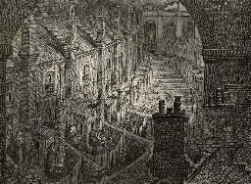

**6.**

**3.**