
Retrieval
British values
Vocabulary threads
Type of History
Victorians



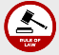
Religion Conflict Leadership KS1 –Grace Darling
Religious Social Economic beliefs power monarchy Y3 - Romans– power/invasion
invasion empire Y4 – Vikings - conflict
Y5 - Tudors – Monarchy
When?
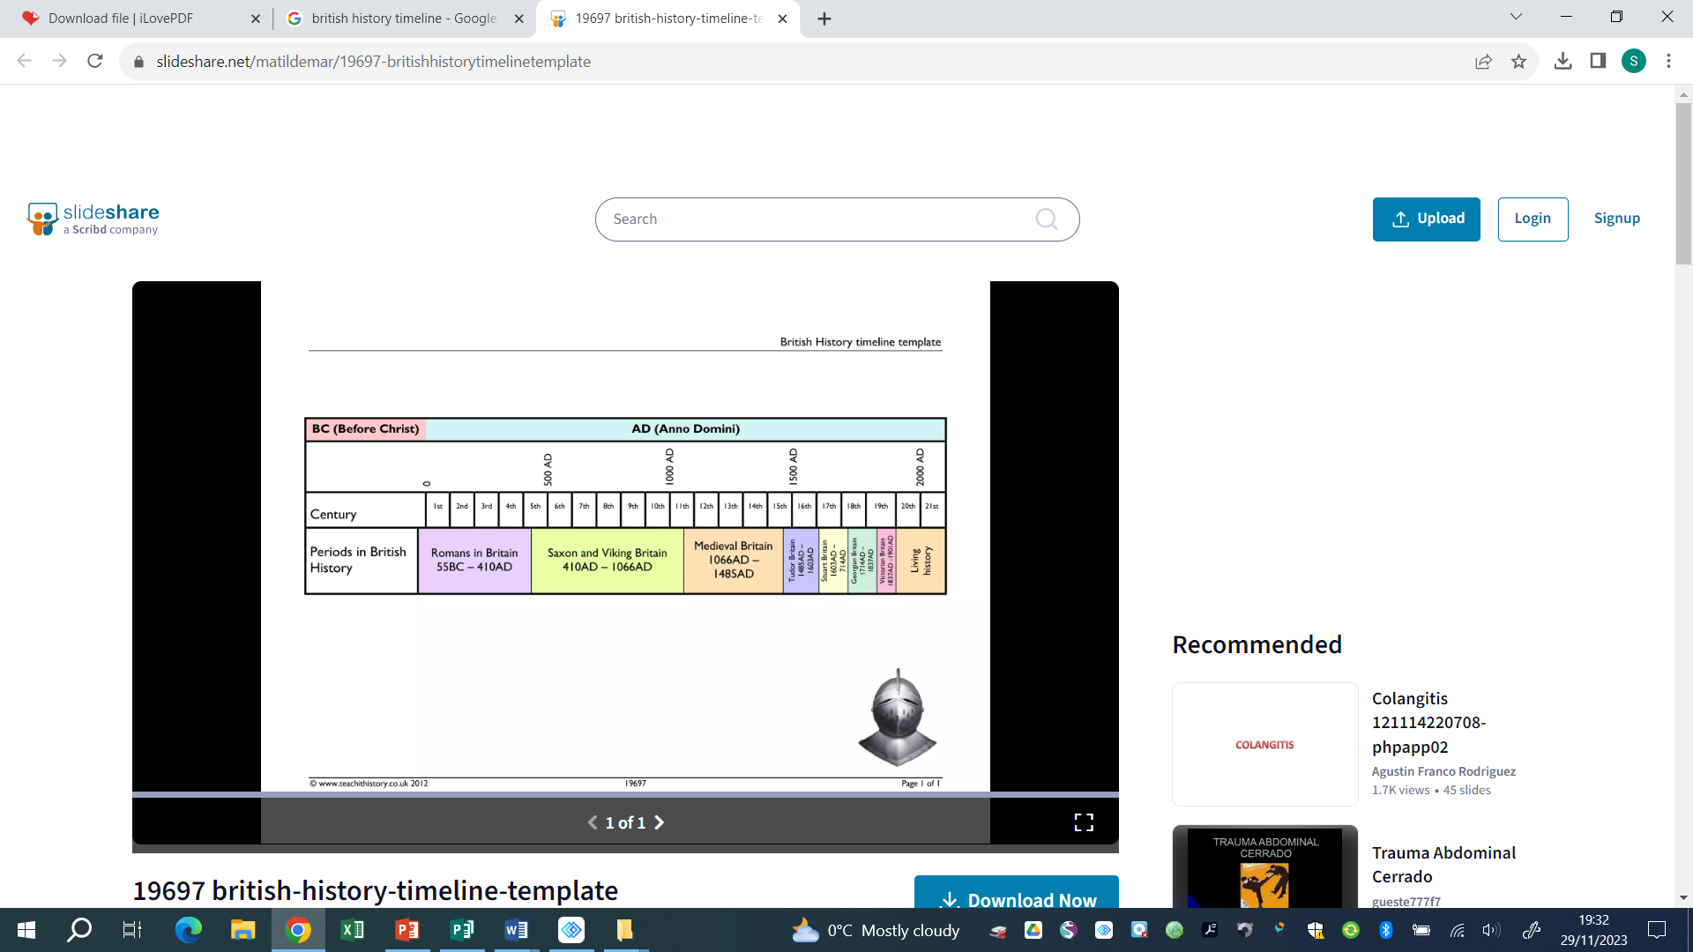

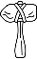
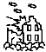

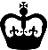

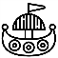




9500- 4000 BCE 2300-800 BCE 800 BCE – 50 CE 43 CE 793 CE 1485 – 1603 CE 1819 – 1901 CE 1888 1939 – 1945 CE
Human occupation of Bronze Age Britain Iron Age Britain Roman Invasion Viking Invasion Tudor Dynasty Victorian England Port Sunlight WWII
Britain began (Stone Age) of Britain soap factory opens
Key vocabulary

Colony | A group of people from one country who build a settlement in another territory or land
Empire | A group of territories ruled by one single ruler or state
Industrial Revolution | A period of major changes in the way products are made
Migration | The movement of a person or people from one place to settle in another
Nation | A country and its people
Rural | An area of land that has few buildings and a low population density
Urban | An area where many people live and work
Urbanisation | More areas become cities and fewer are small towns or farmland
Helpful links -

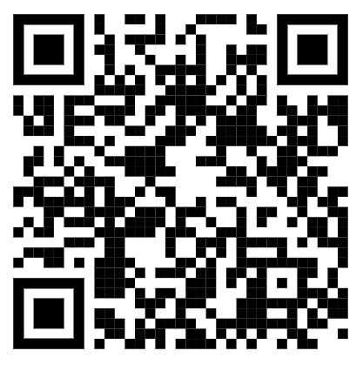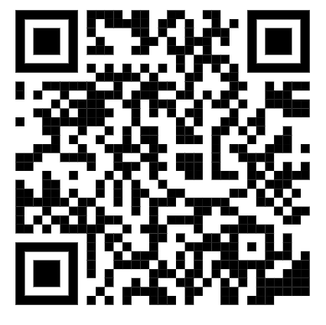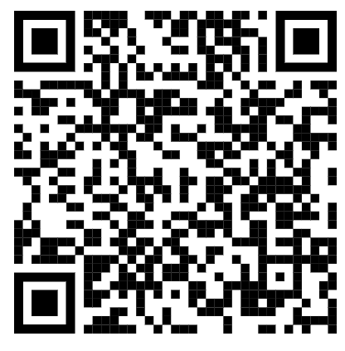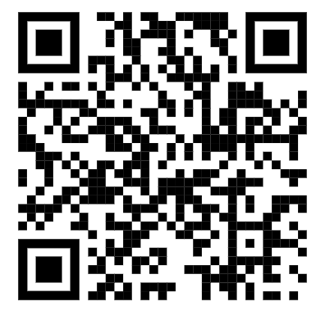
Horrible histories The Victorian Age Birkenhead Park Queen Victoria

QR codes

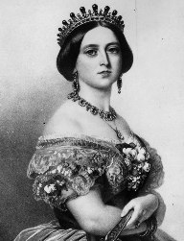
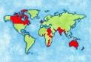
Our curriculum -
The Victorian era began in 1837 when Queen Victoria ascended to the throne. This began a reign that
would last for almost 64 years. This was a period of huge change, seeing the growth of the British
Empire and the beginning of the Industrial Revolution.

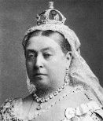
-During the Industrial Revolution there was a surge in the number of people living in cities, having moved from more rural areas to find work.
-some cities became know for the items they produced and sold
-Sadly, the more people that lived in an area the lower their standard of living was and hygiene and cleanliness were difficult to maintain.

-Queen Victoria passed laws to protect children and adults from poor working conditions
-She passed an act that stated all children were entitled to an education
-Victorian school had some differences compared to school today
5.
-The lives of Victorian children were very different to how children live now.
-Working conditions/risk for children, in some jobs, were very dangerous.
-The rights of a child weren’t respected and they did as they were told.

2.
-Great Britain led the way with many inventions during the Industrial Revolution including safe, electric lighting and public flushing toilets.
-Many great inventors lived during Victorian times and made objects that we still use today including Thomas Edison and George Stevenson
4.
1.
-Life locally was also impacted. Liverpool expanded as a result of the Industrial Revolution bringing many people through the port
-Birkenhead/Hamilton Square was developed due to the Industrial Revolution and there was a huge divided between the very rich and the very poor.
-Queen Victoria reigned for many years. She married, had children and ruled a country.
-She became Queen in 1837 at the very young age of just 18.
-She led Great Britain at a time of great industrial change with huge strides forward with technology and machinery.

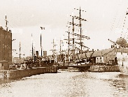

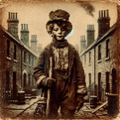
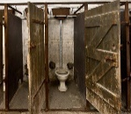

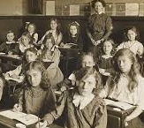
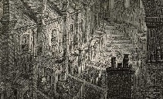
6.
3.

