

Tudors – Reformation of the Church

Retrieval

British values

Vocabulary threads

Type of History



 Religion Conflict Leadership KS1–Fire of London

Religious Political Cultural beliefs power monarchy Y3 - Romans – power

persecution Y4 – Vikings - conflict

Economics

When?

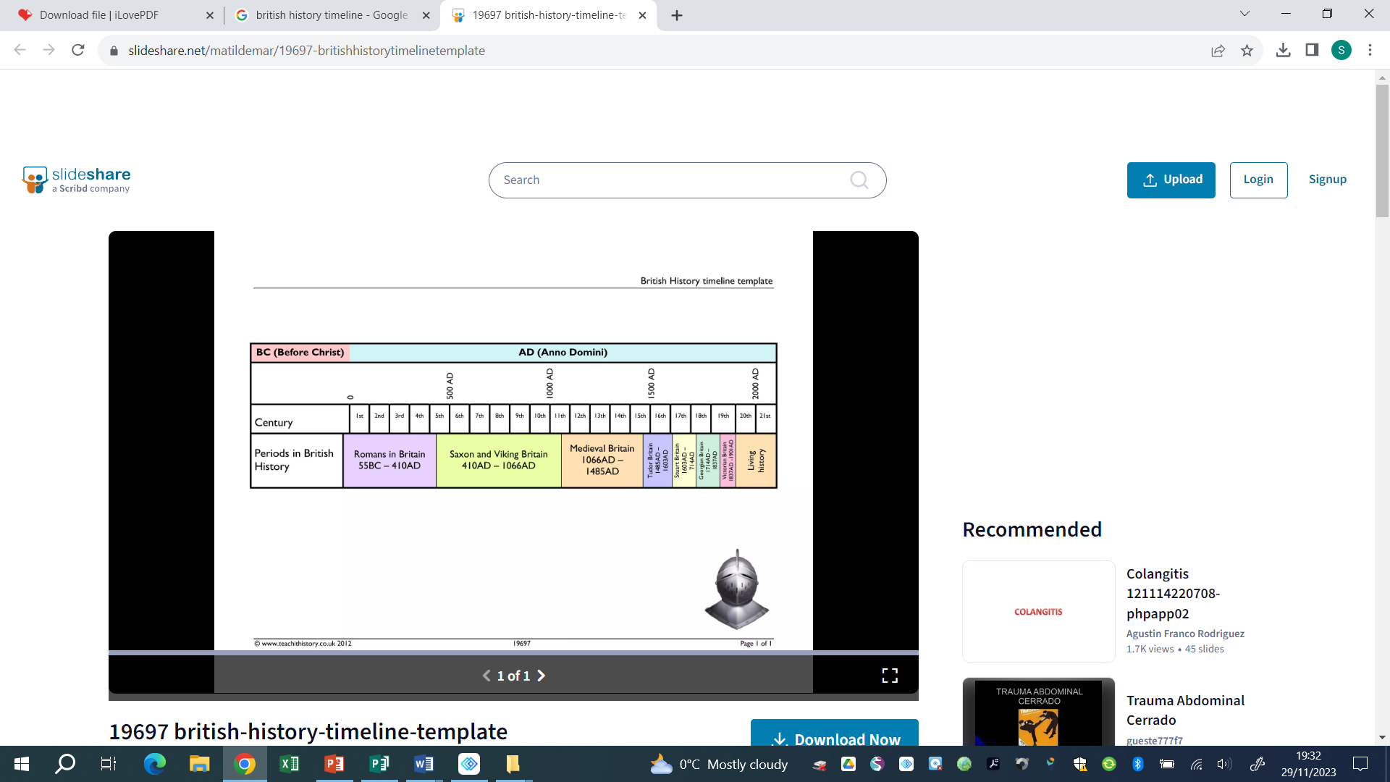



9500- 4000 BCE 2300-800 BCE 800 BCE – 50 CE 43 CE 793 CE **1485 – 1603 CE**  1819 – 1901 CE 1939 – 1945 CE

Human occupation of Bronze Age Britain Iron Age Britain Roman Invasion Viking Invasion **Tudor Dynasty** Victorian England WWII

Britain began (Stone Age) of Britain

Key vocabulary

|  |  |
| --- | --- |
| Catholicism | The traditions and beliefs of the Catholic Church (Christian) |
| Dissolution | The disbanding of monasteries, convents and priories by Henry VIII |
| Heir | A person who has the right to receive another person’s property/title after their death |
| Monarch | A ruler such as a king, queen or emperor |
| Monastery | A religious building used by a community of monks |
| Pope | head of the Roman Catholic Church |
| Protestantism | A Christian religion begun in the 16th century as a protest against the Roman Catholic Church |
| Reformation | the religious movement of the 16th Century that led to the establishment of the Protestant Church |

Helpful links -

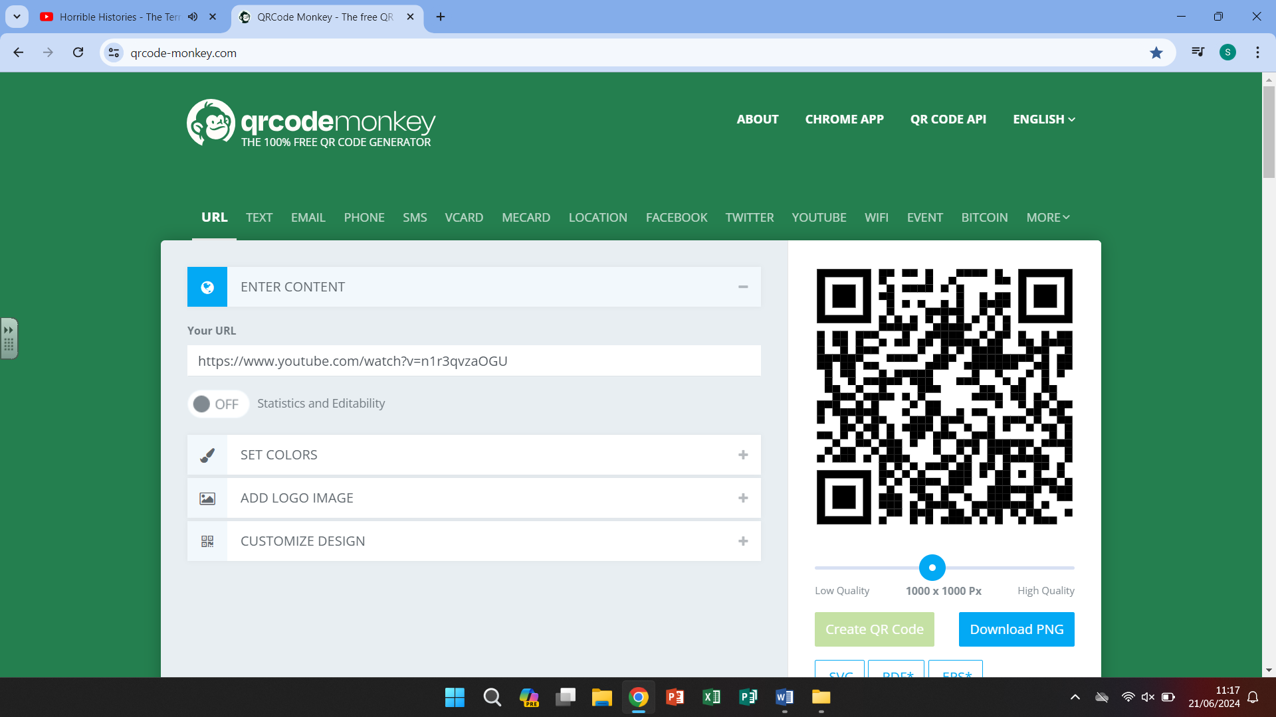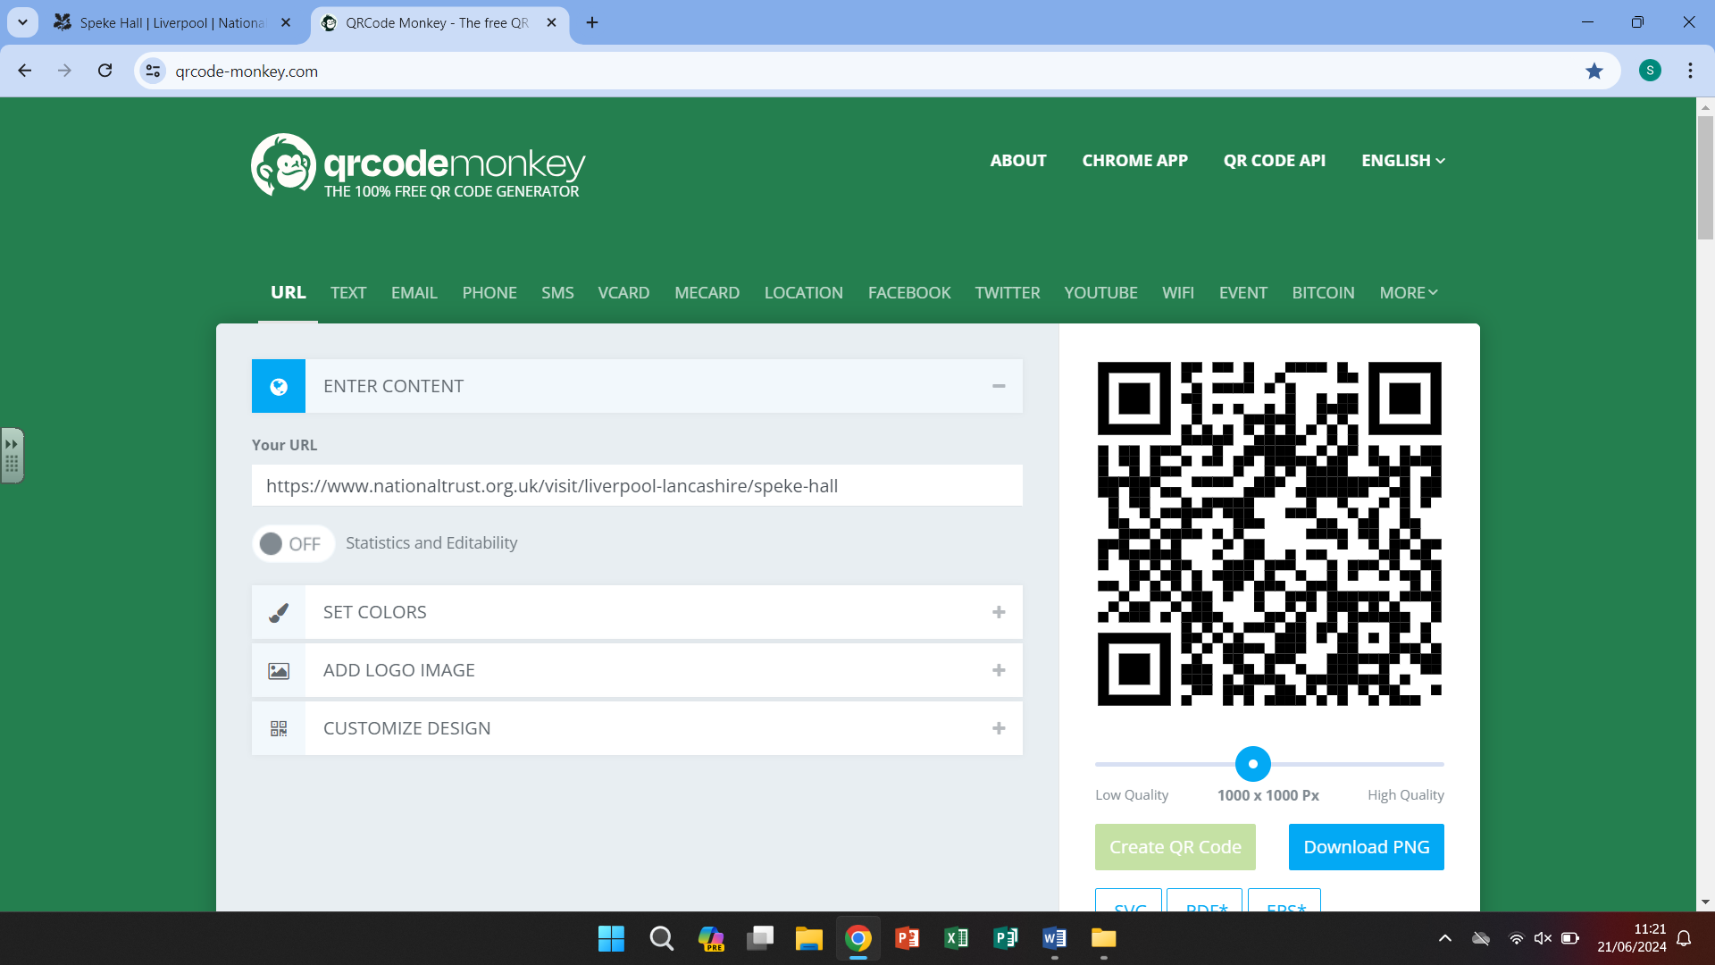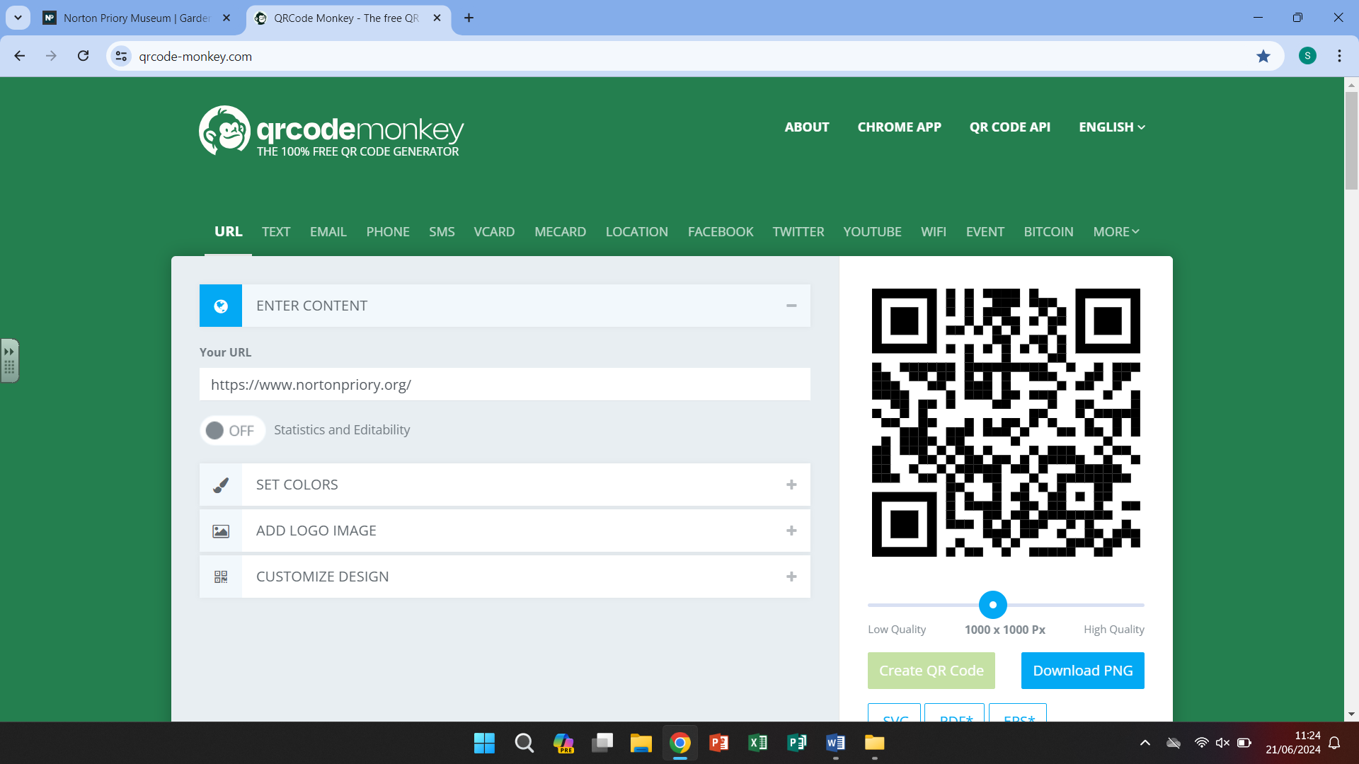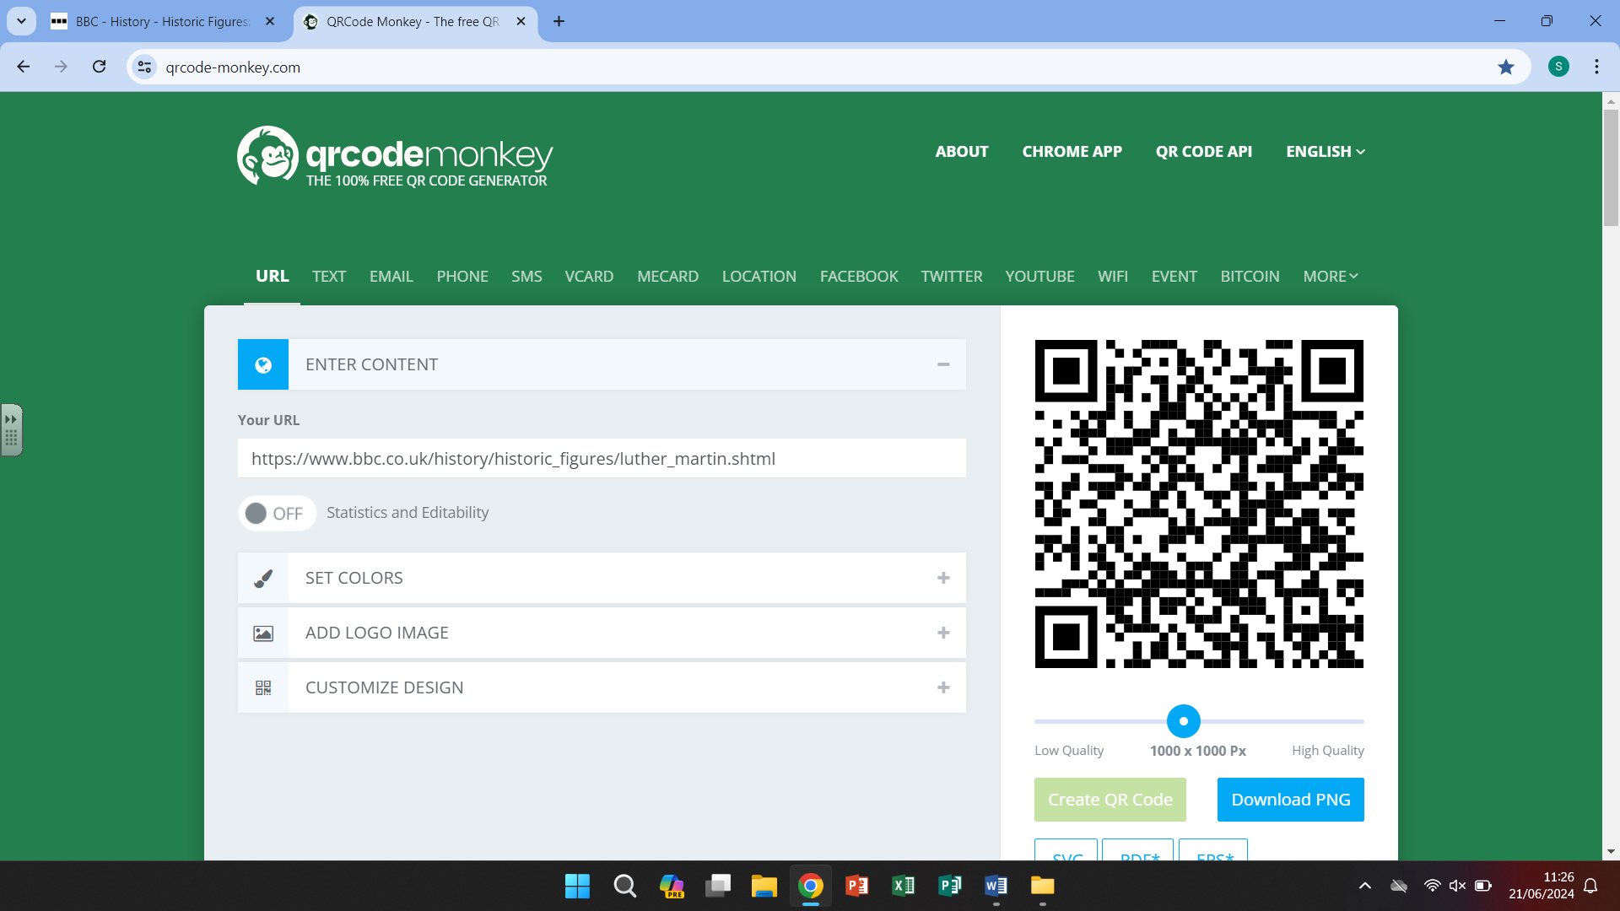

Horrible Histories National Trust Norton Priory Martin Luther

-Speke Hall

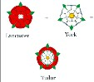

Our curriculum -

The Tudor dynasty began in 1485 when Henry VII won the Battle of Bosworth Field. This began a reign that

would last for 118 years (Henry VII, Henry VIII, Edward VI, Mary I, Elizabeth I). At the start of the Tudor times,

England was a Catholic country. However, events would change and cause religious turmoil for many years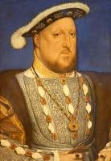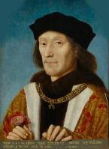.

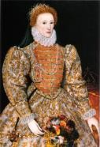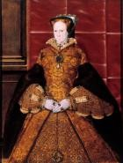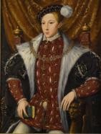

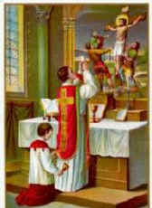

-Henry VIII asks the Pope for an annulment from Catherine of Aragon. He has no heir to his throne.

-The Pope refuses his request.

-Henry begins to break from Rome and creates the Church of England.

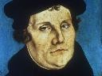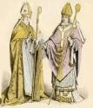

**6.**

-After Henry died, there was many years of religious turmoil.

-Each monarch who ruled next created their own problems but a great dynasty had been created started by Henry VII, then Henry VIII, Edward VI, Mary I and finally Elizabeth I.

**3.**

**5.**

-By 1536 Henry was running out of money.

-He had found his next wife but was still not happy.

-The monasteries had plenty of money and still lots of power. Henry wanted both and so he began ‘The Dissolution of the monasteries’

**2.**

-1517, **Martin Luther** protests against the Catholic Church.

-Henry VIII defends the Catholic Church against Martin Luther’s ideas.

**1.**

-The people of England were beginning to become unhappy with the church and the amount of money it had.

-Breaking with Rome had an impact on everyone living in England during the Tudor times.

-England was a **Catholic** country

-The Roman Catholic Church had **power** over all parts of Tudor society (kings and peasants)

-The **Pope** ruled the church from the Vatican City in Rome, Italy.

**4.**

