
Tudors – Reformation of the Church
Retrieval
British values
Vocabulary threads
Type of History






Religion Conflict Leadership KS1–Fire of London

Religious Political Cultural beliefs power monarchy Y3 - Romans – power
persecution Y4 – Vikings - conflict
Economics
When?
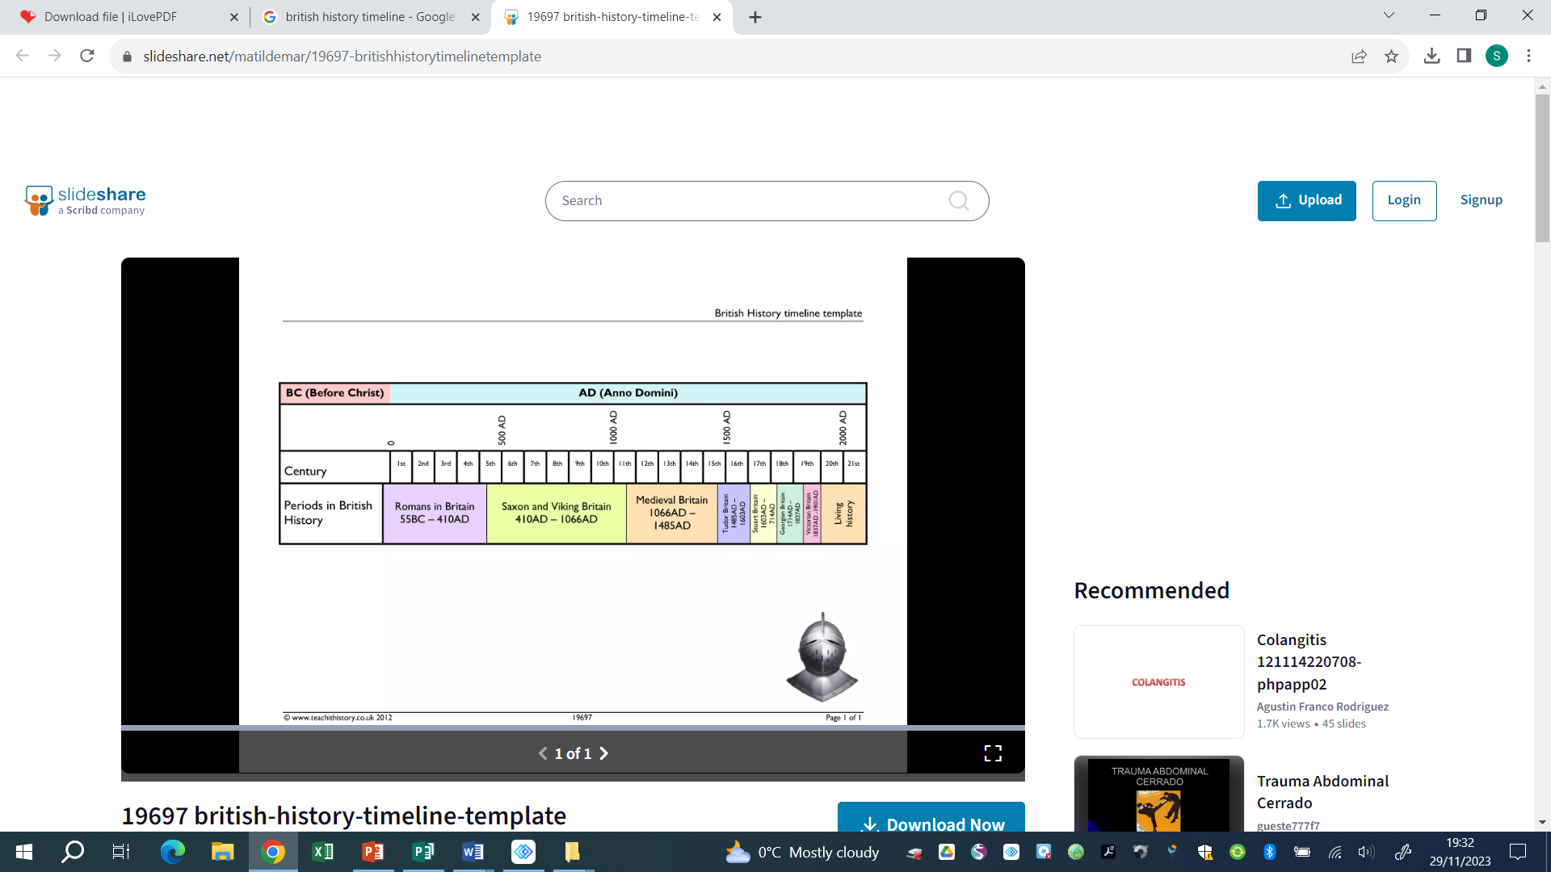


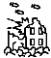

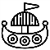

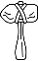



9500- 4000 BCE 2300-800 BCE 800 BCE – 50 CE 43 CE 793 CE 1485 – 1603 CE 1819 – 1901 CE 1939 – 1945 CE
Human occupation of Bronze Age Britain Iron Age Britain Roman Invasion Viking Invasion Tudor Dynasty Victorian England WWII
Britain began (Stone Age) of Britain
Key vocabulary

Catholicism | The traditions and beliefs of the Catholic Church (Christian)
Dissolution | The disbanding of monasteries, convents and priories by Henry VIII
Heir | A person who has the right to receive another person’s property/title after their death
Monarch | A ruler such as a king, queen or emperor
Monastery | A religious building used by a community of monks
Pope | head of the Roman Catholic Church
Protestantism | A Christian religion begun in the 16th century as a protest against the Roman Catholic Church
Reformation | the religious movement of the 16th Century that led to the establishment of the Protestant Church
Helpful links -
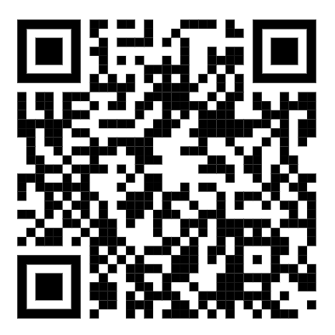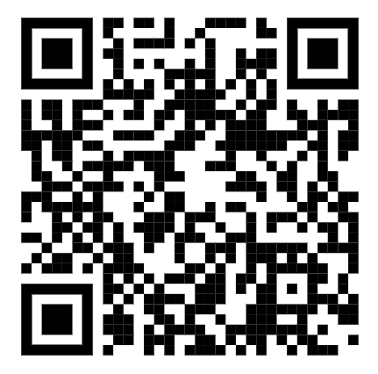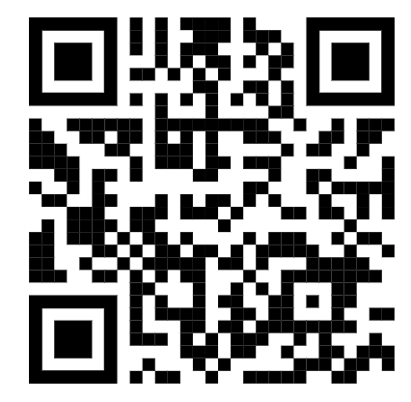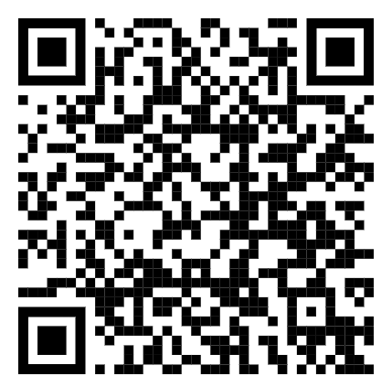
Horrible Histories National Trust Norton Priory Martin Luther
-Speke Hall

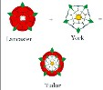
Our curriculum -
The Tudor dynasty began in 1485 when Henry VII won the Battle of Bosworth Field. This began a reign that
would last for 118 years (Henry VII, Henry VIII, Edward VI, Mary I, Elizabeth I). At the start of the Tudor times,
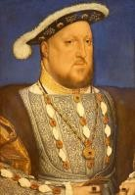
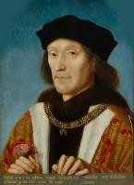
England was a Catholic country. However, events would change and cause religious turmoil for many years.
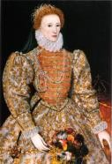
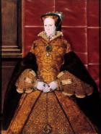
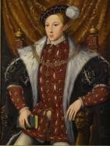

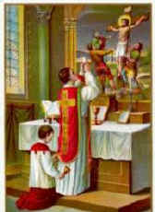
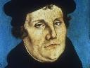
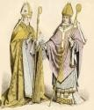
-Henry VIII asks the Pope for an annulment from Catherine of Aragon. He has no heir to his throne.
-The Pope refuses his request.
-Henry begins to break from Rome and creates the Church of England.
6.
-After Henry died, there was many years of religious turmoil.
-Each monarch who ruled next created their own problems but a great dynasty had been created started by Henry VII, then Henry VIII, Edward VI, Mary I and finally Elizabeth I.
3.
5.
-By 1536 Henry was running out of money.
-He had found his next wife but was still not happy.
-The monasteries had plenty of money and still lots of power. Henry wanted both and so he began ‘The Dissolution of the monasteries’
2.
-1517, Martin Luther protests against the Catholic Church.
-Henry VIII defends the Catholic Church against Martin Luther’s ideas.
1.
-The people of England were beginning to become unhappy with the church and the amount of money it had.
-Breaking with Rome had an impact on everyone living in England during the Tudor times.
-England was a Catholic country
-The Roman Catholic Church had power over all parts of Tudor society (kings and peasants)
-The Pope ruled the church from the Vatican City in Rome, Italy.

4.

