

Anglo-Saxons and the Vikings

Retrieval

British values

Vocabulary threads

Type of History



 Religion Conflict Leadership Economy KS1–Castles - settlements

Religious Political Cultural beliefs power monarchy trade Y3 - Romans – power/conflict

invasion kingdom agriculture Y3 – Egyptians - agriculture

Military Economics conquer parliament

When?

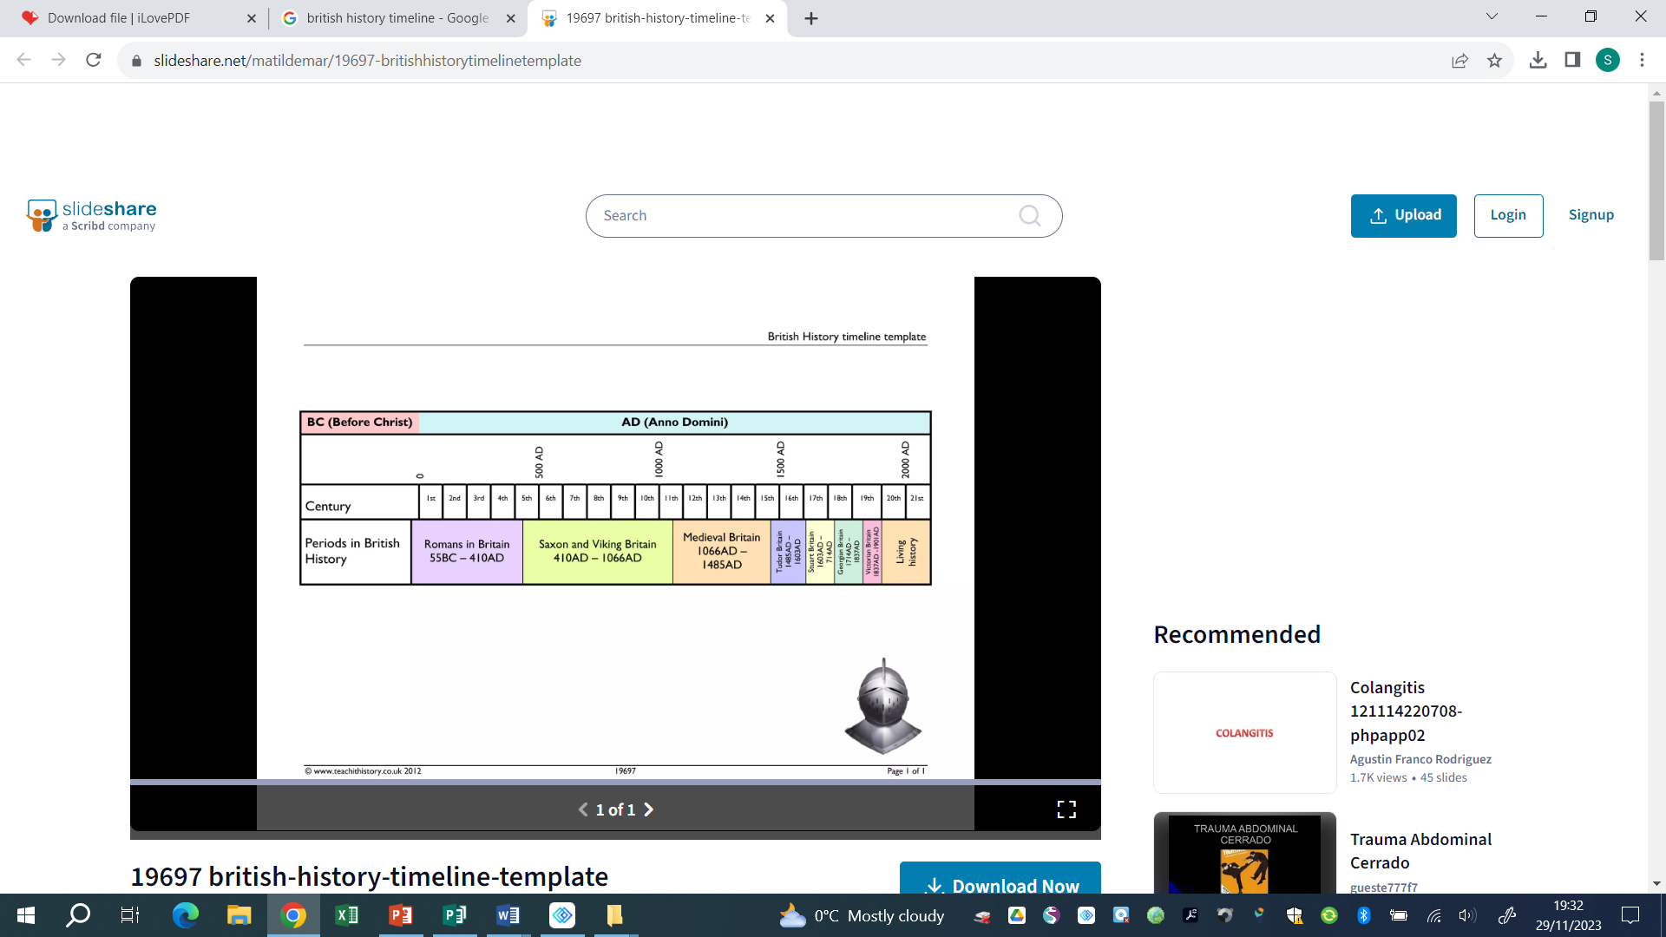

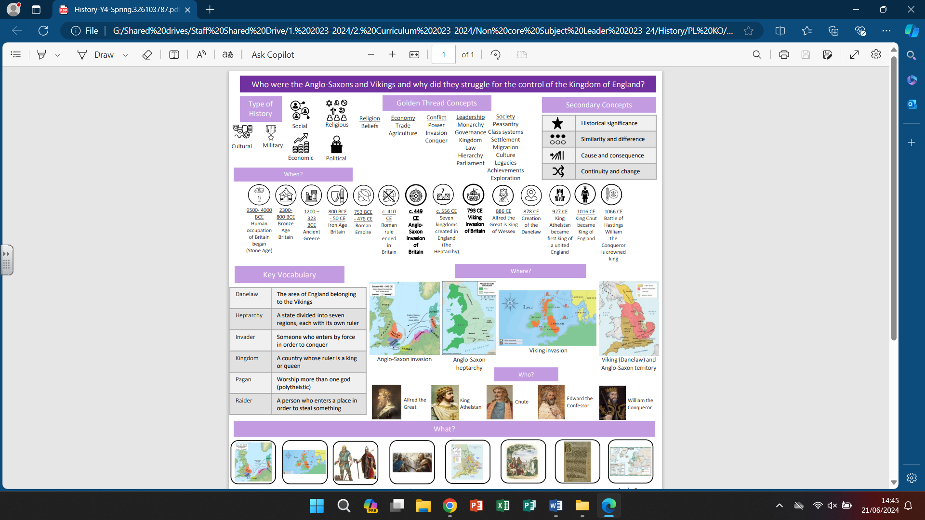



9500- 4000 BCE 2300-800 BCE 800 BCE – 50 CE 43 CE **449CE 793 CE** 1485 – 1603 CE 1819 – 1901 CE 1939 – 1945 CE

Human occupation of Bronze Age Britain Iron Age Britain Roman Invasion **Anglo-Saxon Viking Invasion** Tudor DynastyVictorian England WWII

Britain began (Stone Age) of Britain i**nvasion**

Key vocabulary

|  |  |
| --- | --- |
| Danelaw | The area of England belonging to the Vikings |
| Invader | Someone who enters by force in order to conquer |
| Kingdom | A country whose ruler is a King or a Queen |
| Pagan | Someone who holds a different religion to the main religion of lands |
| Raider | A person who enters with the ntent of stealing something |
| migration | The movement of people from one country of residence to another |
| Settlement | A colony or a small community of people |
| Heptarchy | A state divided into seven regions, each with its own ruler |

Helpful links -

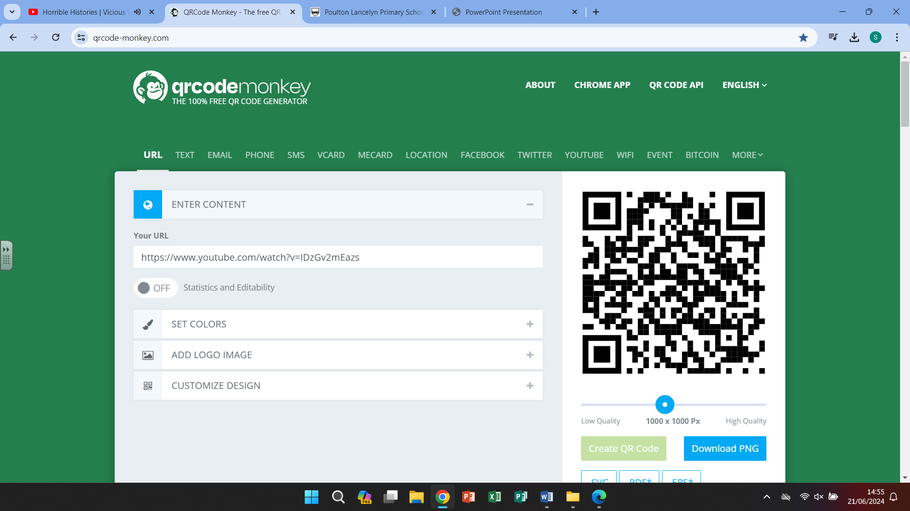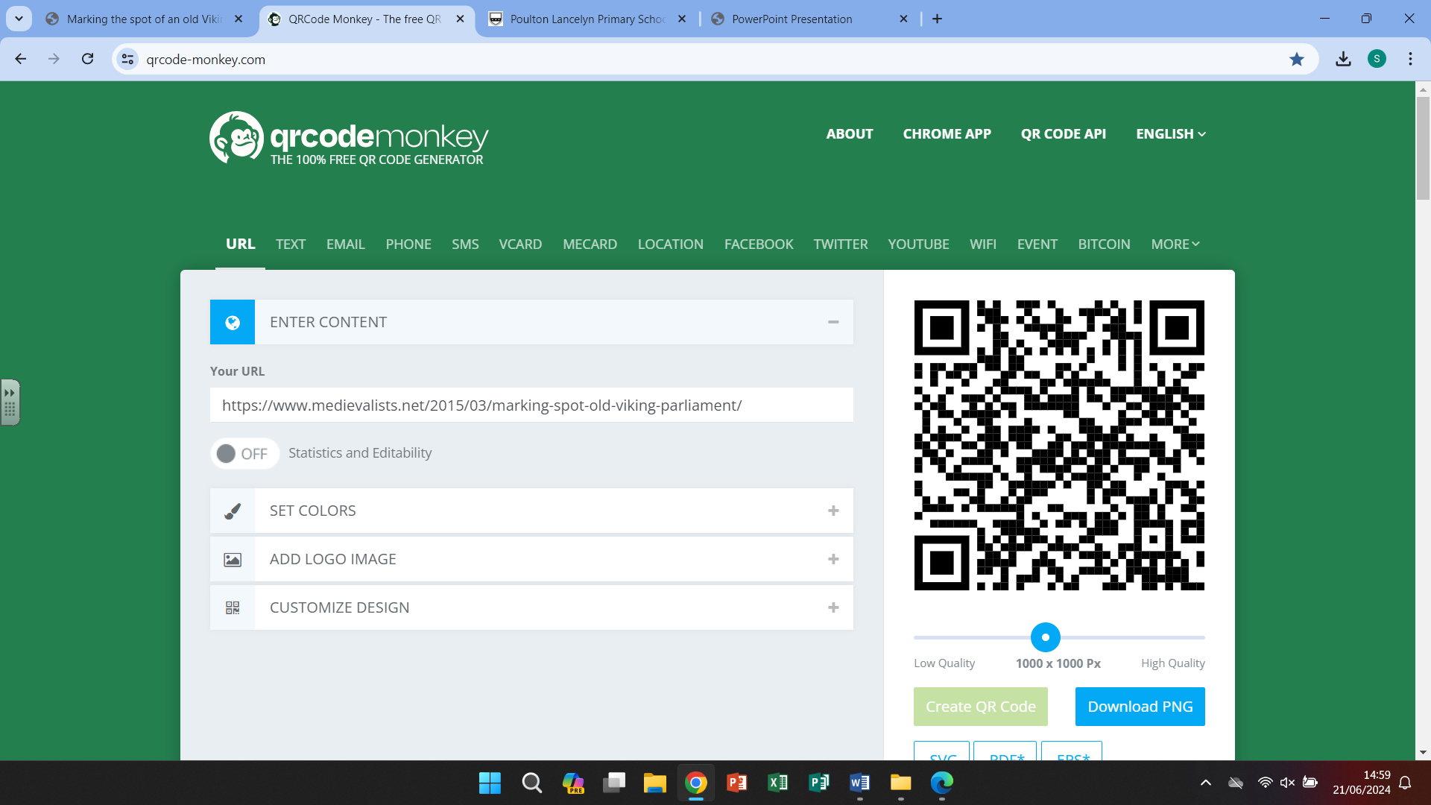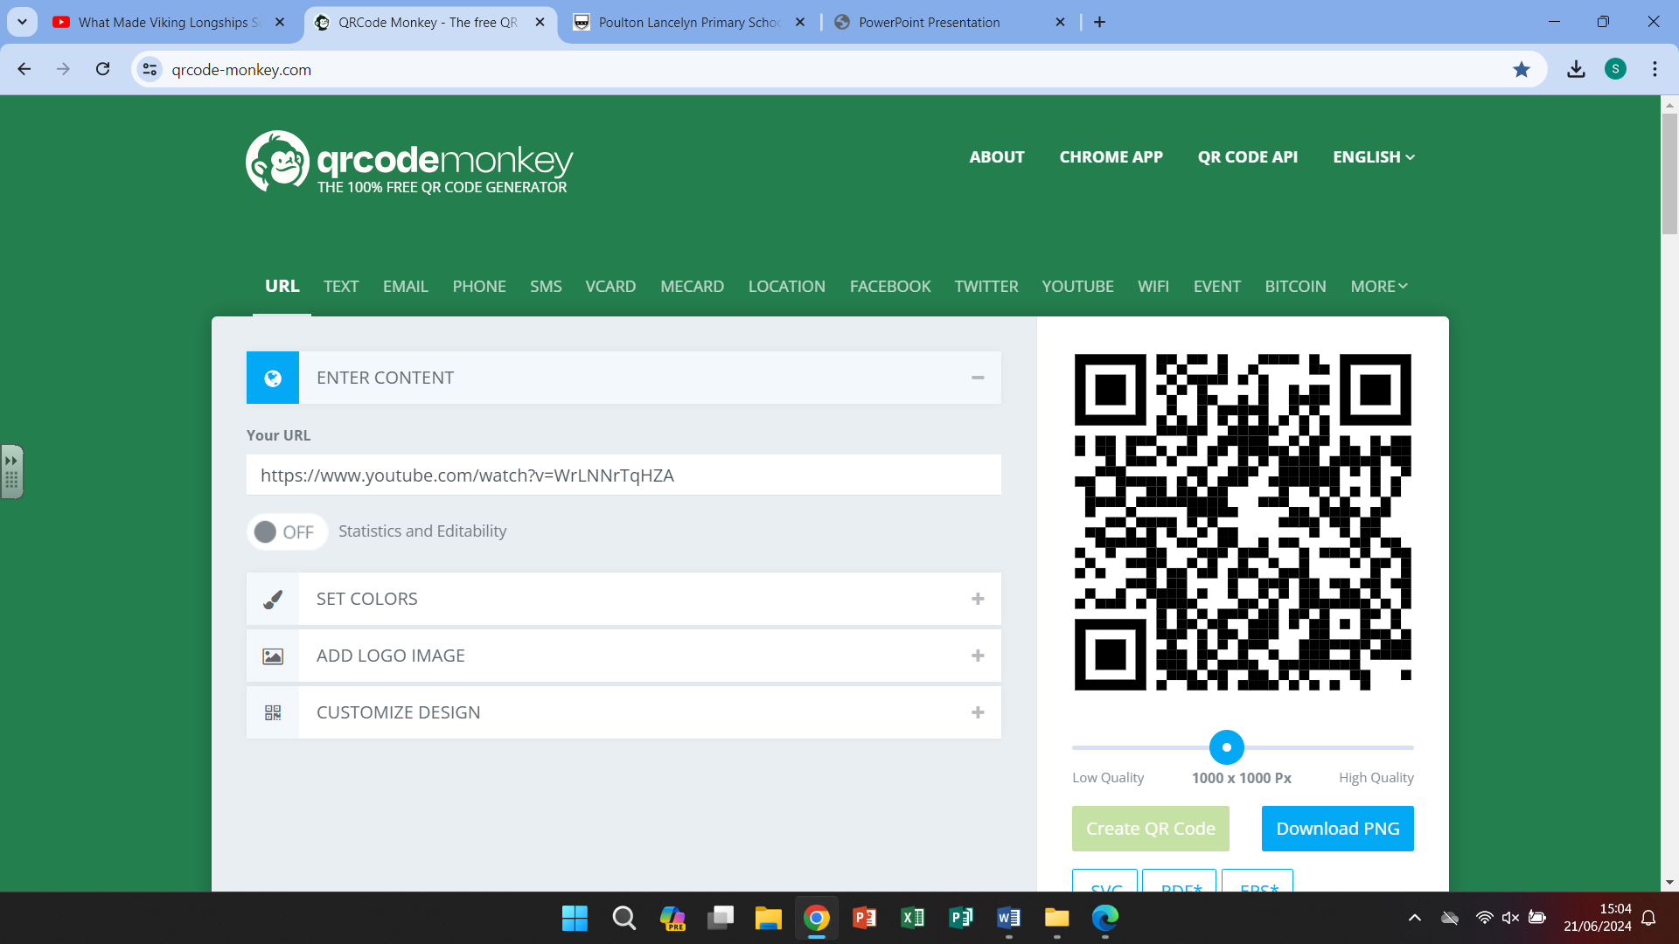

Horrible Histories Parliament on Long ships

Wirral

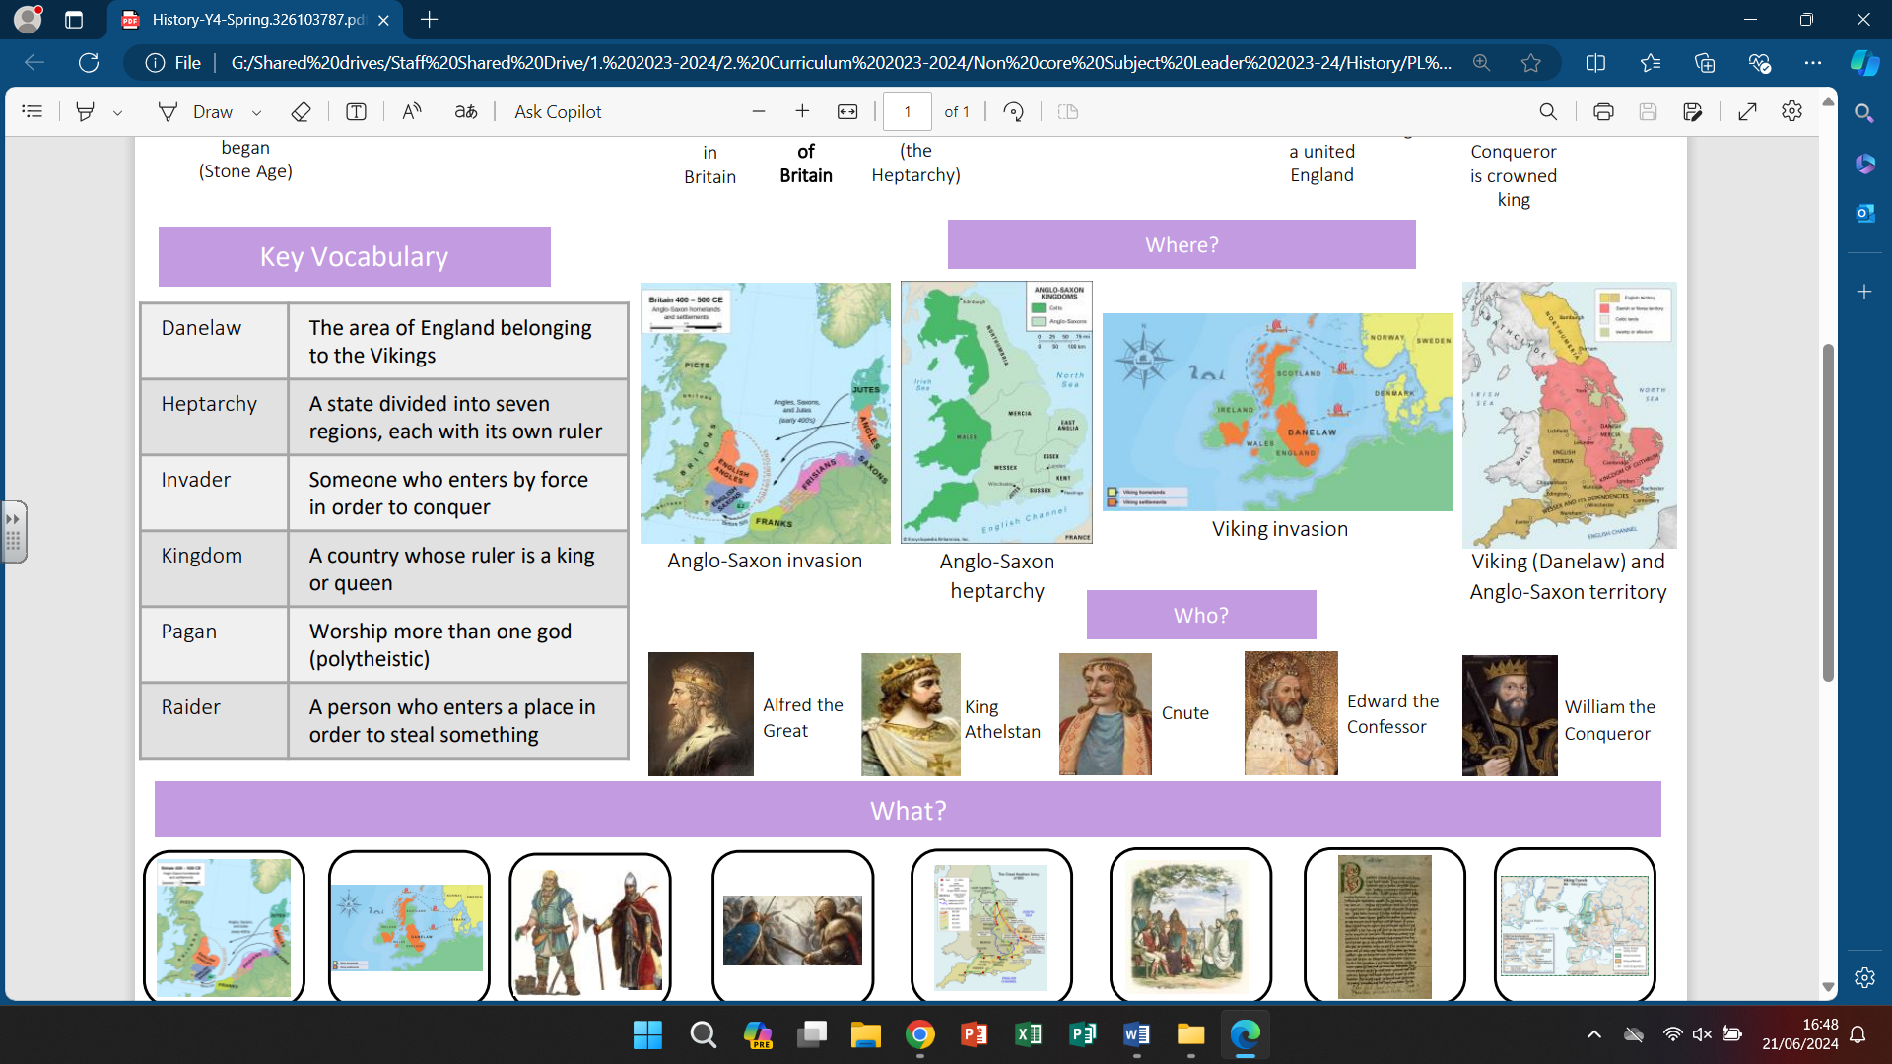

Our curriculum -

The Vikings are often remembered as invaders and raiders, whereas they really struggled to farm on their lands

so travelled and explored to find a better life for their people. They were polytheistic warriors, traders and

craftsmen who built amazing boats and understood the stars to guide them great distances.

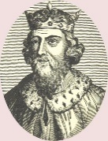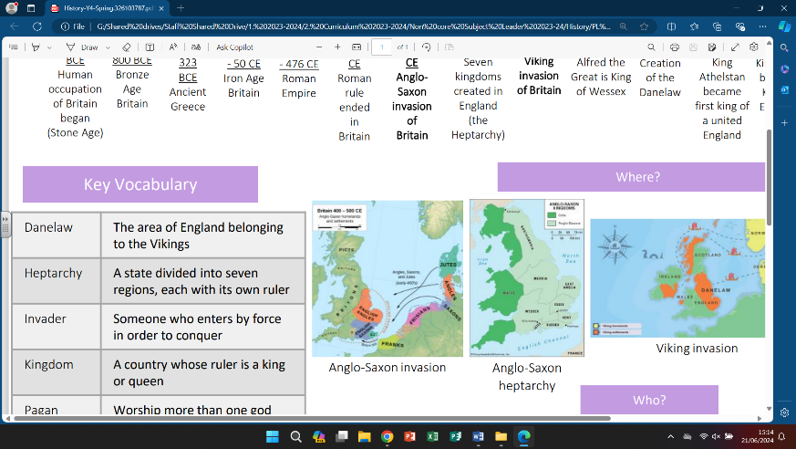

-Not all Vikings came to fight. Many wanted to settle in Briton and become farmers. They made their lives here, built ‘**longhouses**’ and **traded** their goods.

-They had a parliament and held meetings locally to here called a ‘**thing**’

**6.**

-The Vikings shouldn’t be remembered just for their invading and stealing. They were great **explorers** and **craftsmen** too. They **established trade routes**, **invented combs**, had a **system of laws** and the **women** **had more rights** than many other civilizations of the time.

**3.**

**5.**

-After the death of the King in **1066** many noble and regal men thought they had the right to be King.

-There were battles to try to decide – each thinking they had more right than the other.

-Eventually **William** became King of England

**2.**

-The Vikings first **invaded in 793CE**

-They **raided** along the coastline first, often stealing from the wealthy monasteries

-They **settled** locally, establishing a port and a village. Local place names still represent those **Viking invaders**

**1.**

-The battle continued between **King Alfred** and the Viking, everyone wanted to be the ruler.

-The land was split up and ruled by Vikings or Alfred.

-By 1066 there was an invasion by the Normans and the King was killed in the battle

-When the Roman rule ended the Britons found themselves defenceless from attack.

-The Angles and the Saxons **invaded** and Vortigern became King as they settled and made their home in Briton.

**4.**

