
Anglo-Saxons and the Vikings
Retrieval
British values
Vocabulary threads
Type of History





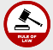
Religion Conflict Leadership Economy KS1–Castles - settlements

Religious Political Cultural beliefs power monarchy trade Y3 - Romans – power/conflict
invasion kingdom agriculture Y3 – Egyptians - agriculture
Military Economics conquer parliament
When?
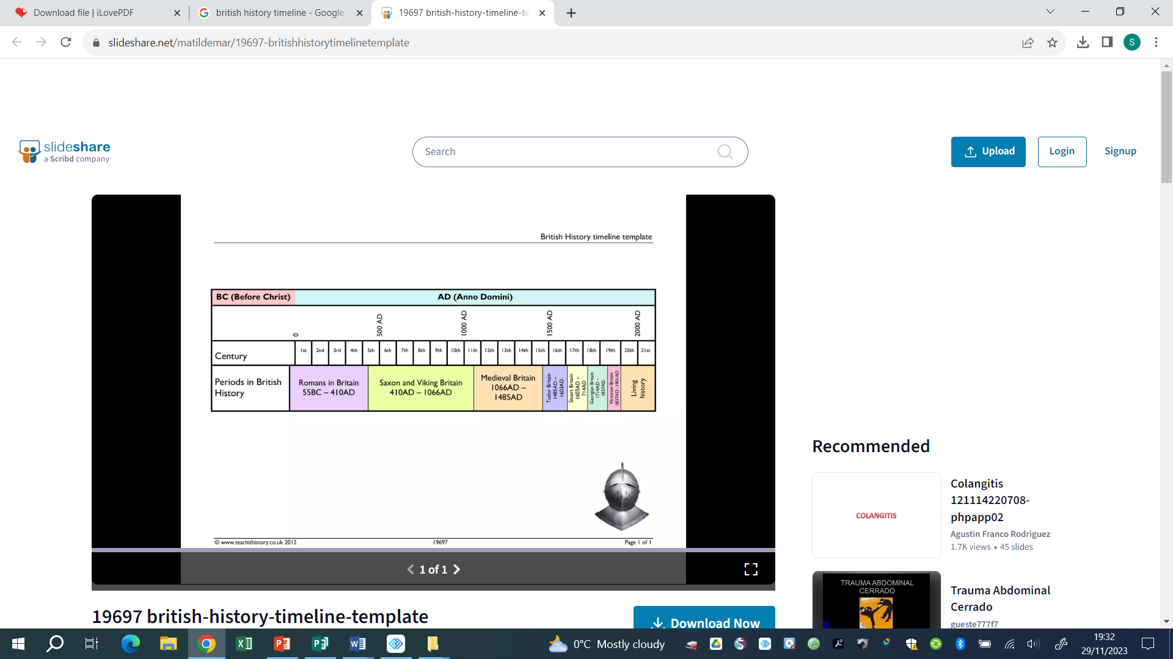

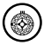
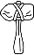
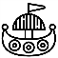


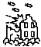




9500- 4000 BCE 2300-800 BCE 800 BCE – 50 CE 43 CE 449CE 793 CE 1485 – 1603 CE 1819 – 1901 CE 1939 – 1945 CE
Human occupation of Bronze Age Britain Iron Age Britain Roman Invasion Anglo-Saxon Viking Invasion Tudor Dynasty Victorian England WWII
Britain began (Stone Age) of Britain invasion
Key vocabulary

Danelaw | The area of England belonging to the Vikings
Invader | Someone who enters by force in order to conquer
Kingdom | A country whose ruler is a King or a Queen
Pagan | Someone who holds a different religion to the main religion of lands
Raider | A person who enters with the ntent of stealing something
migration | The movement of people from one country of residence to another
Settlement | A colony or a small community of people
Heptarchy | A state divided into seven regions, each with its own ruler
Helpful links -
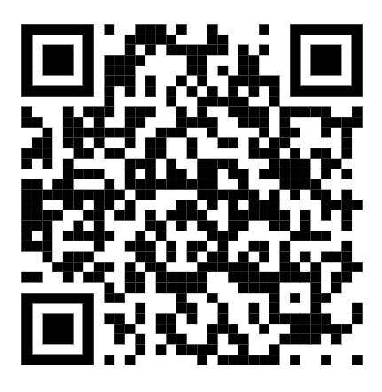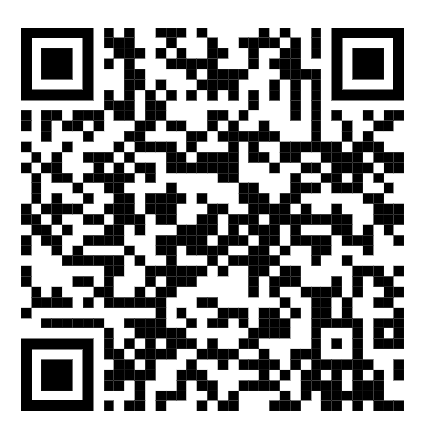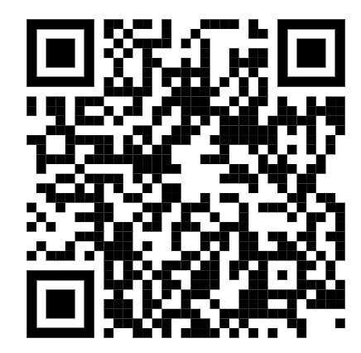
Horrible Histories Parliament on Long ships
Wirral

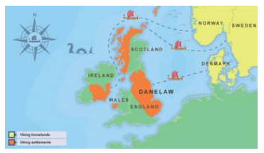
Our curriculum -
The Vikings are often remembered as invaders and raiders, whereas they really struggled to farm on their lands
so travelled and explored to find a better life for their people. They were polytheistic warriors, traders and
craftsmen who built amazing boats and understood the stars to guide them great distances.

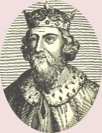
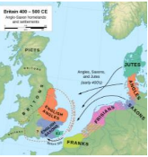
-Not all Vikings came to fight. Many wanted to settle in Briton and become farmers. They made their lives here, built ‘longhouses’ and traded their goods.
-They had a parliament and held meetings locally to here called a ‘thing’

6.
-The Vikings shouldn’t be remembered just for their invading and stealing. They were great explorers and craftsmen too. They established trade routes, invented combs, had a system of laws and the women had more rights than many other civilizations of the time.

3.
5.
-After the death of the King in 1066 many noble and regal men thought they had the right to be King.
-There were battles to try to decide – each thinking they had more right than the other.
-Eventually William became King of England

2.
-The Vikings first invaded in 793CE
-They raided along the coastline first, often stealing from the wealthy monasteries
-They settled locally, establishing a port and a village. Local place names still represent those Viking invaders
1.
-The battle continued between King Alfred and the Viking, everyone wanted to be the ruler.
-The land was split up and ruled by Vikings or Alfred.
-By 1066 there was an invasion by the Normans and the King was killed in the battle
-When the Roman rule ended the Britons found themselves defenceless from attack.
-The Angles and the Saxons invaded and Vortigern became King as they settled and made their home in Briton.

4.

