Retrieval

Type of History

British values

Vocabulary threads

Stone Age to the Iron Age



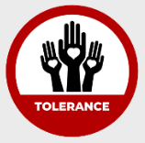 Religion Trade Economy KS1 –

Religious Social Economic beliefs agriculture community -Eastham Woods

When?

settlements -castles

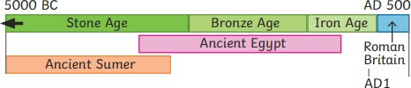



9500- 4000 BCE 2300-800 BCE 800 BCE – 50 CE 43CE 793CE

Human occupation of Bronze Age Britain Iron Age Britain Roman Invasion Viking Invasion

Britain began (Stone Age) of Britain

Key vocabulary

|  |  |
| --- | --- |
| Agriculture | Producing crops and raising livestock; farming. |
| Archaeology | The study of material remains (such as tools, pottery and jewellery) of past human life and activities. |
| Hill fort | A hill fort is a defended settlement. They became more common in the Iron Age. A hill fort could be home to hundreds of people. |
| Hunter gatherer | A hunter-gatherer is a person who lives in a society where food is collected by hunting wild animals or by searching for wild, edible plants. |
| Neolithic revolution | A gradual change from nomadic hunting and gathering communities to agriculture and settlement. |
| Nomadic | Nomadic people (or nomads) are people who move from one place to another, instead of living in one place. |
| Trade | Trade is the. buying and selling of goods and services. People began to trade surplus farming goods. |
| Tribe | A tribe is a social group made up of many families, clans, or generations that share the same language, customs, and beliefs. |

Helpful links -

QR codes

Horrible Histories Prehistoric Merseyside Stonehenge Skara Brae

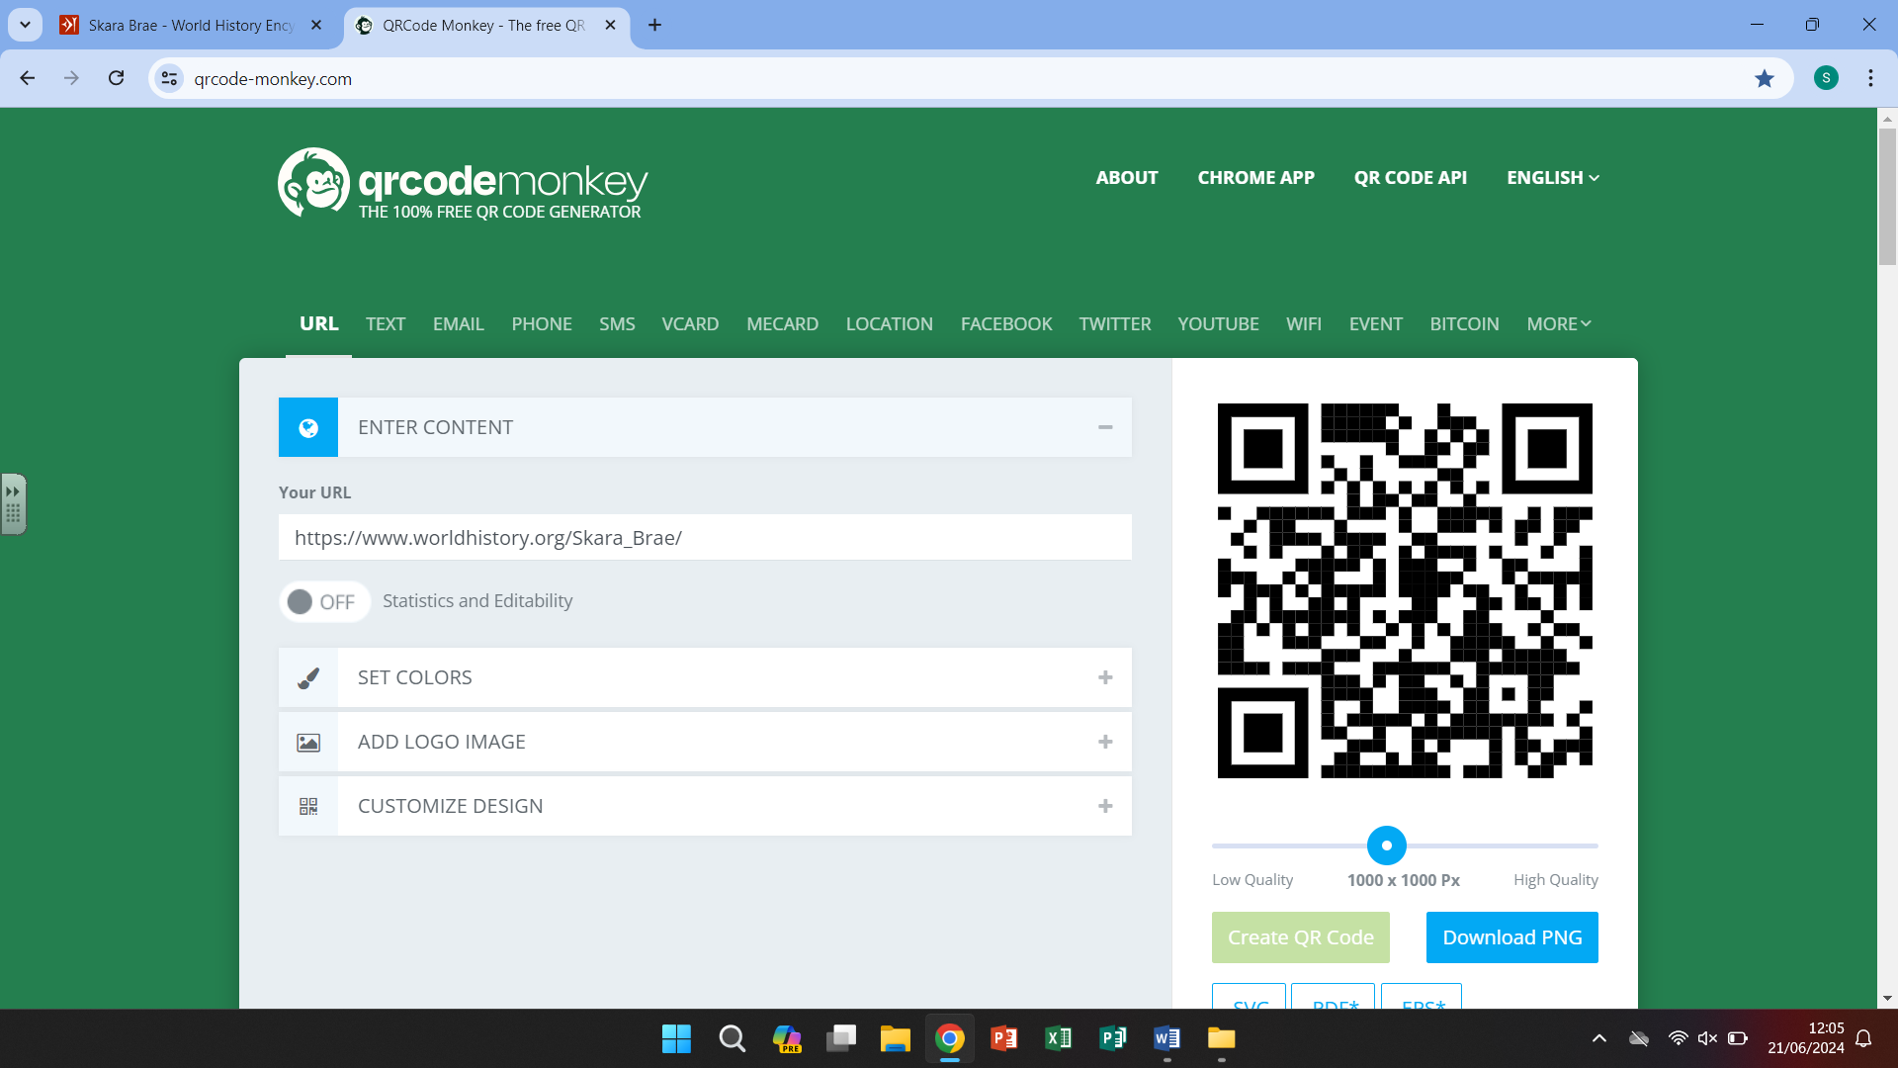

Our curriculum -

Prehistory is the time before written records existed. It is split into Stone Age, Bronze Age and Iron Age. Stone Age



people started farming and eventually became traders. Archaeologists have discovered evidence that shows basic stone

tools developed into metal tools that produced intricate jewellery and weapons.

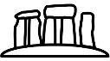

**6.**

-**Skara Brae** – a well preserved prehistory settlement in Scotland demonstrating how people lived then.

-examples of how the dwellings of Stone Age people moved from their **nomadic tribes** to building more permanent **shelters.**

-The discovery of **bronze** and how that impacted on daily life – new items that could now be made better and stronger and the impact that had on families, **settlements and trade.**

-how life changed even further with the discovery of **Iron** for the families and the wider world.

**3.**

**5.**

-introduce and use the terms **primary** (evidence from the time period) and **secondary sourc**es (evidence such as text books, internet websites)

-**Otzi the Ice** **Man** and **Cheddar Gorge Man** – bodies found from prehistory. Used by historians to influence or change what we know about these times.



**2.**

-**Stone Age people** had an everyday routine including – **farming, hunting, religion and homes.**

-recognising the similarities between Stone Age times and now by looking at **artefacts** and their uses (jewellery, flints etc)



**4.**



**1.**

-**Stone Age artefacts** such as knives and combs have been discovered, leading historians to believe stone age people lived in family groups.

-**weapons** and **tools** used throughout the Stone prove that as knowledge/technology improve the people changed and adapted.

-**prehistory** is split into **Stone Age**, **Bronze** **Age** and **Iron Age.**

-the Stone Age covers a vast period and is further split down into **Palaeolithic**, **Mesolithic** and **Neolithic**.