Retrieval
Type of History
British values
Vocabulary threads
Stone Age to the Iron Age




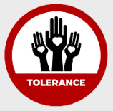

Religion Trade Economy KS1 –
Religious Social Economic beliefs agriculture community -Eastham Woods
When?
settlements -castles
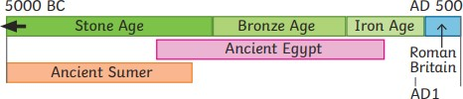







9500- 4000 BCE 2300-800 BCE 800 BCE – 50 CE 43CE 793CE
Human occupation of Bronze Age Britain Iron Age Britain Roman Invasion Viking Invasion
Britain began (Stone Age) of Britain
Key vocabulary

Agriculture | Producing crops and raising livestock; farming.
Archaeology | The study of material remains (such as tools, pottery and jewellery) of past human life and activities.
Hill fort | A hill fort is a defended settlement. They became more common in the Iron Age. A hill fort could be home to hundreds of people.
Hunter gatherer | A hunter-gatherer is a person who lives in a society where food is collected by hunting wild animals or by searching for wild, edible plants.
Neolithic revolution | A gradual change from nomadic hunting and gathering communities to agriculture and settlement.
Nomadic | Nomadic people (or nomads) are people who move from one place to another, instead of living in one place.
Trade | Trade is the. buying and selling of goods and services. People began to trade surplus farming goods.
Tribe | A tribe is a social group made up of many families, clans, or generations that share the same language, customs, and beliefs.
Helpful links -

QR codes

Horrible Histories Prehistoric Merseyside Stonehenge Skara Brae
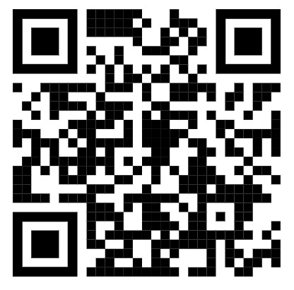




Our curriculum -


Prehistory is the time before written records existed. It is split into Stone Age, Bronze Age and Iron Age. Stone Age
people started farming and eventually became traders. Archaeologists have discovered evidence that shows basic stone
tools developed into metal tools that produced intricate jewellery and weapons.

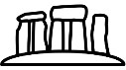










6.
-Skara Brae – a well preserved prehistory settlement in Scotland demonstrating how people lived then.
-examples of how the dwellings of Stone Age people moved from their nomadic tribes to building more permanent shelters.
-The discovery of bronze and how that impacted on daily life – new items that could now be made better and stronger and the impact that had on families, settlements and trade.
-how life changed even further with the discovery of Iron for the families and the wider world.
3.
5.
-introduce and use the terms primary (evidence from the time period) and secondary sources (evidence such as text books, internet websites)
-Otzi the Ice Man and Cheddar Gorge Man – bodies found from prehistory. Used by historians to influence or change what we know about these times.
2.
-Stone Age people had an everyday routine including – farming, hunting, religion and homes.
-recognising the similarities between Stone Age times and now by looking at artefacts and their uses (jewellery, flints etc)
4.
1.
-Stone Age artefacts such as knives and combs have been discovered, leading historians to believe stone age people lived in family groups.
-weapons and tools used throughout the Stone prove that as knowledge/technology improve the people changed and adapted.
-prehistory is split into Stone Age, Bronze Age and Iron Age.
-the Stone Age covers a vast period and is further split down into Palaeolithic, Mesolithic and Neolithic.

