Mental Health Support Team (MHST)

Brackenwood Junior School work in partnership with the Wirral Mental Health Support Team (MHST). This is a service designed to help meet the mental health needs of children and young people in education settings.
They are made up of Children and Young People’s Mental Health Practitioners and Education Mental Health Practitioners (EMHPs).
The service has three core functions:
- To deliver brief evidence-based interventions to support children with mild-moderate mental health problems.
- To support schools in developing their whole school approach to mental health.
- To provide timely advice to school staff and liaison with external services, to help children and young people to get the right help and stay in education.
The team will offer assessments and interventions for a range of mental health needs that may be less complex or may be managed by time-limited interventions. For example, children and young people who demonstrate anxiety, low mood and behavioural difficulties which do not meet the diagnostic threshold for specialist clinical support. Interventions will promote resilience and support children and young people to develop the skills and techniques to manage their emotions. These will be delivered through a range of workshops,individual work and groups for parents/carers as well as through whole class room activities depending on the assessed needs.
To access this service, please discuss your concerns with the school, we will then be able to consult with our team to discuss what level of support would best meet your needs.
Here is our Education Mental Health Practitioner (EMHP) Lesley Forber.
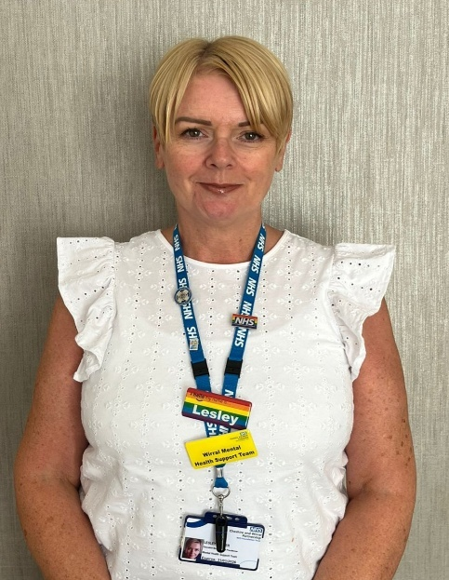
The video below provides more information about the MHST and the services they provide.
https://youtu.be/U588pW_oObI

