By

Year 6 - Families and relationships

|  |  |  |  |
| --- | --- | --- | --- |
|  | | | |
| Earn | To gain something like respect by showing others that you are a good, trustworthy person. |  | Resolve  To find a solution to a problem. |
| Authority | A person with high status and decision-making power |  | A view or idea about something, often someone, which is often untrue.  Stereotype |
|  | A disagreement or argument.  Conflict | Respect  Being thoughtful and polite towards other people. |  |
| Grieving | A period of sadness that someone experiences when someone close to them dies. |  |  |



What are we learning?

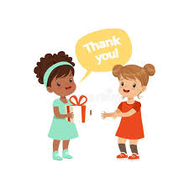

Respectful Relationships

* To know practical steps you can take in a range of different contexts to improve or support respectful relationships

Respect

* That in school and in wider society you can expect to be treated with respect by others, and that in turn they should show due respect to others, including those in positions of authority.

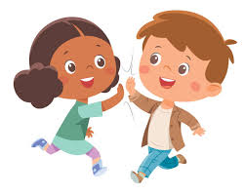

Stereotypes – Attitudes

* What a stereotype is, and how stereotypes can be unfair, negative or destructive.

Challenging Stereotypes

* What a stereotype is, and how stereotypes can be unfair, negative or destructive

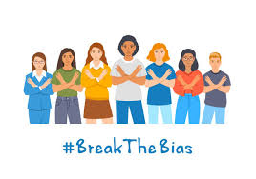

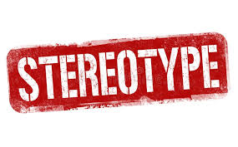

Change and Loss

* How to recognise if family relationships are making you feel unhappy or unsafe, and how to seek help or advice from others if needed.
* That there is a normal range of emotions (e.g. happiness, sadness, anger, fear, surprise, nervousness) and scale of emotions that all humans experience in relation to different experiences and situations.
* How to recognise and talk about your emotions, including having a varied vocabulary of words to use when talking about you own and others’ feelings.

Resolving Conflict

* To know that most friendships have ups and downs, and that these can often be worked through so that the friendship is repaired or even strengthened, and that resorting to violence is never right.

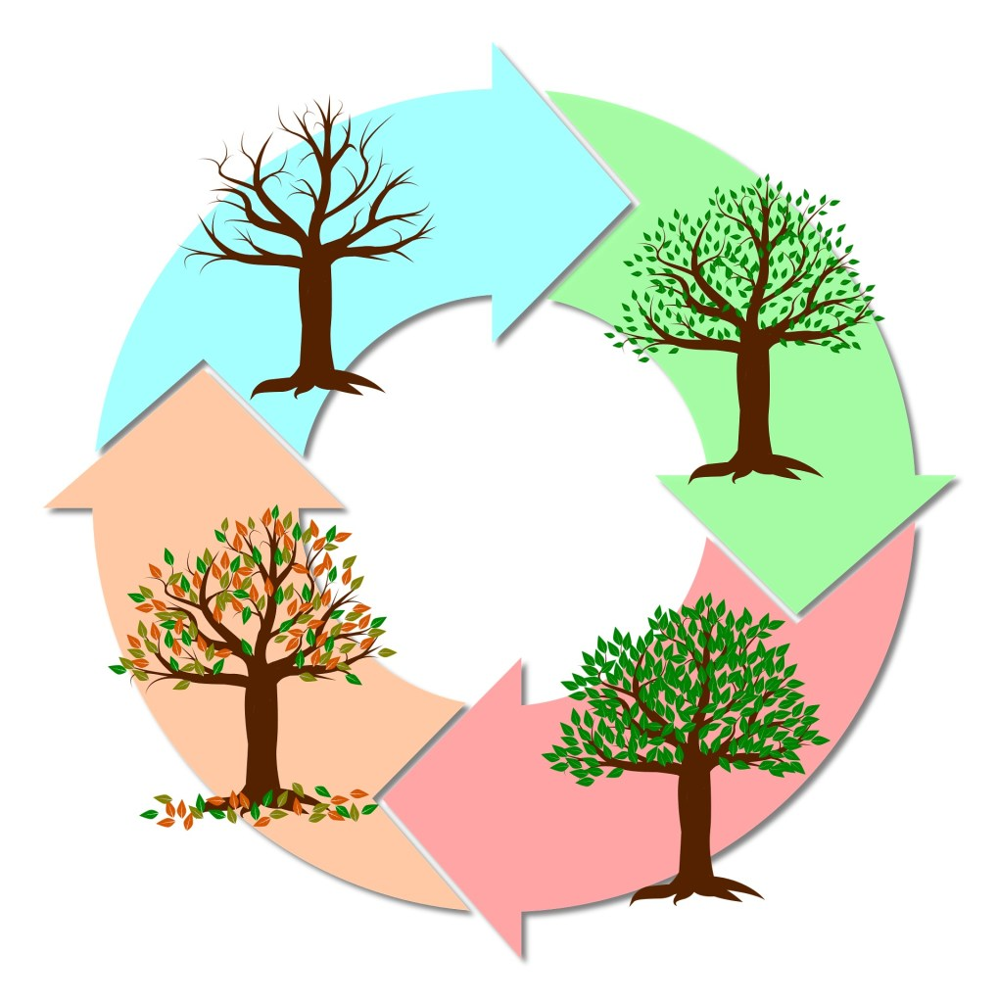



Childline Website



Childline Website

BBC Bitesize Relationships Video

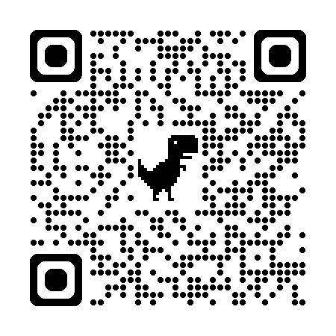

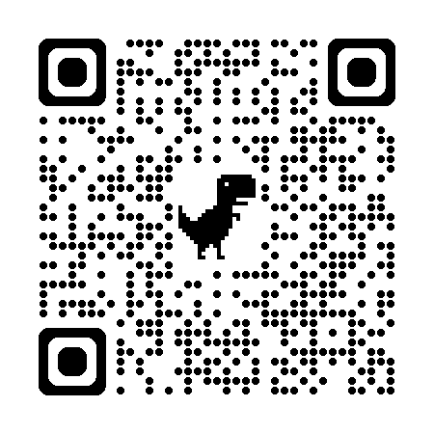

Helpful links

Year 5 Families and Relationships