By

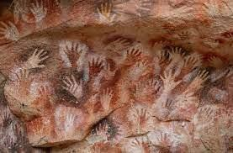

Drawing and Painting

Artist- Sandra Silberzweig and Picassod Picasso

Family and relationships

|  |  |  |  |
| --- | --- | --- | --- |
|  | | | |
| Attributes | Qualities or characteristics that make up someone's personality. |  | Marriage  The legal commitment of two people to each other which is intended to be lifelong. |
| Bullying  Bystander | To cause repeated physical or emotional pain to somebody. | Secret | Something which is not meant to be known or seen by anyone.  The ceremony which celebrates the marriage of two people. |
|  | Someone who watches something happening without getting involved. | Wedding |  |
| Cyberbullying | Bullying that occurs through the internet |  |  |

* What are we learning?

What are we learning?

* Friendships are important for making us feel happy and secure, and how people choose and make friends
* Friendships have ups and downs.
* Friendships can sometimes be strengthened after an issue has occurred.
* Characteristics of friendships, include: mutual respect, truthfulness, trustworthiness, loyalty, kindness, generosity, trust, sharing interests and experiences and support with problems.



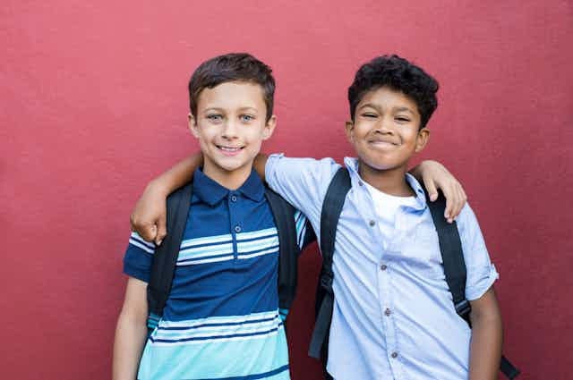

* Marriage is a legal commitment.
* Marriage is an individual choice.
* Marriage represents a formal and legally recognised commitment of two people to each other which is intended to be lifelong.
* Self-talk is the way you talk to yourself or your inner voice.
* Self-care refers to how you care for yourself.
* Being aware of your own boundaries – the invisible line that defines what you think is acceptable or not – is really important, because then you are in a position to communicate those boundaries to others.
* Recognise your own achievements and strength.





* Recognise if family relationships are making you feel unhappy or unsafe, and seek help or advice from others if needed.
* If you are worried about anything in their own family they can talk to someone in school.
* Bullying is intentional behavior that hurts someone else repeatedly.
* The different types of bullying are: physical, emotional and cyber bullying.
* Bullying be by one person or a group of people.
* Bullying can be done face to face or online.
* It is the responsibilities of bystanders (primarily reporting bullying to an adult) and seek help if you have experienced or currently experiencing bullying.

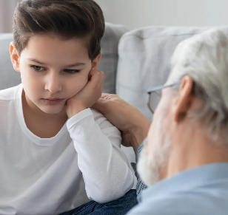

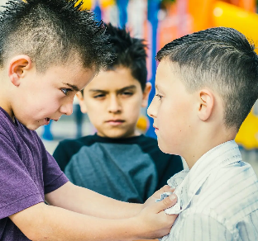

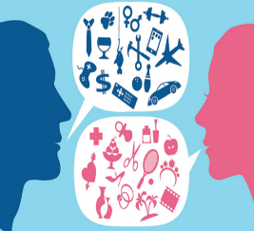

* Stereotypes are present in everyday life.
* Stereotypes can be unfair, negative or destructive.
* The Equality Act 2010 lays out protected characteristics. This means that some characteristics, including sex (but also age, disability, race, religion) are protected by law and it is therefore illegal to discriminate against someone because of one of these characteristics.

Childline Support

* We make assumptions about people based on how they look.
* Stereotypes around race and religion can be harmful.
* Stereotypes can affect the way people are treated and can lead to discrimination.

Knowledge of family and relationships

Helpful links

Scan to complete your Quiz

Anti-bullying Alliance Support