By

Year 4 - Families and relationships

|  |  |  |  |
| --- | --- | --- | --- |
|  | | | |
| Act of kindness | Doing something nice for someone. |  | Bystander  Someone who watches something happening without getting involved. |
| Authority | A person with high status and decision-making power |  | A way of behaving that shows respect for other people.  Manners |
|  | Mourning or grieving somebody who has died.  Bereavement | Permission  Allowing someone to do something once they have asked first. |  |
| Bullying | To cause repeated physical or emotional pain to somebody. | Respect | Being thoughtful and polite towards other people. |
| Stereotype | A view or idea about something, often someone, which is often untrue.  What are we learning? |  |  |

* What are we learning?

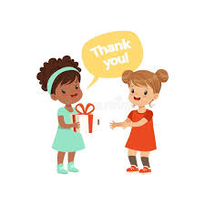

Healthy Relationships

* That healthy friendships are positive and welcoming towards others, and do not make others feel lonely or excluded.
* The importance of permission-seeking and giving in relationships with friends, peers and adults.
* What sorts of boundaries are appropriate in friendships with peers and others (including in a digital context).

Respect and Manners

* That in school and in wider society you can expect to be treated with respect by others, and that in turn you should show due respect to others, including those in positions of authority
* The conventions of courtesy and manners

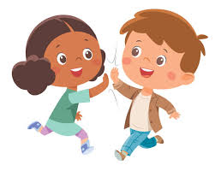

How My Behaviour Affects Others

* Caring friendships > You should know the characteristics of friendships, including mutual respect, truthfulness, trustworthiness, loyalty, kindness, generosity, trust, sharing interests and experiences and support with problems and difficulties.
* Families and people who care for me > You should know the characteristics of healthy family life, commitment to each other, including in times of difficulty, protection and care for children and other family members, the importance of spending time together and sharing each other’s lives.



Bullying

* Respectful relationships > You should know about different types of bullying (including cyberbullying), the impact of bullying, responsibilities of bystanders (primarily reporting bullying to an adult) and how to get help.

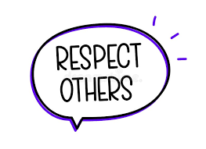

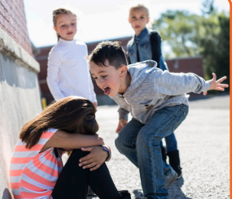

Stereotypes - gender

* What a stereotype is, and how stereotypes can be unfair, negative or destructive

Stereotypes – disability

* What a stereotype is, and how stereotypes can be unfair, negative or destructive

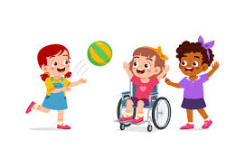

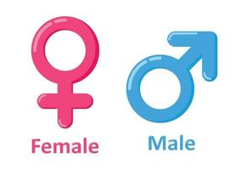

Childline Website

Families in the wider world

* That others’ families, either in school or in the wider world, sometimes look different from your family, but that you should respect those differences and know that other children’s families are also characterised by love and care.
* The importance of respecting others, even when you are very different from them (for example, physically, in character, personality or backgrounds), or make different choices or have different preferences or beliefs.

Change and Loss

* How to recognise if family relationships are making them feel unhappy or unsafe, and how to seek help or advice from others if needed.
* That there is a normal range of emotions (e.g. happiness, sadness, anger, fear, surprise, nervousness) and scale of emotions that all humans experience in relation to different experiences and situations.

How to recognise and talk about their emotions, including having a varied vocabulary of words to use when talking about their own and others’ feelings.

     

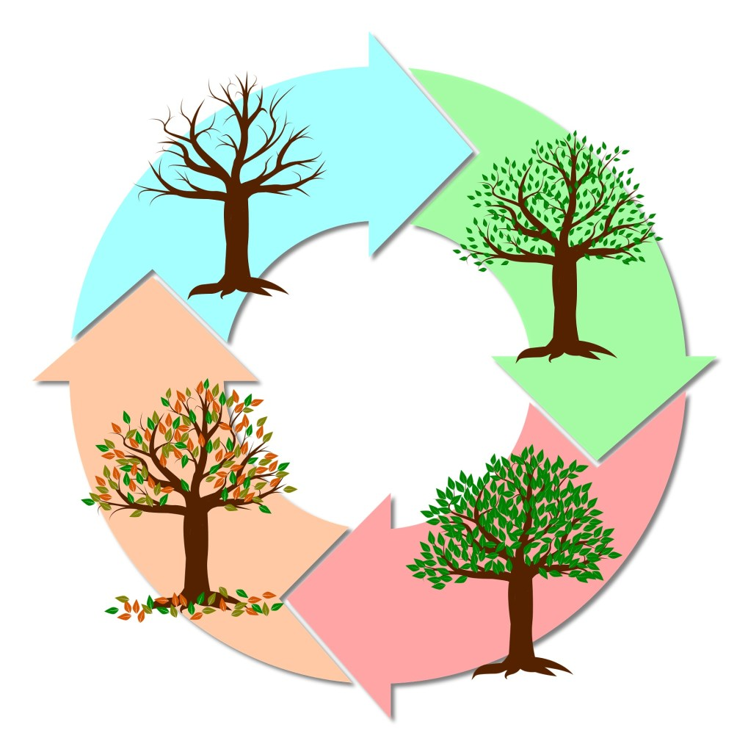

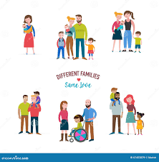



Anti-Bullying Alliance

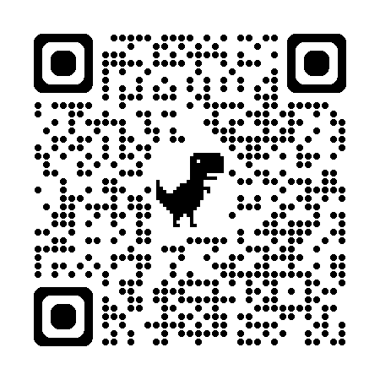

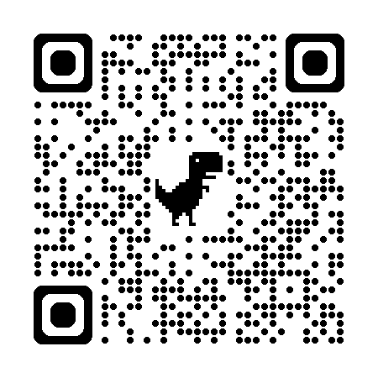

Helpful links

Year 3 Families and Relationships