By

Family and relationships



Drawing and Painting

Artist- Sandra Silberzweig and Picassod Picasso

|  |  |  |  |
| --- | --- | --- | --- |
|  | | | |
| Bullying | To cause repeated physical or emotional pain to somebody. |  | Something that is nearly the same as another thing.  Similar |
| Communicate  Empathy | To interact with other people through words or body language. | Stereotype | A view or idea about something, often someone, which is often untrue.  Feeling sad for someone when something bad happens to them. |
|  | To be considerate and understanding of other people's feelings. | Sympathy |  |
| Open  Questions | Questions that do not have simple one-word answers. | Trust | Relying on someone to do something for you, such as keeping a secret or keeping something safe for you. |

* What are we learning?

What are we learning?



* Understand that friendships have ups and downs and that problems can be resolved.
* Most friendships can often be worked through so friendship is repaired or even strengthened.
* Violence is never the right choice to resolve conflicts.
* To raise problems with friends by telling them how you feel and talk through the problem.
* Talk to an adult if someone’s behavior is making you feel uncomfortable or puts anyone at risk.
* Families love and support each other but sometimes problems can occur and help is available if needed.
* Families sometimes look different from your family but should be respected for their differences.
* Stable, caring relationships are the heart of happy families.
* Seek help or advice from others if family relationships are making you feel unhappy or unsafe.



* Bullying is intentional behavior that hurts someone else repeatedly.
* The different types of bullying are: physical, emotional and cyber bullying.
* Bullying be by one person or a group of people.
* Bullying can be done face to face or online.
* It is the responsibilities of bystanders (primarily reporting bullying to an adult) and seek help if you have experienced or currently experiencing bullying.
* Listen and communicate effectively.
* To listen and show that you are listening by giving eye contact, nodding, asking questions about what is being said and not doing other tasks at the same time.
* Understanding that there are different ways to communicate.

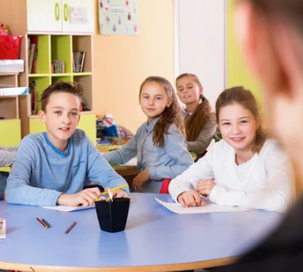



* Trust is an important part of positive relationships.
* Trust a friend and/or a trusted adult to talk to about problems or concerns.
* If trust is broken, talk to the person about it, accept an apology if appropriate and/or talk to a trusted adult.
* Understanding the differences between people and why it is important to respect these differences.
* Identifying differences and similarities between people.
* Treat people with respect even if they are different from you.







Childline Support

* Stereotypes can be unfair, negative or destructive.
* A law called the Equality Act 2010 that protects people from being treated unfairly and promotes a more equal society.
* People may make stereotypes based off of someone’s age, that they can’t do something when this is not true.
* Stereotypes are present in everyday life.
* Stereotypes can be unfair, negative or destructive.
* Toys can reinforce gender stereotypes.
* Stereotyping is harmful and can upset and offend people, both in person and online.
* Be open and honest about the things you see online so you can have healthy discussions around the content with people you trust.

KS1 knowledge

Helpful links

Scan to complete your Quiz

Anti-bullying Alliance Support