
By
Family and relationships
Drawing and Painting
Artist- Sandra Silberzweig and Picassod Picasso


Bullying | To cause repeated physical or emotional pain to somebody. |  | Something that is nearly the same as another thing.  Similar
Communicate  Empathy | To interact with other people through words or body language. | Stereotype | A view or idea about something, often someone, which is often untrue.  Feeling sad for someone when something bad happens to them.
 | To be considerate and understanding of other people's feelings. | Sympathy
Open  Questions | Questions that do not have simple one-word answers. | Trust | Relying on someone to do something for you, such as keeping a secret or keeping something safe for you.
- What are we learning?
What are we learning?

- Understand that friendships have ups and downs and that problems can be resolved.
- Most friendships can often be worked through so friendship is repaired or even strengthened.
- Violence is never the right choice to resolve conflicts.
- To raise problems with friends by telling them how you feel and talk through the problem.
- Talk to an adult if someone’s behavior is making you feel uncomfortable or puts anyone at risk.
- Families love and support each other but sometimes problems can occur and help is available if needed.
- Families sometimes look different from your family but should be respected for their differences.
- Stable, caring relationships are the heart of happy families.
- Seek help or advice from others if family relationships are making you feel unhappy or unsafe.
1
2



- Bullying is intentional behavior that hurts someone else repeatedly.
- The different types of bullying are: physical, emotional and cyber bullying.
- Bullying be by one person or a group of people.
- Bullying can be done face to face or online.
- It is the responsibilities of bystanders (primarily reporting bullying to an adult) and seek help if you have experienced or currently experiencing bullying.

3

- Listen and communicate effectively.
- To listen and show that you are listening by giving eye contact, nodding, asking questions about what is being said and not doing other tasks at the same time.
- Understanding that there are different ways to communicate.
4

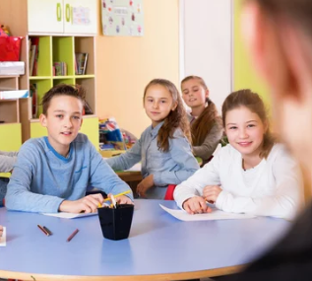



- Trust is an important part of positive relationships.
- Trust a friend and/or a trusted adult to talk to about problems or concerns.
- If trust is broken, talk to the person about it, accept an apology if appropriate and/or talk to a trusted adult.

5
- Understanding the differences between people and why it is important to respect these differences.
- Identifying differences and similarities between people.
- Treat people with respect even if they are different from you.

6






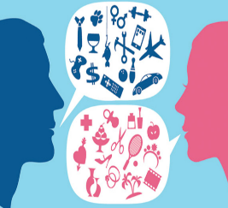

Childline Support
- Stereotypes can be unfair, negative or destructive.
- A law called the Equality Act 2010 that protects people from being treated unfairly and promotes a more equal society.
- People may make stereotypes based off of someone’s age, that they can’t do something when this is not true.
- Stereotypes are present in everyday life.
- Stereotypes can be unfair, negative or destructive.
- Toys can reinforce gender stereotypes.
- Stereotyping is harmful and can upset and offend people, both in person and online.
- Be open and honest about the things you see online so you can have healthy discussions around the content with people you trust.
7
8
KS1 knowledge
Helpful links
Scan to complete your Quiz
Anti-bullying Alliance Support

