Science  Electricity  - Describe the parts of an electric circuit  - Explore voltage and its effect on an electrical circuit  - Apply knowledge to identify and correct problems in a circuit  - Investigate what affects the output of a circuit  - Build a set of traffic lights  - Apply knowledge of conductors and insulators.  Light  - Explore how light travels  - Explore reflection  - Explore reflection and explain how it can be used to help us see  - Investigate how shadows can change  - Investigate how we can show why shadows have the same shape as the object that casts them  - Explore light phenomena | Music  Baroque  - Define some key features of Baroque music, including recitative, canon, ground bass and fugue.  - Take part in a vocal improvisation task based on Baroque recitative.  - Play several parts of a canon using staff notation, with or without letter names.  - Compose a ground bass melodic ostinato.  - Notate a ground bass pattern using staff notation.  - Name some well-known Baroque composers and describe what musical features they were known for.  - Learn a fugue part by reading staff notation, with or without note names.  - Perform a fugue.  Composing and performing a leavers’ song  - Identify and evaluate the musical features of a song.  - Contribute ideas to their group chorus, suggesting how lines three and four could rhythm.  - Fit and existing melody over a four-chord backing track.  - Create a melody that fits both the lyrics and the four-chord backing track of the chorus, using tuned percussion instruments.  - Record melodies using letter notation.  - Perform the leavers’ song with confidence. | Spanish  Free Time in Spain  - To read a cartoon to identify how verb endings change.  - To report about seasonal activities using regular verb endings.  - To answer questions about free time in Spain using appropriate verb endings.  - To translate travel reports from English to Spanish.  - To construct a descriptive travel blog using a range of verbs in the present tense.  - To compare and respond to different travel blogs to express preference.  Maya City Treasure Hunt  - To translate sentences to find out about Ancient Maya cities.  - To describe the Ancient Maya people.  - To deduce and follow simple directions to different Maya city landmarks.  - To interpret directional language to navigate around a Maya city.  - To create written clues for a treasure hunt around an Ancient Maya city.  - To evaluate the use of language used in giving directions.
History  Ancient Civilisations - Identify where and when ancient civilisations began - To understand the importance of rivers on settlements and agriculture -to learn how the Ancient civilizations communicated -to understand the different religious beliefs -look at the inventions, innovations and trade | Brackenwood Junior School    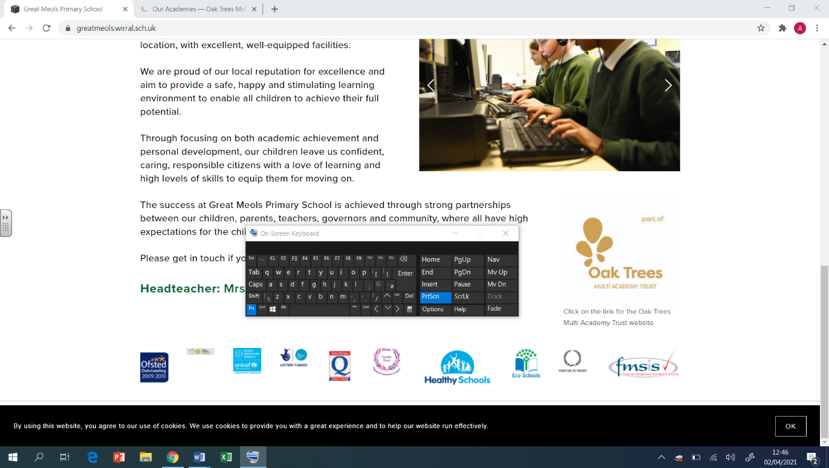  Y6  Summer Overview | PE  Ultimate Frisbee  - Throw a frisbee accurately using the backhand  - How to create angles  - How to defend against an opponent  - Learn the rules of ultimate frisbee  Athletics  - Controlling my running over middle distances  - To generate power from my thigh  - High jump techniques  - How to hurdle effectively  - Transfer the relay batton effectively  OAA  - Work as part of a team  - Give clear instructions  - Work quickly and effectively against the clock  - Communicate positively with other members of your group  Rounders  - Throw accurately  - Strike with some accuracy into a given area  - Back up fellow fielders
Geography  Interconnectivity  - To locate UK, China and UAE on a map and identify land borders  - To plan relevant questions for a fieldwork study.  - To explore transportation links between different countries.  - To investigate the trends and patterns of a country’s economy and population.  - To identify causes and solutions of air pollution in the UAE, China and UK. | DT  Cooking & Nutrition: Come Dine with Me  - To research and design a three-course meal.  - To apply culinary skills and knowledge (starter).  - To apply culinary skills and knowledge (main).  - To apply culinary skills and knowledge (dessert).  Electrical Systems: Steady Hand Game  - To design a steady hand game.  - To construct a stable base.  - To assemble electronics and complete an electrical game. | The Natural World  ● To know what different faiths say about how the world was created  ● Look at similarities between the creation stories  ● To know the scientific and non-religious views on how Earth was created  ● Learn what it means to have stewardship over the Earth  ● To know what faith members do to care for the world and the environment
Computing  Sensing Movement  - I can identify examples of conditions in the real world  - I can decide what variables to include in a project  - I can test my program against my design  Coding - Code Studio | Art  Artist: Phil Dean: The Shoreditch Sketcher  Drawing  - Develop ideas using different mixed media, using a sketchbook.  - Manipulate and experiment with the elements of art: line, tone, pattern, textures, form, space, colour and shape.  Sculpture  - Describe the different qualities involved in modelling, sculpture and construction.  - Develop skills working in 3D  - Make a models and develop, making alterations to create a final piece.  - Create sculpture and constructions with increasing independence | PSHE  Economic Well Being  - Understand feelings about money and the impact they can have.  - Explain how to safeguard money in both digital and physical environments.  - Know the money changes when moving to secondary school.  - Understand the risks of gambling.  - Explain how careers function in different settings and what roles and responsibilities come with them.  - Explore different career routes and their requirements.  Identity  - Understand the factors which make up identity.  - Understand that images can be manipulated by the professional media but also by individuals and that they are not realistic.  Transition  - I understand that change can bring opportunity but also worry.  - I can explain some ways I can deal with change.  - I can explain some strategies I can use if I feel stressed or anxious.

