Science  Living Things and their habitats  - Understand the life processes of a plant  - Understand the life cycles of mammals  - Compare the life cycles of insects and amphibians  - Understand the life cycle of birds and reptiles  - know about the life and work of Jane Goodall and DAvid Attenborough  - Research and present the life cycle of a creature.  Animals, including Humans  - Identify the key stages of a mammal’s life cycle  - explore the gestation periods of mammals  - Learn about foetal development  - Investigate the hand span of differently aged children  - Learn about the changes experienced in puberty  - Describe the changes humans may experience during old age | Music  Looping and remixing  - Perform a looped body percussion rhythm; keeping in time with their group.  - Use loops to create a whole piece of music, ensuring that the different aspects of music work together.  - Play the first section of ‘Somewhere Over the Rainbow’ with accuracy.  - Choose a suitable fragment of music and be able to play it along to the backbeat.  - Perform a piece with some structure and two different loops.  Musical theatre  - Explain what musical theatre is and be able to recall at least three features of this kind of music.  - Categorise songs as action songs or character songs.  - Select appropriate existing music for their scene to tell the story of journey.  - Perform in time with their groups, ensuring smooth transitions between spoken dialogue, singing and dancing. | Spanish  A trip across Spain  - To describe the location of some Spanish cities.  - To use a range of strategies to widen vocabulary for describing places.  - To construct sentences describing future plans.  - To discuss future travel plans.  - To create a role-play conversation about future travel plans.  - To perform a role-play conversation about future travel plans.  Saving South America  - To interpret locational language in a description of South America.  - To construct comparative sentences about South America’s environment.  - To discuss ways to help protect South America’s environment.  - To write a set of instructions for creating a healthy world.  - To script an advert campaigning for action on South America’s environmental problems.  - To present adverts campaigning for action on South America’s environmental problems.
History  Local area study – Cammell Lairds and Birkenhead:  -looking at how land was used and when and why Cammell Lairds factory was built  -look at the impact on the people of Birkenhead and the changes the wealth of shipbuilding brought to our local area  -investigate any lasting impact the factory still has today | Brackenwood Junior School    Y5  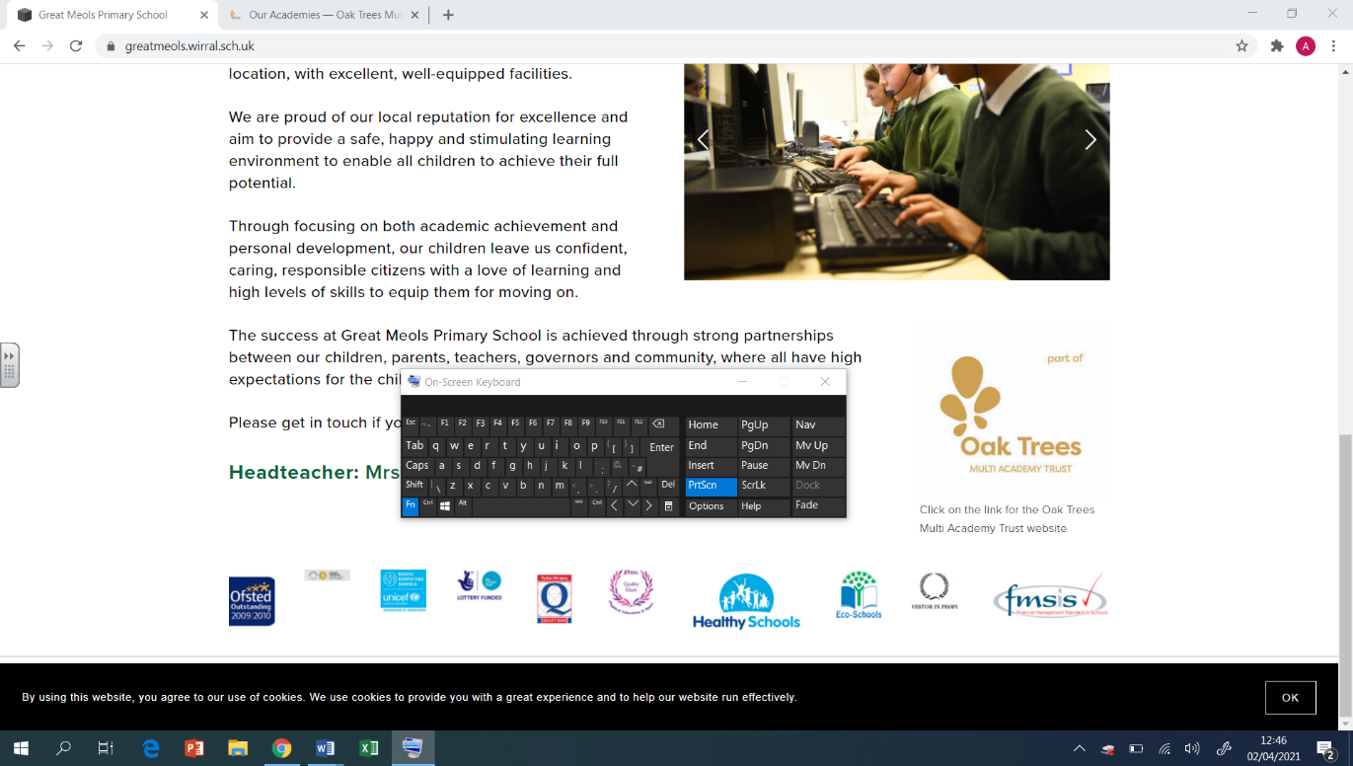  Summer Overview | PE  OAA  - Developing a plan before I undertake a challenge  - How to keep a partner safe  - Use a simple map to navigate myself around  - What do ordnance survey symbols mean?  Cricket  - Position of anticipation when fielding  - How to bowl from a crease  - One-handed pick-up technique  - Why walk in with the bowler when fielding?  Dodgeball  - Aim low to get an opponent out  - Keep moving  - Working as part of a team  - Who to target on the other team  - Rules of the game  Football  - How to get free from a defender  - When defending how to make it difficult for the attacker  - How to work together effectively as a team  - How to create goal-scoring opportunities
Geography  Climate change and pollution  - To identify causes of pollution  - To identify our carbon footprint  - To explore pollution levels around the world  - To explore pollution levels in our locality  - To explain what global warming is  - To identify the effect of global warming on Earth  - To identify basic ways that we can improve the climate at home  - To identify how we can improve pollution levels through transport  - To identify how renewable energy sources improve the environment  - To identify different types of renewable energy | DT  Structures: Bridges  - To explore how to reinforce a beam (structure) to improve its strength.  - To build a spaghetti truss bridge.  - To build a wooden truss bridge.  - To complete, reinforce and evaluate my truss bridge. | Humanism  ● Understanding what is a worldview is  ● Learn what Humanists believe  ● To know what is important to Humanists  ● To know how they lead a good life and make the most of their lives  ● Understand how they decide how to behave  ● Ask how can we make the world a better place
Computing  Vector Drawing  - I can recognise that vector drawings are made using shapes  - I can use the zoom tool to help me add detail to my drawings  - I can create a vector drawing for a specific purpose  - Coding- Code Studio | Art  Artist: William Morris  Drawing:  - Use a variety of source material for their work. Work in a sustained and independent way from observation, experience and imagination.  - Use a sketchbook to develop ideas.  - Explore the potential properties of visual elements, line, tone, pattern, texture, colour and shape.  Printing:  - Select broadly the kinds of materials to print with in order to get the effects they want.  - Organise their work in terms of pattern, repetition, symmetry or random printing styles.  - Explain a few techniques, including the use of poly-blocks, relief, mono and resist printing.  - Alter and modify work  - Work relatively independently. | PSHE  Economic Well Being  - Prioritise needs over wants.  - Manage a weekly budget.  - Understand the responsibilities and consequences of borrowing and loaning.  - Recognise the risks and considerations associated with spending money online.  - Explain why workplace stereotyping needs to be challenged.  - Describe how interests and skills align with future careers.  Transition  - I understand the skills needed to take on roles in school.  - I can explain the skills I have and those I need to develop.

