Science  Living Things in their Habitats  - To identify different habitats.  - To research a habitat  - To understand how animals can be classified  - To create a classification key  - To understand classification and adaptations within species  Animals including Humans  - To identify the organs in the digestive system  - To describe the main functions of the organs in the digestive system  - To identify the types of human teeth and their functions  - To investigate the effect of different liquids on teeth  - To understand food chains | Music  Samba and carnival sound and instruments.  - Explain what samba music is and that it is mainly percussion instruments used in celebrations such as Carnival in Brazil.  - Clap on the off-beat (the and of each beat) and be able to play syncopated rhythm.  - Play their rhythm in time with the rest of their group (even if they are not always successfully playing in time with the rest of the class).  - Play their break in time with the rest of their group and play in the correct place in the piece.  - Play in time and with confidence; accurately playing their break.  Adapting and transposing motifs  - Learn a new song, singing in time and in tune while following the lyrics.  - Identifying motifs aurally and play a repeated pattern on a tuned instrument  - Create and performing a motif, notating it with a reasonable accuracy.  - Transpose their motif, using sharp and flat notes where necessary and change the rhythm.  - Combine different versions of musical motif and perform as a group using musical notation. | Spanish  Spanish Celebrations  - To identify the meaning of vocabulary related to important Spanish festivals.  - To use a bilingual dictionary to look up the meaning of new verbs.  - To apply new and familiar vocabulary to express what I like and dislike to do.  - To identify people’s likes and dislikes during a festival.  - To create phrases describing actions in detail.  - To describe likes and dislikes at specific celebrations.  The Amazon Rainforest  - To identify and describe the geography of Peru.  - To use spelling patterns and rhythms to learn and perform rainforest animal names.  - To write descriptive sentences about rainforest animals.  - To describe the physical features of some rainforest animals using singular and plural nouns.  - To describe the features of rainforest creatures and their habitat.  - To present a podcast to introduce different Amazon animals.
History  The Mayans: -To understand how Mayan architecture reflects the society’s values and beliefs  -to learn how innovations and inventions helped the Maya to make sense of the world  -learning how the Maya’s army and leaders help their cities to succeed -to understand the achievements of the Maya people | Brackenwood Junior School    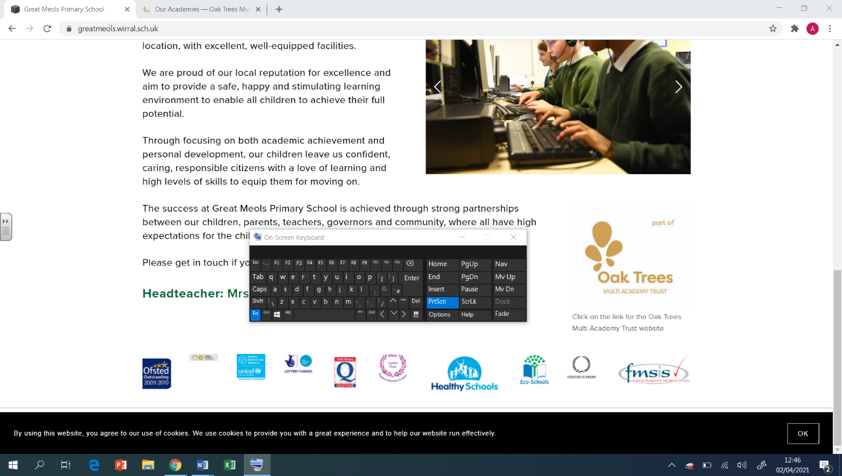  Y4  Summer Overview | PE  Badminton:  - Assume the ready position  - Rules associated with serving  - What is a rally  - How to move your opponent around the court  OAA  - Working out the meaning of symbols  - communicating and problem solving as a group  - Compass points How to orientate a map and find clues  Rounders  - Make decisions about when to run  - body stance when bowling and batting  - What is a no ball?  - Fielding techniques  Tennis  - What does a ready position look like?  - Strike with the backhand with some consistency  - Adjust body positioning to select an appropriate shot  - Use tactics against an opponent
Geography  Africa - Kenya  - To locate the continent Africa, its countries and surrounding oceans  - To identify time zones around Africa and why they exist.  - To identify the human and physical features of Kenya.  - To identify the climate zones of Africa and compare them to the UK.  - To understand who the Maasai Mara are.  - To explain the impact of tourism on the Maasai Mara.  - To summarise how Kenya compares to the UK. | DT  Structures: Pavilions  - To create a range of different shaped frame structures.  - To design a structure.  - To build a frame structure.  - To add cladding to a frame structure. | Religion and the Environment – Making a difference for now and for the future.  -To know the impact of my actions on others and on the world  -To know how can we help the earth recover before it is too late  -To know that we all have a collective responsibility to protect the earth for now and for the future  -How can I make a positive impact?  -What does it mean to be a responsible citizen?
Computing  Photo Editing  - I can explain why I might crop an image  - I can remove parts of an image using cloning  - I can experiment with tools to select and copy part of an image  Coding - Code Studio | Art  Artist- Gayle Gerson  Collage:  - Use collage to create a composition.  - Refine and alter ideas and explain choices using an art vocabulary.  - Collect visual information from a variety of sources, describing with vocabulary based on the visual and tactile elements.  Painting:  - Make colours using water colours with increasing accuracy  - Show increasing independence and creativity with the painting process. | PSHE  Economic Well Being  - Identify and justify items they consider good value for money.  - Identify multiple factors that influence whether something is good value for money.  - Understand the importance of tracking spending.  - Identify different ways to keep money safe.  - Identify a range of influences on job choices.  - Suggest ways to respond to certain influences over career choices.  - Identify different reasons why people might change careers  - Suggest proactive steps that can be taken to challenge and overcome these stereotypes.  Transition  - I can identify my achievement this year.  - I can set myself goals.  - I know who I can talk to if I am worried about anything.

