Science  Light  - Identify the difference between light sources and non light sources  - Explore the light that comes from the sun and how to stay safe  - explore materials which are reflective  - Discover how shadows are formed  - Investigate how shadows change throughout the day  - Investigate how you can change the size of a shadow | Music  Developing singing technique: Theme Vikings  - Move and sing as a team, following the lyrics on the screen.  - Recognise minims, crotchets and quavers often by ear and reliably by sight.  - Perform rhythms accurately from notation and layer them to create composition.  - Add appropriate sound effects to their performances using untuned percussion.  - Join in with the performances confidently, and reasonably in time and tune.  - Make suggestions for improving their performances.  Pentatonic melodies and compositions  - Match their movements to the music, explaining why they chose these movements.  - Accurately notate and play a pentatonic melody.  - Play their part in a composition confidently.  - Work as a group to perform a piece of music. | Spanish  Where do you live in Spain?  - To name places in Spain using key phonemes.  - To practise answering questions about who I am and where I live.  - To use a bilingual dictionary to identify nouns and their gender.  - To listen for key information about where people live.  - To read and interpret information from a short descriptive text.  - To compose a short, written paragraph to introduce yourself.  Journey around Latin America  - To identify and pronounce Spanish-speaking countries in Latin America.  - To speak in short phrases to describe travel plans.  - To recognise and use the prepositions en and a when describing travel.  - To say the days of the week as part of a sentence in Spanish.  - To compose a travel diary in Spanish.  - To perform a travel diary in Spanish.
History  Ancient Egyptians: -look at where and how the Egyptians rules -learn the significance of the River Nile and its impact on agriculture and society -understand Ancient Egyptian religious beliefs  -understand how and why the pyramids were built  -looking at the leaders of the Ancient Egyptians | Brackenwood Junior School    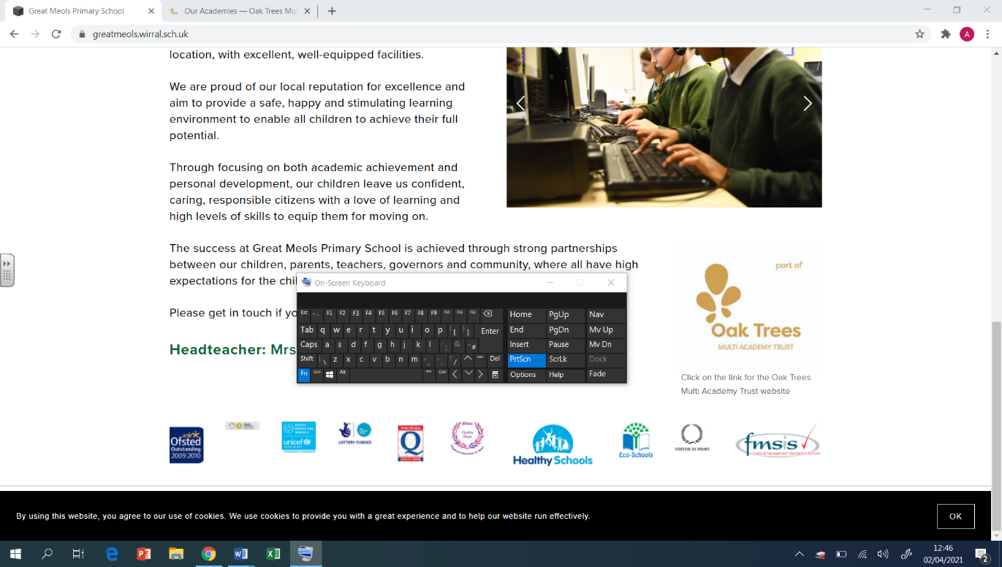  Y3  Summer Overview | PE  Cricket  - Assume a ready position when fielding  - How to grip a bat  - How to grip a ball when bowling  - Positioning oneself when wicketkeeping  - Tactics when batting  - Effective communication with teammates when fielding  Personal Challenges  - Why is core strength important in most sports  - Assume a ready position when throwing and catching  - To move with my head up and at a steady pace  - Develop all-around strength for my body  Football  - How to receive a pass  - Utilising different parts of the foot when dribbling  - To get the ball outwide and use the full pitch effectively  - Defending in a 1v1 situation  - How to attack decisively  - Defending in a side-on stance  Hockey  - How to hold the stick  - Importance of close control  - Push passing  - How and when to jab tackle  - How to create an effective team strategy
Geography  Where does our food come from?  - I can understand that the food we eat comes from many different places around the world.  - I can recall how land in temperate climate zones is used to produce food.  - I can understand how land in tropical climate zones is used to produce food.  - I can describe the way in which land in tropical biomes is being changed to enable more food to be produced.  - I can explain how land is used to produce food in the United Kingdom.  - I can explore how food is produced in Mediterranean climate zones. | DT  Cooking & Nutrition: Eating Seasonally  - To explain the benefits of seasonal food.  - To evaluate seasonal ingredients.  - To design a mock-up using criteria.  - To create a seasonal dish.  - To evaluate a dish. | Christians Who Inspired and Influenced the World  -To know what a role model is  -To know why people are driven to action change?  -To know how faith plays a part in the paths that people choose  -To know what it means to put your faith into action  -To know how actions have impacts/lasting legacies
Computing  Creating media – Desktop publishing  - I can recognise that text and images can communicate messages clearly  - I can change font style, size, and colours for a given purpose  - I can say why desktop publishing might be helpful  Coding- Code Studio | Art  Artist: Clare Young  Drawing  - Use different media to achieve variations in line, texture, tone, colour, shape and pattern.  - Plan, refine and alter their drawings as necessary.  Printing  - Print using a variety of materials, objects and techniques included layering.  Collage  - Create backgrounds and papers to collage with.  - Experiment with combing materials. | PSHE  Economic Well-being  - Describe how different payment methods may be used in given scenarios.  - Suggest why specific payment methods might be more beneficial.  - Explain what a budget is and how we can benefit from budgeting.  - Identify how they would feel in a money scenario.  - Understand the impact our spending choices can have on others and the environment.  - Understand that a wide range of jobs are available.  - Know that skills and interests lead people to certain jobs.  - Know that job stereotypes sometimes exist but these should not limit anyone.  Transition  - I understand that there are different strategies I can use to deal with change.  - I can explain the opportunities and responsibilities that change might bring.

