Science  Animals including Humans  - To identify and name the parts of the human circulatory system  - To describe the function of the heart, blood vessels and blood  - To recognise the impact of diet, exercise, drugs and lifestyle on the body  - To describe the way nutrients and water are transported within animals including humans | Music  Film Music  - Identify how different styles of music contribute to the feel of a film.  - Use the terms ‘major’ and ‘minor’.  - Identify different instruments to describe how music evokes different emotions.  - Identify pitch, tempo and dynamics, and use these to explain and justify their answers.  - Create a musical graphic score and create a composition with sound effects.  Theme and Variations: Pop Art  - Identify the sounds of different instruments and discuss what they sound like.  - Recall the names of instruments according to their orchestra sections  - Keep the pulse using body percussion  - Sing in control and confidence.  - Name rhythms correctly.  - Show differences between musical variations. | Spanish  Household Tasks in Spanish  - To interpret and translate opinions about household tasks.  - To find and categorise vocabulary from descriptions of different robots.  - To describe a robot’s purpose using verbs and adverbs.  - To write a descriptive text about an invented robot.  - To describe the functions of a robot using a persuasive advert.  - To evaluate and justify a choice of robot.  Shopping in Spain  - To explore pronunciation rules using vocabulary for food and market stalls.  - To describe the location of a market stall using prepositions.  - To express different amounts of money using numbers up to 100.  - To express how much / how many using food vocabulary.  - To create and use dialogue for a shopping transaction.  - To adapt and use language structures for a shopping game.
History  World War 2  -To understand why Britain declared war and other countries also became involved  -look at how and why Hitler became leader  -begin to understand the impact on Jewish communities and the Holocaust  -To understand the impact of the blitz, even in our local area  -To understand that war has an impact everywhere. Learn about how our local area was impacted during WW2 | Brackenwood Junior School    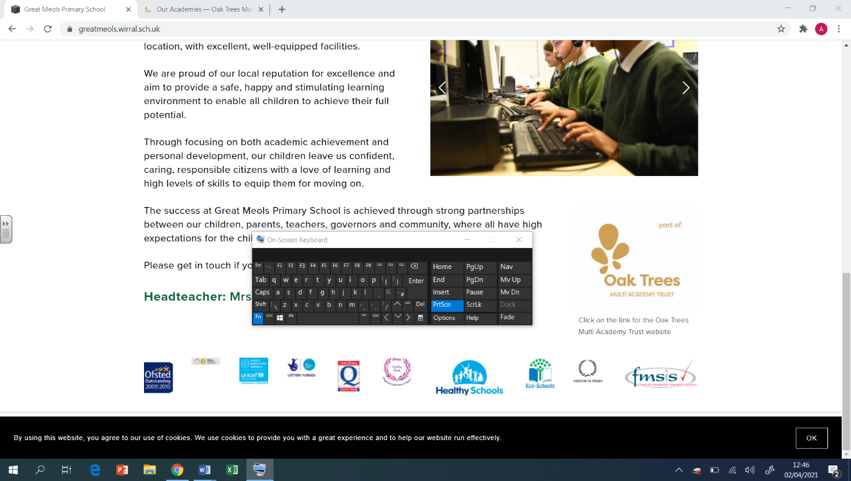  Y6  Spring Overview | PE  Dance  - World War 2 link  - Show different levels, pathways and directions when I travel  Tri Golf  - Adopt and efficient stance to strike the ball  - Chip over hazards  Badminton  - To serve long and short  - Serve with accuracy  Team building and problem-solving  - To perform calmly under pressure  - Communicate clearly
Geography  - To locate mountains and identify their features  - To understand how mountains are formed  - To locate key geographical features of the USA  - To understand what a canyon is and how they are formed  - To explain why some places may be more populated than others  - To explore the climate across the USA | DT  Mechanical Systems: Automata Toys  - To prepare wood for assembly by measuring, marking and cutting each piece.  - To assemble the automata frame components and supports with the help of an exploded diagram.  - To explore the relationship between cam profiles and follower movement to inform a design decision.  - To apply the housing and finishing touches to the automata frame. | RE  Journeys – Christian and Muslim  - Understand what is meant by the term rite of passage  - Look at people who could be there for them on a religious journey  - To know what a pilgrimage is  - Compare a Christian pilgrimage to the Hajj  - understand the importance of pilgrimages to people of religion  Christianity – The Afterlife  - recalling the resurrection from the Easter Story  - understanding that people have different views on resurrection/afterlife  - look at other faiths and their rituals around life, death and resurrection  - look at different beliefs and how not believing in an afterlife/resurrection might impact how we live
Computing  Coding - Code Studio  Data and information - Introduction to Spreadsheets  I can suggest how to structure my data  I can choose an appropriate format for a cell  I can construct a formula in a spreadsheet  I can create a formula which includes a range of cells  I can explain why data should be organised  I can suggest when to use a table or chart | Art  Artist:  Drawing  - Develop ideas using different mixed media, using a sketchbook.  - Manipulate and experiment with the elements of art: line, tone, pattern, textures, form, space, colour and shape.  Painting  - Create shades and tints using black and white.  - Choose appropriate paint, paper and implements to adapt and extend their work.  - Carry out preliminary studies, test media and materials and mix appropriate colours.  - Work from a variety of sources, inc. those researched independently.  - Show an awareness of how paintings are created (composition) | PSHE  Safety and the Changing Body  - Developing an understanding about the reliability of online information.  - Exploring online relationships including dealing with problems.  - Discussing the reasons why adults may or may not drink alcohol.  - Discussing problems which might be encountered during puberty and using knowledge to help.  - Learning how to help someone who is choking.  - Placing an unresponsive patient into the recovery position.  Citizenship  - Learning about environmental issues relating to food.  - Discussing how education and other human rights protect us.  - Identifying causes that are important to us.  - Discussing how people can influence what happens in parliament.  - Discussing ways to challenge prejudice and discrimination.  - Identifying appropriate ways to share views and ideas with others.

