Science  Forces  - To learn about gravity  - To identify the effects of air resistance, water resistance and friction  - To recognise mechanisms such as pulleys, levers and gears  Earth & Space  - To describe the movement of the Earth in relation to the Sun  - To describe the movement of the moon in relation to the Earth  - To recognise the Earth, Sun and moon as approximately spherical bodies  - To explain night and day as the movement of the Sun across the sky | Music  South and West Africa  - Sing using the correct pronunciation and with increasing confidence.  - Play a chord with two notes, remaining in time.  - Maintain their part in a performance with accuracy.  - Play the more complicated rhythms in time and with rests.  - Play more complicated rhythms in time with rests.  - Create an eight-beat break and play this in the correct place.  Compositions for the festival of colour  - Suggest a colour to match to a piece of music.  - Create a graphic score and describe how this matches the general structure of a piece of music.  - Create a vocal composition in response to a picture and justify their choices using musical terms.  - Create a vocal composition in response to a colour.  - Record their compositions in written form.  - Work as a group to perform a piece of music. | Spanish  DAILY LIFE  Sports in Spanish  - To apply knowledge of verbs when asking and answering questions about sport. verbs for questions about sport.  - To recognise and use imperative verbs to give game instructions.  - To translate written instructions for the Maya ball game.  - To use instructions and motivational language when playing the Maya ball game.  - To identify and classify keywords from instructions for games.  - To create written instructions for an original ball game.  Spanish Food and Drink  - To express likes and dislikes about food.  - To ask and answer questions about food preferences.  - To listen to spoken language and identify food preferences.  - To deduce a person’s pizza choice by finding out their food preferences.  - To conduct an interview about food preferences.  - To develop questioning skills to find out about food preferences.
History  Benin  -To locate Benin and understand the historical chronology  -To understand about religious beliefs and how they can differ from our understanding today  -To understand trade links, the trade triangle and the impact on the people involved  -Understand why the civilisation came to an end  -To look at changes within the laws and the eventual abolishment of slavery | Brackenwood Junior School    Y5  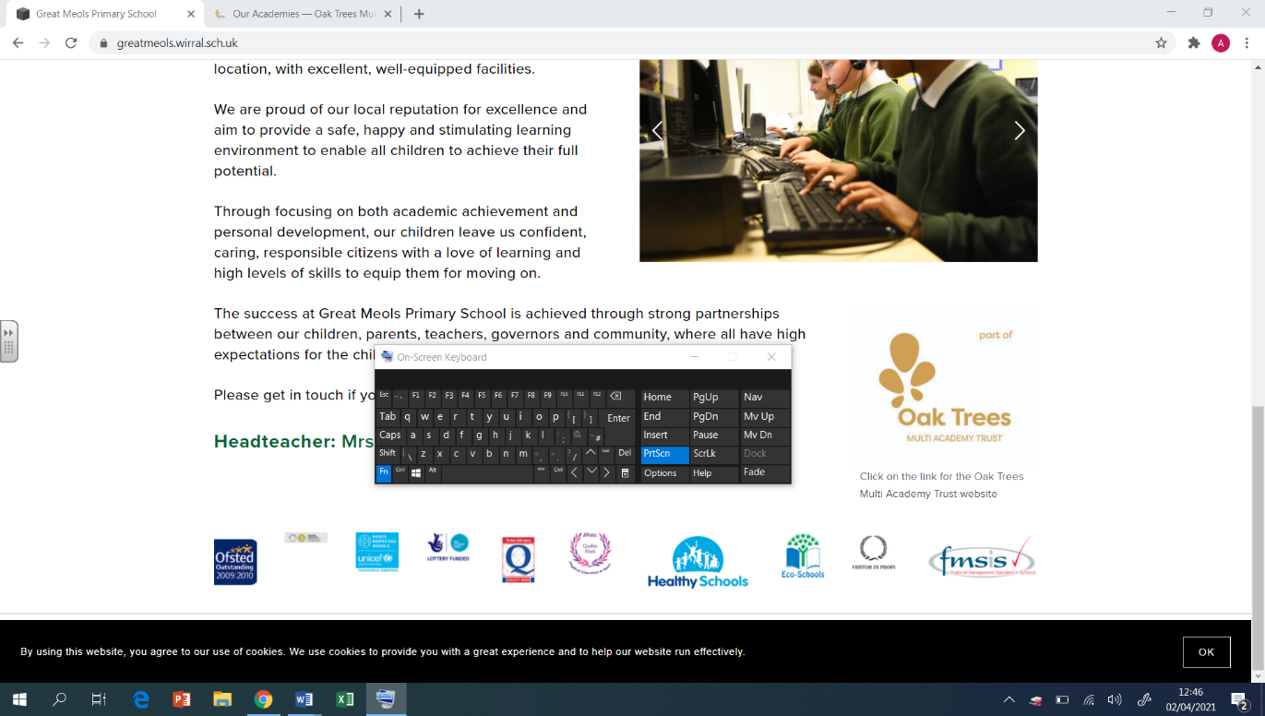  Spring Overview | PE  Athletics  - Run and throw with greater control, accuracy and efficiency  - Throw with accuracy and power using the pull technique  Basketball  - How to manipulate and manoeuvre a basketball within the rules  - Use a variety of ways to pass  Netball  - Send a netball in a variety of ways  - How to disguise my passes  Tennis  - Work with a teammate to apply a plan  - Develop a variety of playing strategies
Geography  - I understand what a biome is and can identify different biomes on a world map  - I understand longitude and latitude and how location impacts biomes  - I understand the layers of a rainforest  - I understand how the climate of the Amazon Rainforest impacts its biodiversity  - I understand the water cycle and how water moves around the world  - I can compare two temperatures either side of the Equator (line graph) | DT  Digital World: Monitoring Devices  - To carry out research to develop design criteria.  - To write a program to monitor the ambient temperature, including an alert.  - To generate creative and unique Micro:bit case, stand or housing ideas.  - To learn about and practise 3D CAD skills.  Mechanical Systems: Pop-up Book  - To design a pop-up book.  - To follow a design brief to make a pop-up book.  - To use layers and spacers to cover the working of mechanisms.  - To create a high-quality product suitable for a target user. | RE  Faith in Action  - Understanding that faith can mean needing to do the right thing, even if that means facing consequences  - Listening to the lyrics and faith that Stormzy puts in his music  - Understanding why Corrie Ten Boom would hide Jewish people during WW2  - How changing his name and religion impacted Muhammed Ali -looking at organisation that combine faith and charity  Christianity – Journey to the cross  - Understand the significance of the Last Supper  - knowing about a fair trial and questioning if Jesus was given a fair trial  - Look at the actions of Judas and the significance of his betrayal
Computing  Coding - Code Studio  Data and information – Flat-file databases  - I can explain how information can be recorded  - I can explain what a field and a record is in a database  - I can group information using a database  - I can outline how ‘AND’ and ‘OR’ can be used to refine data selection  - I can explain the benefits of using a computer to create charts  - I can present my findings to a group | Art  Artist: Monet  Painting:  • Create a colour palette based upon colours observed in the natural or built world.  • Use the qualities of watercolour and acrylic paints to create visually interesting pieces.  • Combine colours, tones and tints to enhance the mood of a piece.  • Use brush techniques and the qualities of paint to create texture.  • Develop a personal style of painting, drawing upon ideas from other artists.  Drawing:  - Use a sketchbook to develop ideas.  - Explore properties of visual elements, line, tone, pattern, texture, colour and shape. | PSHE  Safety and the Changing Body  - Developing an understanding of how to ensure relationships online are safe.  - Learning to make ‘for’ and ‘against’ arguments to help with decision making.  - Learning about the emotional changes during puberty.  - Identifying reliable sources of help with puberty.  - Learning about how to help someone who is bleeding.  Citizenship  - Developing an understanding about the reliability of online information.  - Exploring online relationships including dealing with problems.  - Discussing the reasons why adults may or may not drink alcohol.  - Discussing problems which might be encountered during puberty and using knowledge to help.  - Learning how to help someone who is choking.  - Placing an unresponsive patient into the recovery position.

