Science  Sound  - To identify how sounds are made  - To recognise that vibrations travel from a medium to the ear  - To find patterns in pitch  - To find patterns in volume  - To recognise that a sound gets fainter the further away the object making the sound is from the ear  Key Scientist  - Miller Reese Hutchinson | Music  Royal Liverpool Philharmonic Orchestra project ‘The world in One City: A Musical Journey’ where they will be exposed to a variety of famous historical orchestral pieces.  Throughout this unit, they will progress in a range of musical skills;  - Listening  - Singing  - Composing  - Performing  - Different instruments within an orchestra | Spanish  DAILY LIFE  Weather in Spain  - To name and identify types of weather in Spanish.  - To ask and answer questions about the weather.  - To read and interpret a text about the weather.  - To follow a spoken and written passage about the weather.  - To compose a weather forecast script.  - To perform a weather forecast in Spanish.  In a Spanish café  - To apply comprehension strategies and discover the meaning of new words.  - To make polite requests about what I want to eat and drink.  - To identify conversational language.  - To engage in conversations that involve making requests.  - To write a role play script for a conversation.  - To perform, evaluate and improve a role play.
History  Ancient Greeks  -Location of Greece within a historical timeline  -looking at the Greek myths and if they give clues to how the ancient Greeks lived  -Compare the lives of people in Athens and Sparta  -looking at archaeology/sources and what we can tell about the time they came from | Brackenwood Junior School    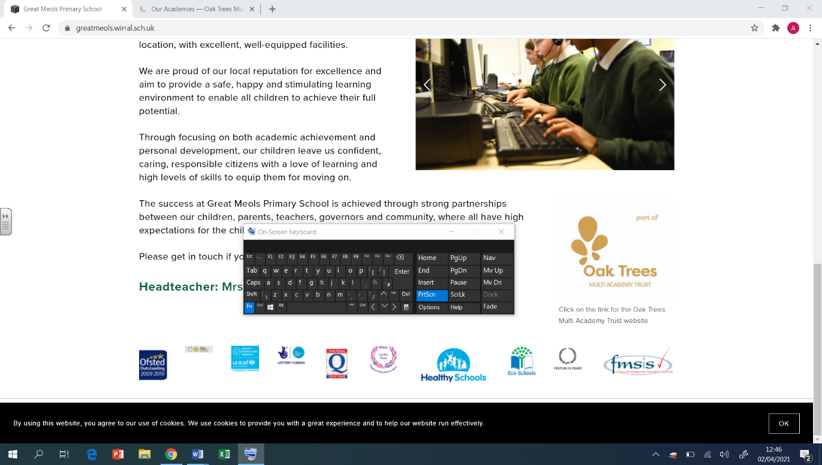  Y4  Spring Overview | PE  Gymnastics  - Rolling and traveling low  - Forward roll with good technique and control  Health-related fitness  - To sustain performance even when the body is tiring  - What stamina is and can you sustain physical  exertion over periods of time  Dodgeball  - To understand when to attack and when to defend  - Judge which balls to try and catch and which to dodge  Handball  - Catch a handball on the run  - To move into space after passing
Geography  - To know that there are three kinds of rocks: igneous, sedimentary and metamorphic.  - To understand the different layers of Earth’s core and location of the tectonic plates  - To understand how volcanoes erupt and locate dormant and active volcanoes across the world.  - To understand the key parts of a volcano.  - To identify the advantages and disadvantages of living near a volcano.  - To compare two volcanic eruptions. | DT  Cooking & Nutrition: Adapting a Recipe  - To evaluate existing biscuit products.  - To prepare and cook a dish.  - To budget for ingredients and create a recipe.  - To make and test a prototype biscuit.  Electrical Systems: Torches  - To analyse and evaluate electrical products.  - To design a product to fit a set of specific user needs.  - To make and evaluate a torch | RE  Journeys  - what a special journey is, pilgrimages, journeys completed by Moses and why they were important.  -the work of a modern day missionary  -the rites of passage  Christianity - understanding the order of events around the Easter Story  - Knowing why Jesus was upset by the money lenders in the temple  - Learning the significance of bread and wine to Christian traditions  -Jesus’ crucifixion and the resurrection
Computing  Coding Code Studio  Data and information – Data logging  - I can identify data that can be gathered over time  - I can explain what data can be collected using sensors  - I can talk about the data that I have captured  - I can explain that there are different ways to view data  - I can use a data logger to collect data  - I can draw conclusions from the data that I have collected | Art  Artist: Quentin Blake  Drawing:  • Explore the relationship between line and tone, pattern and shape, line and texture.  • Use shading to show light and shadow.  • Use hatching and cross hatching to show tone and texture.  Painting:  •Make colours using water colours with increasing accuracy  Show increasing independence and creativity with the painting process. | PSHE  Safety and the Changing Body  - Discussing how to seek help if I need to.  - Exploring what to do if an adult makes me feel uncomfortable.  - Learning about the benefits and risks of sharing information online.  - Discussing the benefits of being a non-smoker.  - Discussing some physical and emotional changes during puberty.  - Learning how to help someone who is having an asthma attack.  Citizenship  - Discussing how we can help to protect human rights.  - Identifying ways items can be reused.  - Explaining why reusing items is of benefit to the environment.  - Identifying the benefits different groups bring to the local community.  - Discussing the positives diversity brings to a community.

