Science  Plants  - To identify and describe the functions of different parts of flowering plants  - To explore what a plant needs in order to survive  - To investigate how water is transported in plants  - To explore the part that flowers play in the lifecycle of flowering plants, including pollination, seed dispersal and seed formation  Animals Including Humans  - To explored the 5 key food groups.  - To lean about the nutrition in the food we eat.  - To learn about the different types of skeletons.  - To learn about animals and their skeletons.  - To explore the role of muscles. | Music  EdSential 10-week Ukulele workshops  Throughout this unit, they will progress in a range of musical skills;  - Listening  - Singing  - Composing  - Performing  - Learning to play the Ukulele. | Spanish  Daily Life - Shapes and Colours in Spanish  - To recognise and name some colours in Spanish.  - To begin to describe shapes using colour adjectives.  - To create and practise descriptive phrases orally.  - To read and recognise descriptive phrases in Spanish.  - To write a design brief using shape and colour vocabulary.  - To create a short presentation using descriptive phrases.  Classroom Objects in Spanish  - To recognise and respond to spoken classroom instructions.  - To name school bag objects and identify if they are masculine or feminine nouns.  - To identify how a noun phrase changes in the plural form when describing classroom items.  - To construct a phrase using the negative form, no tengo – I do not have.  - To read and interpret sentences featuring the conjunctions y and pero.  - To compare a piece of writing describing what is in a school bag.
History  Romans  -Recognise where and when the Romans ruled  -understand the reasons why Emperor Claudius want to invade Britain  -Understand the role of the Roman soldiers  -look at local city, Chester and its significance in the Roman rule over Britain  -understand the significance of Boudicca fight with the Roman army | Brackenwood Junior School    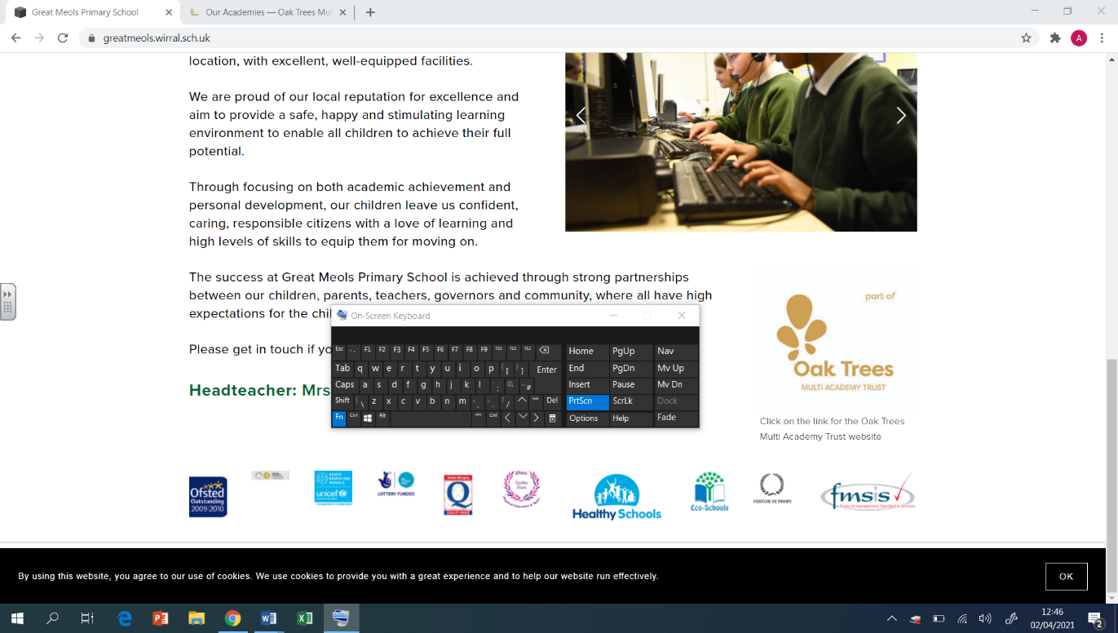  Y3  Spring Overview | PE  Athletics  - Use running, jumping, throwing and catching in isolation and in combination  - To position my body sideways-on when throwing  Yoga  - Retain focus and control breathing  - Perform a variety of poses  Tennis  - Striking the ball on the forehand and backhand striking the ball downward  - What the ‘ready position’ is  Golf  - To understand that a golf club must strike underneath the ball to cause elevation.  - Which club to use and when
Geography  - To explain what climate means and how climates differ in different parts of the world  - To understand the key features of deserts and locate deserts around the world.  - To study of the Atacama Desert (South America study) and compare this to our own locality  - To know what animals live in the Atacama Desert (South America study)  - To know what vegetation grows in the Atacama Desert (South America study) | DT  Mechanical Systems: Pneumatic Toys  - To design a toy that uses a pneumatic system.  - To create a pneumatic system  - To test and finalise ideas against design criteria.  Digital World: Wearable Technology  - To develop design criteria  - To use code to program and control a product.  - To develop and communicate ideas  - To develop ideas through Computer-aided design. | RE  Sikhism  - how Sikhism began  - the importance of Guru Nanak to Sikhs  - the 5Ks and their significance  - why the Guru Granth Sahib is so important to Sikhs  - to understand the Festival of Light  Christianity  - Looking at the significance of artefacts  - understanding the events of Palm Sunday  - understanding the support the disciples gave Jesus knowing the role Judas played in Jesus’ arrest
Computing  Coding - Code Studio  Data and information – Branching databases  - I can investigate questions with yes/no answers I can create a group of objects within an existing group  - I can select objects to arrange in a branching database  - I can compare two branching database structures  - I can create questions that will enable objects to be uniquely identified  - I can suggest real-world uses for branching databases | Art  Artist: Sandra Silberzweig  Drawing  - Use different media to achieve variations in line, texture, tone, colour, shape and pattern.  - Experiment with different grades of pencil and other implements.  Painting  - Mix a variety of colours and know which primary colours make secondary colours.  - Experiment with different effects and textures inc, blocking in colour, washes, thickened paint etc. | PSHE  Safety and the Changing Body  - Exploring ways to respond to cyberbullying or unkind behaviour online.  - Developing skills as a responsible digital citizen.  - Identifying unsafe things people might do near roads unsafe.  - Beginning to recognise unsafe digital content.  Citizenship  - Exploring how children’s rights help them and other children.  - Considering the responsibilities that adults and children have to maintain children’s rights.  - Discussing ways we can make a difference to recycling rates at home/school.  - Identifying local community groups and discussing how these support the community.

