Science  Materials  - Grouping and classifying materials  - Solutions  - Mixtures  - Uses of materials  - Reversible and irreversible changes | Music  Composition- notation (Egyptian themed)  - Sing in time and in tune  - Remember lyrics to a song  - Identify the structure of a piece of music  - Improvise their own piece of music  - Play a melody with reasonable accuracy  - Perform with confidence and in time with others.  - Use hieroglyphic notation to show the structure of their piece.  Blues  - Name 3 key features of blues music.  - Sing in tune, using vocal expression to convey meaning.  - Explain what a chord is and play the chord of C sixteen times.  - Play 12-bar blues correctly.  - Play the notes of the blues scale in the correct order, ascending and descending.  - Play a selection of blues scale notes out of order in their own improvisation. | Spanish  Describing family and friends in Spanish  - To ask and answer questions about family members.  - To describe the relationship between family members.  - To identify the third person singular form of some common verbs.  - To describe what someone likes to do.  - To write a short description text about a person.  - To identify key information in descriptive sentences.  Spanish Portraits  - To determine the meaning of new vocabulary.  - To describe a person’s eyes and hair.  - To expand vocabulary of facial features.  - To describe plural nouns.  - To describe portraits orally.  - To describe a portrait in detail.
History  Tudors  -understand the origins of the Tudor dynasty  -to know how Henry VIII changed the church and what it was like before he did  -the impact on the monasteries, including the monks living in Birkenhead  -to understand the impact of the religious upheaval on the people of Britain and Henry VIII’s own children | Brackenwood Junior School    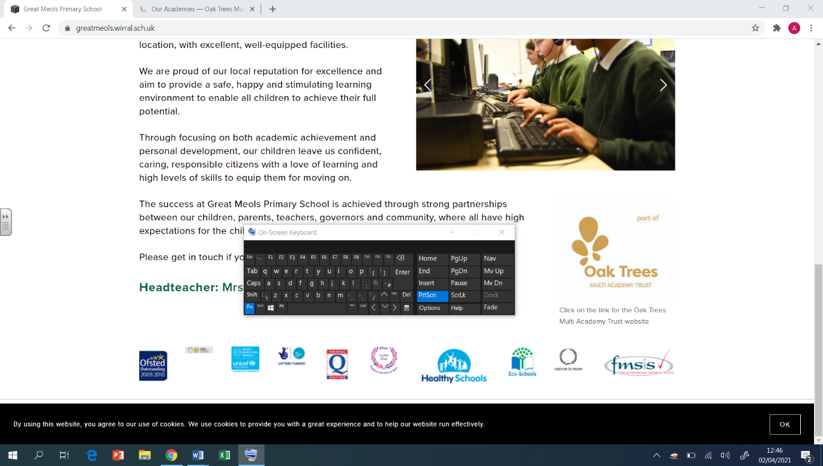  Y5  Autumn Overview | PE  - Tag Rugby  - To pass well to my left and right  - How to grip a ball and the importance of carrying it in 2 hand  - Dance- Through the ages  - Creatively change static actions into travelling movements  - Communicate effectively within a group  - Gymnastics – Partner work under and over  - Perform with good technique and seamless transitions  - How to vary the speed of my movements, to  demonstrate contrast  - Health Related Fitness  - Why core strength is important in most sports  - Why it is important to warm up prior to exercise
Geography  - To locate South America and its surrounding oceans  - To identify countries in South America and their capital cities  - To investigate the similarities and differences in rainfall and temperature in Brazil and the UK  - To identify the physical features of South America  - To investigate the areas of Brazil and compare the lives of children there and here. | DT  Cooking & Nutrition: Developing a Recipe  - To make adaptations to design a recipe.  - To evaluate nutritional content.  - To practise food preparation skills.  - To follow and make an adapted recipe.  Electrical Systems: Doodlers  - To understand how motors are used in electrical products.  - To investigate an existing product to determine the factors that affect the product’s form and features.  - To apply the findings from research to develop a unique product. | RE  Judaism  -The Jewish sacred texts are the Torah – the Written Torah and the Oral Torah.  -Jews are required to follow the Ten Commandments and the other laws in the Torah.  -The weekly celebration of Shabbat (Sabbath) is sometimes seen as the most important. It requires that no work is undertaken from sunset on Friday until sunset on Saturday.  -That the principal Jewish place of worship is the home, but the central place for community worship is the synagogue.  -Know that faith and commitment are intertwined through practice and tradition and almost every aspect of Jewish life is influenced by religion: eating; clothes; prayer.  The true meaning of Christmas  -Know why Christians celebrate Christmas  -know the importance of love at Christmas time  -understand the meaning of ‘incarnation’.  -To know why people give gifts at Christmas time.  -To know the meaning of commercialisation and its impact on Christmas
Computing  Computing systems and networks  - Develop understanding of computer systems and how information is transferred between systems and devices.  Creating media  - Learn how to create short videos and develop the skills of capturing, editing, and manipulating video.  - Keeping private and personal information to ourselves. | Art  Artist: LS Lowry  Drawing (perspective)  - Use a sketchbook to develop ideas.  - Use a variety of source material for their work. Work in a sustained and independent way from observation, experience and imagination.  - Explore the potential properties of visual elements, line, tone, pattern, texture, colour and shape. | PSHE  Family and Relationships  - Developing an understanding: of families, including marriage, of what to do if someone feels unsafe in their family; that issues can strengthen a friendship; exploring the impact of bullying and what influences a bully’s behaviour; learning to appreciate our attributes.  Health and Wellbeing  - Perform some yoga poses, following the instructions from a video, and describe how yoga makes them feel.  - Describe how they can get a good night’s sleep and explain why this is important.  - Describe why they should embrace failure.  - Describe a strategy to help manage feelings of failure and to help them to persevere.  - Set themselves goals and consider how they will achieve them.  - Describe a range of feelings and suggest two ways of dealing with a difficult situation.  - Demonstrate an understanding of what calories are and how to use them to help plan healthy meals.  - Recognise the food groups and acknowledge that having a variety of food is important for having a balanced and healthy diet.  - Understand how to keep safe in the sun and some of the risks, now and in the future, if they don’t.

