Science  States of Matter  - Solids, liquids and gases  - Heating and cooling  - The water cycle  Electricity  - Electrical appliances  - Simple circuits  - Electrical components  - Conductors and insulators | Music  Body and tuned percussion (Rainforest theme)  - Identify the structure of a piece of music  - Be able to identify when there is more than one layer of music  - Play a sequence in the correct order in time with a partner.  - Play two contrasted rhythms  - Play two different melodies.  - Play a piece of music with four layers.  Rock and Roll  - Perform the hand jive actions in sequence and in time with the music.  - Sing in tune and perform their actions in time.  - Play the notes of the walking bass in the correct sequence.  - Independently play their part with some awareness of the other performers. | Spanish  Dates in Spanish  - To identify and say the numbers 13 to 31.  - To ask and answer questions about the months of the year.  - To identify and say dates.  - To ask and answer questions about significant dates.  - To identify and give the dates of specific events.  - To listen to and understand spoken language.  Pets in Spanish  - To apply new vocabulary to talk about pets.  - To recognise that an adjective must agree with the noun it describes.  - To describe an animal’s characteristics.  - To read and understand a short story.  - To write a story about pets in Spanish.  - To rehearse and perform a short role-play.
History  Anglo Saxons and Vikings  -to know what Britain was like before the Viking invasion  -local area links to Wirral and understanding why the Vikings would have settled here and how they kept order  -look at the leadership of Ingimund and why he was important  -look at the legacy left by the Vikings and how this is significant for Wirral | Brackenwood Junior School    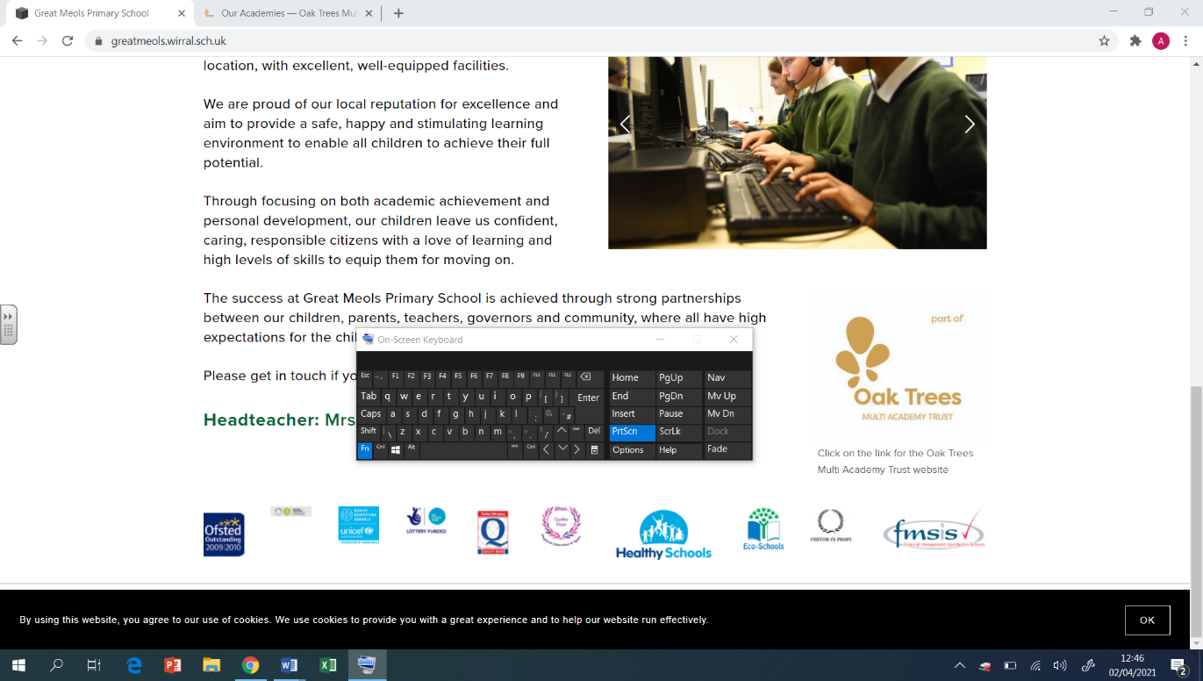  Y4  Autumn Overview | PE  Swimming  - To swim one stroke effectively for 15m  Athletics  - Develop my coordination to improve my speed  - Develop the technique and consistency of my  - jumps  Hockey  - To receive a pass on the run  - Not to raise the stick above waist height  Netball  - To pass in front of my teammates so they can run on to the ball  - Rules which apply to attackers and defenders when shooting
Geography  - To locate European countries and capital cities within the continent and examine its seas.  - To explore the locations of countries within Europe (and in relation to the seas)  - To make connections and draw conclusions about a European country | DT  Mechanical Systems: Slingshot Cars  - To build a car chassis.  - To design a shape that reduces air resistance.  - To make a model based on a chosen design.  - To assemble and test my completed product.  Textiles: Fastenings  - To design a product to meet design criteria.  - To make and test a paper template.  - To assemble a book jacket. | RE  Islam and Christianity  -What it means to pray and how there are rules to follow  -To understand the ‘Call to Prayer’ and what it means to Muslim people.  -To understand the Lord’s Prayer and what it means to Christians.  -To know there are different holy books for each of the World Religions and they will know how to respect the Qur’an.  -Understand why the Qur’an is sacred to Muslims and begin to understand how God is respected in the Islamic faith.  Christianity - Shepherds  -To recall the key points of the Christmas Story.  -To know why the shepherds were chosen and to consider how the shepherds may have reacted to the angel visitation.  -To know what the role of a shepherd might involve and to understand what their lives may have been like in Biblical times
Computing  Computing systems and networks – The Internet  - Apply knowledge and understanding of networks, to appreciate the internet as a network of networks which need to be kept  Creating media - Audio production  - Learners will identify the input device (microphone) and output devices (speaker or headphones) required to work with sound digitally. Learners will discuss the ownership of digital audio and the copyright implications of duplicating the work of others. | Art  Sculpture (clay) and Painting  - Make informed choices about the 3D techniques chosen. Show an understanding of shape, space and form.  - Plan, design, make and adapt models.  - Talk about their work understanding that it has been sculpted, modelled or constructed. | PSHE  Family and Relationships  - Learning that families are varied and differences must be respected; understanding: physical and emotional boundaries in friendships; the roles of bully, victim and bystander; how behaviour affects others; appropriate manners and bereavement.  Health and Wellbeing  - Identify and share key facts about dental health.  - Describe a calm place that helps them to feel relaxed.  - Describe how they feel when they make a mistake and explain what can be learned from making mistakes.  - Write or describe their strengths and how they could use these in school.  - Describe what makes them happy, suggesting how they could work towards this as a goal.  - Explain that there are some things they can control and others they cannot.  - Understand the range of emotions we can experience.  - Understand what mental health is and that sometimes people might need help.

