Science  Forces and magnets  - Friction  - Push, pull and twist  - North and south poles of a magnet  - Magnet fields  Rocks  - Comparing and classifying rocks  - Fossils  - Soils | Music  Ballads  - Identify key features of a ballad  - Perform a ballad using actions  - Sing in time and in tune with a song and incorporate actions.  - Retell a summary of an animation’s story.  - Write a verse with rhyming words which tell part of a story.  - Perform their lyrics fluently with actions.  Creating compositions for an animation (mountains)  - Verbalise how the music makes the feel.  - Create actions or movements appropriate to each section of a piece of music.  - Play in time and with an awareness of other pupil’ parts, giving some thought to dynamics.  - Play melodies and rhythms which represent the section of animation they are accompanying. | Spanish  Spanish Greetings  - To greet someone and make an introduction in Spanish.  - To say goodbye and listen and recognise key phonemes ‘o’ and ‘a’.  - To recognise different greetings in Spanish.  - To find out how someone is feeling in Spanish.  - To explore a Spanish tradition through learning and performing a Spanish rhyme.  Spanish Numbers and Ages  - To recognise and recall numbers 1 to 6 in Spanish.  - To recognise and practise numbers 1 to 10 in Spanish.  - To read and recognise numbers up to 12 in Spanish.  - To recognise and build a phrase to give your age in Spanish.  - To ask and answer questions giving personal information.  - To identify key phonemes in number words.
History  Stone Age to Iron Age  -to know the order of Stone, Bronze and Iron ages  -look at how shelters change throughout the time periods  -understand how farming and settlements changed daily life  -look at the use and development of weapons and tools  -look at the historical sources found in Skara Brae | Brackenwood Junior School  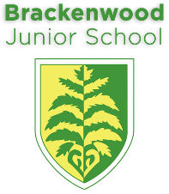  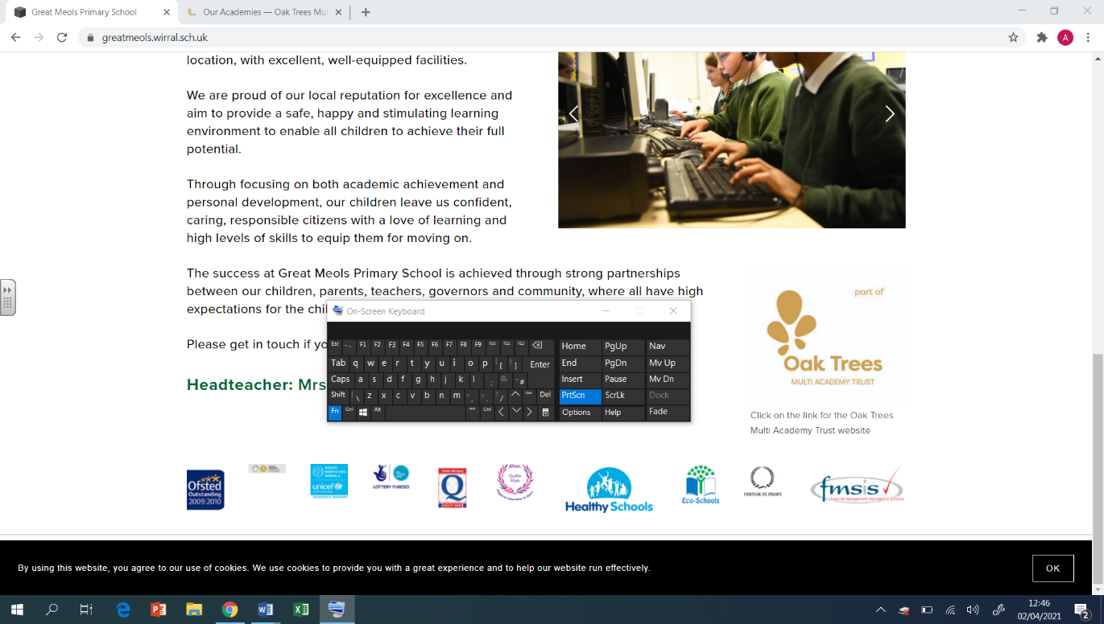  Y3  Autumn Overview | PE  Tag Rugby  - To run at pace and commit a defender when attacking  - How to hold a rugby ball  Modern Dance (Dance Around the World)  - Creatively change static actions into travelling movements  - How to recognise good timing, execution and  - performance skills  Gymnastics (Linking Movements Together)  - How to move from one from one shape to another smoothly  - How to use the space available to the best of my ability  Basketball  - How to shoot the basketball  - The techniques of passing the ball
Geography  To know the difference between the UK, Great Britain and the British Isles and locate major cities in the UK using the 8 point compass  To use a legend to find areas of higher ground on a map  To name and locate seas surrounding the UK and identify ways land has changed over time  To name and locate major rivers in the UK  To name and locate lakes using topographical maps  To define a county and locate our local counties | DT  Textiles: Cross-stitch and Appliqué (Egyptian Collars)  - To learn how to sew cross-stitch and appliqué.  - To develop and use a template.  - To assemble fabric parts into a fabric product.  - To decorate fabric and using appliqué and cross-stitch.  Structures: Constructing a Castle  - To design a castle.  - To construct 3D nets.  - To construct and evaluate my final product. | RE  Islam  -The difference between the terms Islam and Muslim  -They will know about the 5 pillars and be able to name them and refer to them.  -What is a mosque and to know what happens there.  -To know about some Islamic traditions.  -To know what makes someone a role model.  Christmas  -Know the importance of Angels and their work for believers and non-believers  -Know importance of the role of the Angels in the Christmas Story
Computing  Computer systems and Networks Learners will develop their understanding of digital devices, with an initial focus on inputs, processes, and outputs. They will also compare digital and non-digital devices.  Creating Media Learners will use a range of techniques to create a stop-frame animation. Next, they will apply those skills to create a story-based animation | Art  Light and Shade- Drawing and Painting  - Experiment with different grades of pencil and other implements.  - Plan, refine and alter their drawings as necessary.  - Use their sketchbooks to collect and record visual information from different sources.  - Use different media to achieve variations in line, texture, tone, colour, shape and pattern.  - Mix a variety of colours and know which primary colours make secondary colours. | PSHE  Family and Relationships  Learning: how to resolve relationship problems; effective listening skills and about non-verbal communication. Looking at the impact of bullying and what action can be taken; exploring trust and who to trust and that stereotyping can exist.  Health and Wellbeing  - Create a healthy diary, where energetic activities and high-energy food are scheduled for the same day.  - Understand the different aspects of their identity.  - Identify their own strengths and that they can help other people.  - Describe how they would break a problem down into small, achievable goals.  - Understand the benefits of healthy eating and dental health.

