# am

Year 6 Autumn 2 - Christianity

Theme: Special People, Special Places: Christmas Around the World

Golden Threads: Celebration and Diversity



British Values –

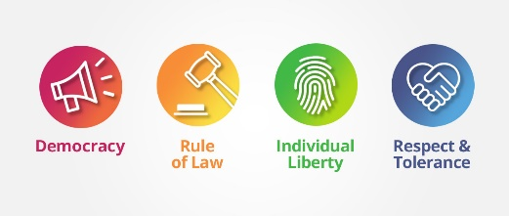

Democracy Mutual Respect

& Tolerance

Individual liberty

Retrieval links –

EYFS

Year 1 and 2

Year 3 and 4

Year 5

Links to other religions –

Judaism Islam

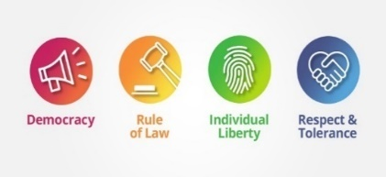

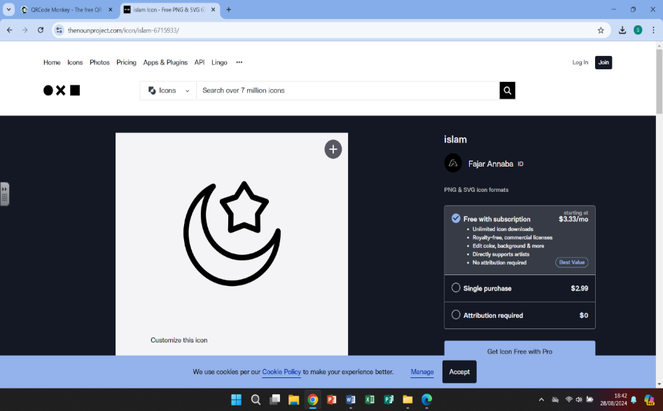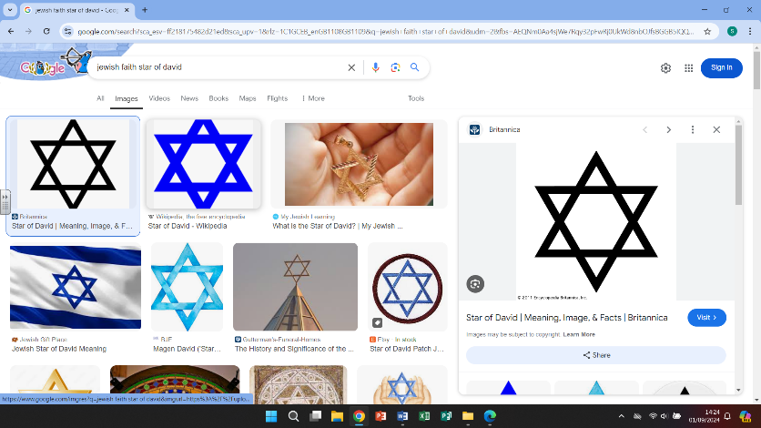

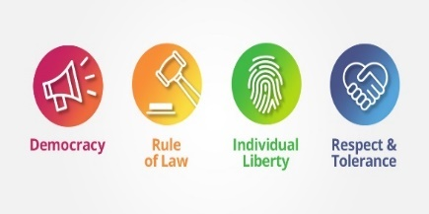

|  |  |
| --- | --- |
| Vocabulary - | |
| Christianity | Religions that believe the son of God was born a man named Jesus of Nazareth |
| Catholic | Followers of the Roman Catholic Church |
| Secular | Not connected with religious or spiritual matters |
| Tradition | Customs or beliefs from generation to generation |
| Midnight Mass | A Christian church service that takes place on Christmas Eve |
| St Nicholas | An early Christian bishop |
| Moral | Being concerned with right or wrong/having high principles |
| Epiphany | A moment of sudden and great realization and revelation |
| Advent | The four Sundays in the lead up to Christmas |
| Fasting | To abstain from all food and drink -as part of a religious belief |
|  |  |

Christianity

# 

Christianity grew from the Judaism religion in the Middle East. When Jesus, who was born to

a Jewish mother, began to preach the Christian religion. Christianity now has a huge following

and is one of the largest of the world religions.



Christmas is celebrated by Christians all over the world. Although, all countries have their

own traditions, there are many similarities including the belief that helping others is

fundamental to living a good Christian life.

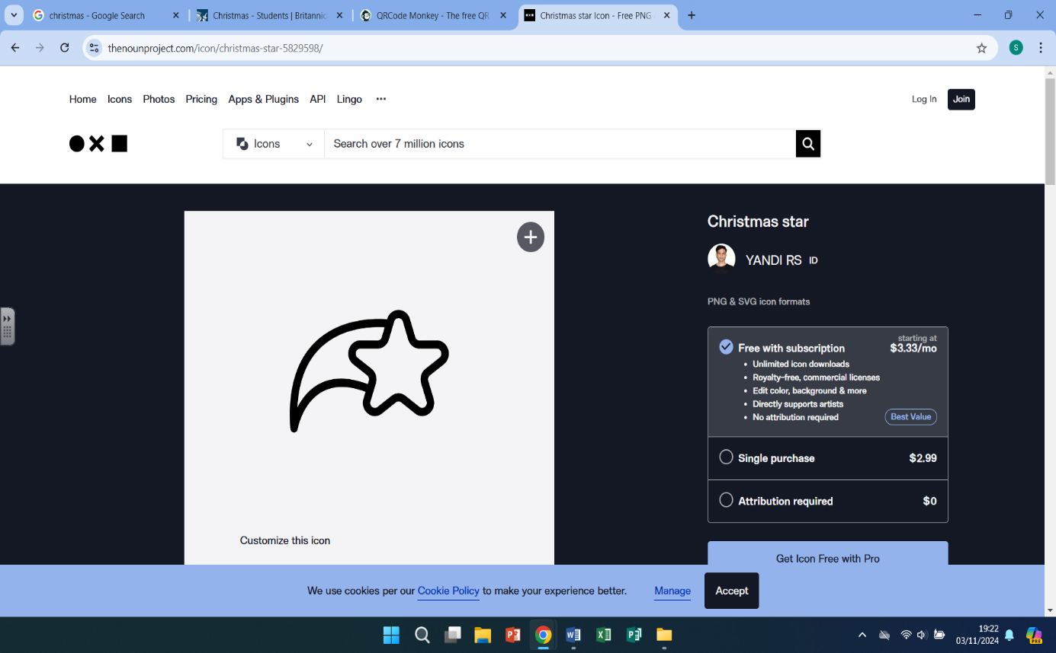

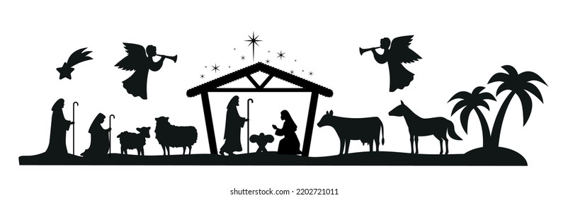

What we are learning

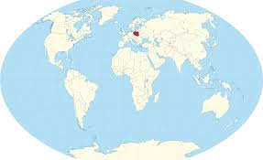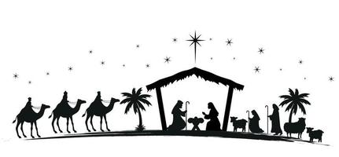

4.

-look for Poland on a map

-understand the importance of St Nicholas

-learn about the importance of food and fasting during the celebrations. How Catholics believe it sharpens their faith and how to be charitable

1.

-Looking at what Christmas means

to me – Christmas traditions, origins of Christmas (as we

celebrate today), the Christmas story and the birth of

Jesus,

-How has Christmas changed over the years

WHAT?

5.

-Learn where Nigeria is in the world

-look at how the Nigerian people celebrate

With music

-compare Nigerian Christmas traditions to

celebrated in the UK – similarities and differences

2.

-

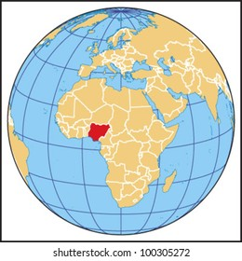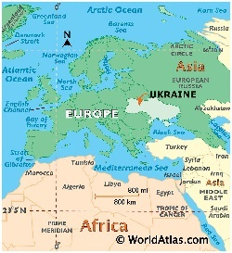 2.

-Learn where Ukraine is on a map

-Understand that traditions are different

In other countries

-Learn the story of the Christmas spider – a symbol of

good luck and fortune for the new year.

6.

Look at the traditions in

Brazil – including giving

White gifts on Christmas

Eve, at midnight mass, and the moral belief that

they must help the poor

3.

-Identify Mexico on a world map

-Learn different traditions – how

Christmas day is quiet, that January 6th is traditionally the day the King’s visit with gifts

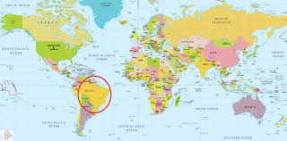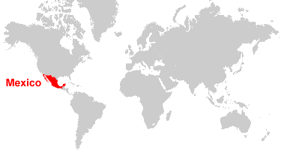

Helpful links

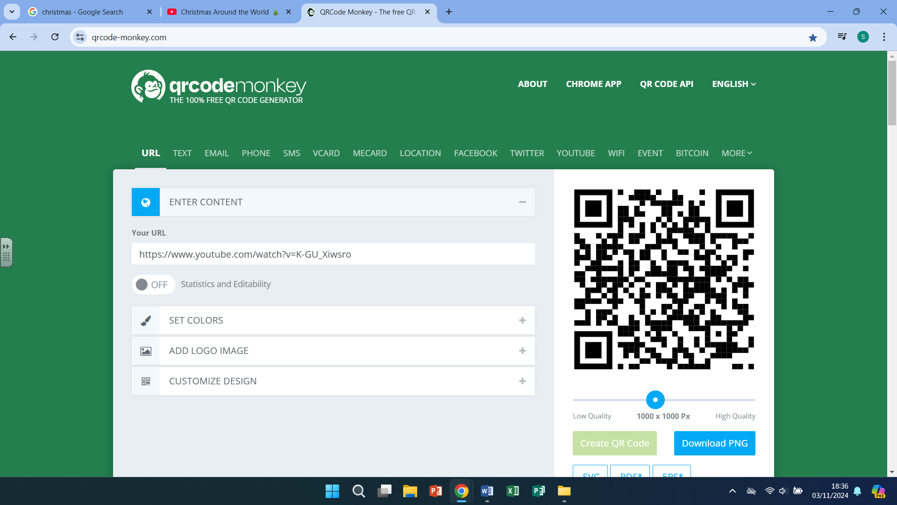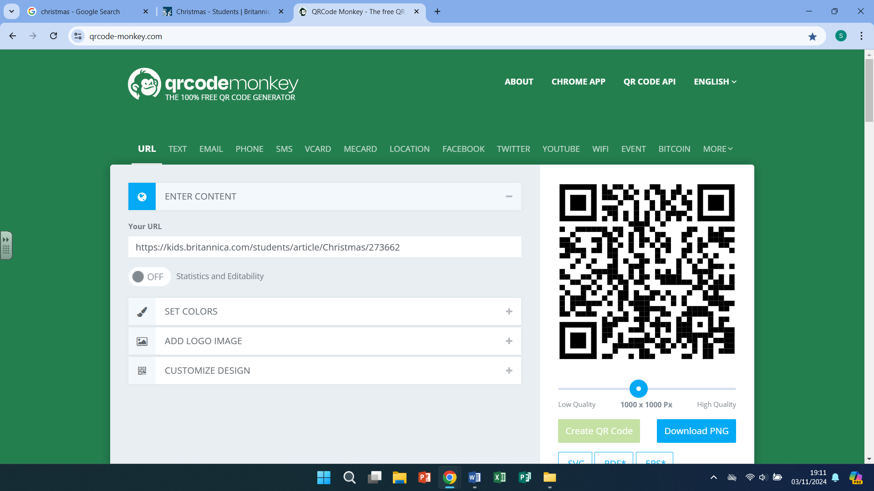

Christmas Around the World Britannica Kids

-Christmas traditions