# am

Year 5 Autumn 2 - Christianity

Theme: Special People, Special Places: The True Meaning of Christmas

Golden Threads: Celebration



British Values –

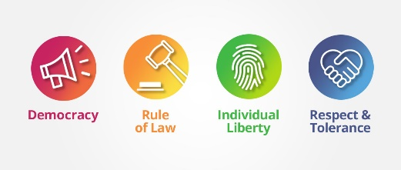

Democracy Mutual Respect

& Tolerance

Retrieval links –

EYFS

Year 1 and 2

Year 3 and 4

Year 5

Links to other religions –

Judaism Islam

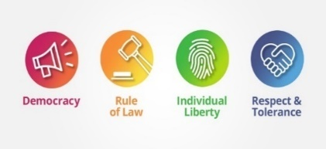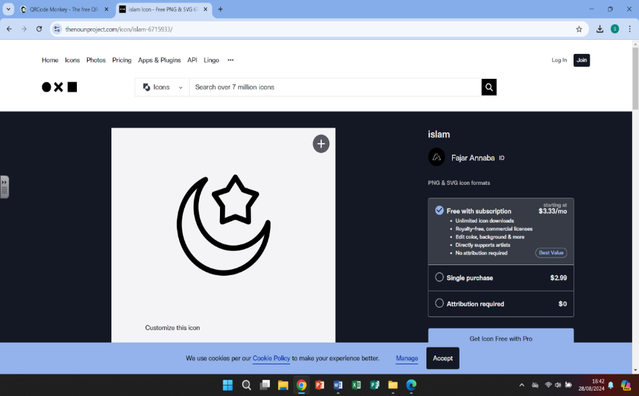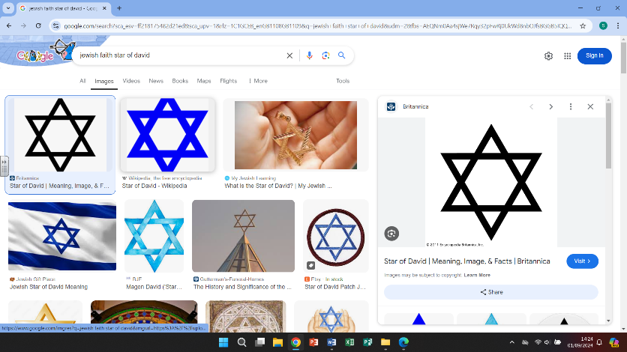

|  |  |
| --- | --- |
| Vocabulary - | |
| Christianity | Religions that believe the son of God was born a man named Jesus of Nazareth |
| Pagan | A person holding religious beliefs not those held by the main/recognized big religions |
| Secular | Not connected with religious or spiritual matters |
| commercialisation | Managing or running something for financial gain |
| Midnight Mass | A Christian church service that takes place on Christmas Eve |
| St Nicholas | An early Christian bishop |
| Moral | Being concerned with right or wrong/having high principles |
| Refugee | People who have fled war, violence or persecution, crossing borders to find safety |
| Incarnation | A person who embodies in the flesh a deity, spirit or quality |
| Precious | Something of great value – but not always valuable |
|  |  |

Christianity

# 

Christianity grew from the Judaism religion in the Middle East. When Jesus, who was born to

a Jewish mother, began to preach the Christian religion. Christianity now has a huge following

and is one of the largest of the world religions. Christmas is now traditionally celebrated to

remember the birth of Jesus.



Although Christmas is traditionally about the birth of Jesus, many people focus more on the

traditions and the gift giving rather than the true religious meaning.

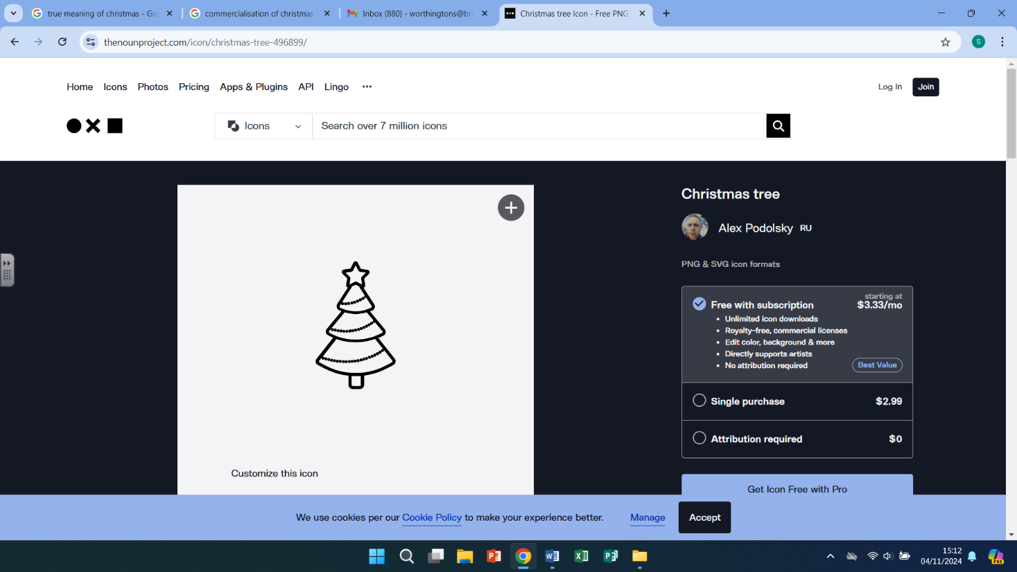

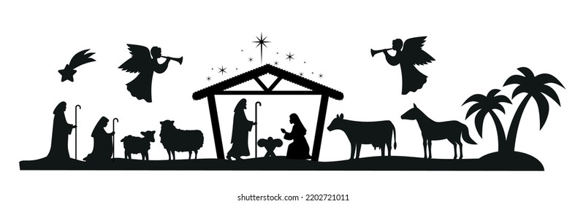

What we are learning

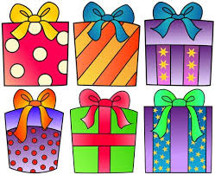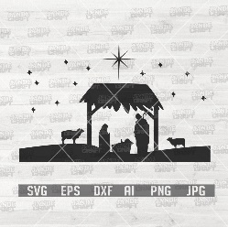

4.

-think about what precious means

(something of value but not always valuable)

-think about giving gifts and how much pleasure we

get from giving – make links to how the Wise men brought gifts for Jesus

1.

-Discuss what Christmas means

-Look at the origins of Christmas and how Christmas is

celebrated

-Recap the Christmas story and the birth of Jesus,

-How has Christmas changed over the years

WHAT?

5.

- looking at the origins of the

Christmas Story

-look at how Christmas has changed and the now

How it is more commercialized

-Can we still find the true meaning of Christmas?

2.

-

 2.

-Look at how the bible talks

about helping others

- How do we show love and appreciation, at Christmas,

and all year round?

-children to make pledges of kindness

3.

-Explore the meaning of incarnation

(embodying physically a deity or spirit)

-look at how helping people is important

to Christians

-look at the modern world and how we can help others, with a focus on refugees

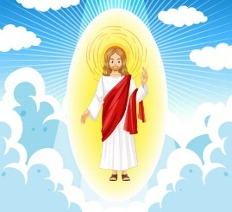

Helpful links

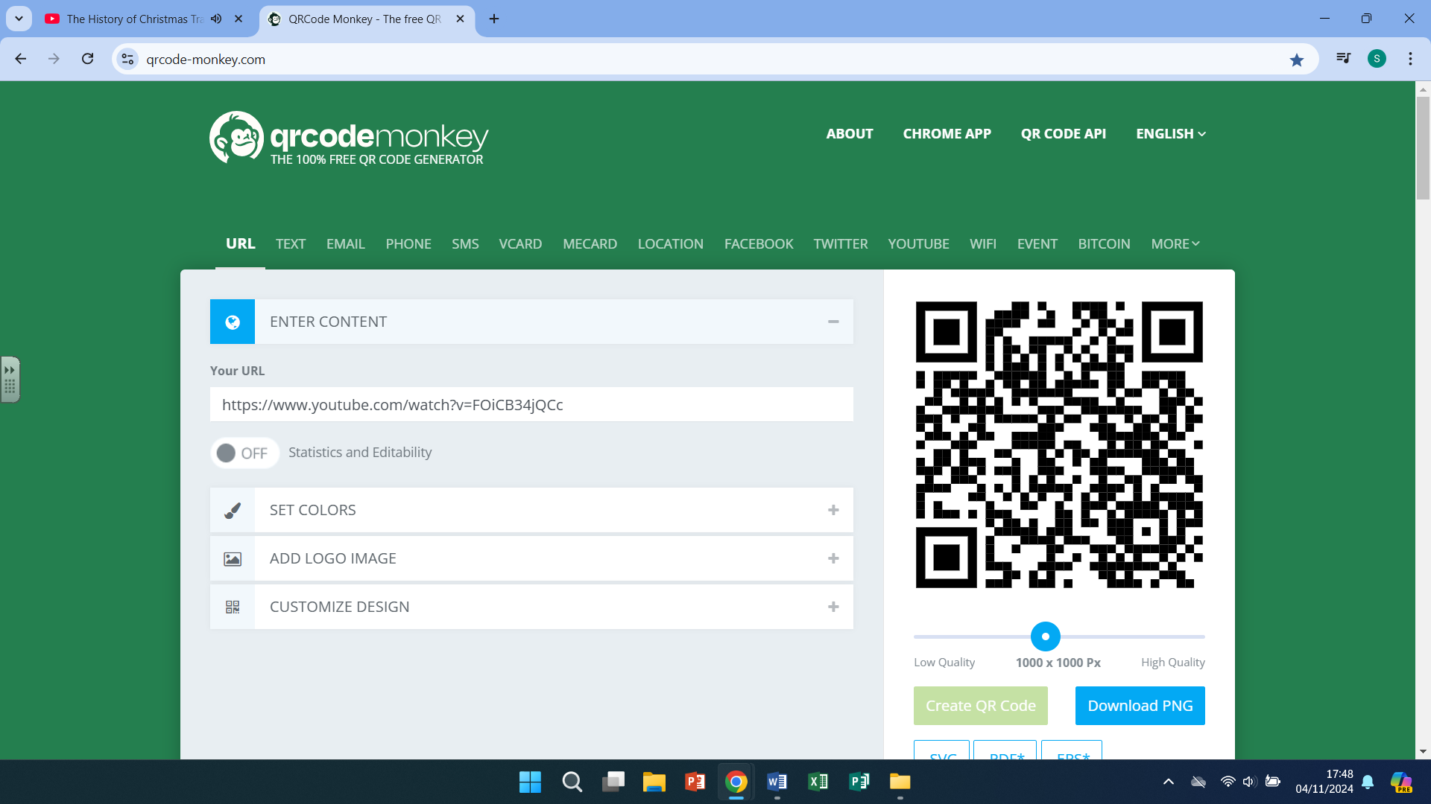

The true meaning of Christmas Christmas traditions in the UK