# am

Year 4 Autumn 2 - Christianity

Theme: Special People, Special Places: The role of the shepherds in the Christmas Story

Golden Threads: Love, Faith, Journey



British Values –



Democracy Mutual Respect

& Tolerance

Individual liberty

Retrieval links –

EYFS

Year 1

Year 2

Year 3

Links to other religions –

Judaism



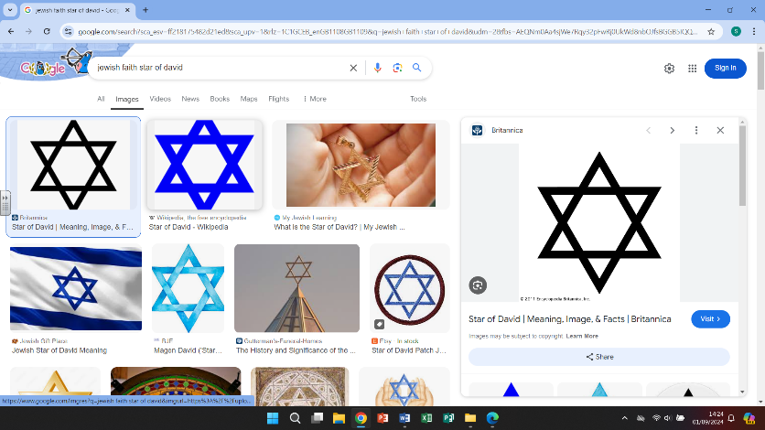



|  |  |
| --- | --- |
| Vocabulary - | |
| Christianity | Religions that believe the son of God was born a man named Jesus of Nazareth |
| Angel Gabriel | Best known for his appearance in the Christmas Story |
| Bethlehem | The biblical birthplace of Jesus |
| Shepherds | A person who tends or rears sheep |
| Star of Bethlehem | A prominent star that is said to have guided visitors to the baby Jesus |
| Astronomy | The branch of science that deals with celestial objects, space and the universe |
| flocks | A group of sheep |
| Israel | A country in the southern region of West Asia |
| Old Masters | Artists that painted in the 13th-17th century, mostly in Europe |
|  |  |
|  |  |

Christianity

# 

Christianity grew from the Judaism religion in the Middle East. When Jesus, who was born to

a Jewish mother, began to preach the Christian religion. Christianity now has a huge following

and is one of the largest of the world religions.



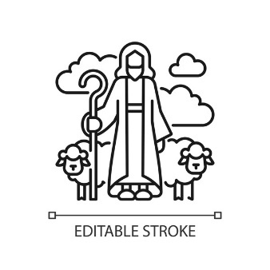

The shepherds were visited by the angels. They gave a message about the upcoming birth of

the baby Jesus. The shepherds left on the long journey to Bethlehem.

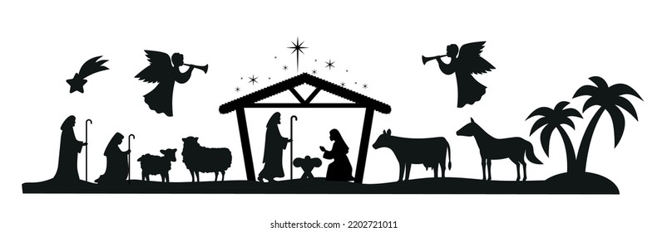

What we are learning

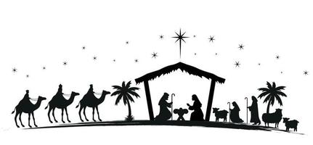

4.

- following the long, arduous and

dangerous journey taken by the

Shepherds.

-compare items that they would have taken with them and the items we would consider important now.

1.

-Recall the order and events of the

Christmas story

--look at the role of the shepherds and why they were chosen to meet the baby Jesus

-The shepherds were ordinary people with no riches

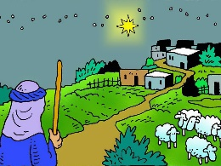WHAT?

5.

-looking at how the shepherds are

portrayed in famous, classic art

-how despite being ordinary people

their importance on the journey is

recorded, just like the kings and

others from a higher status

2.

-

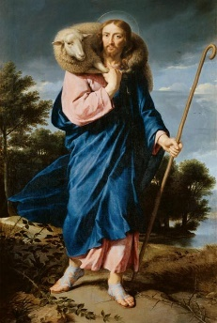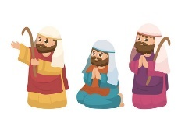 2.

-Looking at the job of a shepherd (the positives and

negatives working with animals, but lonely working on

your own)

-comparing the job of a shepherd from the Christmas story

with the role of a shepherd now and if the job is still

similar to how it was.

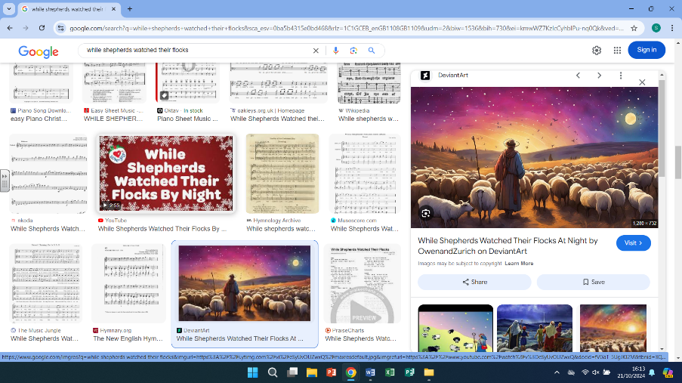

3.

-Look at a map and identify where

Bethlehem is.

-Look at how the star lead the way

and how it was used by the Kings to find the baby Jesus.

6.

-focus on the Christmas Carol ‘While Shepherds watched’ Read through and identify the parts of the journey and how closely the lyrics are to the Bible story

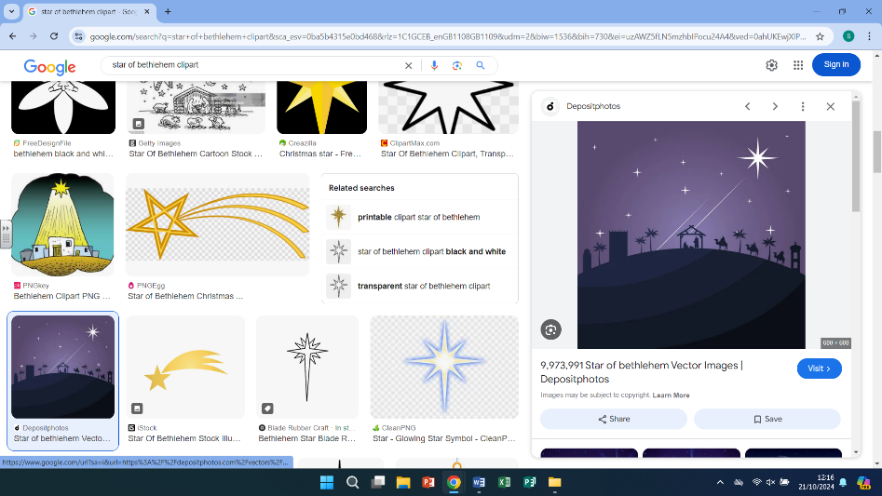

Helpful links



The Christmas Story Britannica Kids Role of the shepherds

-The Shepherds - Christmas