# am

Year 3 Autumn 2 - Christianity

Theme: Special People, Special Places: The role of the Angels in the Christmas Story

Golden Threads: Belief, Belonging, Celebration



British Values –

Mutual Respect and Tolerance

Retrieval links –

EYFS

Year 1

Year 2

Links to other religions –

Judaism Islam

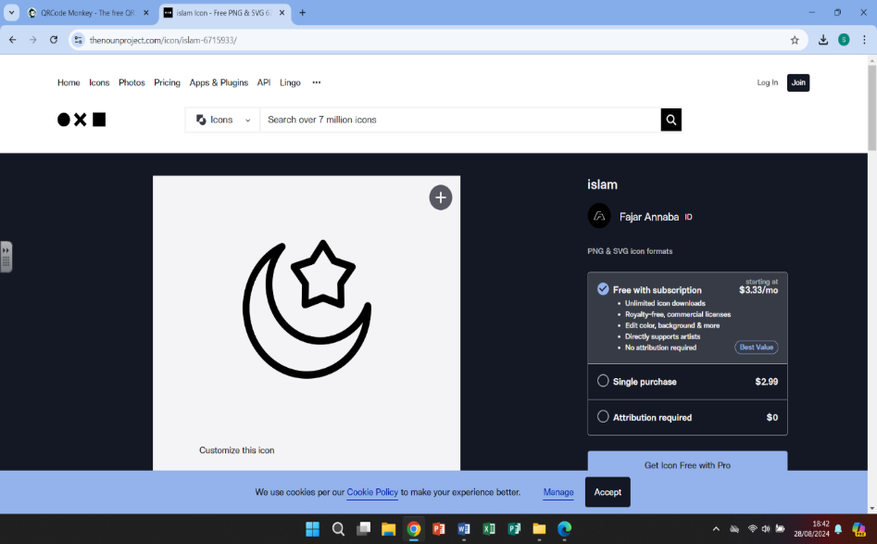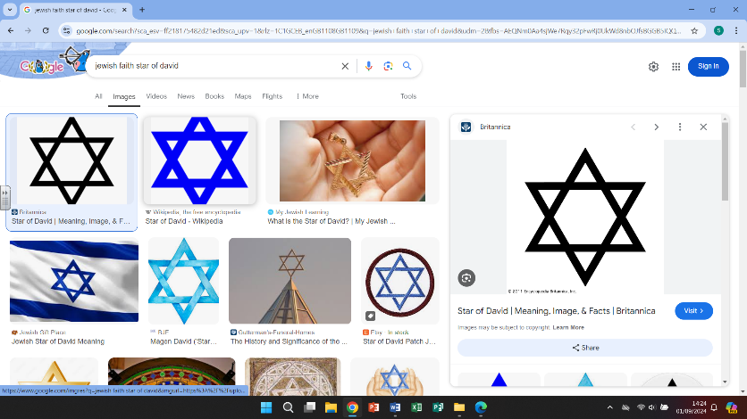

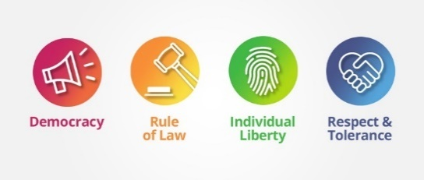

|  |  |
| --- | --- |
| Vocabulary - | |
| messenger | Someone or something that carries a message/errand for another, as a matter of duty |
| Angel Gabriel | Best known for his appearance in the Christmas Story |
| Angels | A spiritual being that acts as a messenger of God. Represented in human form with wings |
| Christianity | Religions that believe the son of God was born a man named Jesus of Nazareth |
| protection | In relation to religion – he protects, defends or is a guardian to his followers |
| guardian angel | A spirit that is thought to watch over or protect a person or a place |
| Bethlehem | The biblical birthplace of Jesus |
| Nazareth | The biblical city where the Angel Gabriel spoke to Mary |
| Jerusalem | A holy city with importance to Christians, Jewish and Muslim faiths |
| King Herod | The king of Judea at the time that Jesus was born |
| Judaism | The monotheistic religion of the Jewish people |

Christianity

# 

Christianity grew from the Judaism religion in the Middle East. When Jesus, who was born to

a Jewish mother, began to preach the Christian religion. Christianity now has a huge following

and is one of the largest of the world religions.



One night, Mary was visited by the Angel Gabriel (the archangel). Gabriel explained that God

was to send his son to earth for mankind and that Mary would soon have a baby, that baby

would be named Jesus and would be God's son.



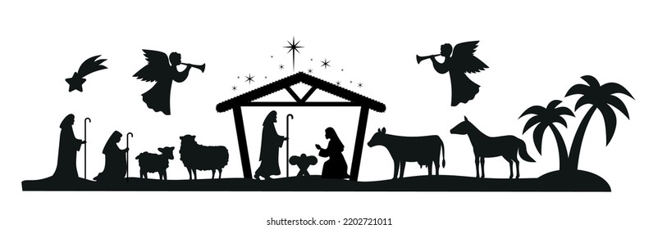

What we are learning

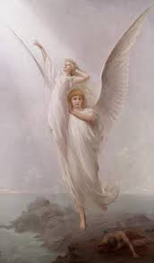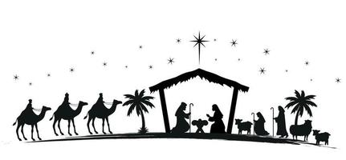

4.

- Looking at a selection of famous

paintings depicting angels – how do

the images represent angels and how

does that make us feel?

1.

-Recall the order and events of the

Christmas story

-Create biographies of each character, exploring their relationships

-Investigate the role of Herod

-Look at how it can be difficult to do the right thing in all situations

WHAT?

5.

-look at how angels are depicted in

Other religions and find the similarities

In the stories

-focus on how the angel Jibril spoke to

Muhammed

2.

-

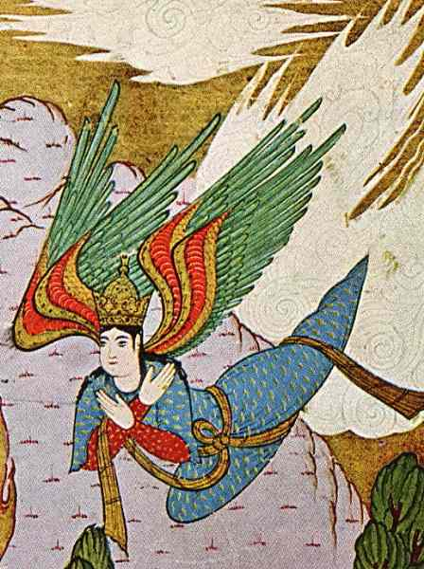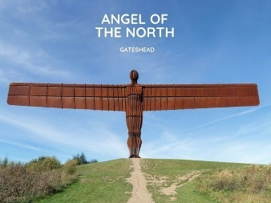 2.

-Look at the symbolism of choosing an angel for a

sculpture

-discuss the role of a guardian angel

-Look at how the angel appears to Mary and Joseph

throughout the Christmas Story

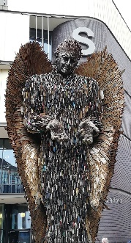

3.

-learn the reason behind the knife angel

-why use the image of an angel?

-look at how the angel travels the

country to spread the word of hope

6.

-focusing on why the angels

appeared to ordinary people, like the shepherds

-how did this make the shepherds fell? Special? Chosen? Important?

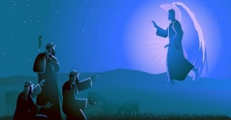

Helpful links





Britannica kids – BBC Bitesize Christianity from Judaism

The Christian faith -What is Christianity?