# Islam

Year 6 Autumn 1 – Islam

Theme: What is it like to follow a Muslim way of life in Britain today?

Golden Threads: Worship, Faith, Identity



British Values –

Rule of law

Mutual Respect/ Tolerance

Retrieval links –

Islam -

Year 1

Year 3

Year 4

Links to other religions –

Christianity

|  |  |
| --- | --- |
| Vocabulary - | |
| Islam | One of the world religions. An Abrahamic monotheistic region based around the Qur’an |
| Muslim | A person who follows the Islamic religion |
| Muhammad | The religious founder of the Islamic religion |
| Allah | The Arabic word commonly used for God |
| Hajj | A pilgrimage (journey) to Mecca |
| Adhan | Adhan means ‘call’ – the adhan calls Muslim people to their prayers |
| Shahadah | One of the 5 Pillars – calls for Muslim people to show their faith in their one God, Allah |
| Sawm | One of the 5 Pillars - Fasting from dawn until dusk during Ramadan |
| Zakat | A payment given to the needy of the community by all Muslims |
| Salat | The belief that all Muslims have an individual relationship with God |
| Qur’an | The holy book of Islam |

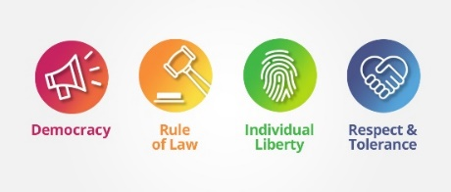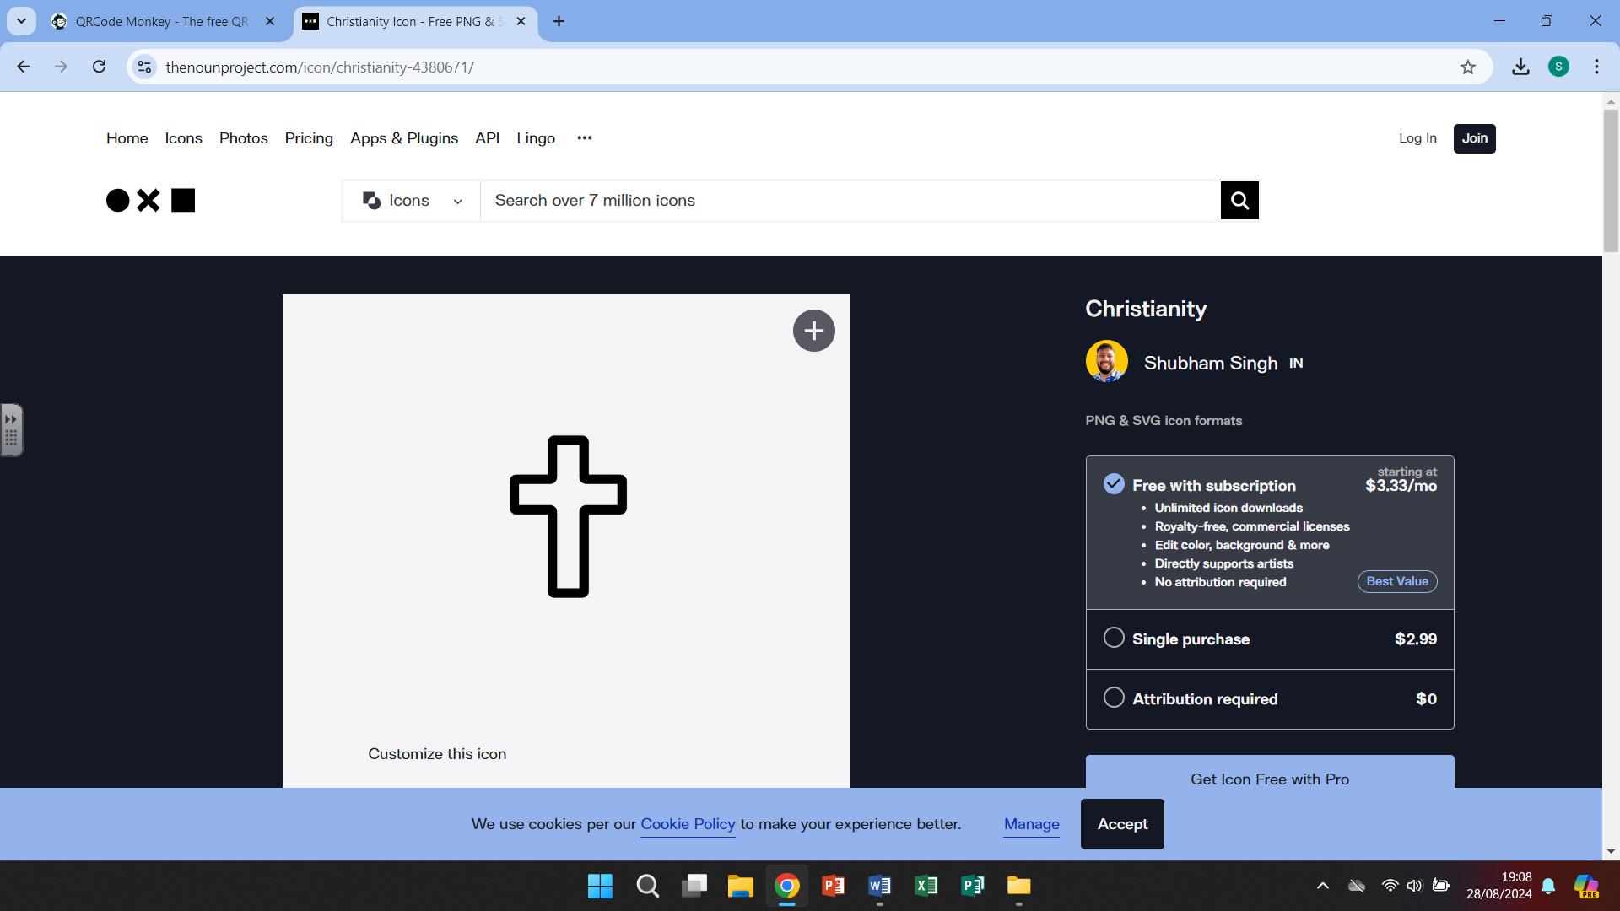

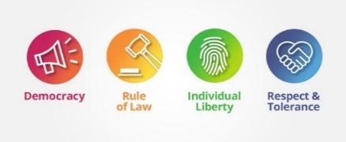

Islam

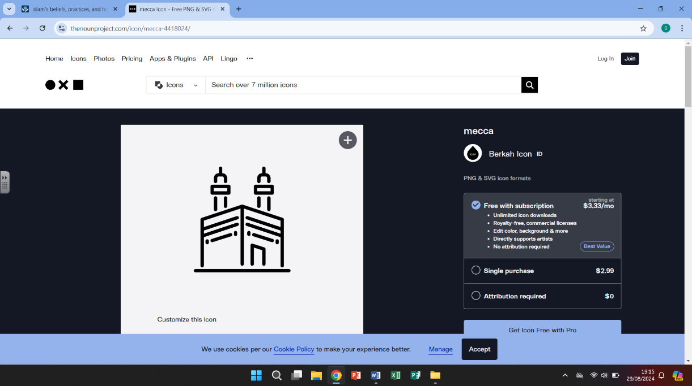

Islam is the second largest religion in the world (over 1.9 billion followers), worldwide only Christianity has more followers. The holy scripture of Islam is called the Qur’an, this contains Allah’s revelations to Muhammed. The prophet Muhammed was born in Mecca and many Muslims take a pilgrimage to pray in Mecca. The Five Pillars of Islam form the foundation of a Muslim’s way of life

# 

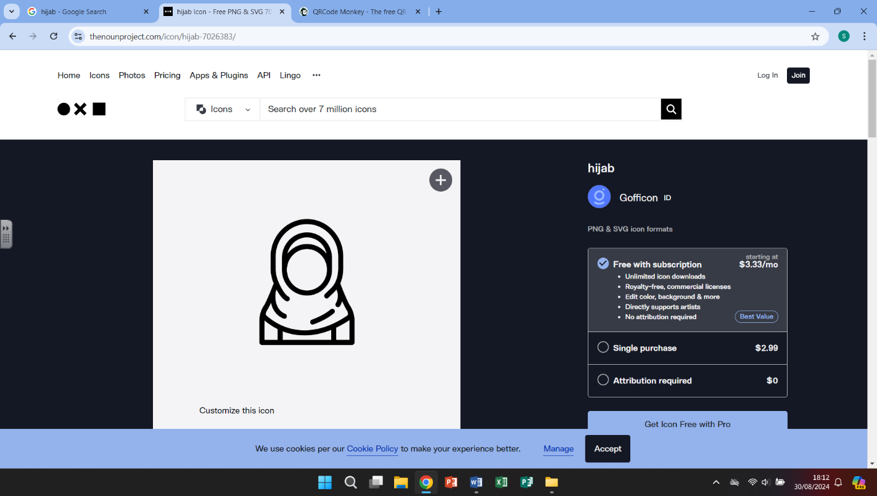

The hijab is usually a scarf worn by women that is wrapped around the head, covering the neck, hair and ears while leaving the face visible. Many view the hijab as a show of modesty and of faith.

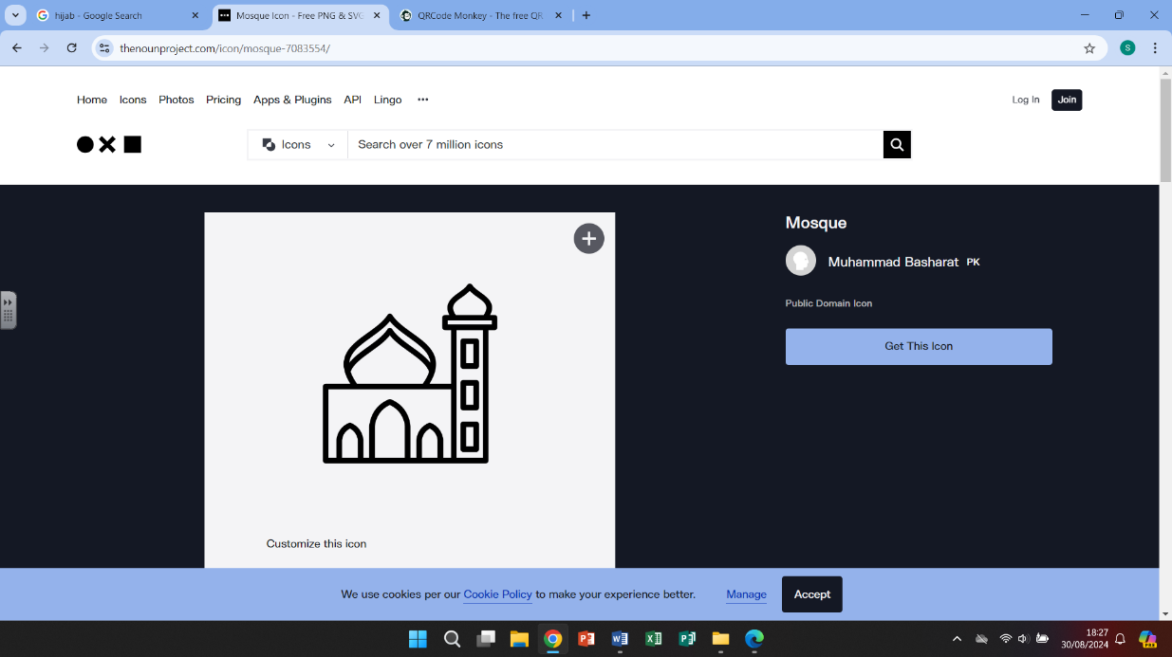

A mosque is a place of prayer. A mosque includes an open space for worship with rugs to cover the floor. A nook in one wall, called a mihrab, shows the direction of Mecca, Islam’s holy city. To the right of the mihrab is a platform, called a minbar. This is where the religious leaders speak to the worshippers. Muslims are required to wash before prayer. Outside most mosques is a tall tower, called a minaret. From the minaret a crier, or muezzin, calls Muslims to prayer.

What we are learning

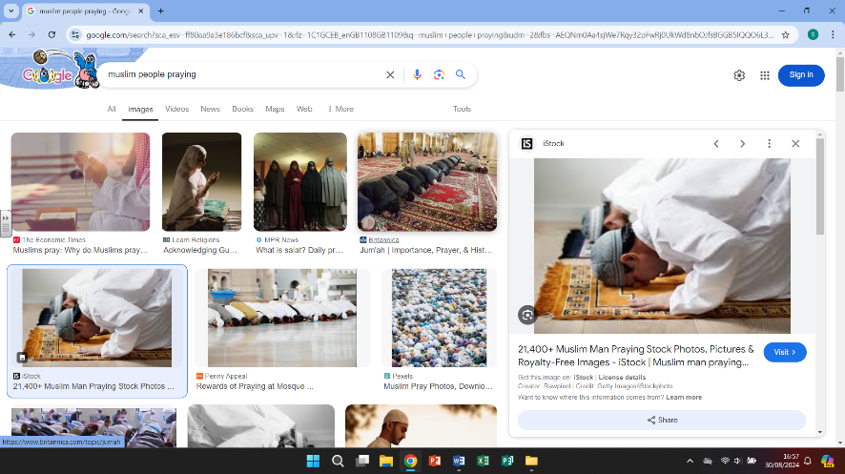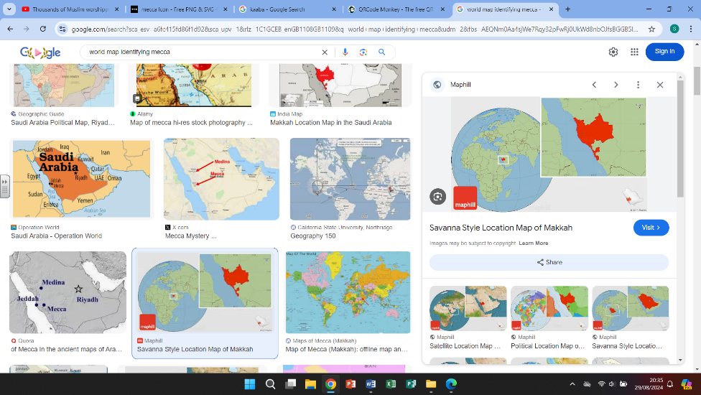

4.

-Prayer plays an important part in a Muslim’s life

-Look at how many times, during a day, a Muslim person spends praying and how we could fit that devotion in our daily schedule

1.

-Learning where Mecca is in the world

-Clarifying and defining what it means to be a Muslim person

WHAT?

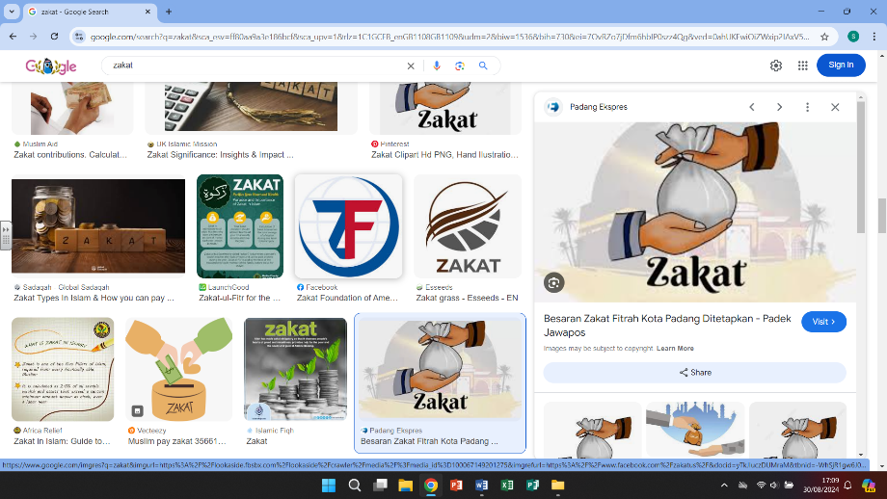

5.

-Learning about the rules we follow in our life

-One of the Five Pillars is called Zakat – this is an obligation and not a choice, to donate to a charity but for no personal benefit or credit for doing the act

2.

-The Qur’an is the holy book of the Islam faith.

-The Qur’an is treated carefully and Muslim

people show great respect to the book.

-The Qur’an is to be recited in the Arabic language

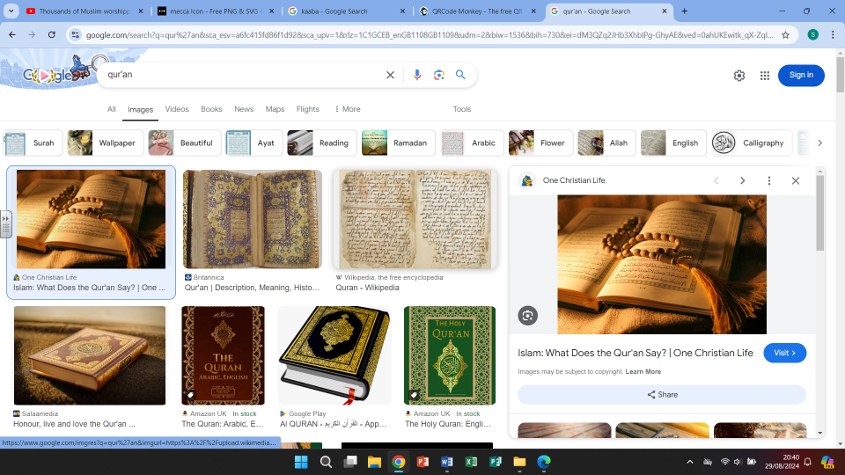

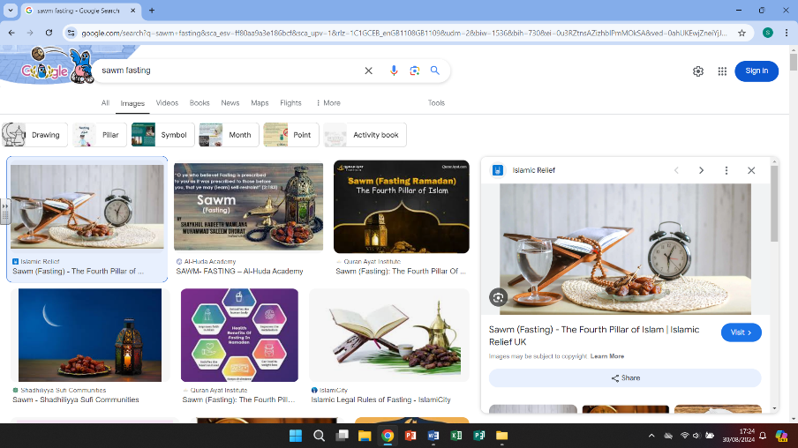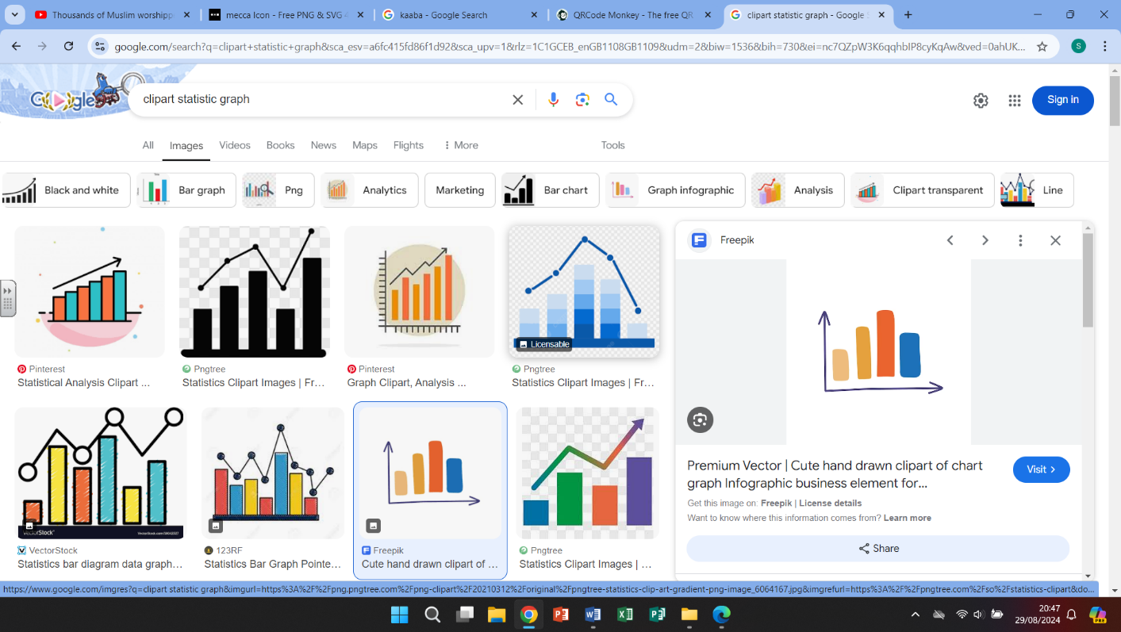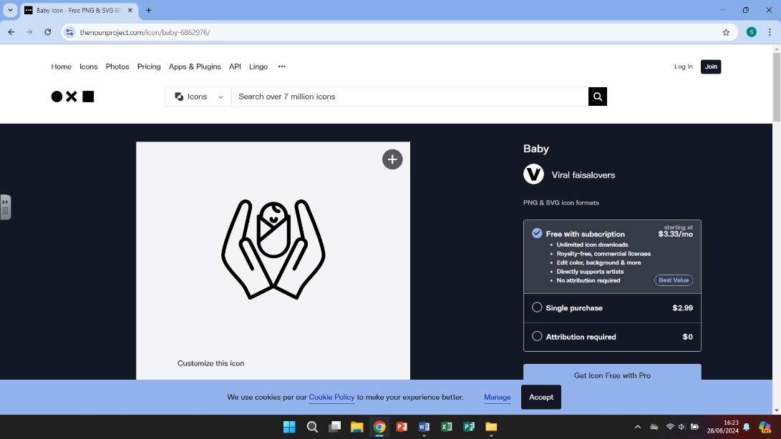

6.

-Sawm is the Arabic term for fasting

-Muslim people are required to fast during the month of Ramadan, from dawn until dusk

3.

-Looking at the population of Great Britain

and how many of the population follow the

Islamic faith.

-Looking at one of the Five Pillars, focusing on Shahadah (that there is only one God and that Muhammed was a messenger

Helpful links

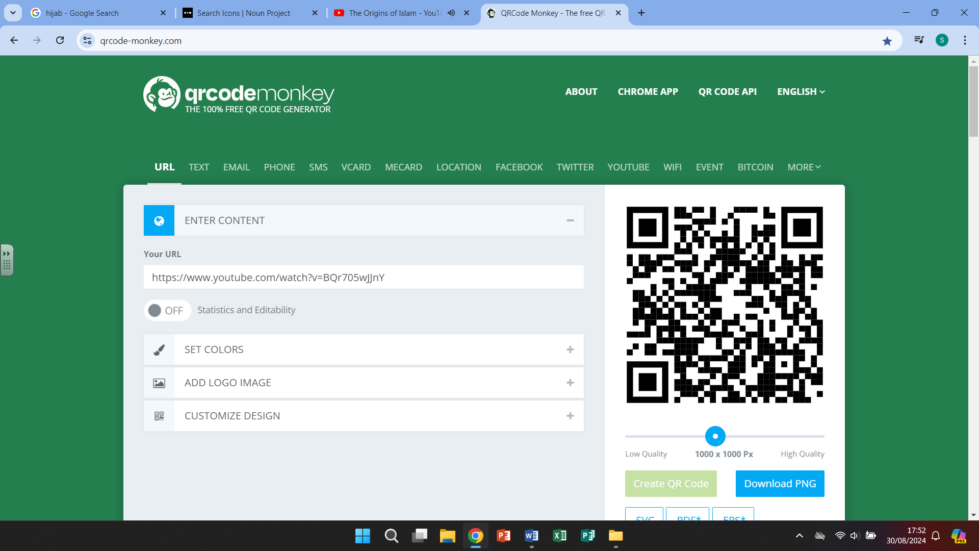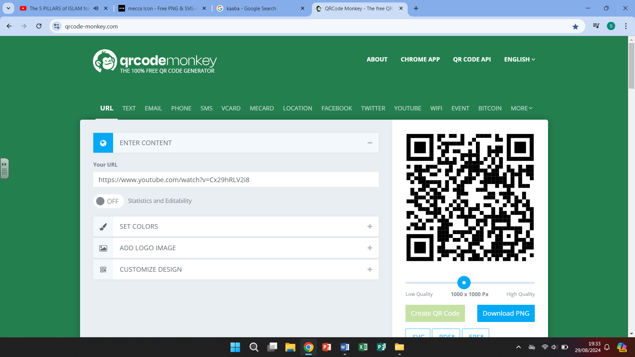

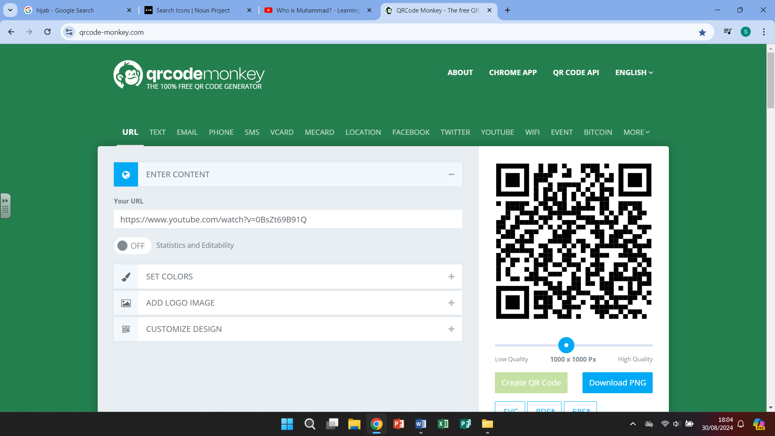

The origins/brief history Who was Muhammed? The Five Pillars

of Islam of Islam