# Islam

Year 5 Autumn 1 - Judaism

Theme: What is it like to follow a Jewish way of life in Britain today?

Golden Threads: Belonging, Belief, Community, Responsibility and Freedom



British Values –

Mutual Respect and Tolerance

Rule of law

Retrieval links –

Judaism -

Year 2

Links to other religions –

Christianity Islam

|  |  |
| --- | --- |
| Vocabulary - | |
| Rabbi | A Jewish religious leader |
| Torah | First five books of the Hebrew bible – Genesis, Exodus, Leviticus, Numbers and Deuteronomy |
| Shabbat | The Jewish day of rest, beginning at sunset on a Friday until sunset on a Saturday |
| Hebrew | A Semitic language used by the ancient Hebrews and in modern Israel |
| Abraham | The first to teach the Jewish people that there is only one God. Jews try to follow his examples |
| Synagogue | A place for Jewish people to worship, meet and study. Sometimes called a temple or a shul |
| Passover | A festival celebrating the story of Exodus (remembering how they escaped from slavery) |
| Star of David | Is generally recognized as the symbol of the Jewish people |
| Kosher | The laws of kosher determine which foods Jewish people can eat. Kosher means fit or proper |
| Yon Kippur | The most sacred day for Jews – time to reflect on the past year and seek forgiveness for any sins |
| Menorah | A candleholder used during the Hanukkah celebration. The menorah holds nine candles. |

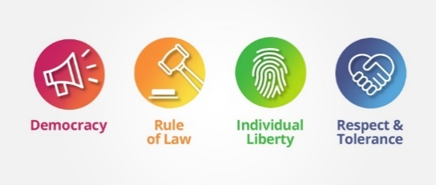

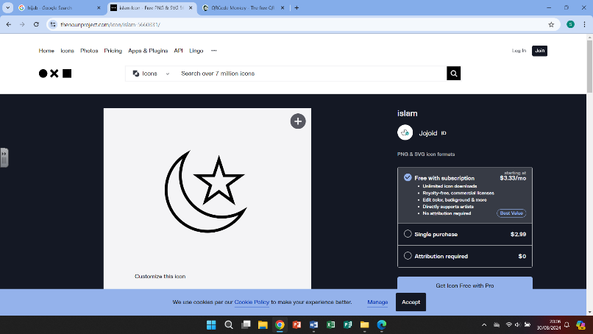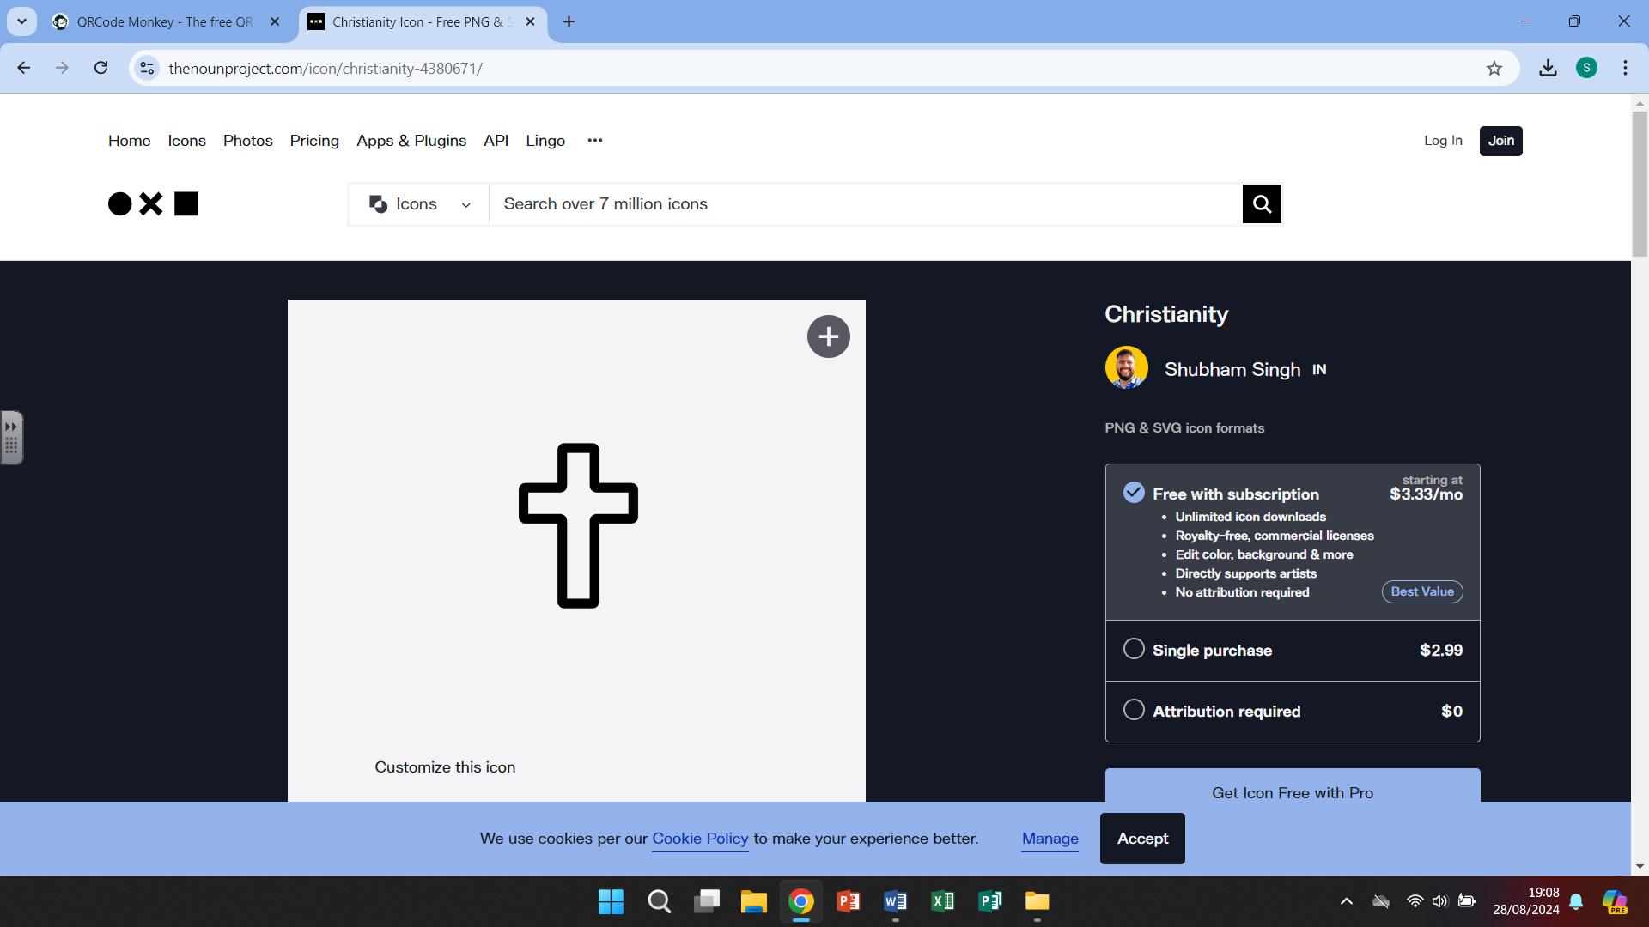

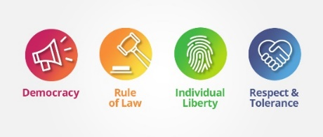

Judaism

The Synagogue is a place of worship for the Jewish people. The Torah scrolls are kept in a cupboard called The Ark. Bimah is a raised platform where most of the service takes place. Siddur is the main prayer book. The Torah Scrolls contain the words of the Hebrew Bible. Memorial Boards are full of name plates, each remembers someone who has died. The Eternal Light hangs above the Ark and is always burning to remind them that God is always with them

# 

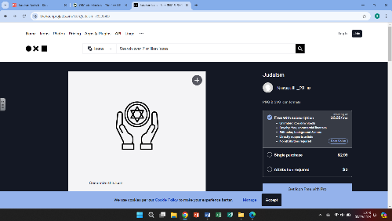

Rosh Hashanah is the birthday of the world. During the festival Jews recall how God created the world in 6 days and rested on the seventh. It is a day to reflect on the past year and ask God's forgiveness for any sins. It is a fasting day which lasts from sunset to sunset.

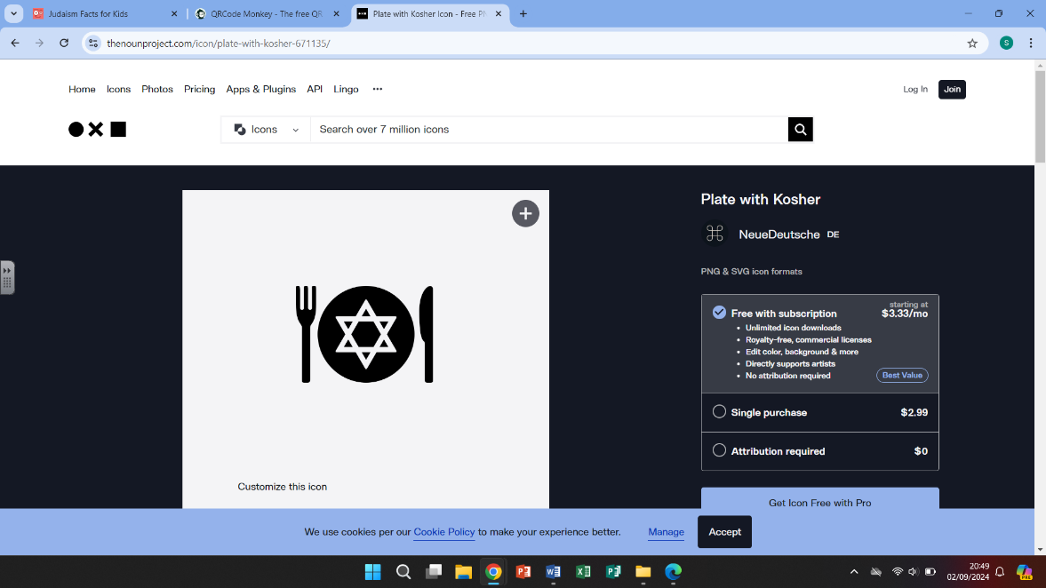

Judaism’s food and dietary laws are known as kashrut. Food that is allowed to be eaten is called kosher. Food that is not allowed is called treif or trefah. Examples include shellfish, pork products and food that has not been slaughtered in the correct way, known as shechitah.

What we are learning

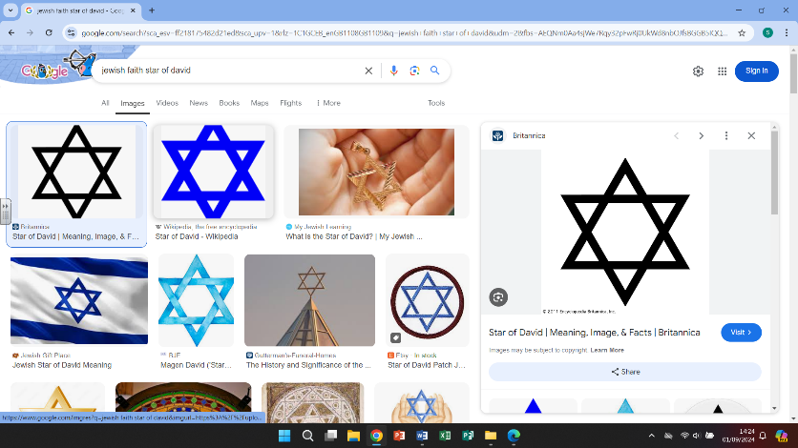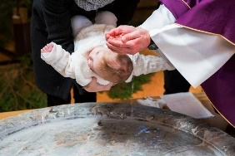

4.

-Look at the baptism traditions of

the Christian faith, including different church services, open air services, accepting Christ, symbolism and god parents

-making a comparison to the Islamic traditions

1.

-Looking at the origin of the Jewish faith - looking at a map of the world, historically and at modern census information about population

-Begin looking at how Jesus was born into the Jewish religion and how Christianity then began to develop

WHAT?



5.

- Find out about the festival of Passover – The Jewish feast of freedom. It is celebrated around Easter time and lasts around 7 or 8 days. Jewish people use the festival as a time to remember how they escaped from slavery in Egypt

2.

-Discuss and understand what the word

holy means and what it means to be

holy – how can we do that in our everyday life?

-Look at ways the Jewish people have used their faith during times of adversity and have used their faith to do good in the world.

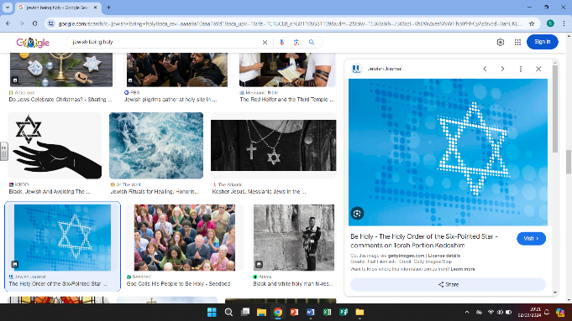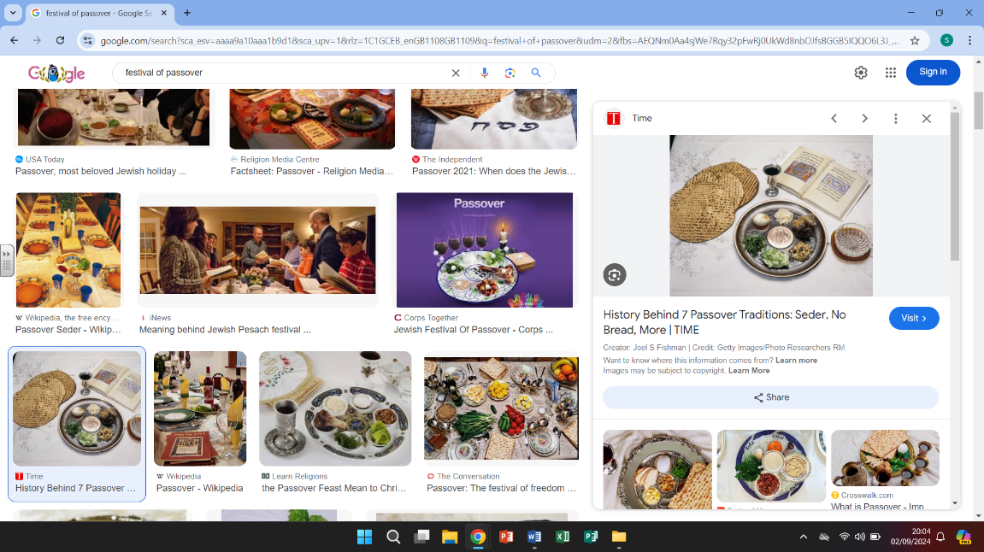

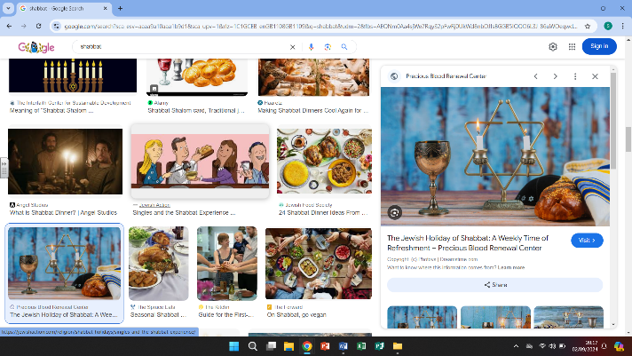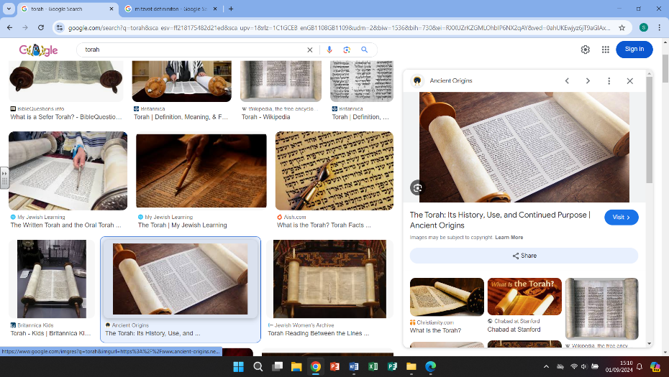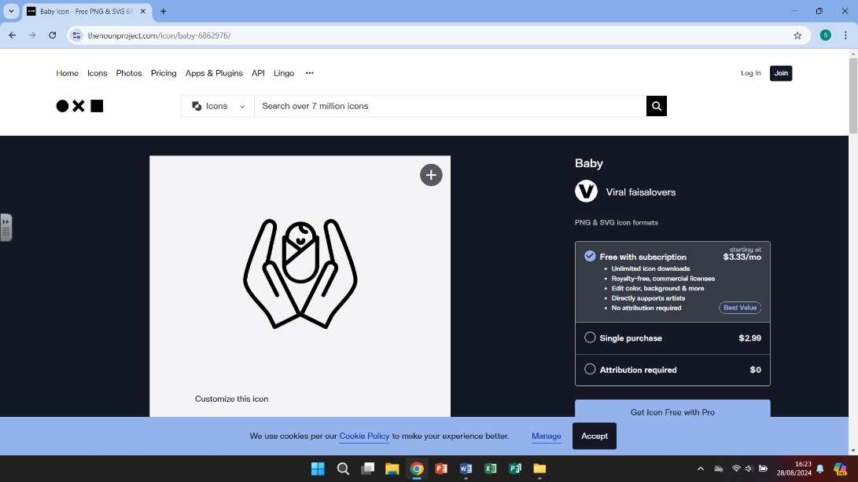

6.

-Look at Shabbat, they Jewish day of rest, that happens every Saturday. Learn about the rituals/habits that surround the day including no working or cooking and even no driving.

3.

-Looking at the holy book (Torah) and how it is respected and taken care of

-Learning about Mitzvot – commandments sent from God for the Jewish people to perform as part of their daily life

-make a comparison to other religions and any commandments or rules that must be obeyed

Helpful links

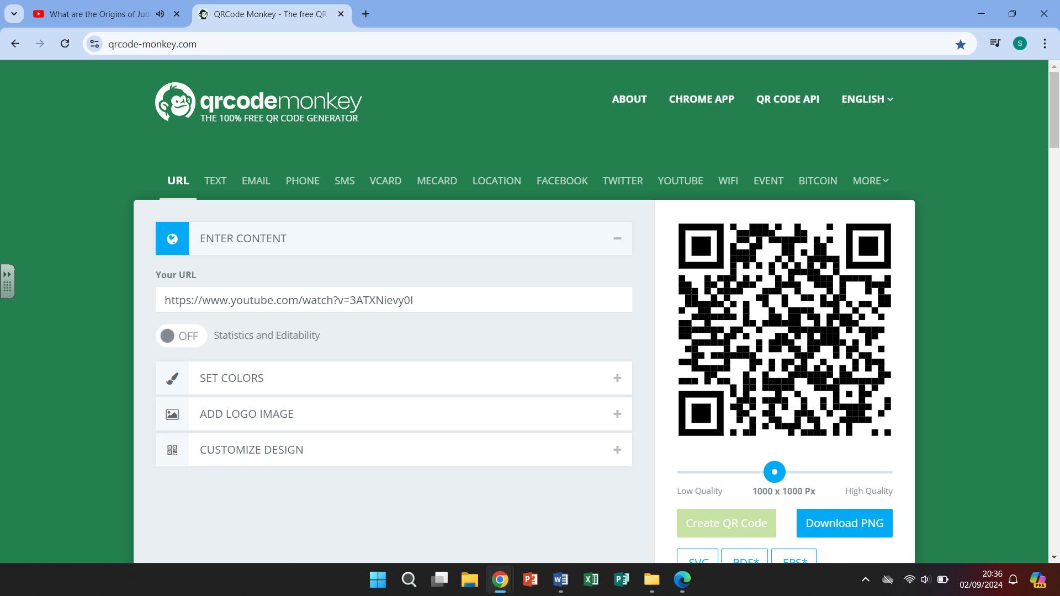

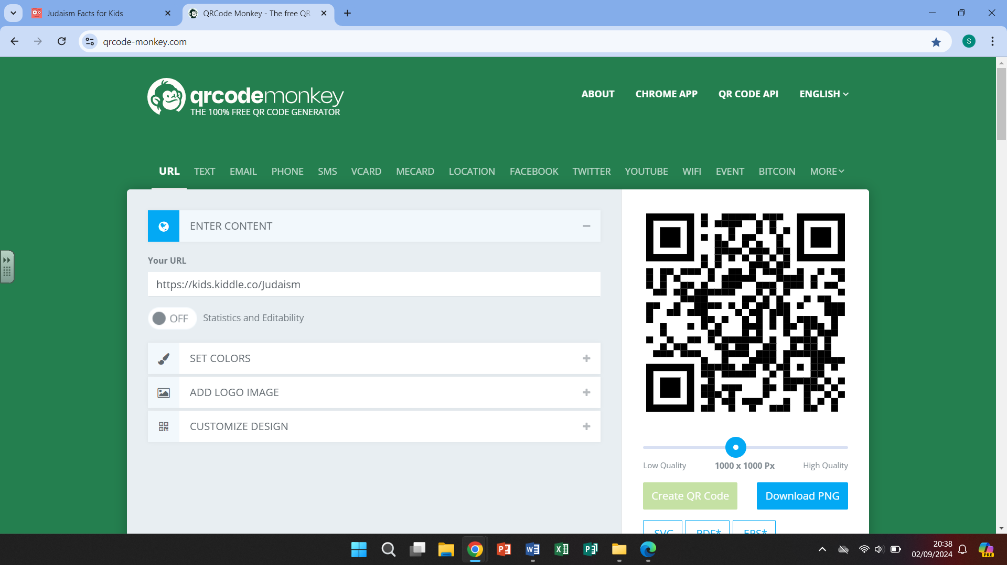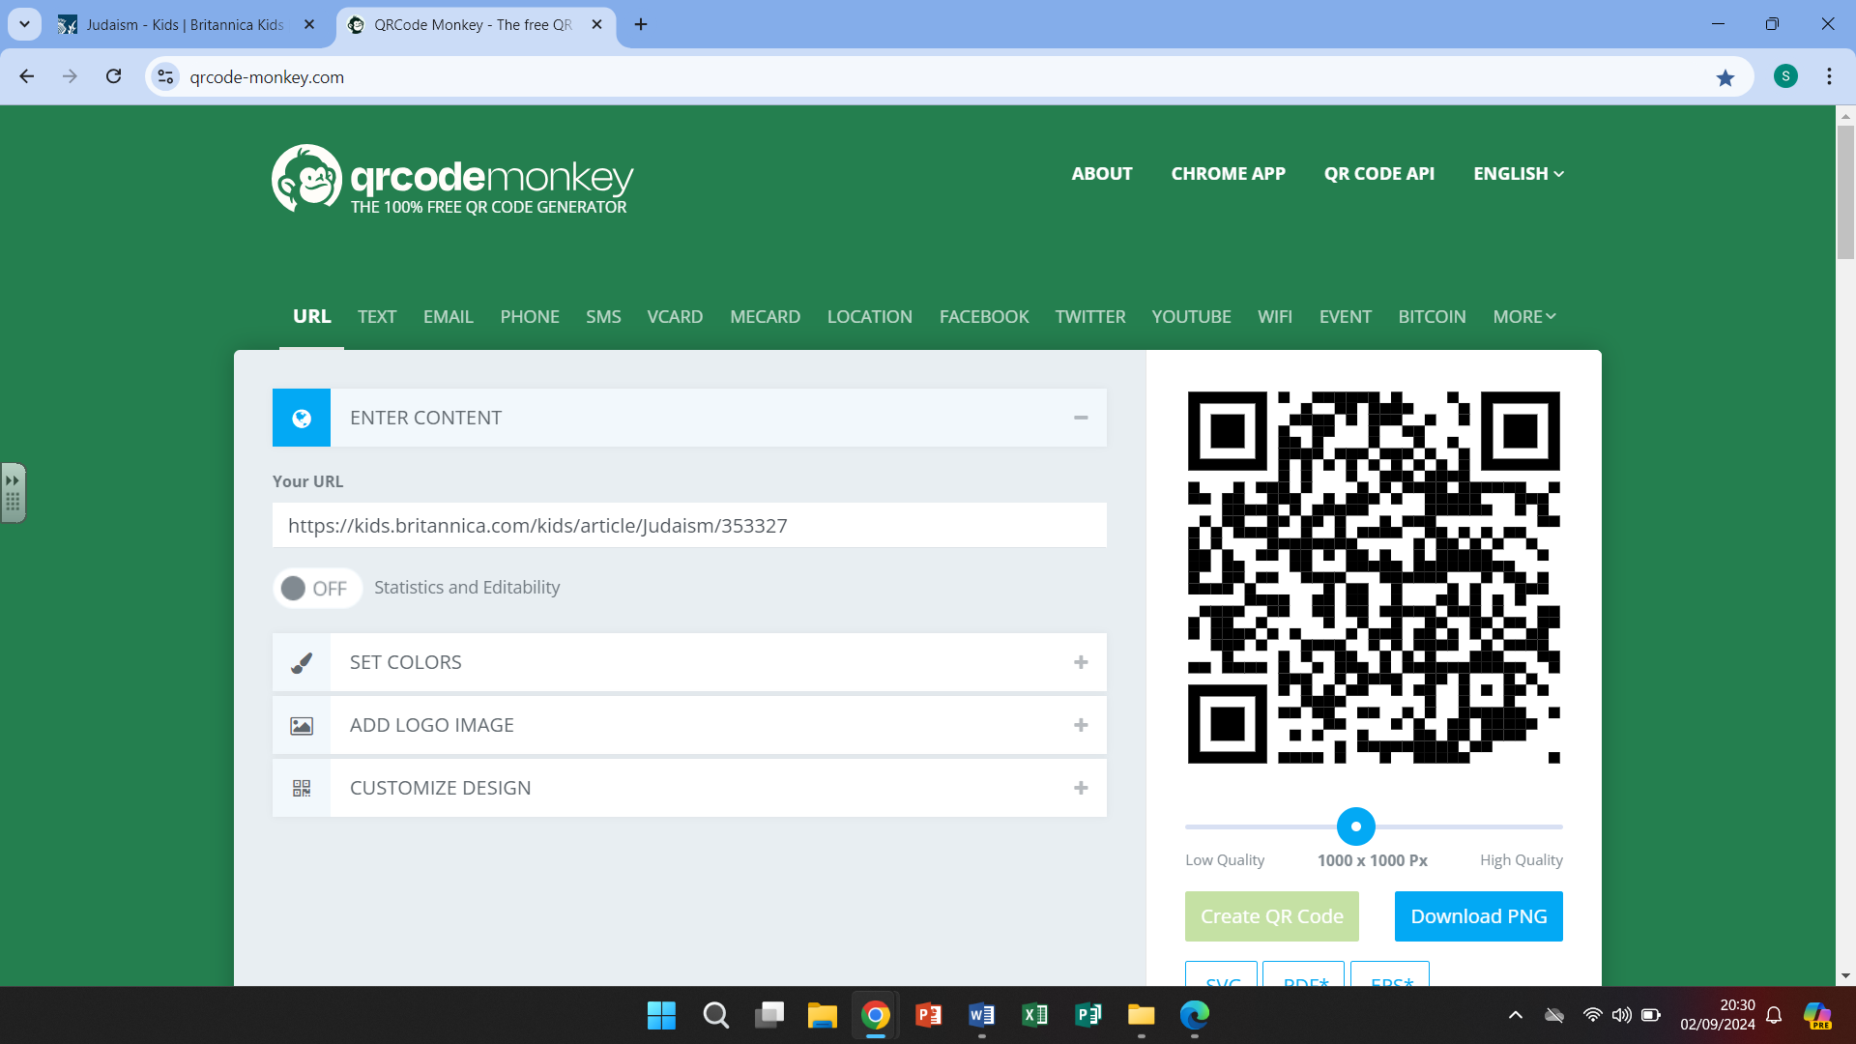

Britannica kids The Origins of Judaism Facts about Judaism