# Islam

Year 4 Autumn 1 – Islam and Christianity

Theme: Worship and Worshipping: A Comparison of Islam and Christianity

Golden Threads: Worship, Prayer



British Values –

Democracy Rule of law

Mutual Respect/ Individual Tolerance liberty

Retrieval links –

Islam -

Year 1

Year 3

Links to other religions –

Christianity

|  |  |
| --- | --- |
| Vocabulary - | |
| Islam | One of the world religions. An Abrahamic monotheistic region based around the Qur’an |
| Muslim | A person who follows the Islamic religion |
| Muhammad | The religious founder of the Islamic religion |
| Allah | The Arabic word commonly used for God |
| Hajj | A pilgrimage (journey) to Mecca |
| Adhan | Adhan means ‘call’ – the adhan calls Muslim people to their prayers |
| Shahadah | One of the 5 Pillars – Muslim people show their faith to their one God, Allah |
| Qur’an | The holy book of Islam |
| Salat | One of the 5 Pillars – the belief that individuals have a direct relationship with God |
| Christianity | One of the world religions. A monotheistic religion based around the life and teachings of Jesus |
| Bible | The holy book of Christianity |

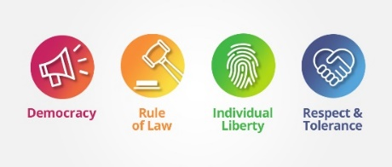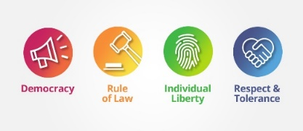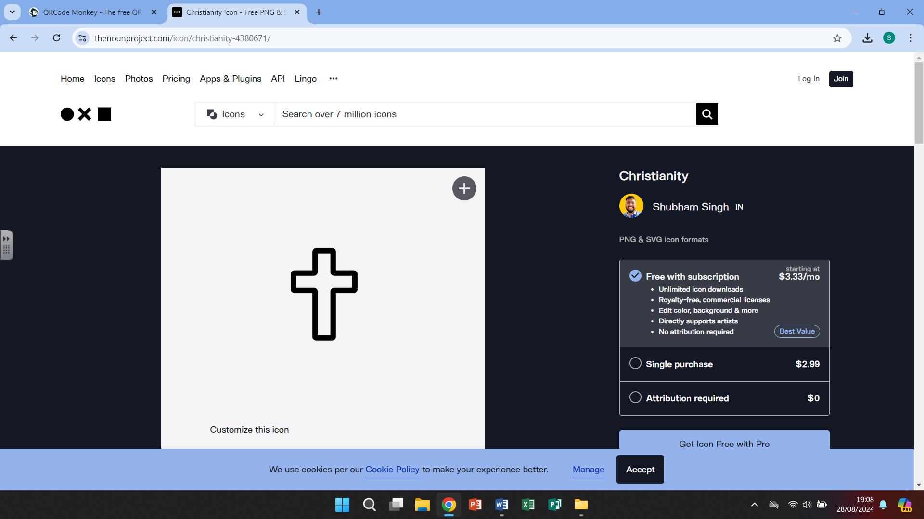

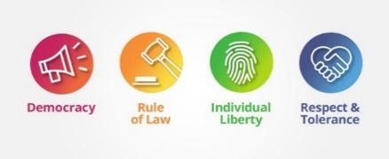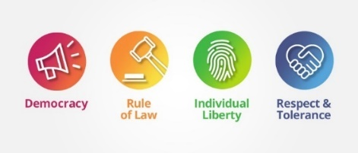

Islam

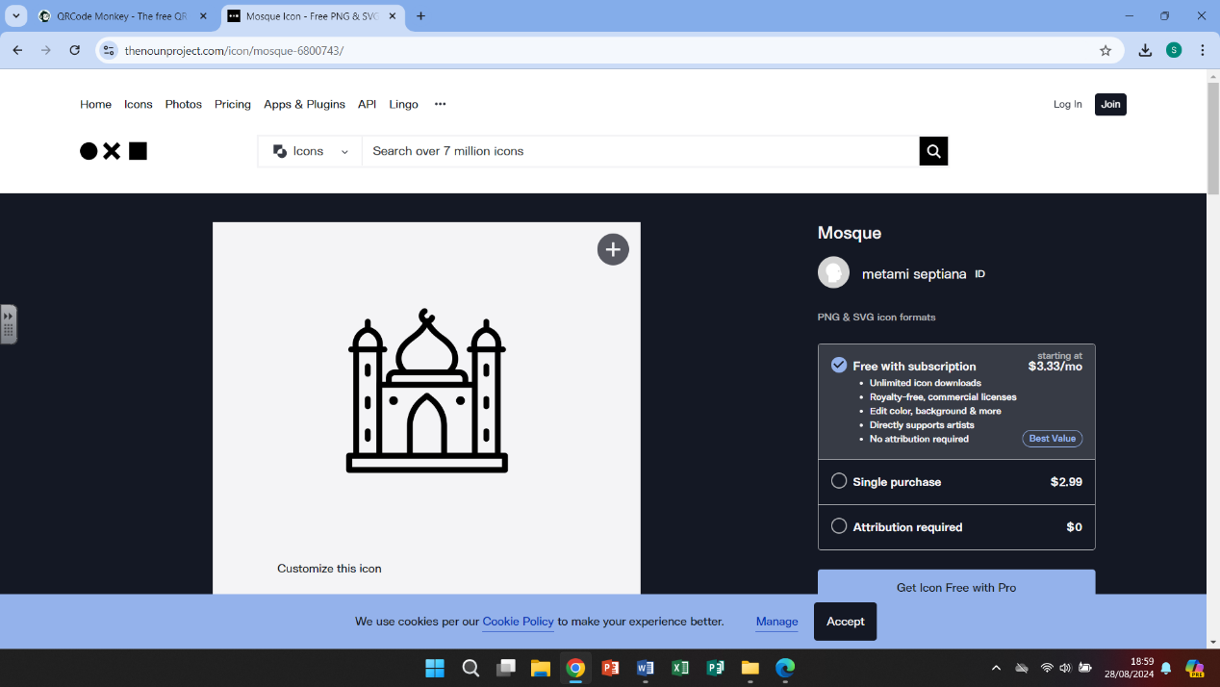

Islam is the second largest religion in the world (over 1.9 billion followers), only Christianity has more followers. The sacred scripture of Islam is called the Qur’an, this contains Allah’s revelations to Muhammed. The prophet Muhammed was born in Mecca and many Muslims take a pilgrimage to pray in Mecca.

# 

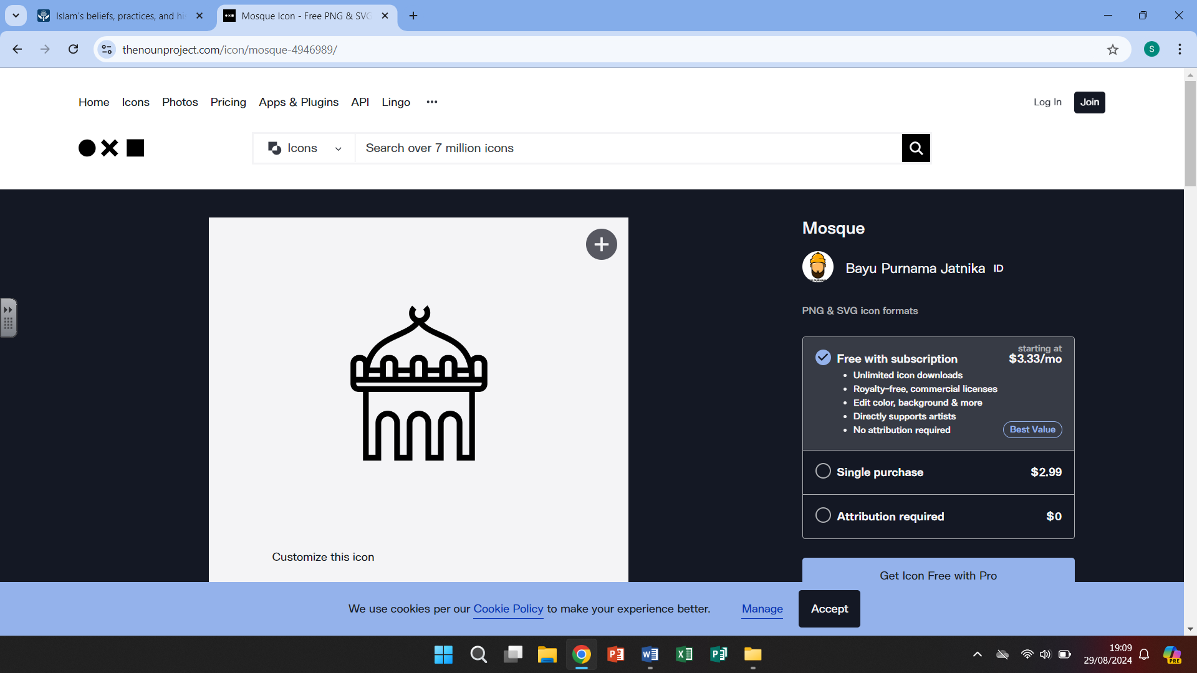

The fundamental obligations of the religion can be summed up in the Five Pillars.

There are five key practices that all Muslims are obligated to fulfil throughout their lifetime. These practices are referred to as pillars because they form the foundation of Muslim life. Thefive pillars of Islam are Shahada, Salah, Zakat, Sawm, and Hajj.

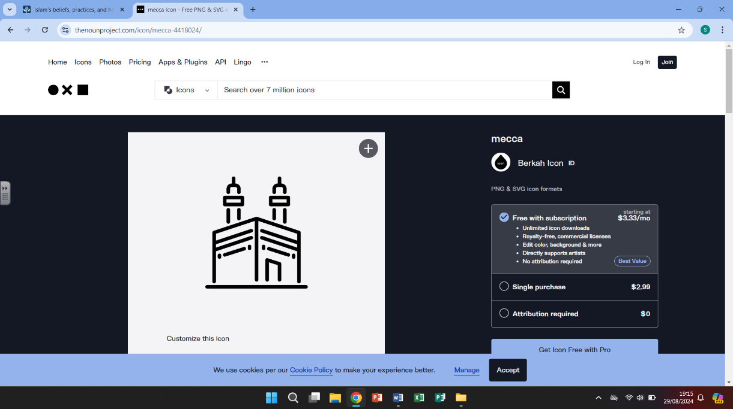

The Hajj is a pilgrimage taken by Muslim followers. They visit Mecca and pray around the Kaaba, the ‘house of Allah’. Mecca is a holy city in Saudi Arabia.

What we are learning

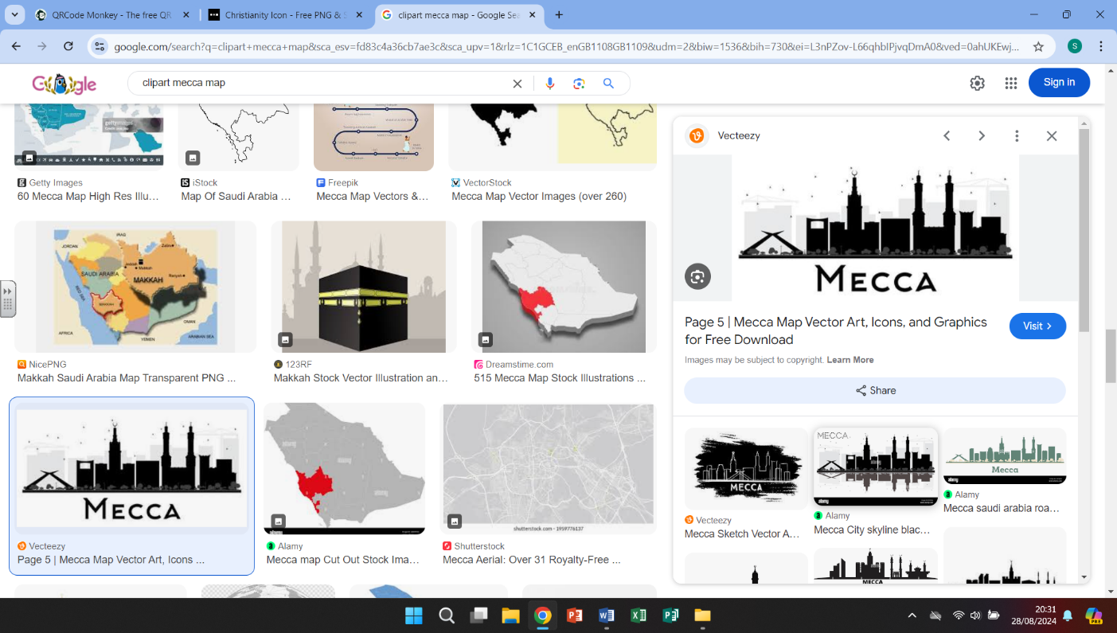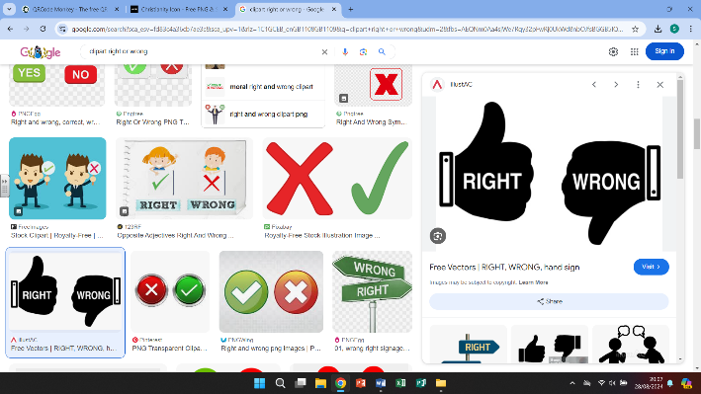

4.

-locating Mecca on a map and understanding that many Muslims while carry out a pilgrimage and visit Mecca

- listening to and learning the words in the call to prayer (Adhan)

1.

-Asking questions about morals –

knowing right from wrong.

-Is there ever a time when doing something wrong is right?

-Think about times when we have ourselves done the right or wrong thing.

WHAT?



5.

-Muslim people believe that there is only one God and that Muhammed is a messenger of God.

-Look at how this compares with the Christian faith and how Christian people also believe in only one God.

2.

-The importance of prayer

-looking at how different religions use prayer as part of their traditions.

-comparing how prayer is different within different religions

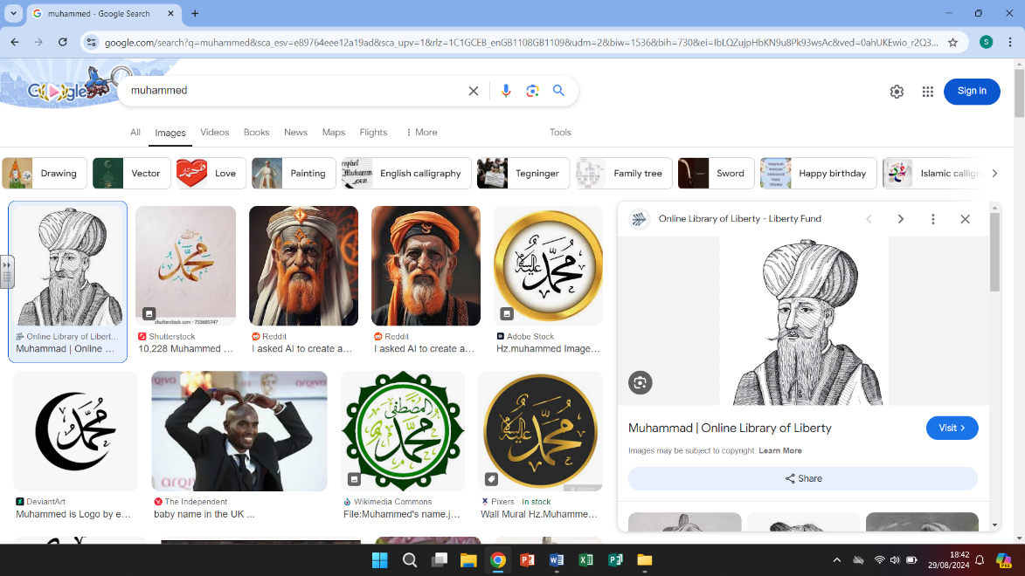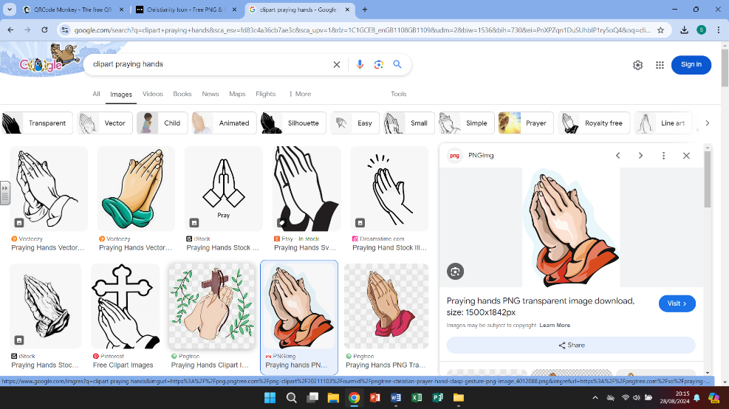

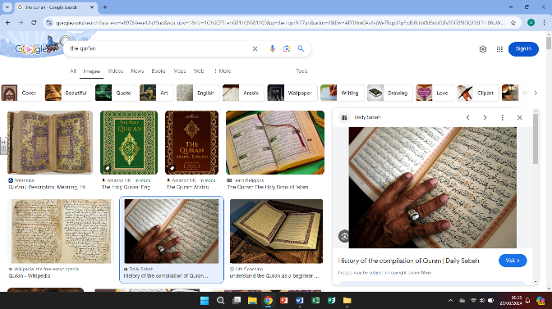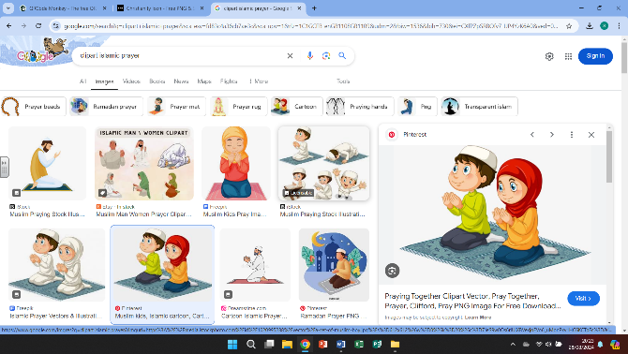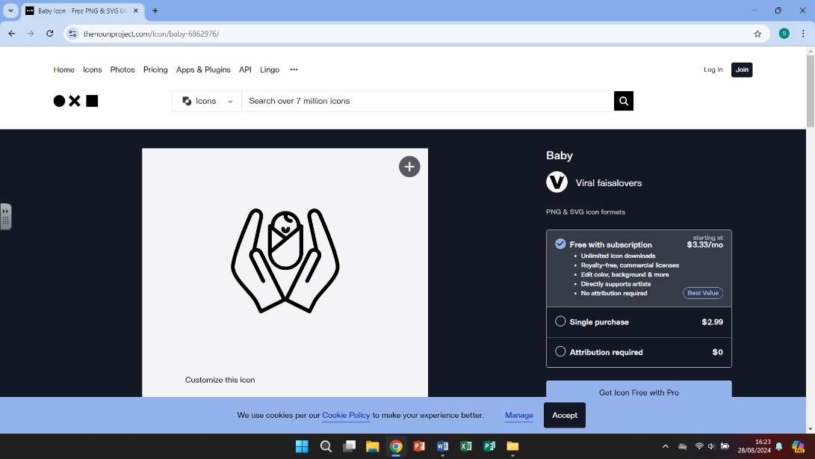

6.

-The Qur’an is the Islamic holy book and there are rules to using. Muslims show respect to their book by keeping it on the highest shelf in the room, by keeping it covered when not in use and users must wash their hands before touching the text.

3.

-Prayer is a very important part of the Islamic religion

-Muslim people must pray 5 times a day and face Mecca, men and women pray separately, they also use prayer beads and a prayer mat.

Helpful links

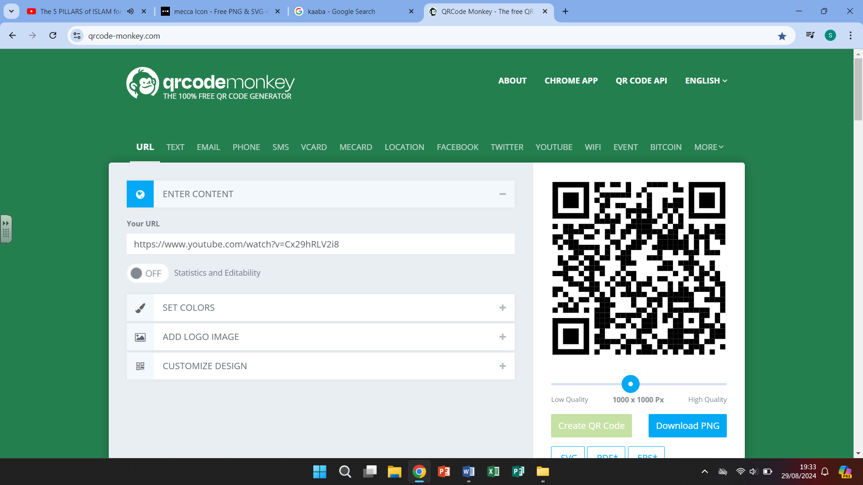

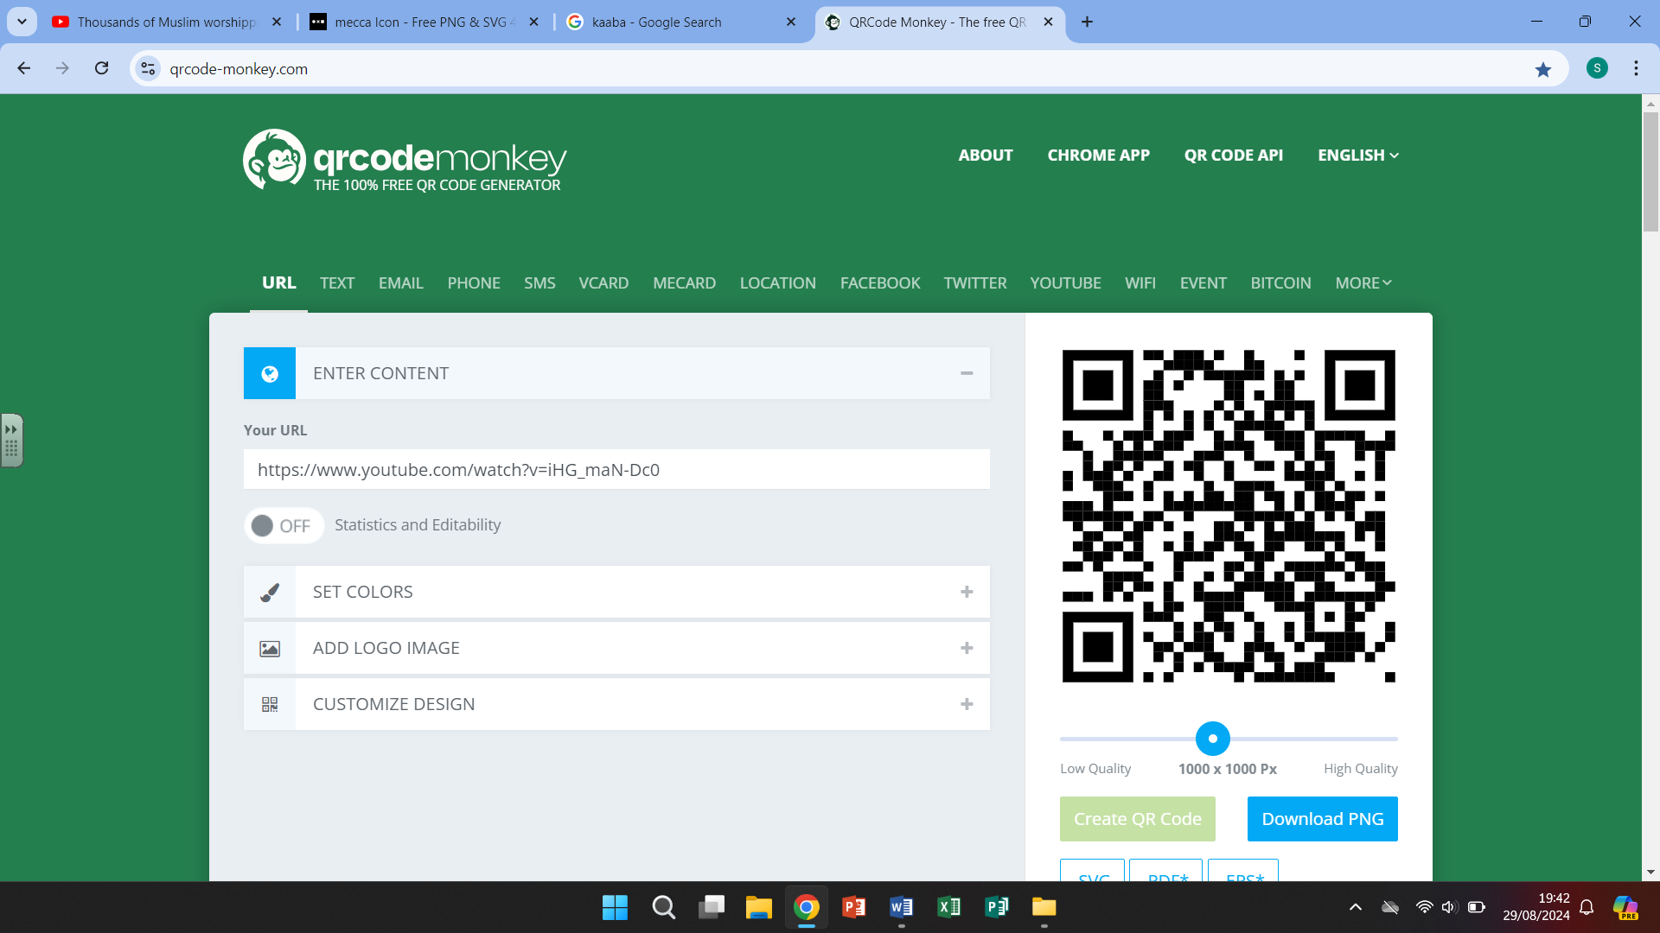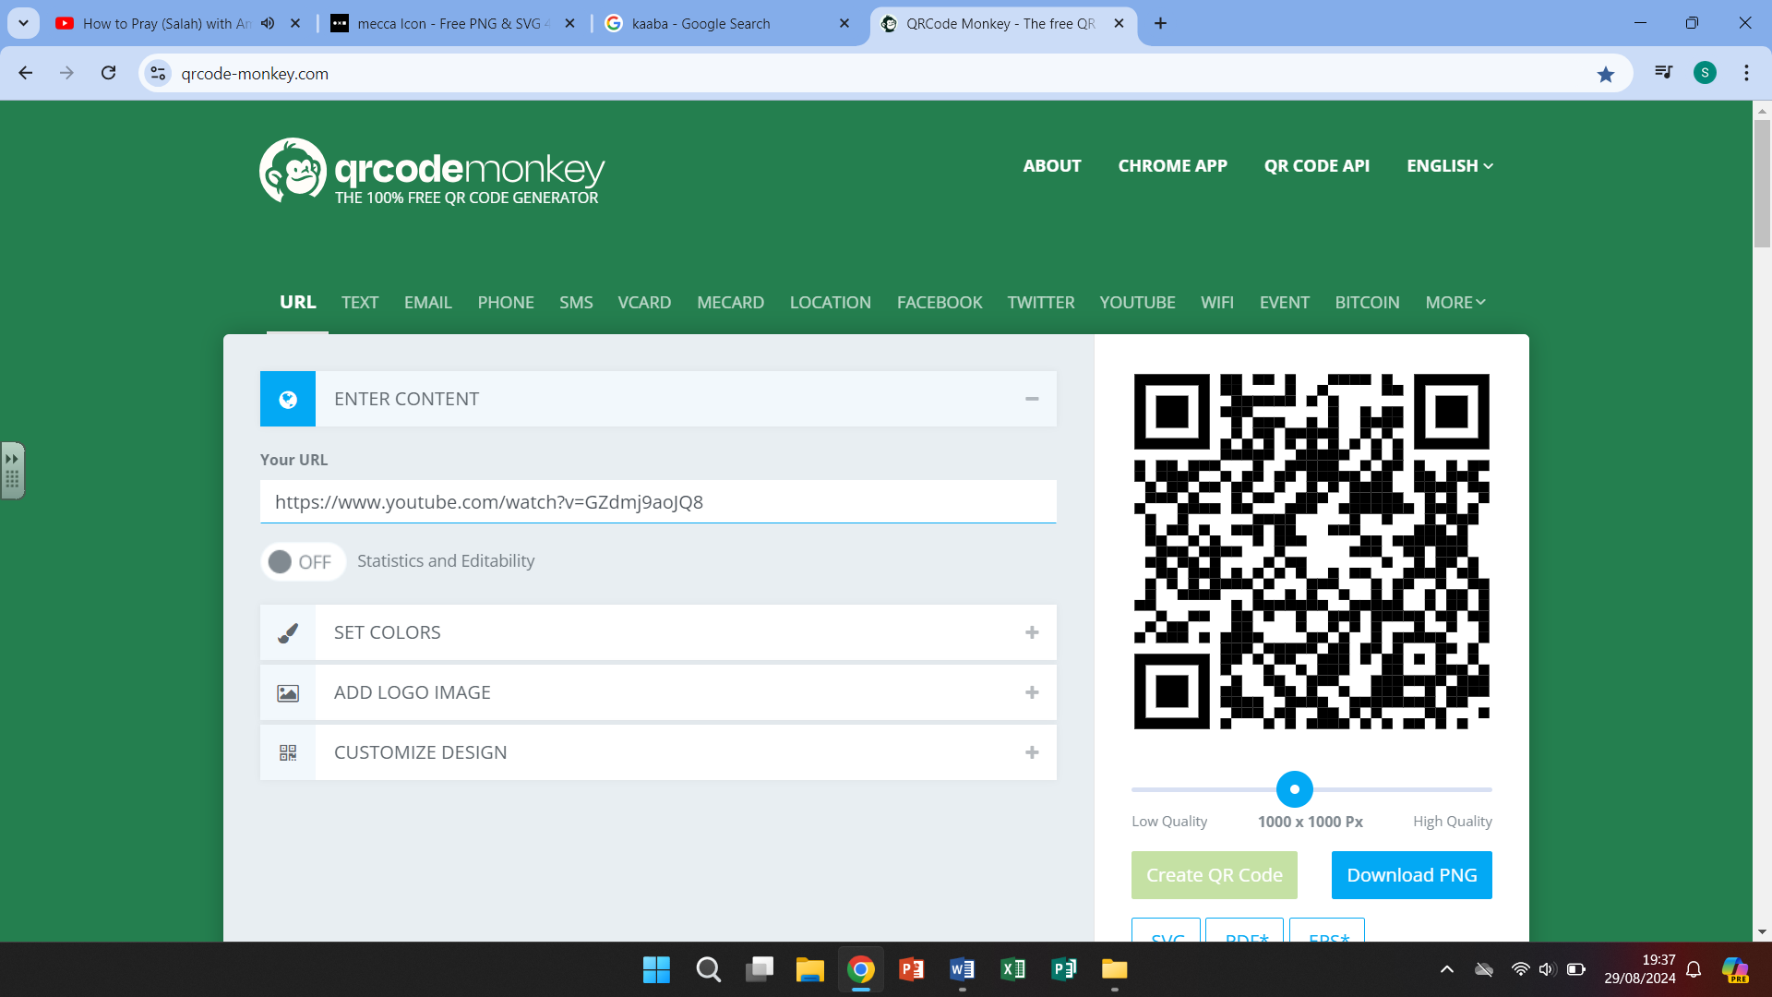

The Five Pillars Islamic prayer Mecca pilgrimage

of Islam