# Islam

Year 3 Autumn 1 - Islam

Theme: Life from the perspective of a Muslim child.

Golden Threads: Worship, Faith, Identity



British Values –

Mutual Respect and Tolerance

Individual Liberty

Retrieval links –

Year 1

Links to other religions –

Christianity

|  |  |
| --- | --- |
| Vocabulary - | |
| Islam | One of the world religions. An Abrahamic monotheistic region based around the Qur’an |
| Muslim | A person who follows the Islamic religion |
| Muhammad | The religious founder of the Islamic religion |
| Allah | The Arabic word commonly used for God |
| Hajj | A pilgrimage (journey) to Mecca |
| Adhan | Adhan means ‘call’ – the adhan calls Muslim people to their prayers |
| Shahadah | One of the 5 Pillars – calls for Muslim people to show their faith in their one God, Allah |
| Qur’an | The holy book of Islam |
| Christianity | One of the world religions. A monotheistic religion based around the life and teachings of Jesus |
| Baptism | A religious service that initiates people into the Christian faith, with the use of water |
| Bible | The holy book of Christianity |

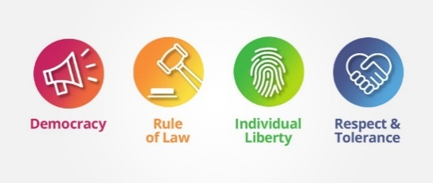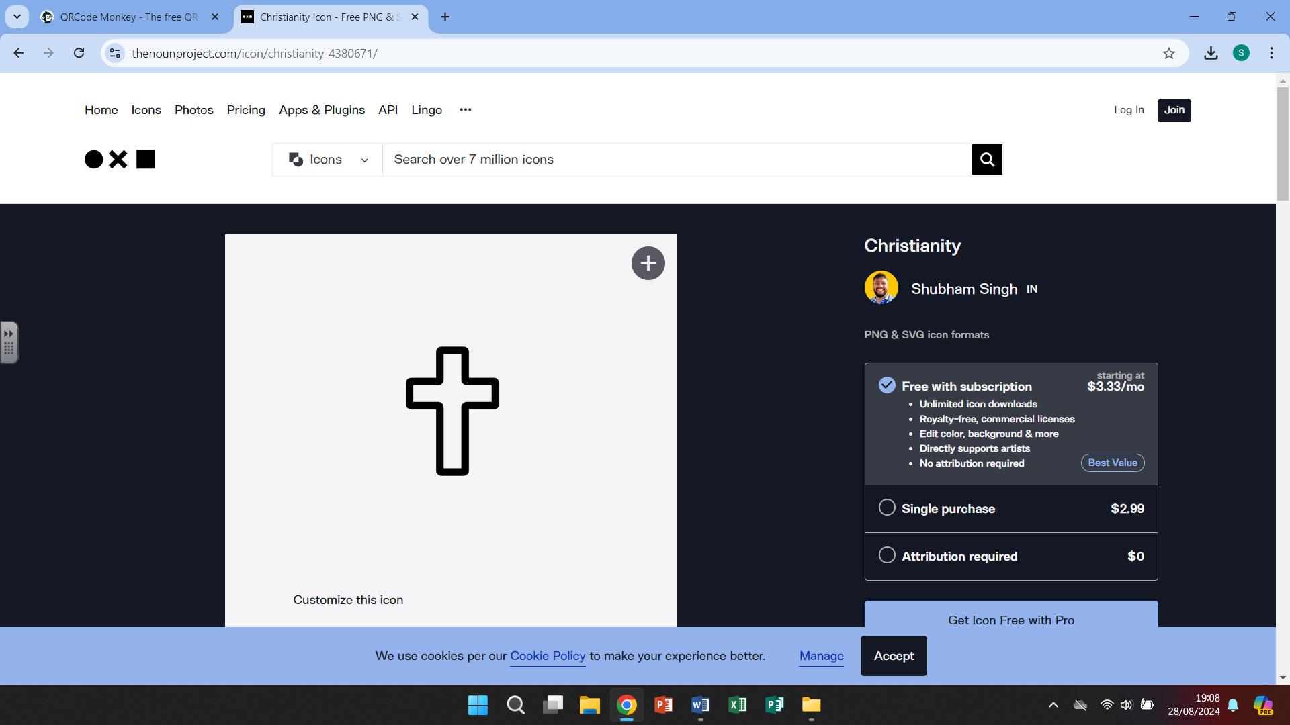

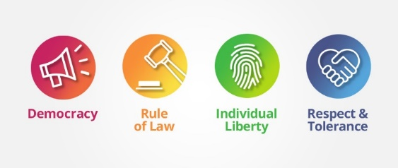

Islam

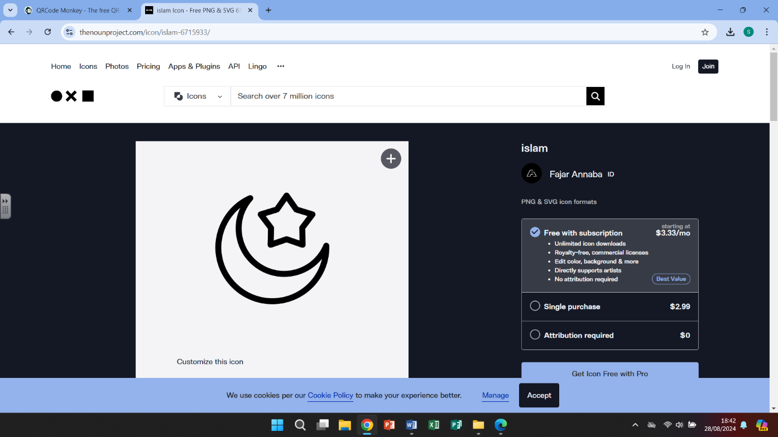

Islam began in Saudi Arabia. Islam is the second largest religion in the world (over 1 billion

followers). Followers of Islam are called Muslims. Muslims believe there is one true

God (Allah). Muslims believe that Islam was revealed over 1400 years ago by a man called

Muhammad.

# 

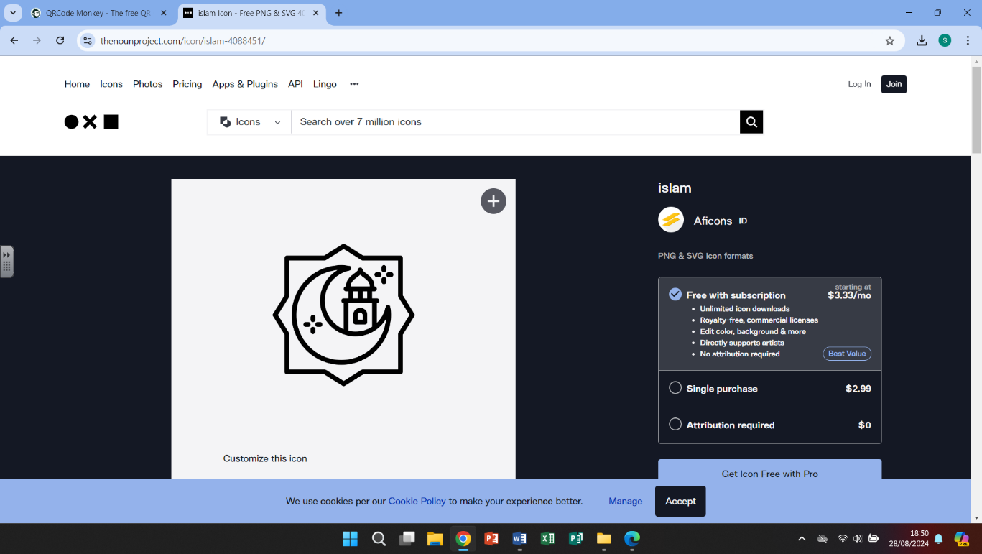

The prophet Muhammad (peace be upon him) was born in A.D. 570 in Mecca. He was the

founder of Islam. He was the last prophet to be sent by Allah (God). The first prophet was

Adam. Followers of Islam, called Muslims, believe that Muhammad received messages from

Allah (God).

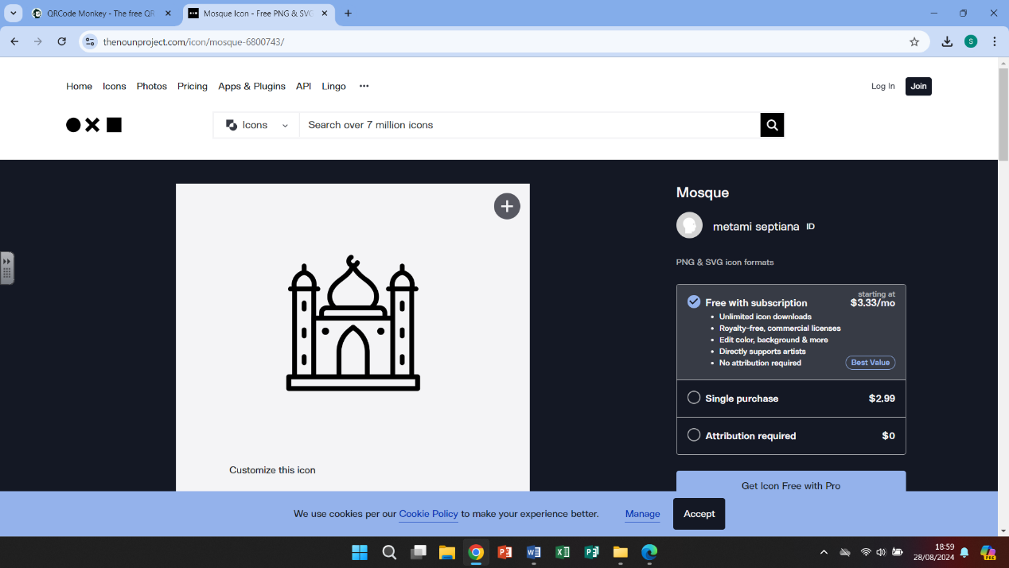

A mosque is a place of prayer for Muslims. Insides a mosque there is an open space for

Worship with rugs/mats covering the floor. A nook in one wall, called a mihrab, shows

the direction of Mecca, Islam’s holiest city.

What we are learning

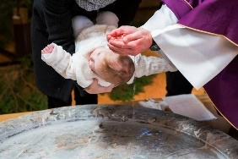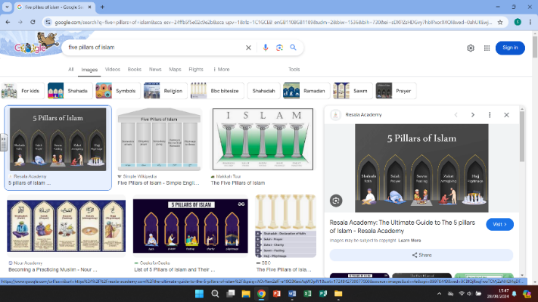

4.

-Look at the baptism traditions of

the Christian faith, including different church services, open air services, accepting Christ, symbolism and god parents

-making a comparison to the Islamic traditions

1.

-Islam refers to the religion as a whole

- Muslim refers to an individual person who follows the Islamic faith

-Understand that the Islamic religion is based around the ‘Five Pillars of Islam’. Each Pillar represents something that all Muslim people must achieve throughout their lifetime

WHAT?



5. 

-Looking at role models and the qualities that we admire in other people and our friends

-Reading Malala’s Magic Pencil and discuss why she is a good role model to children and young girls specifically

2.

-Each of the Pillars are important to the

Muslim community

- Shahadah is the most important of the pillars to Muslim people

-Make connections of community and religion with some of our school values

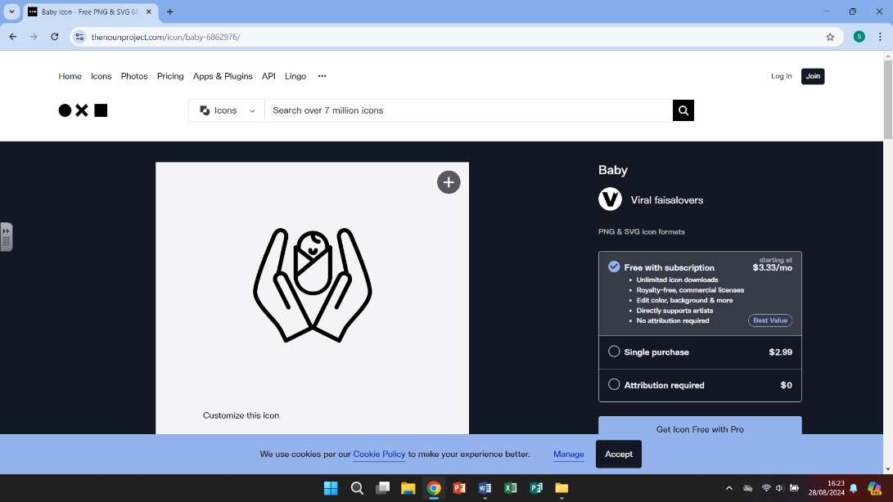

6. 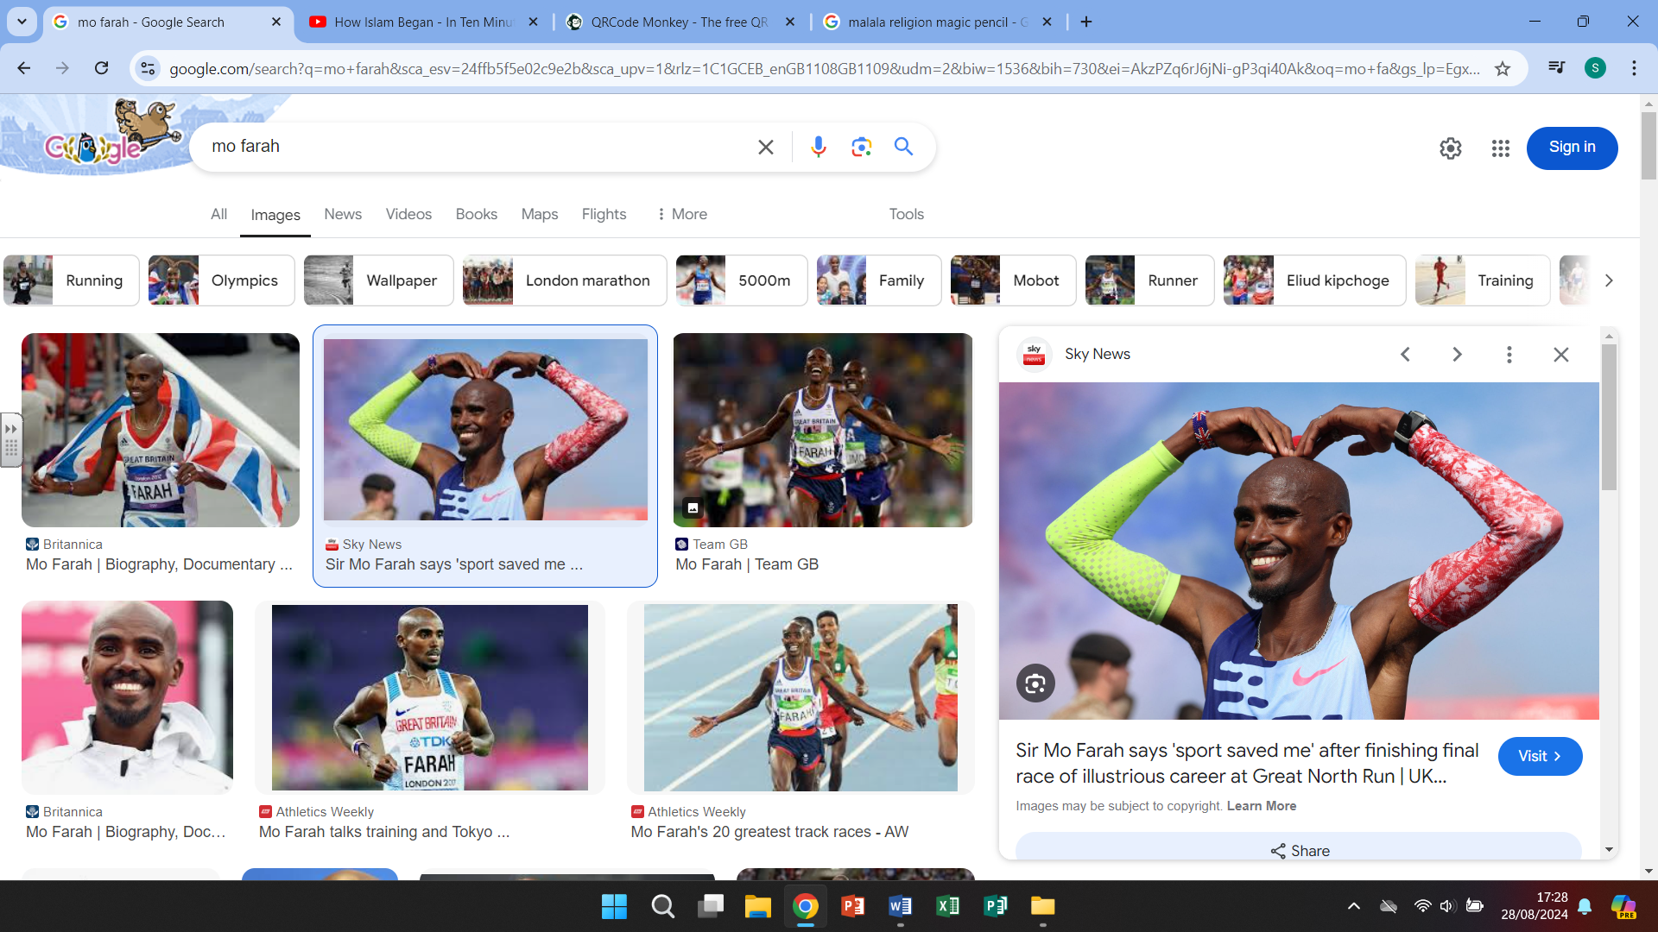

-continuing to look at people we admire and the qualities they have to make them determined, hardworking and successful

-Read about Sir Mo Farah and his life, including his religion

3.

-looking at the traditions and rituals that

happen once a baby is born into a Muslim

family, including washing the baby, whispering the Adhan, taking suggestions for the baby name and giving to charity.

-Children share own family/religious traditions

Helpful links

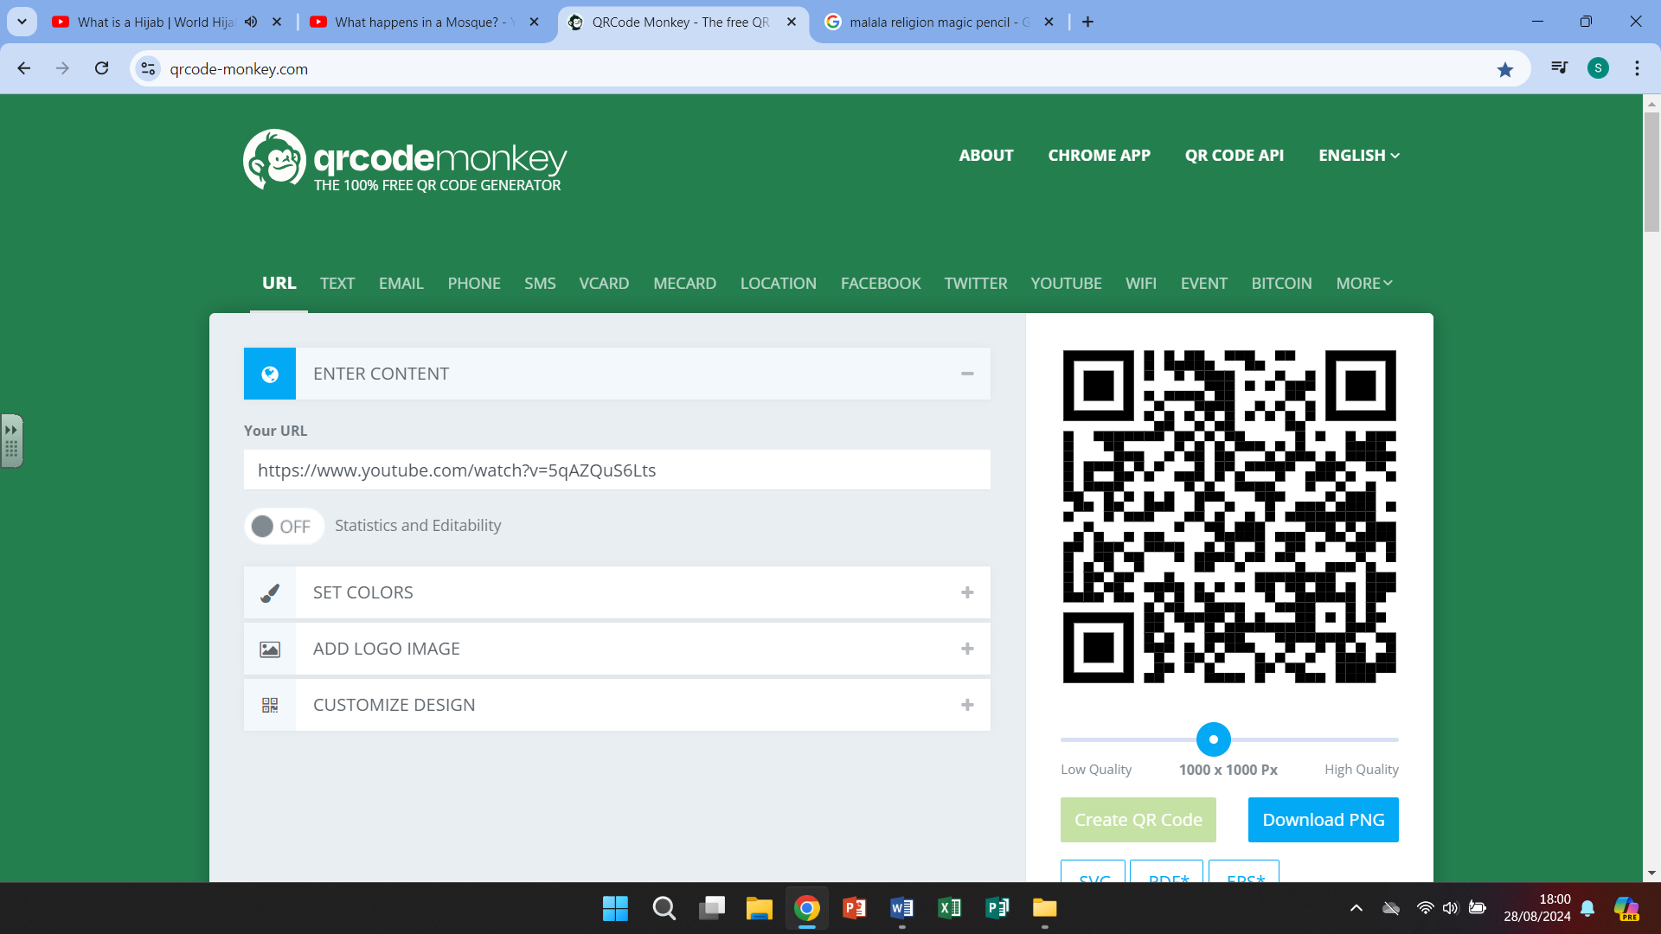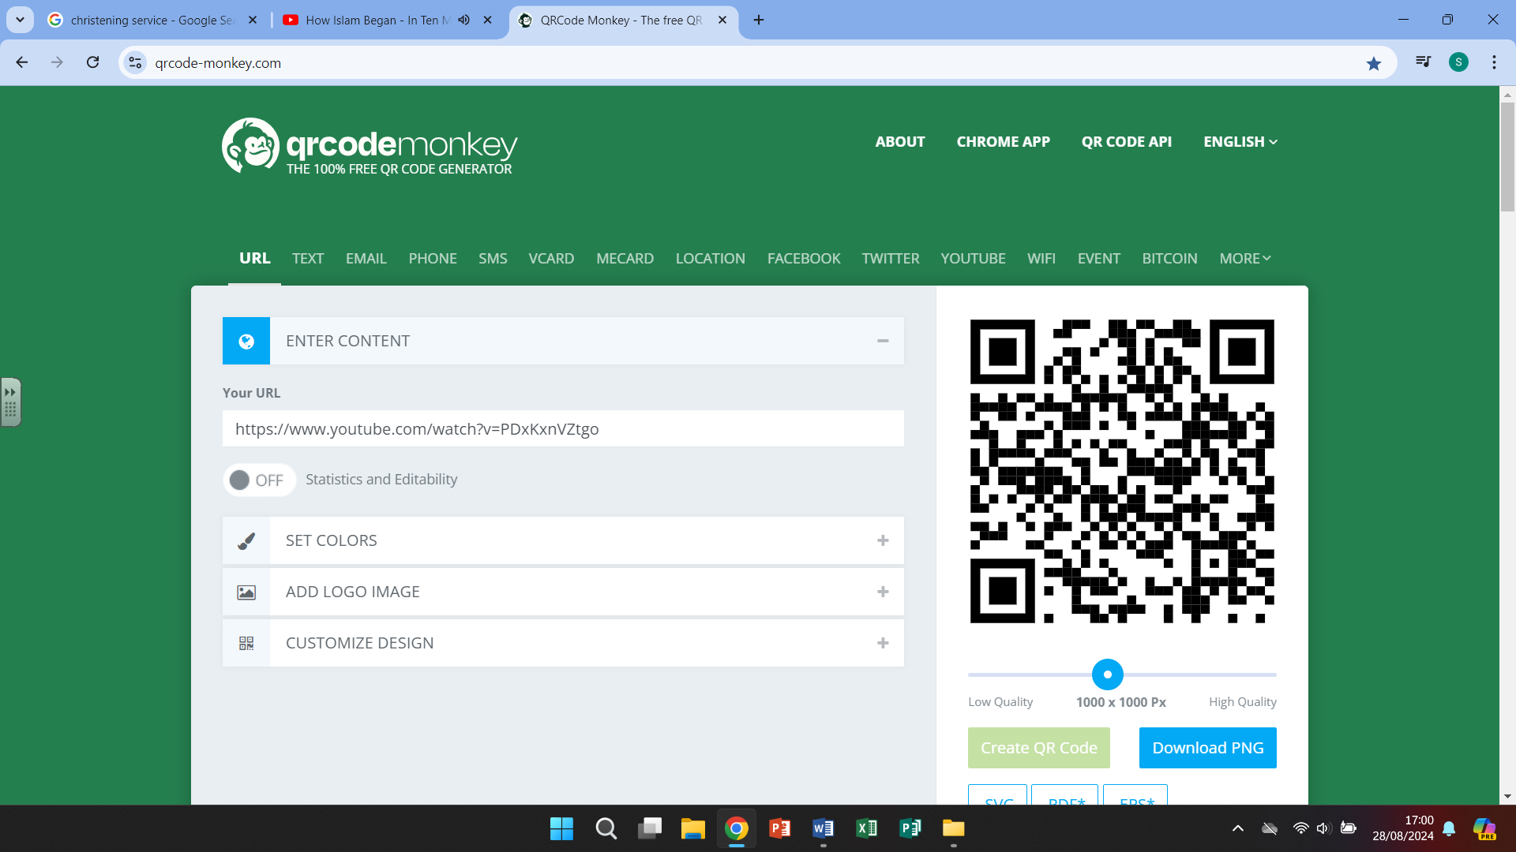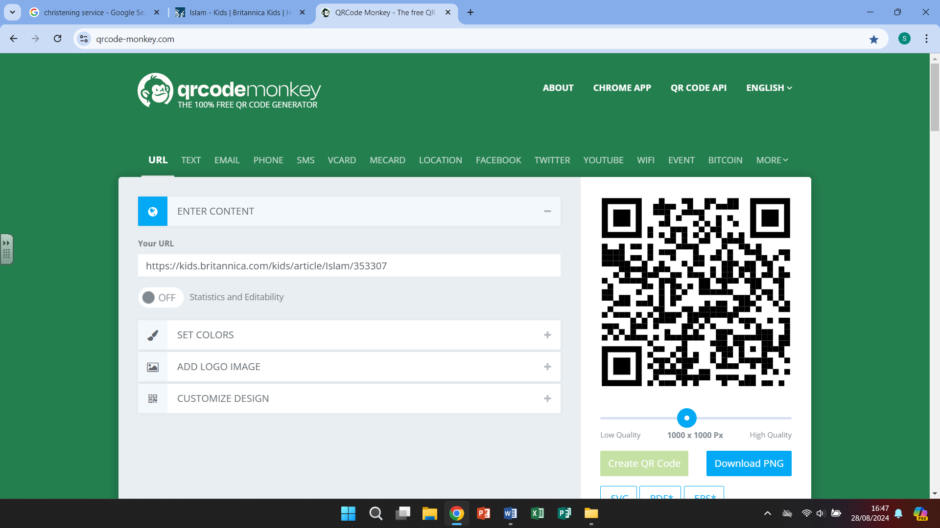

Britannica kids – The Origins of Islam What is a hijab?

The Islamic faith -animated