By

Musical Genre: Blues

Blues

|  |  |  |  |  |
| --- | --- | --- | --- | --- |
| Blues music is often sad and emotional, which is why we say we have ‘the blues’ when we feel sad. Its main features are the 12-bar blues and the blues scale, and it includes a lot of improvisation. | | | **Year 5 key knowledge**   * To understand that a chord is the layering of serval pitches played at the same time. * To know that 12-bar Blues is a sequence of 12 bars of music, made up of three different chords. * To know that the ‘blues’ music aims to share feelings and blues song tends to be about sadness or worry. * To know that a ‘bent note’ is a note that varies in its pitch, e.g. the pitch may slide up or down. | |
| Two or more notes that are plated at the same time and work in harmony. | | | | |
| chord |  | A set of notes used to play a melody over a 12-bar blues. | | Blues scale |
| scale | Any set of musical notes which are in order of their  pitch |  | | Improvisation  Making up music as it is played or performed.  A musical notes that varies in pitch usually going up slightly at the end. |
| Ascending scale | A scale in which the pitch of the notes goes up. | Bent notes | |  |
|  | quaver  A scale in which the pitch of the notes goes down.  Descending  scale | A note which last for half a beat. | |  |

* What are we learning?

What are we learning?

**Blues music** originated from music sung by **black Africans** who were taken to be **slaves** in **South America, North America and the Caribbean islands.**

The slaves sang to help them with their hard work and to keep their spirits high.

**Features of Blues music**

* Blues music is usually about **sharing feelings.**
* Blues songs tend to be about **sadness and worry.**
* To know that a chord is **2 or more notes** played at the same time.
* To know that the **12-bar Blues** is **twelve bars of 3 chords,** played in a specific order, each chord being played **4 times.**
* To know that **chord C** is made of the notes **C, E and G.**

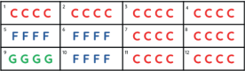

In this lesson, you will be learning about notation

* **Tempo**- How fast or slow the music is
* **Ensemble-** A group of people who perform instrument or vocal music.

**Pitch-** How high or low a note or piece of music is.

**Notation-** Written symbols used to represent musical notes.

**Composition-** To create an original piece of music.

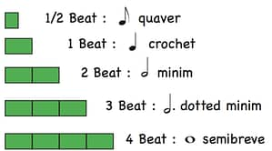

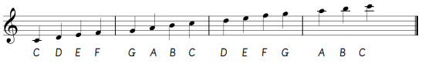

In this lesson, you will compose and perform your Egyptian farewell.

* **Compose-** To create an original piece of music.
* **Ensemble-** A group of people who perform instrument or vocal music.
* **Notation-** Written symbols used to represent musical notes.
* **Minor-** A tonality where the music sounds sad or tense.
* **Tempo-** how fast or slow a piece of music is.

Year 1, 2, 3 and 4 musical skills and elements.



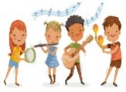

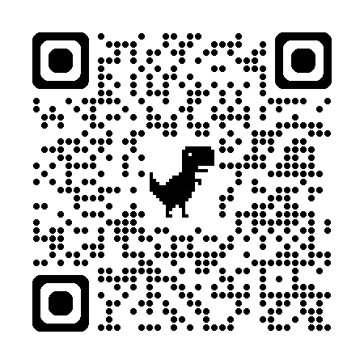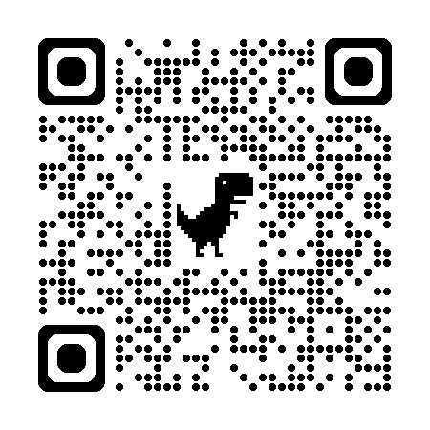 

Scan to learn more about Egyptian music.

Scan to learn more musical vocabulary and terms.

Scan to learn more about musical notation.

Helpful links