By

Musical style: Rock and Roll

Rock and Roll

|  |  |  |  |  |
| --- | --- | --- | --- | --- |
| Rock and roll was created in America in the 1950s after the war and was made to depict happiness and a new life. The name comes from the phrase ‘rocking and rolling’ which was used by mariners to explain the movement of a ship, which influenced the dance steps. Rock and roll stems from the jazz, gospel and blues music and uses the blues structure and chords. It often has a fast tempo with strong vocals, which may use creaming and shouting. Rock and roll formed the basis of our modern-day rock music. | | | **Year 4 key knowledge**   * To know that rock and roll music uses blues chord structure, with a fast tempo and strong vocals. It was created after the second world war and it was intended to represent happiness. * To know that a bass line is the lowest pitch line of notes in a piece of music, and a waling bassline (where patterns of notes go up then down again) is common in rock and roll. * To know that playing in time means all performers playing together at the same speed. * To know that playing ‘in time’ requires playing the notes for the correct duration as well as at the correct speed. | |
| The lowest part of the music, played by a bass or bass guitar in rock and roll. | | | | |
| **Base Line** |  | **Pitch**  How high or low a note is. | |  |
| **Walking bass** | A bass line that moves step by step using pitches that are next to each other. | **Tempo** | | The speed or pace of the music. |
| The way that music is written so that others can play it.  **Notation** |  | **Dynamics** | | How loud or quiet the notes/music is. |
| **In time** | Playing or singing at the same speed as the music. | **In tune** | | Singing or playing with correct pitch. |

* What are we learning?

What are we learning?

When performing, it is important to sing in time.

* Playing in time means **all performers playing together** **at the same speed.**
* Playing in time requires **playing the notes for the correct duration as well as the correct speed.**
* Rock and roll music was created in **1950s in America.**
* It stems from **jazz, gospel and blues.**
* Rock and roll music **depicted happiness and a new life after the war.**
* The main instruments in rock and roll music are;
* **Vocals**
* **Double bass**
* **Brass instruments**
* **Electric guitar**
* **Harmonica**
* **Piano**
* **Saxophone.**

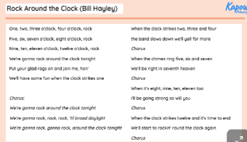

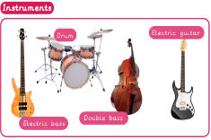

In this lesson, you will be creating a walking bass line.

* A **walking bassline-** The bass line that moves step by step using pitches that are next to each other.
* Walking bass lines **use specific note** which are the **black notes on the keyboard-**
* Walking bass line 1-

**C E G A A♯ A G E**

* **Walking bass line 2-**

F A C D D**♯** D C A

In this lesson , you will continue to practice and perform your walking bass line to a piece of music.

* Notation- the way we write down music.
* A **walking bassline-** The bass line that moves step by step using pitches that are next to each other.
* Walking bass lines **use specific note** which are the **black notes on the keyboard-**
* Walking bass line 1-

**C E G A A♯ A G E**

* **Walking bass line 2-**

F A C D D**♯** D C A

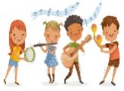



In this lesson, you will be performing a piece of rock and roll music as an ensemble.

* Playing in time together
* Pay attention to dynamics
* Think about tempo (speed)
* Think about and change how the layers build up.
* A **walking bassline-** The bass line that moves step by step using pitches that are next to each other.
* Walking bass lines **use specific note** which are the **black notes on the keyboard-**
* Walking bass line 1-

**C E G A A♯ A G E**

* **Walking bass line 2-**

F A C D D**♯** D C A

Year 1, 2, 3 and 4 musical skills and elements.





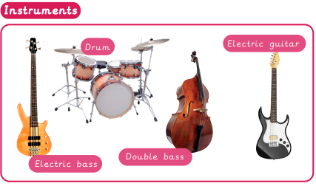

Helpful links

Scan to listen to Rock and Roll music.

Scan to learn more about rock and roll music.