Science  Light  - Identify the difference between light sources and non light sources  - Explore the light that comes from the sun and how to stay safe  - explore materials which are reflective  - Discover how shadows are formed  - Investigate how shadows change throughout the day  - Investigate how you can change the size of a shadow | Music  Jazz  - Explain what ragtime is.  - Play on the ‘off beat’ and sing a syncopated rhythm.  - Play a call and then improvise a response.  - Improvise or compose a scat singing performance with sounds and words.  - Compose and play a jazz motif fluently, using swung quavers.  - Play a swung rhythm using a tuned percussion instrument.  Traditional instruments and improvisation (Theme: India)  - Verbalise feelings about music and identify likes and dislikes.  - Read musical notation and play the correct notes of the rag.  - Improvise along to a drone and tal.  - Play a rag and tal accurately alongside a drone.  - Sing accurately from musical notation and lyrics.  - Sing and play in time with others with some degree of accuracy and awareness of each other’s parts. | Spanish  Where do you live in Spain?  - Name places in Spain using key phonemes.  - Practise answering questions about who I am and where I live.  - Use a bilingual dictionary to identify nouns and their gender.  - Listen for key information about where people live.  - Read and interpret information from a short descriptive text.  - Compose a short, written paragraph to introduce yourself.  Journey around Latin America  - Identify and pronounce Spanish-speaking countries in Latin America.  - Speak in short phrases to describe travel plans.  - Recognise and use the prepositions en and a when describing travel.  - Say the days of the week as part of a sentence in Spanish.  - Compose a travel diary in Spanish.  - Perform a travel diary in Spanish.
History  Ancient Egyptians:  · the significance of the River Nile  · Ancient Egyptian daily life and beliefs  · Ancient Egyptian pyramids  · Ancient Egyptian inventions including hieroglyphics, medicine and shipbuilding  the life of Tutankhamun | Brackenwood Junior School    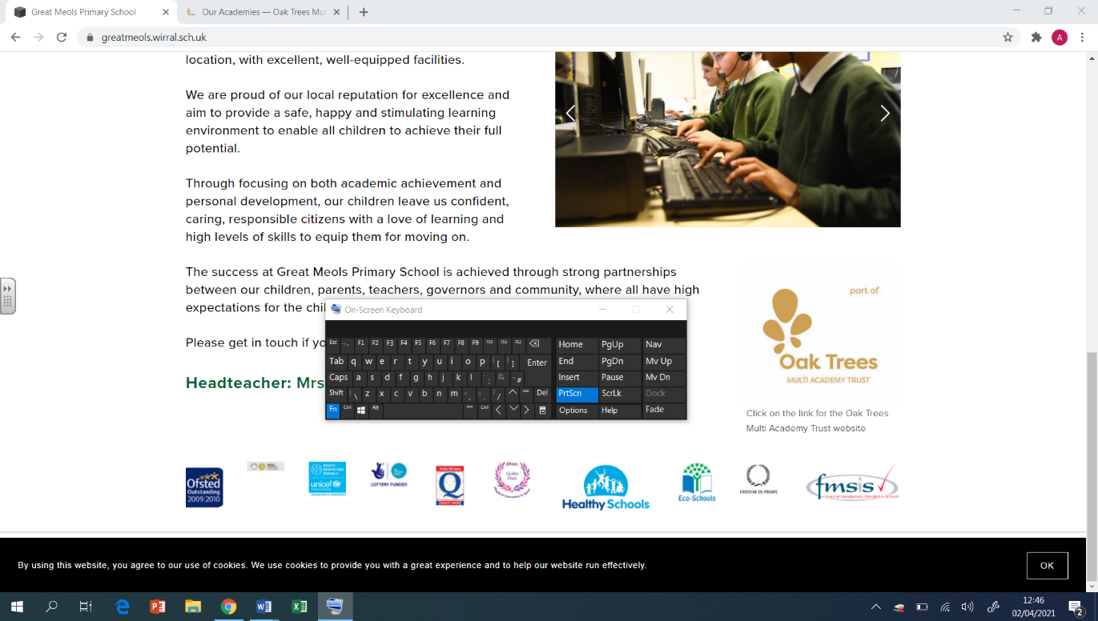  Y3  Summer Overview | PE  Cricket  - Assume a ready position when fielding  - How to grip a bat  - How to grip a ball when bowling  - Positioning oneself when wicketkeeping  - Tactics when batting  - Effective communication with teammates when fielding  Personal Challenges  - Why is core strength important in most sports  - Assume a ready position when throwing and catching  - To move with my head up and at a steady pace  - Develop all-around strength for my body  Football  - How to receive a pass  - Utilising different parts of the foot when dribbling  - To get the ball outwide and use the full pitch effectively  - Defending in a 1v1 situation  - How to attack decisively  - Defending in a side-on stance  Hockey  - How to hold the stick  - Importance of close control  - Push passing  - How and when to jab tackle  - How to create an effective team strategy
Geography  Where does our food come from?  - I can understand that the food we eat comes from many different places around the world.  - I can recall how land in temperate climate zones is used to produce food.  - I can understand how land in tropical climate zones is used to produce food.  - I can describe the way in which land in tropical biomes is being changed to enable more food to be produced.  - I can explain how land is used to produce food in the United Kingdom.  - I can explore how food is produced in Mediterranean climate zones. | DT  Cooking & Nutrition: Eating Seasonally  - To explain the benefits of seasonal food.  - To evaluate seasonal ingredients.  - To design a mock-up using criteria.  - To evaluate a dish. | RE  Christians Who Inspired and Influenced the World  ● What is a role model?  ● What does it mean to be a courageous advocate?  ● How are people driven to action change?  ● How does faith play a part in the paths that people choose?  ● What does it mean to put your faith into action?  ● How do actions have impacts/lasting legacies?
Computing  Creating media – Desktop publishing  - I can recognise that text and images can communicate messages clearly  - I can change font style, size, and colours for a given purpose  - I can say why desktop publishing might be helpful  Programming B- Events and actions in programs  - I can explain the relationship between an event and an action  - I can choose blocks to set up my program  - I can make design choices and justify them | Art  Artist: Clare Young  Drawing  - Use different media to achieve variations in line, texture, tone, colour, shape and pattern.  - Plan, refine and alter their drawings as necessary.  Printing  - Print using a variety of materials, objects and techniques included layering.  Collage  - Create backgrounds and papers to collage with.  - Experiment with combing materials. | PSHE  Economic Well-being  - Describe how different payment methods may be used in given scenarios.  - Suggest why specific payment methods might be more beneficial.  - Explain what a budget is and how we can benefit from budgeting.  - Identify how they would feel in a money scenario.  - Understand the impact our spending choices can have on others and the environment.  - Understand that a wide range of jobs are available.  - Know that skills and interests lead people to certain jobs.  - Know that job stereotypes sometimes exist but these should not limit anyone.  Transition  - I understand that there are different strategies I can use to deal with change.  - I can explain the opportunities and responsibilities that change might bring.

