Science  Animals including Humans  To identify and name the parts of the human circulatory system  To describe the function of the heart, blood vessels and blood  To recognise the impact of diet, exercise, drugs and lifestyle on the body  To describe the way nutrients and water are transported within animals including humans | Music  Film Music  - Identify how different styles of music contribute to the feel of a film.  - Use the terms ‘major’ and ‘minor’.  - Identify different instruments to describe how music evokes different emotions.  - Identify pitch, tempo and dynamics, and use these to explain and justify their answers.  - Create a musical graphic score and create a composition with sound effects.  Theme and Variations: Pop Art  - Identify the sounds of different instruments and discuss what they sound like.  - Recall the names of instruments according to their orchestra sections  - Keep the pulse using body percussion  - Sing in control and confidence.  - Name rhythms correctly.  - Show differences between musical variations. | Spanish  Sports in Spanish / Spanish Food and drink  - Using verbs for questions about sport.  - Recognise / use imperative verbs for game instructions.  - Translate written instructions for the Maya ball game.  - Use instructions and motivational language when playing the Maya ball game.  - Identify and classify keywords from instructions for games.  - Create written instructions for a ball game.  - Express likes and dislikes about food.  - Ask / answer questions about food preferences.  - Listen and identify food preferences.  - Deduce a person’s pizza choice by their food preferences.  - Conduct an interview about food preferences.  - Ask questions to find out food preferences.
History  World War 2  - Understand why Britain declared war and other countries involved  - How and why Hitler became leader  - Impact on Jewish communities and the Holocaust  - The impact of the blitz  - Our local area and the impact of the war | Brackenwood Junior School    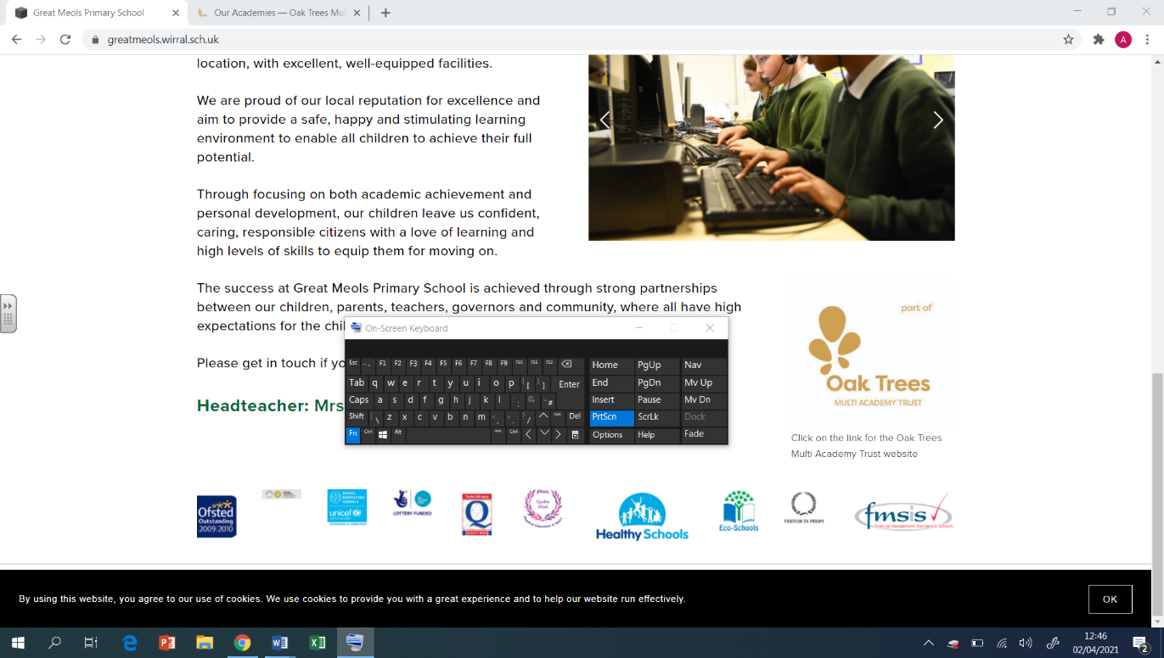  Y6  Spring Overview | PE  - Dance  World War 2 link  - Tri Golf  Adopt and efficient stance to strike the ball  - Badminton  To serve long and short  - Team building and problem solving  To perform calmly under pressure
Geography  - To locate mountains and identify their features  - To understand how mountains are formed  - To locate key geographical features of the USA  - To understand what a canyon is and how they are formed  - To explain why some places may be more populated than others  - To explore the climate across the USA | DT  Mechanical Systems: Automata Toys  - To prepare wood for assembly by measuring, marking and cutting.  - To assemble the automata frame components and supports with the help of an exploded diagram.  - To explore the relationship between cam profiles and follower movement to inform a design decision.  - To apply the housing and finishing touches to the automata frame. | RE  Journeys – Christian and Muslim  - Understand what is meant by the term rite of passage  - Look at people who could be there for them on a religious journey  - To know what a pilgrimage is  - Compare a Christian pilgrimage to the Hajj  - understand the importance of pilgrimages to people of religion  Christianity – The Afterlife  - recalling the resurrection from the Easter Story  - understanding that people have different views on resurrection/afterlife  - look at other faiths and their rituals around life, death and resurrection  - look at different beliefs and how not believing in an afterlife/resurrection might impact how we live
Computing  Programming - Variables in Games  To define a ‘variable’ as something that is changeable To explain why a variable is used in a program To choose how to improve a game by using variables To design a project that builds on a given example To use my design to create a project To evaluate my project  Data and information - Introduction to Spreadsheets  I can suggest how to structure my data  I can choose an appropriate format for a cell  I can construct a formula in a spreadsheet  I can create a formula which includes a range of cells  I can explain why data should be organised  I can suggest when to use a table or chart | Art  Drawing  - Develop ideas using different mixed media, using a sketchbook.  - Manipulate and experiment with the elements of art: line, tone, pattern, textures, form, space, colour and shape.  Sculpture  - Describe the different qualities involved in modelling, sculpture and construction.  - Develop skills working in 3D  - Make a models and develop, making alterations to create a final piece.  - Create sculpture and constructions with increasing independence | PSHE  Safety and the Changing Body  - Developing an understanding about the reliability of online information.  - Exploring online relationships including dealing with problems.  - Discussing the reasons why adults may or may not drink alcohol.  - Discussing problems which might be encountered during puberty and using knowledge to help.  - Learning how to help someone who is choking.  - Placing an unresponsive patient into the recovery position.  Citizenship  - Learning about environmental issues relating to food.  - Discussing how education and other human rights protect us.  - Identifying causes that are important to us.  - Discussing how people can influence what happens in parliament.  - Discussing ways to challenge prejudice and discrimination.  - Identifying appropriate ways to share views and ideas with others.

